UniPhi 15
Cost Management
Training Manual

Contents
Creating Projects 5
Resources 14
Budgets 20
Phasing 26
Budget Snapshots 40
Cost Budget Summary 46
Creating a Cost Plan Report 49
Contracts 60
Variation Management 80
Progress Recommendations 90
Certifying Progress Claims 95
Project Cost Reports 101
Communication 105
Correspondence 107

Course Aim
This training manual distils down aspects contained within more detailed and comprehensive UniPhi training manuals, such as the System Administration, and Financial Management, manuals. The aim of this manual is to provide end to end instructions to people who are responsible for cost management. The manual starts with the creation of projects and resources, and then explains how to establish an initial budget, and how to create and manage contracts. You will also learn how to manage the post-contract phase including variations management, progress claims, cost reporting and project status/PCG reporting. Lastly, you will learn how to leverage the functionality within UniPhi to efficiently manage communications.
As this manual has been designed for use by cost managers, some of the concepts covered have been summarised. More detailed and comprehensive information can be found in the full suite of UniPhi training manuals.
How to use this Training Manual
The following icons are used throughout this manual to assist in highlighting and enabling you to quickly locate activities and summary areas, and to avoid potential problems.
Puzzle Piece:
The puzzle piece appears at the beginning of each session and any major section to mark the overview of that item’s content or concept.
Cogs:
The cogs denote a step by step activity to be completed using UniPhi by the participant relative to the section it is located in.
Light bulb:
The light bulb denotes a helpful hint or tip you should be aware of.

Screen shots have been used throughout the manual to demonstrate what you should be viewing as you move through the activities. They are for illustrative purposes only. Details such as dates, budget figures and other entered text/data may vary.

Creating Projects

Projects need to be created so that all related items remain associated with an individual project, for example all documents and issues need to be aligned with the project to which they belong. Project specific data is also used when presenting information at the reports and dashboard level. Each business identifies information to be captured against the project that is utilised in their reports and dashboards.
Creating the project involves entering the name of the project, classifying it (e.g. the sector it belongs, lifecycle phase, location etc.), assigning resources, defining milestones, and estimating the timeline for the lifecycle phases.
Each lifecycle phase contains two start and end dates per phase, a baseline and an actual/forecast. The baseline dates enable you to measure actual and forecasted progress versus original schedule. Assigned resources can have effort estimated against the relevant phases in the resource planning section and from this a forward workload for all resources in the company can be analysed.
Project creation and categorisation is documented in more detail in the UniPhi Systems Administration Manual. The steps below are included at a summary level to guide you through the project creation process.
Creating New Projects
- Select Summary tab and make sure “All Projects” is selected from the Project filter.
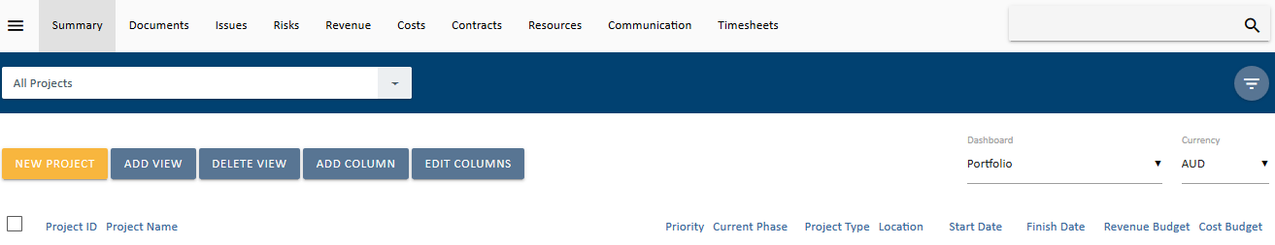
- Click 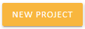 and following form will appear:
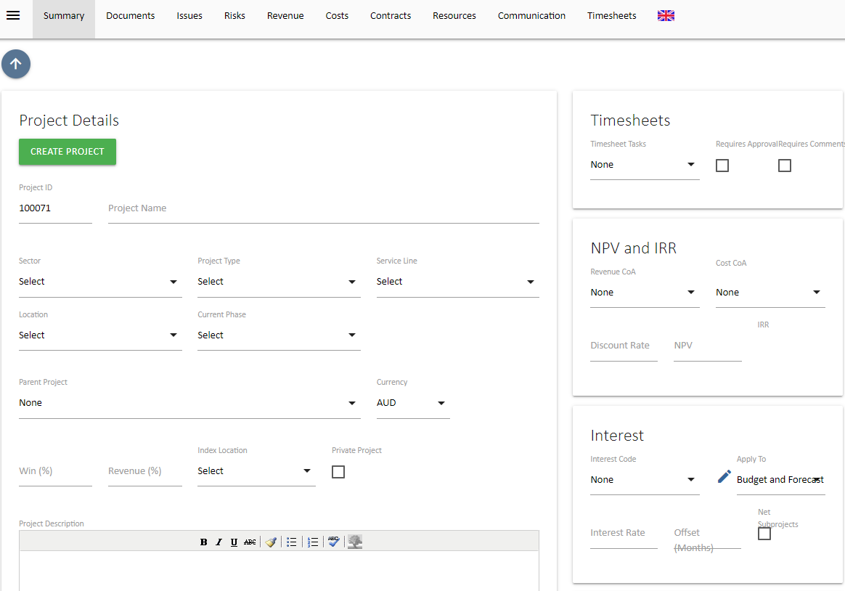
- Fill in the following fields, Project Name, Sector, Project Type and Current Phase. A Project ID is generated automatically. The remaining fields are optional, apart from adding Resources.
Adding Resources
An important component of creating a new project is adding resources. If a resource/contact already exists in UniPhi, simply press the 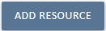 button and select Internal, External, or Asset from the dropdown filter.
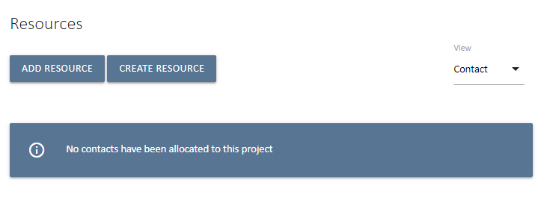
Start typing the person’s name, and select that person to add to your project.
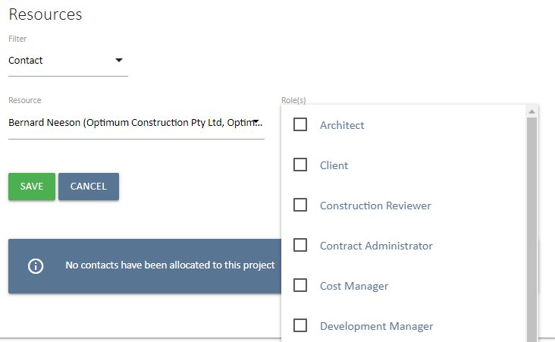

Next simply select the role(s) that they will perform on the project and Select to add the resource.
Note if you are uncertain of the resource name that you would like to add, you can press the space bar and all names will be displayed to you.

Adding and Deleting Roles to existing Resources:
Adding Roles: You can assign additional roles to a resource at any time. Select the 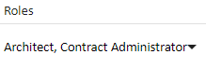 dropdown to the right of the resource and select the role you want to add:
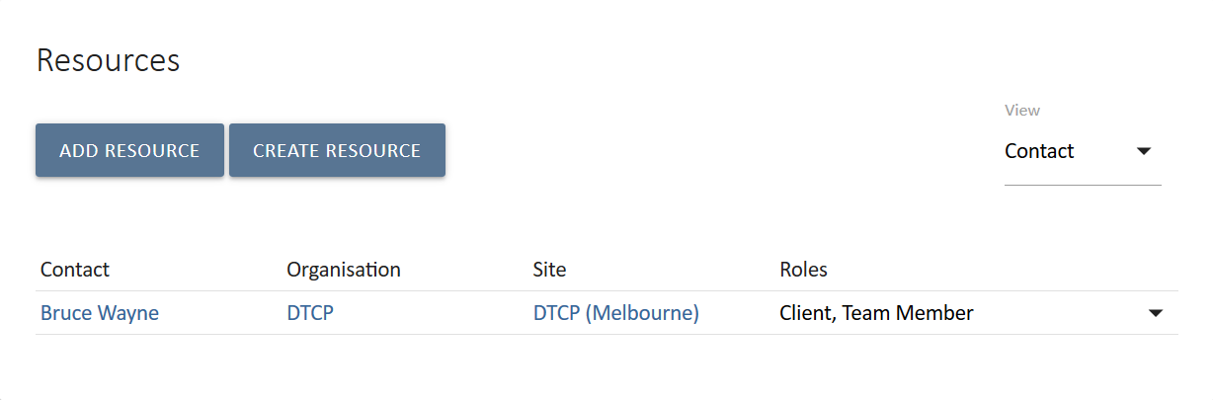
Deleting Roles: To remove a role select the dropdown button next to the role you wish to untick box.
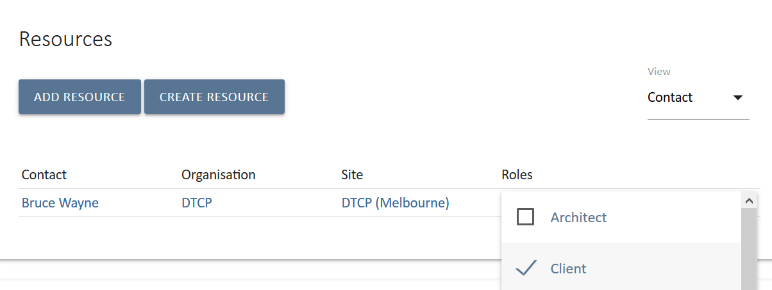

What if my resource is not in the list?
If a resource is not shown in the resource list you will need to enter them in to your resources database. Use the 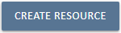 button as described in the next section, Resources.

Optional Fields
Not all fields are relevant to all projects / portfolios and can be ignored. If a field is mandatory you will not be able to create the new project and will be notified with a red warning message.
Project Details
Parent Project: UniPhi allows for a program of works within a portfolio to have an unlimited number of “child” projects underneath it. This is managed through selecting the Parent Project that the newly created project belongs to. Parent projects will consolidate budgets and contract costs and revenue for all children allocated to it. The Parent project will also display issues and risks that exist across the program (i.e. within each child)

The resulting project filter will look like this:
Currency: UniPhi supports an unlimited number of foreign currency translations. The currency selected here will be the default currency for the project and will be used to determine the currency project fees and costs have been estimated in. It is possible to have mixed currencies for contracts in the project but these will be converted to a common currency in the fees, costs and reports module. The currency selected by default in these tabs is based off the default selected here. It can be changed by the end user if they wish to see the end results converted into other currencies.
Win %: When fees, costs and hours are estimated, UniPhi will automatically adjust these fees in reports by the win % allocated to the project. The win % represents the probability that the organisation will win the job. The end result is a risk adjusted resource plan and cash flow forecast for the business. Win/loss ratios displayed in the Submissions dashboard can assist the user in determining a value for this particular field.
Revenue %: The fee % functions the same as the win % thereby compounding the risk adjustment factor. The revenue % adjustment reflects the likely reduction in fees that will occur through contract negotiation phase.
Private Project: If this box is ticked only resources assigned to the project can view it. Use great caution when selecting a project to become private as it is possible for the project to become invisible, i.e. if no resources are assigned to a project and it becomes Private.
Index Location: UniPhi can index historical costs based on CPI data. If your deployment in configured for this feature, select the Index location relevant to the project.
Project Description: This is a useful reference to other members of the project team as it provides a high-level summary about what the project is aiming to achieve. It is a free text field and the data contained within this panel can also be used to pre-populate documents generated from UniPhi.

Project Prioritisation Framework
Each deployment of UniPhi can configure a Project Prioritisation Framework which the user creating the project can complete to establish a projects’ priority. The prioritisation framework is displayed at the bottom of the create project screen. If you complete the Project Prioritisation Framework the result will automatically populate in this field once the project is created. Alternatively, you can enter in a priority manually. Project prioritisation allows team members to make discretionary decisions over work that needs to be completed at the same time. Knowing which project has a greater priority to the organisation can assist in the decision making, reducing the management time required to review and prioritise tasks.
Timesheets
Timesheet Tasks: defaults to a predetermined list that is visible to add work hours against the project when time sheeting. Standard tasks are used when work is completed on a project without specific contract deliverables. Examples of this type of work would be support work for a product that has been already commissioned or project management during a defects liability period in the construction industry.
Requires Approval: This option is selected if all timesheets entered and submitted require an oversight and approval.
Timesheet approval in UniPhi is based off the access level of roles on the project. If a project role has a program manager access level (as appose to a project manager or team member access level) then people in this role are able to approve submitted timesheets.
Rejecting a timesheet reverts the timesheet back to a “saved” state rather than a “submitted” state. The person submitting their timesheet can then amend and re-submit for approval. If timesheet approval is not selected then timesheets can still be reviewed in both the contracts module and via reports.
Timesheets can be “rolled back” to allow the team member to correct the error and re-submit. Only submitted hours are displayed in the contracts module while saved but not submitted hours can optionally be displayed in the timesheet reports.
Requires Comments: Select if daily comments next to each task are required for successful submission of timesheets. If this is selected, staff will not be able to submit their timesheets unless they have entered text in the comments field.
Primary Chart of Accounts
Revenue CoA: This sets the default Revenue CoA in Dashboard views and is required if you are auto Calculating NPV or Interest.
Internal Costs CoA: This sets the default Internal Costs CoA in Dashboard views.
Project Cost CoA: This sets the default Project Cost CoA in Dashboard views and is required if you are auto Calculating NPV or Interest. Note that if you are using an Internal Cost CoA for Interest and/or NPV you must select that CoA here.
Funding CoA: This sets the default Funding CoA and is required if you using UniPhi’s Feasibility module.
Interest
Interest Code: Select the code for auto-calculated interest to be allocated to. This references the Project Cost CoA selection in the Primary Chart of Accounts card. This calculates interest based on a net position and also requires a selection in the Revenue CoA in the Primary Chart of Account card.
Apply To: Determines if the interest auto-calculation applies to the Budget, Forecast or to both Budget and Forecast.
Interest Rate: Sets the rate of auto-calculated interest. This is an annual rate.
Offset (months): Allows for the month that the interest will apply to be offset.
NPV and IRR
Discount Rate: Sets the rate to apply for UniPhi to auto-calculate the NPV and IRR for the Project. The requires a Revenue and Project Cost CoA to be selected in the Primary Chart of Accounts card.
NPV: NPV stands for Net Present Value. UniPhi will auto-calculate the NPV value for the project if a Revenue and Project Cost CoA are selected in Primary Chart of Accounts card and you set a Discount Rate in the previous field. Alternatively, if not Discount Rate is set you can use this as a data capture field for NPV.
IRR: IRR stands for Internal Rate of Return. If UniPhi is auto-calculating the NPV it will also calculate the IRR.
Risks
Risk Contingency COA: UniPhi’s risk management module allows for the build-up of a dollar value for risks in the project cost budget. Risks identified have contingency values allocated to them. The total of which is then transferred to the project budget via the relevant contingency code selected. Risk contingency dollar values are applied to costs, not revenue, so this is only relevant when managing a project cost budget. The code list available is all code structures that have “Contingency” codes flagged in their chart of accounts
Risk Contingency Code: The account codes that have been flagged as contingency codes in the chart of accounts selected are displayed here. Selecting one code will provide for a default code selection when creating risks. This default can be changed for each risk identified but the default selected here should be the most common contingency code (e.g. construction contingency).

Resources

Within UniPhi, resources are typically people, though in some cases resources may be materials. For the context of this manual we will focus on resources as people. Each resource is entered into UniPhi via the Resource module as a Contact. The information entered per contact can be captured to the level of that you have on the particular person, and can therefore be very high level (simply a name), or fully detailed with all contact details, the organisation and site that they belong to, projects that they are assigned to etc.
Resources are categorised as Internal and External. Internal refers to the people internal to your organisation, and generally considered as staff in your business entity while External is anyone else that could be associated with a project, i.e. Clients, and Suppliers.
Filtering for a specific project will present all resources assigned to that project.
Resources can be edited (i.e. you can add or remove resources) at any time.

Creating Contact Resources
If the resource contact does not already exist you can create a new resource. Resources in UniPhi are split into 2 main types: Contacts and Assets. For the purposes of this manual, only Contacts are demonstrated.
A resource can be created when setting up a project, when viewing the Project Resources or when viewing the Resource Pool. At project set up or when viewing the project or from the Resource Pool click.
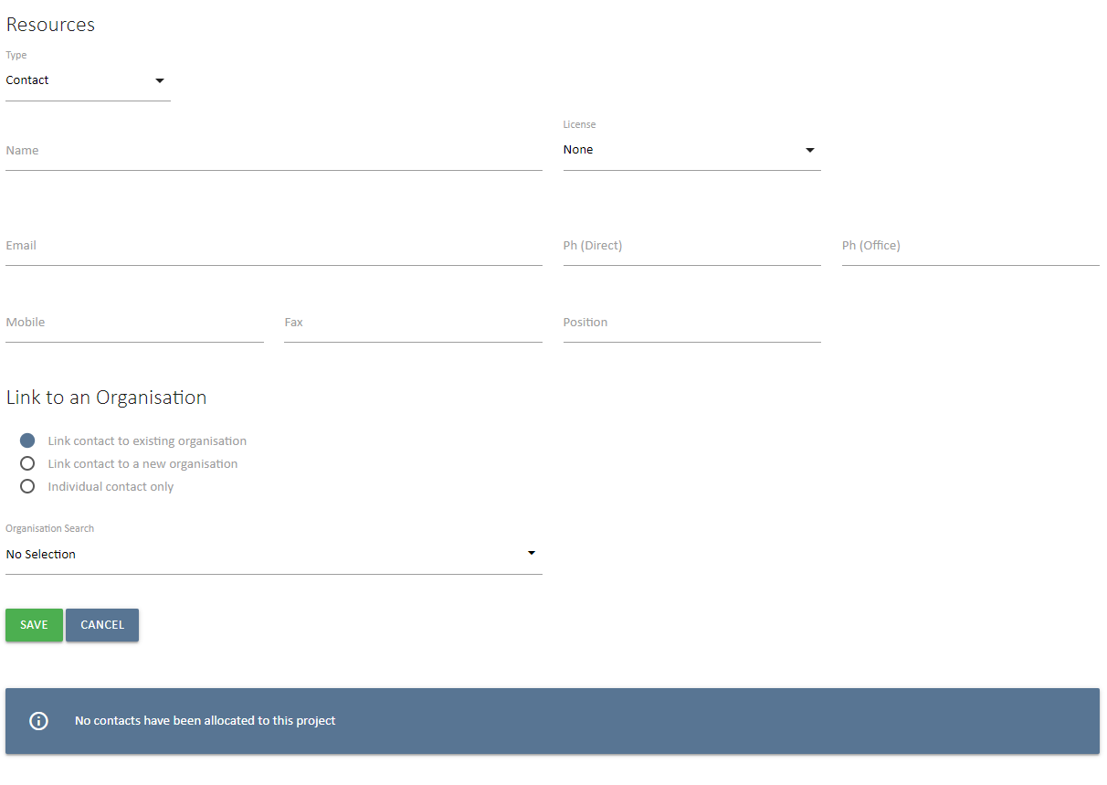
If the resource you are creating belongs to an organisation not currently in the system, this can also be created. By selecting you will be presented with the view as seen below.
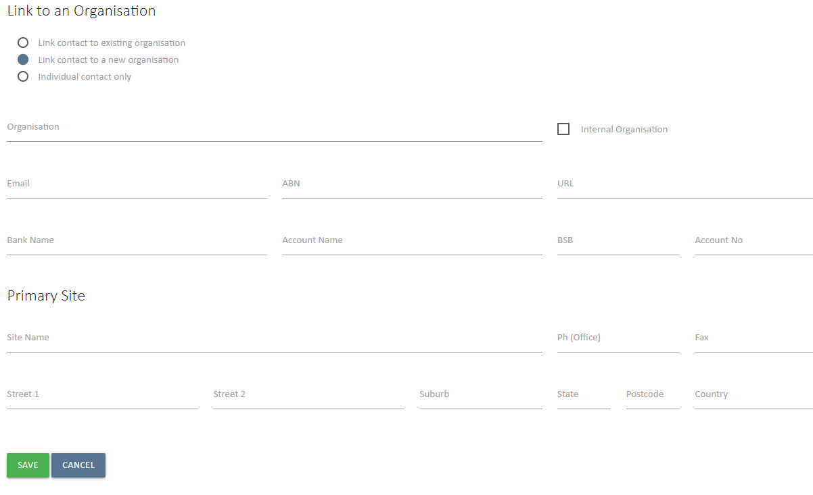
Click to add the resources to your new project. The default role of a newly created resource will be Team Member. From here you can use the Roles: dropdown to re-assign each resource to their correct role on the project.

Adding and Deleting Roles to existing Resources:
Adding Roles: You can assign additional roles to a resource at any time. Select the dropdown to the right of the resource and select the role you want to add:
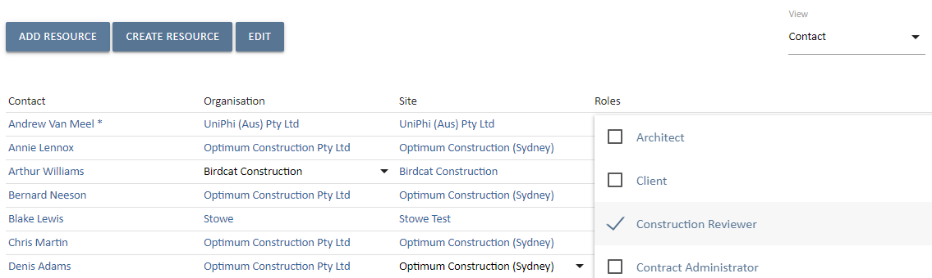
Deleting Roles: To remove a role select the dropdown button next to the role you wish to remove and untick the box.
There are several contact fields that you may choose to populate at any time. The only mandatory field that requires input at this stage is the resource Name. All other fields, such as phone numbers, email address, licence type, and position detail can be updated or amended at a later date. Remember to save your new resource details before leaving this page.
The access level that your resource will have to the UniPhi system will depend on the licence type that you select. The five licence types available to you are:

- None. No access to your UniPhi deployment, the purpose of this licence type is purely to store your external client information. This information can be used when generating documents, and emailing from UniPhi.
- Team Member. A lower level of access which will allow your team members to see their issues and actions, a view project related documents, and allocate time via their own timesheet.
- Project Manager. Access to issues, documents, and financial information relevant to projects they are assigned to
- Program Manager. High level access to documents, issues, and financials across all projects.
- Administrator. Full access to issues, documents, financials, and methodology changes.

Resources are specified as being Internal or External based on the Organisation & Sites that they are assigned to. (See below for Organisations & Sites)
Organisations & Sites
Organisations and sites are effectively the company or companies that a contact resource is associated with. Organisations refer to the company or business, while Sites refer to locations of that organisation. Therefore, a site is always linked to an Organisation.
Creating Sites & Organisations

- To add a new Organisation, go to the Resources tab and press the Create Organisations button 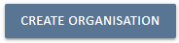
As is the case when creating new contact resources, you will be presented with several detail fields that can be populated with organisation specific information. The only mandatory field that requires information at this stage is the organisation name, and the primary site details. Obviously, the more details you have entered here, the more useful your resource information will be, particularly when performing tasks such as generating documents, or invoices, etc.
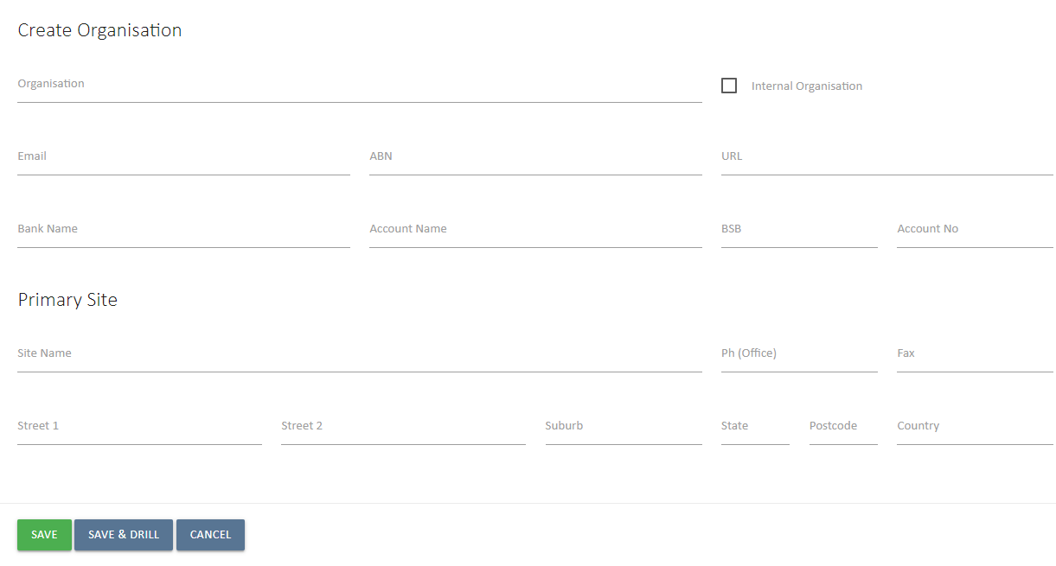
Once you have created an organisation and primary site details, you can add additional sites by pressing the Add button under Sites.
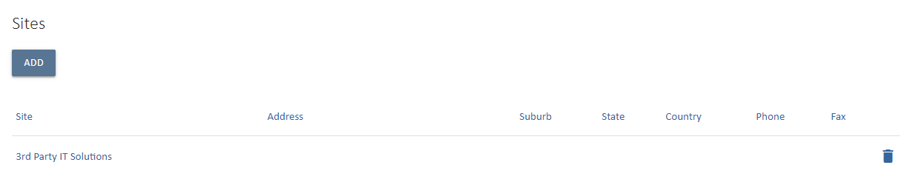
- The organisation should be marked as internal if this is your organisation, and resources assigned to your organisation are internal employees. Leaving the Internal box un-ticked will treat the organisation (and associated sites) as an external organisation (e.g. a client).
- To add existing contact resources to a site, simply drill into the specific site, and press the 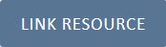 Link Resource button.
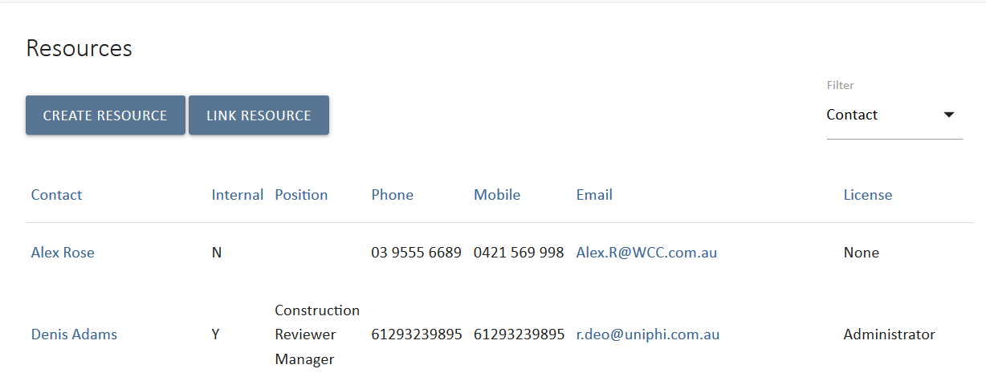
- It is possible to add multiple contact resources at one time; simply search and select the relevant resources displayed in the search. If you wish to see all resources type a space in the search field.
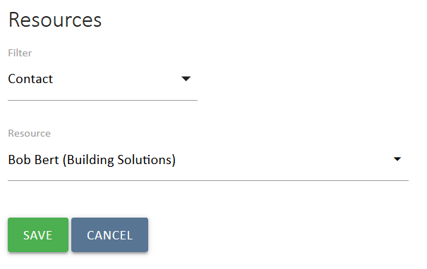

Budgets
The first step in post contract management is to establish the original budget that you will track commitments. These budgets may be used for projects in pre or post contract management. Typically, this is completed via an import from Excel, though there are few methods available to you for entering your cost data. Depending on the size and complexity of your cost breakdown, you may choose to enter your budget against a defined structure, create your own structure, or import your costs from an Excel sheet. This section explains all three methods.

Using a Defined Budget Structure
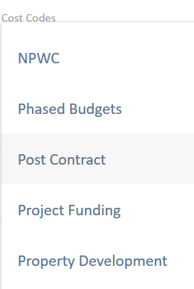
To create your project cost budget, select your project from the project drop down list. When you then go to the Costs module you will find your project cost code budget structure. It may be that case that your organisation has a number of predefined cost structures, and these structures can be found via the cost codes drop down menu. The cost codes may vary in detail from very high-level structure, to a more detailed and granular. Select your desired cost code structure.

Creating Your Own Cost Code Structure
Where the structure is defined at a high level, you can actually create your own project specific cost breakdown structure. To do this, choose the Blank cost structure from the drop-down list.
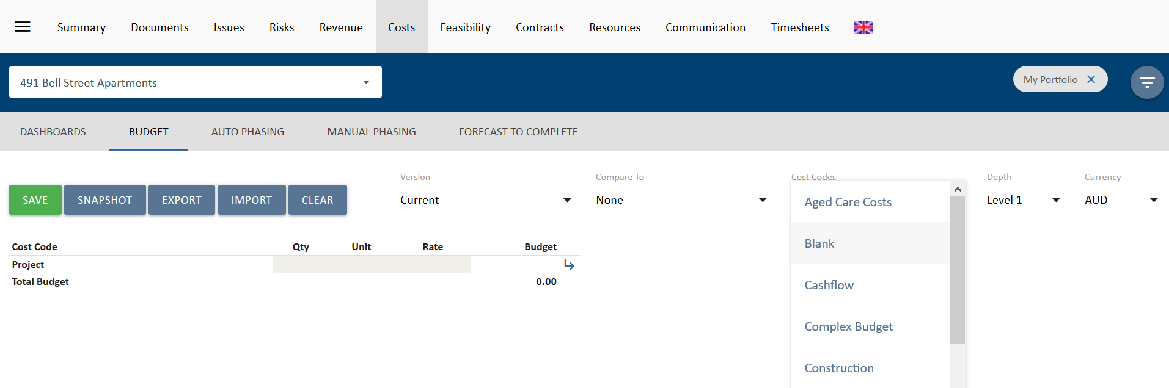
From this point you can create your own cost code structure. To do this, simply press the arrows located on the right-hand side. A new window will pop up and allow you to create the next level of your data structure.
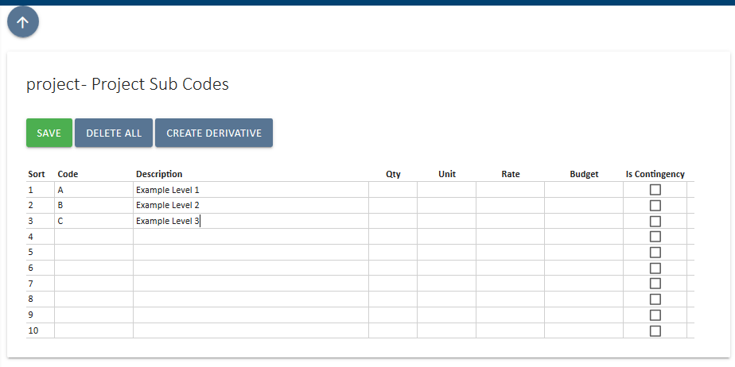
After clicking 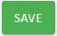notice that the right-hand side of your new structure has the same arrow icon. This means that as you need additional levels of detail, you can click on the arrow, to expand down to the next level.
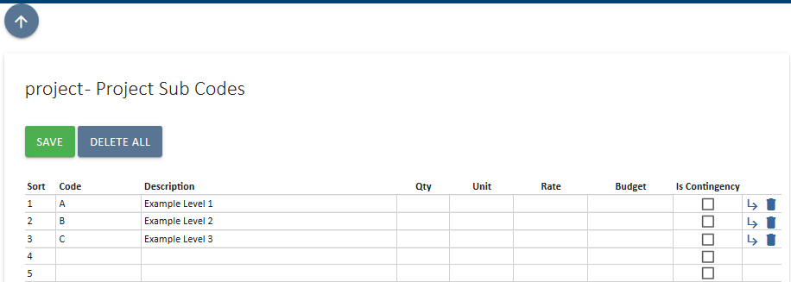
This allows you the flexibility to create codes to addition levels and per the structure that suits your particular project.
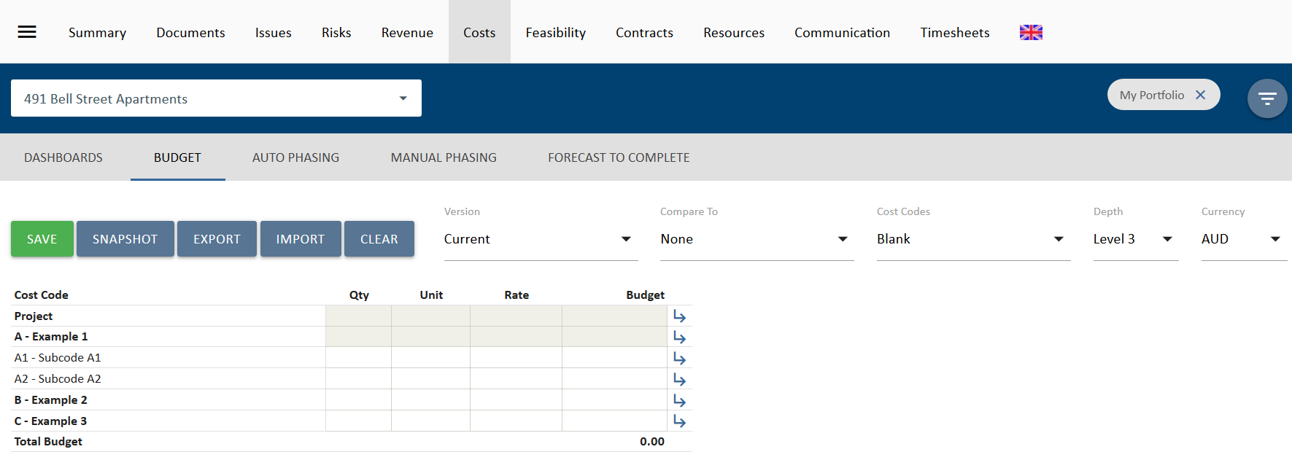
When you come back up to the top level of your budget, you will be able to select the view depth of your budget.
Data can only be entered at the bottom level of your code structure. All values entered against your budget line items will calculate up to the higher level code, and ultimatley provide you with a total project budget at the top level

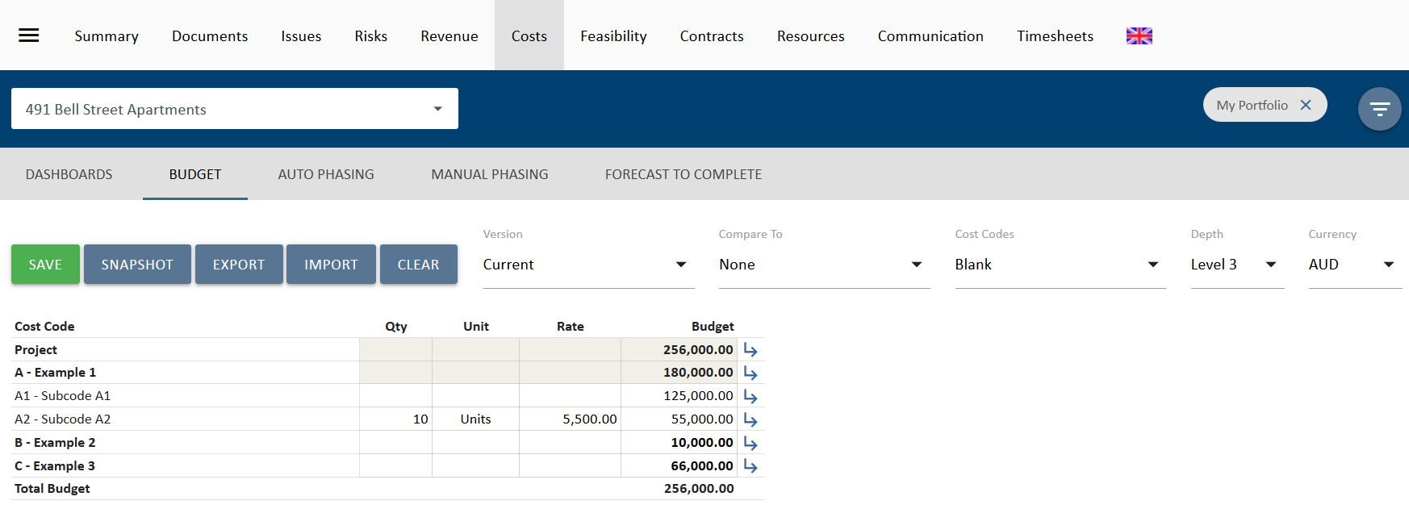

Import Budget from Excel
As a faster method of creating your cost budgets, you may also choose to import your data into UniPhi from Excel. The excel sheet may be configured by an individual, or by exporting a similar budget from UniPhi and then importing the extracted format into your required project.
- Filter for the project you wish to work on from the Projects filter
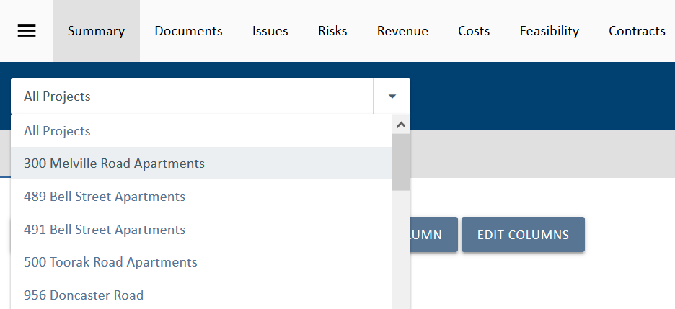
- Click on the Costs module and then Budget on the navigation bar.
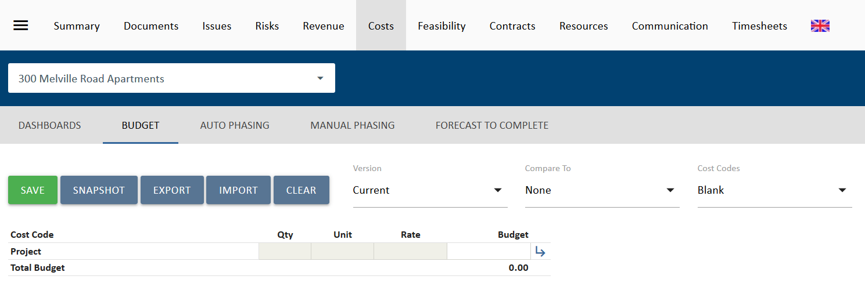
- Firstly, in order to generate an excel template which contains your cost code structure, click on 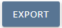
- Within the excel template, either copy/paste your budget from another system or spreadsheet in order to align it with the required format to import into UniPhi.
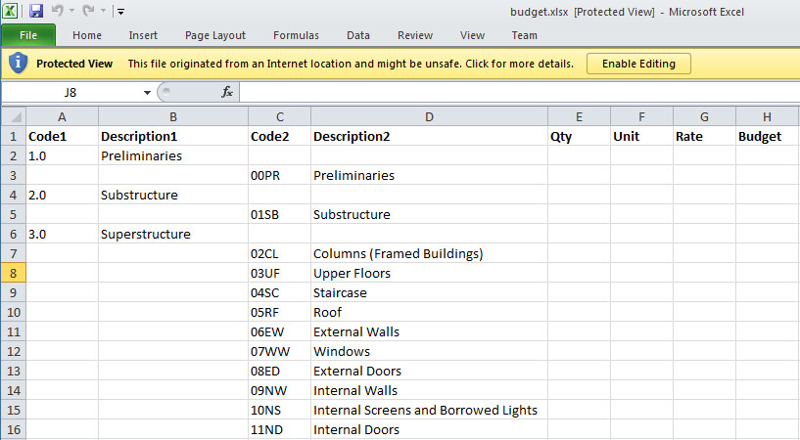

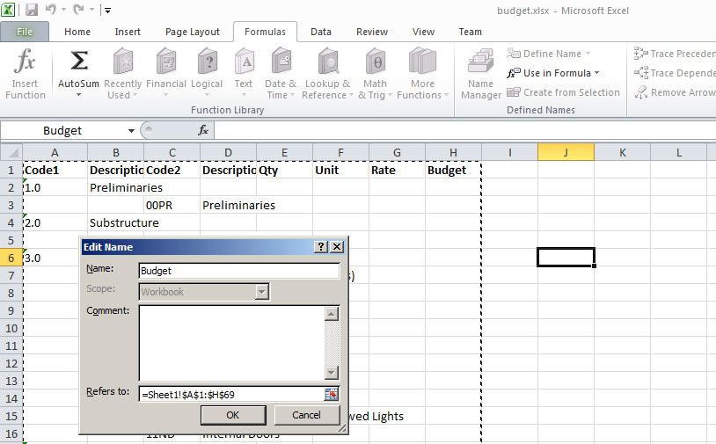
Note that the spreadsheet template has a name range called Budget which encompasses the rows and columns to be imported back into UniPhi.
- Once you have filled in the budget spreadsheet template, click on 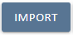 in order to bring those values into UniPhi.
The most important thing to note here is that the Levels of information are structured so that Level 1 is captured in Column A under the heading Code1 and its description is captured under the Description1 heading. Level 2 must be indented so that is appears under the heading of Code2 with the corresponding description being noted under Description2. Multiple subsequent levels may be added so long as the same structure is used. For example, a sub-set of Preliminaries may be added by inserting a column called Code3, and Description3.
Data Entry
For each code, you may choose to enter either the Qty, Unit, and Rate and allow UniPhi to calculate the total for you, or you may enter in the Budget as a dollar figure only.

Phasing
UniPhi allows phasing of costs across months. This can be done for Budgets, Contracts and Forecasts and is the starting point in developing a cash flow in UniPhi. UniPhi allows phasing to be done manually or automatically. To phase a budget, after ensuring the budget has been entered and saved, navigate to the Costs Module then select Manual Phasing from the sub-navigation menu.

Manual Phasing
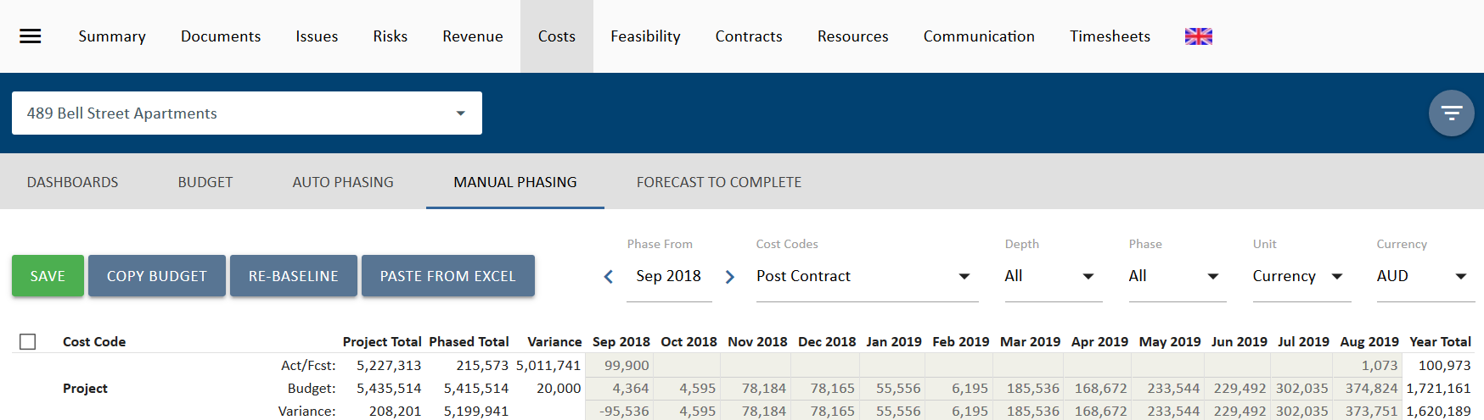
There is a set of dropdown filters on the right hand side of the phasing screen.
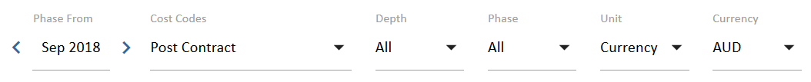
- Phase From = the selected month from which a 12 month period will be shown in order to phase.
- Cost Codes = the chart of account from which the budget and contract will be phased.
- Depth = the chart of account level at which phasing will be done. Phasing can only be done at the lowest level. Also selectable is Contracts. The forecast can be hased against contracts, but not the budget.
- Phase = All shows Budget and Actual/Forecast, or select either Act/Fcst or Budget to just view that information.
- Unit = show the phasing as Currency or %
- Currency = If your deployment is set up to handle multiple currencies, you can pick the relevant currency.
Tha ACT/Fcst lines and view show Actual costs for past months, where the month has been closed. For current and furture months Forecast data is shown. The closed onths with actual data are greyed out and cannot be edited. Firecast motnhs are white an dcan be edited. In the view below, actual costs are shown up to and including April 2020 and from May 2020 forecast data is show.
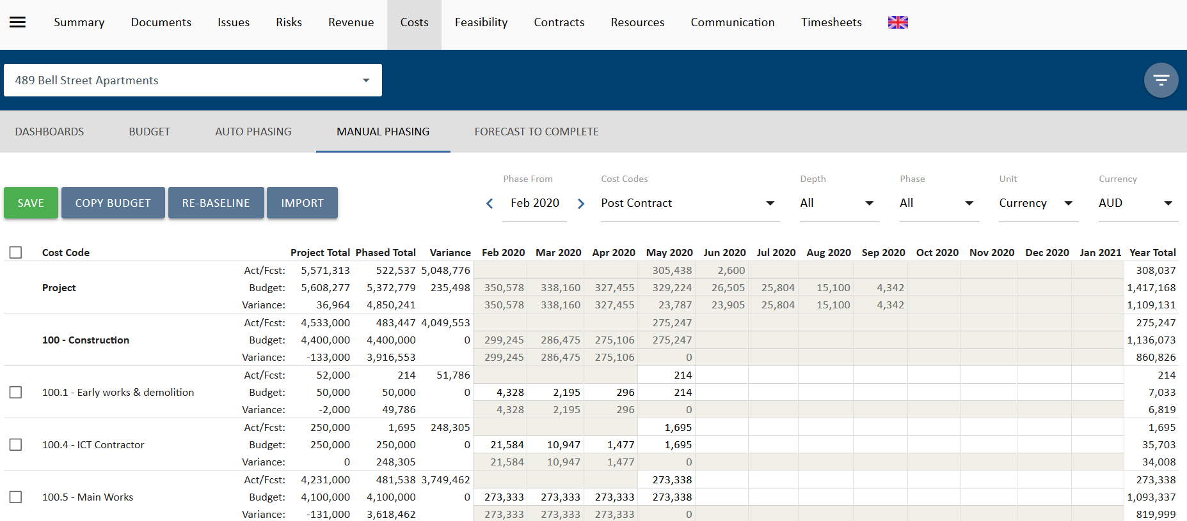
The buttons on this page have the following functions:
- 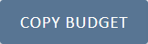 Copy Budget copies the phased budget data to the forecast. Note that if any of the data is in closed months, the budget values will nto overwrite the actuals values.
- 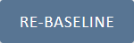 Re-baseline copies both phased actual and forecast data to the phased budget.
- 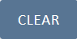 This option appears when you check the selection boxes for the detail lines on the left of the screen. When used it will clear all phased data form the selected lines. In the Phase All view it clears budget and forecast data, but not actual data. In Phase Budget view it only clear phased budget data. In Phase Act/Fcst view it clears forecast data but not actual data.
- 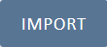 Import allows you to paste budget and forecast data from Excel. See the section below on importing phasing for more informtion.
- Save will save changes to the manual phasing data.

Input Manual Phasing
Phasing can be input directly in to the Manual Phasing view.

- Filter for the project you wish to work on from the Projects filter
- Go to the Costs module, then select Manual Phasing on the navigation bar
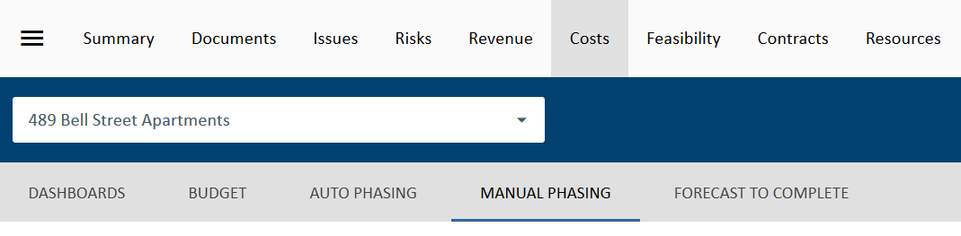

- If not already show, select the Cost Code you want to work in from the Cost Codes filter
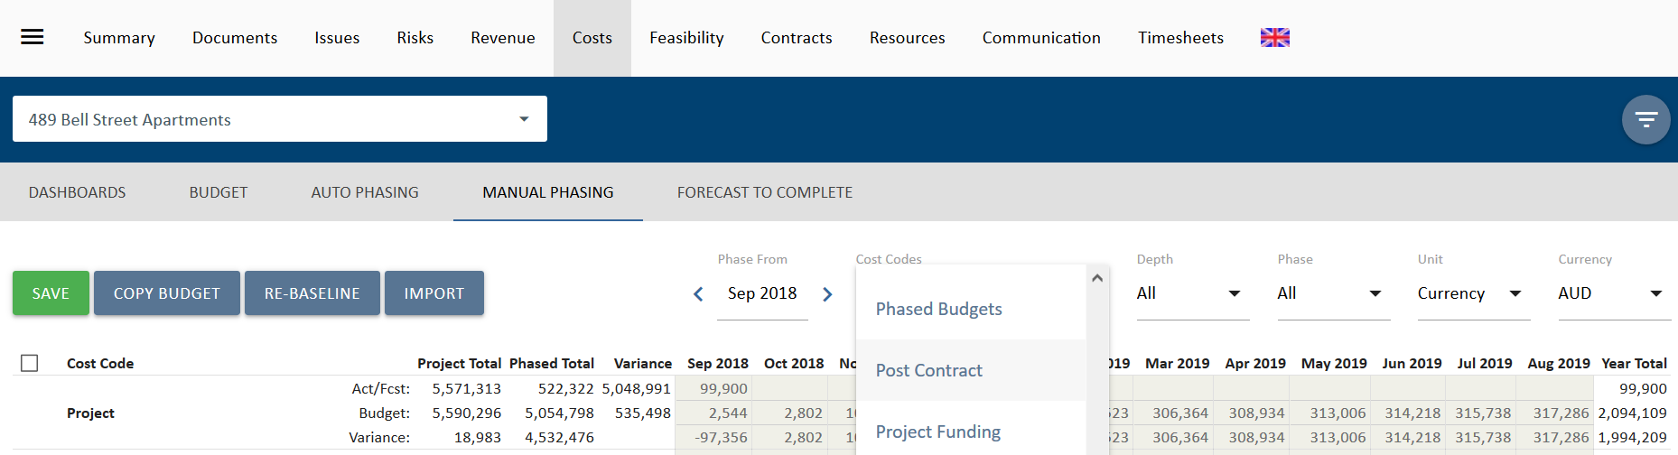
- Select the month you want to start in in the Phase From data selector.
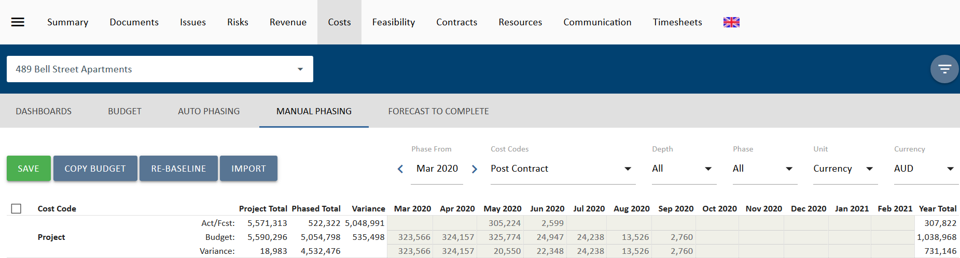
- Select the other filters to show depth, phase view, unit and currency.
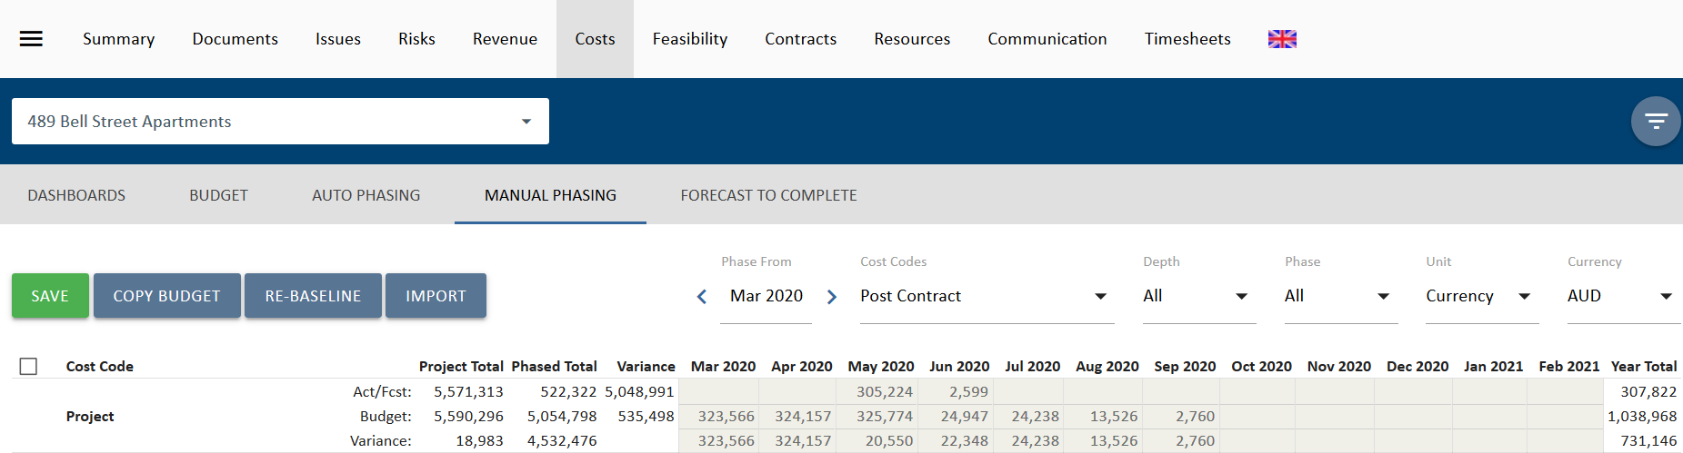
- Enter the values in the cells as appropriate. In the example below, a budget of $1,000,000 has been phased manually across 12 months from May 2018.
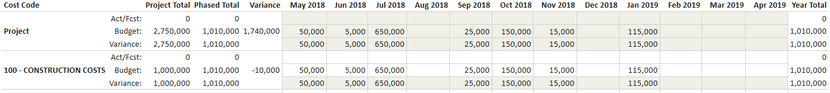
- Once the amounts have been entered, click .

Import Phasing
Phasing can be imported from Excel to update the budget or the forecast. This reduces the need to enter data and duplicate work.

- Filter for the project you wish to work on from the Projects filter
- Go to the Costs module, then select Manual Phasing on the navigation bar

- If not already show, select the Cost Code you want to work in from the Cost Codes filter
- Select the Import button to go to the Paste from Excel interface.
- Select to import ether Budget or Forecast
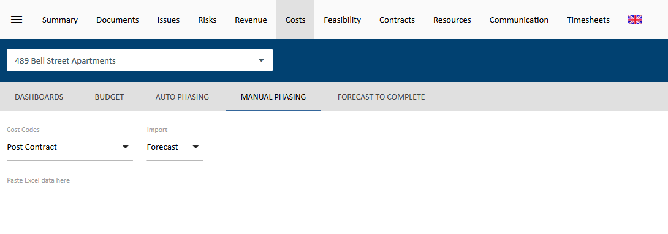

- Paste the month by month cash flow data from Excel into the area labelled “Paste Excel data here”.
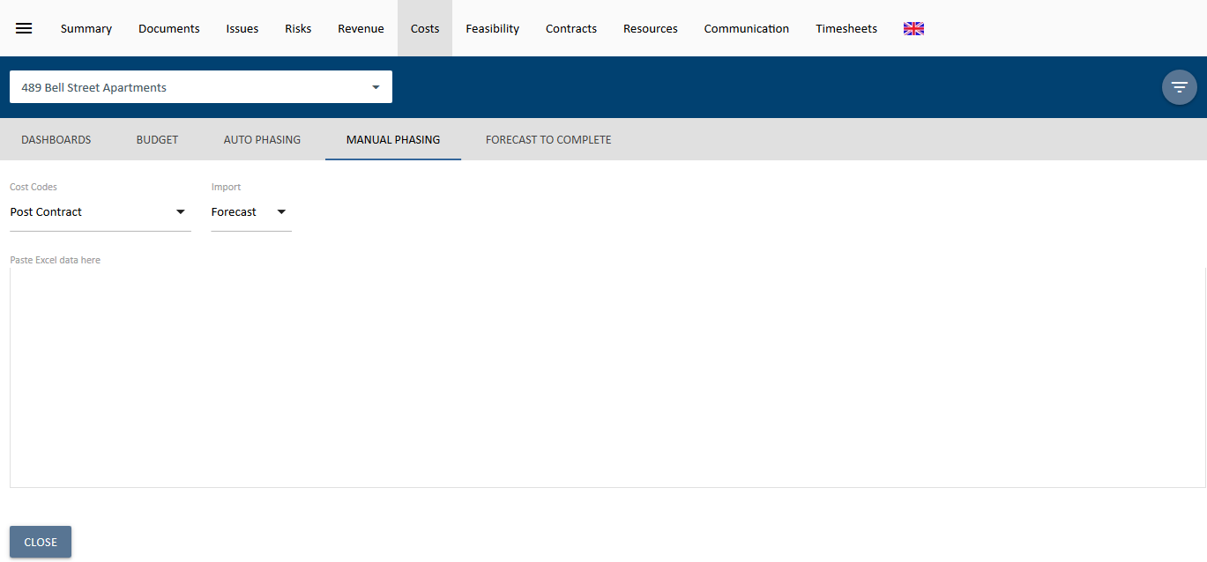
- When you paste the data, UniPhi will validate it for you. In the example below, columns that are not relevant are ignored, but the data cannot be imported because there is not a column with the Heading “Code” to tell UniPhi where to put the phased cash flow against the coding structure. To clear this and try again. Select Reset 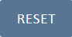 to clear these.
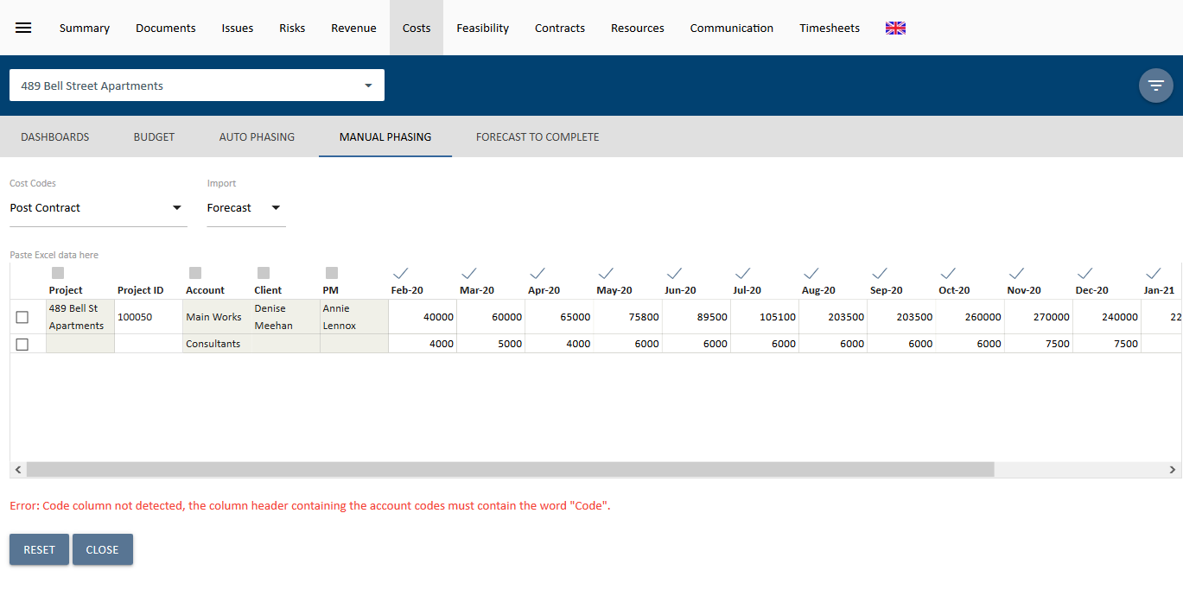
- This time it has been pasted with a column heading containing “Code” that corresponds to the coding structure. Once again, irrelevant columns have been ignored and are greyed out. Each line of the import is ticked, indicating that it will be imported. Select Save to confirm the import
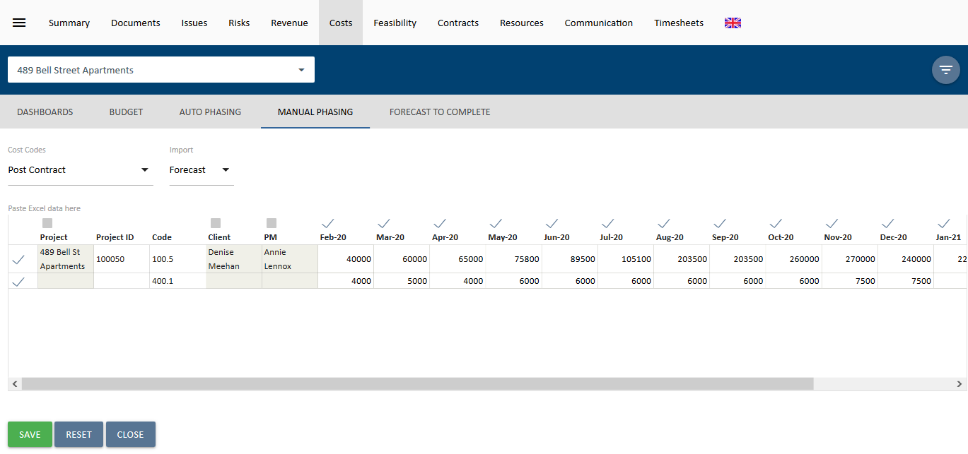
- All data imported will be shown in green. Select 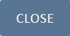 Close to complete and go back to the Manual Phasing view.
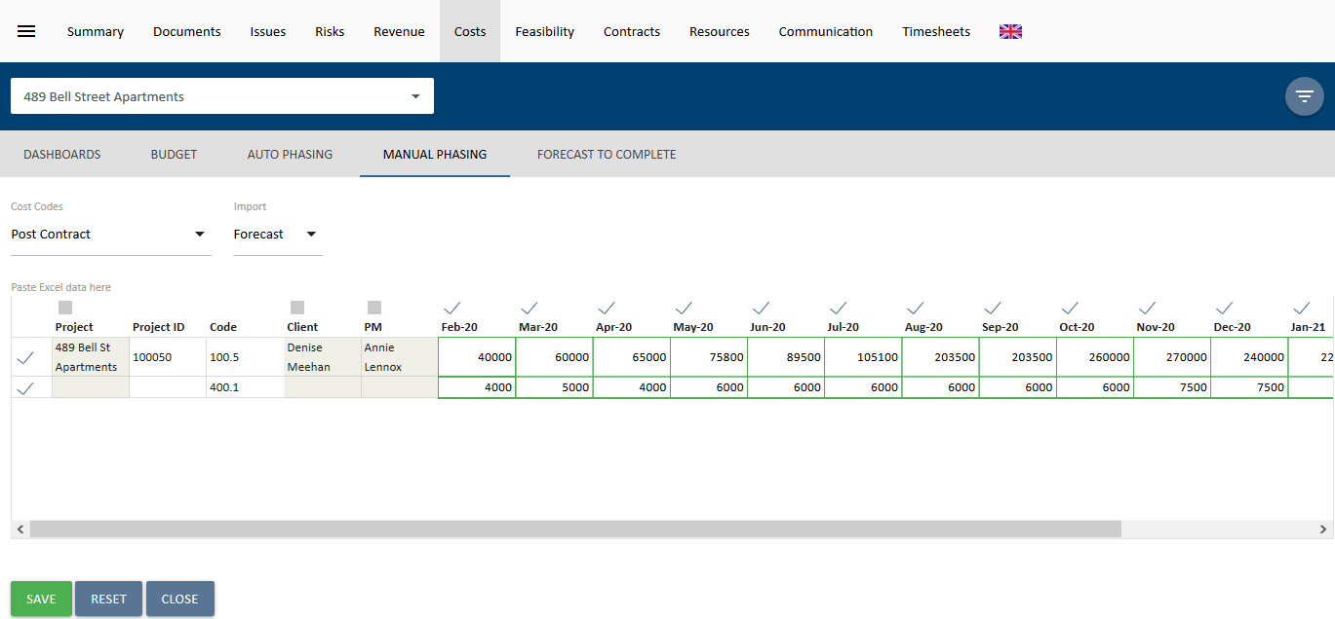

Auto Phasing
In order to phase automatically, click on Auto Phasing in the sub-navidation menu.
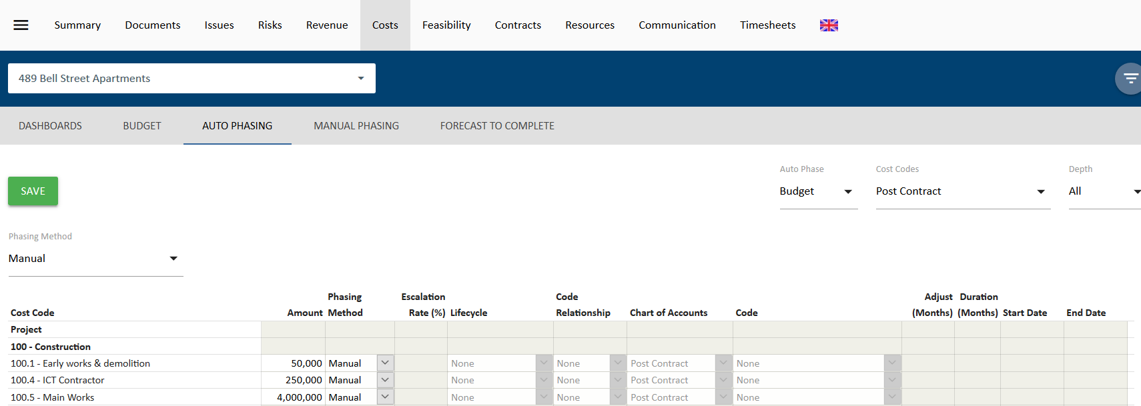
In this screen, the you can either auto phase the entire budget against a specific criteria or auto phase each code of the budget against criteria specified.
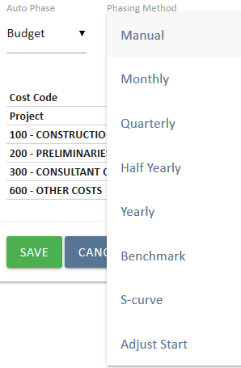
Clicking the Phasing Method dropdown reveals a list of auto phasing options.
- Monthly, Quarterly, Half Yearly and Yearly = when selected will present more options to for the user. These 4 options will split the budget equally over the date range specified (see below) into the respective method chosen. i.e in the example below, each code will divided by 4 and the result displayed in each month from May to August.
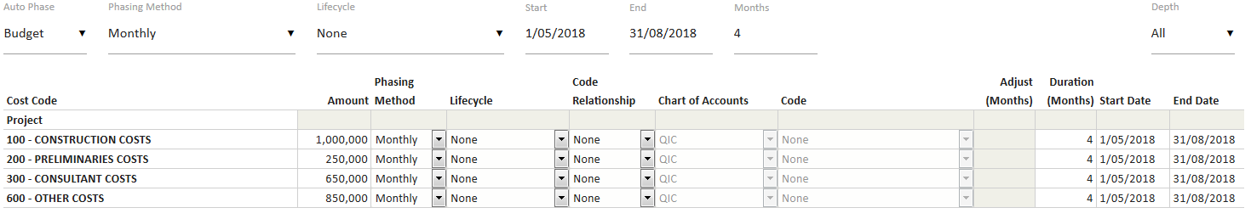
- Benchmark = a method which uses existing closed projects in UniPhi to generate a similar spend pattern. When this selection is chosen, a range of filters become available to filter for appropriate projects that are similar to the current project in order to copy its cost profile.
- S-Curve = a method which uses UniPhi’s S-curve algorithm to generate an S-Curve using the budget or forecast
- Adjust Start = this allows you to adjust the start date of previously phased line items forwarsd ro backways by X number of months. This is useful if you have phased you project cahs flow and then the prject is delayed.
All of the above methods can be chosen globally to affect the entire budget or individually for each code.
Once your phasing method has been selected you may choose to apply phasing to a lifecycle phase or simply phase at a global whole of project level. When phasing according to any of the options you will be presented with set of configurable phasing options.
If phasing via a linear method (Monthly, Quarterly, etc.), you will specify the start and end dates, either for all items in the header of the page, which pushes the dates into all the individual line items, or in the individual line items. Each line item can be controlled for different phasing methods.
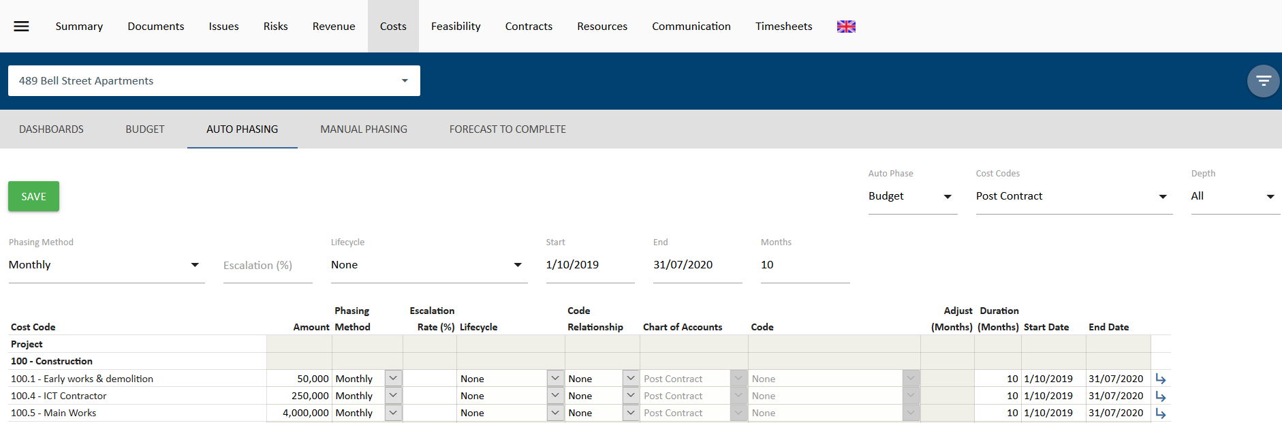
Entering a start date and a duration will calculate the end date, entering an end date and a duration will calculate the start date.

If Phasing via Benchmark method you will be presented with project custom fields that allow you to selectively choose projects of a similar size and nature. The projects that are displayed within this screen are those which have moved to a completed status in UniPhi.
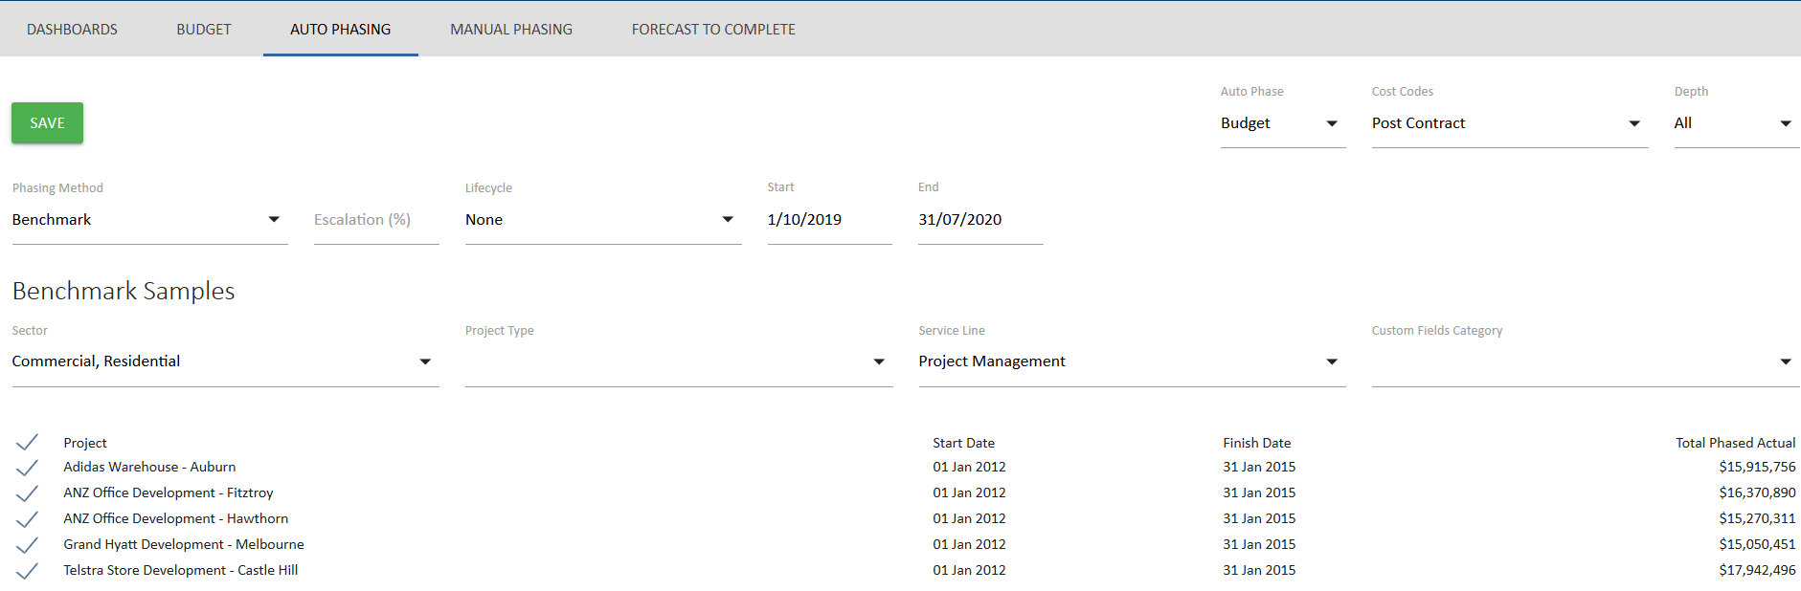Selecting the Manual phasing option allows you to specify how each line item is to be phased. 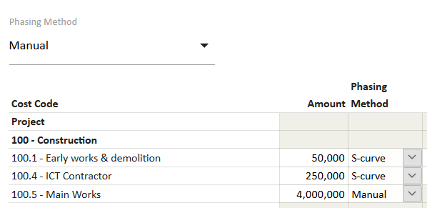
Once the phasing method has been selected, the fields for individual line items will be editable therefore the user is able to overwrite the Global Options at each individual line item.
Lifecycle phasing uses the project schedule dates maintained in Summary Project Schedule.
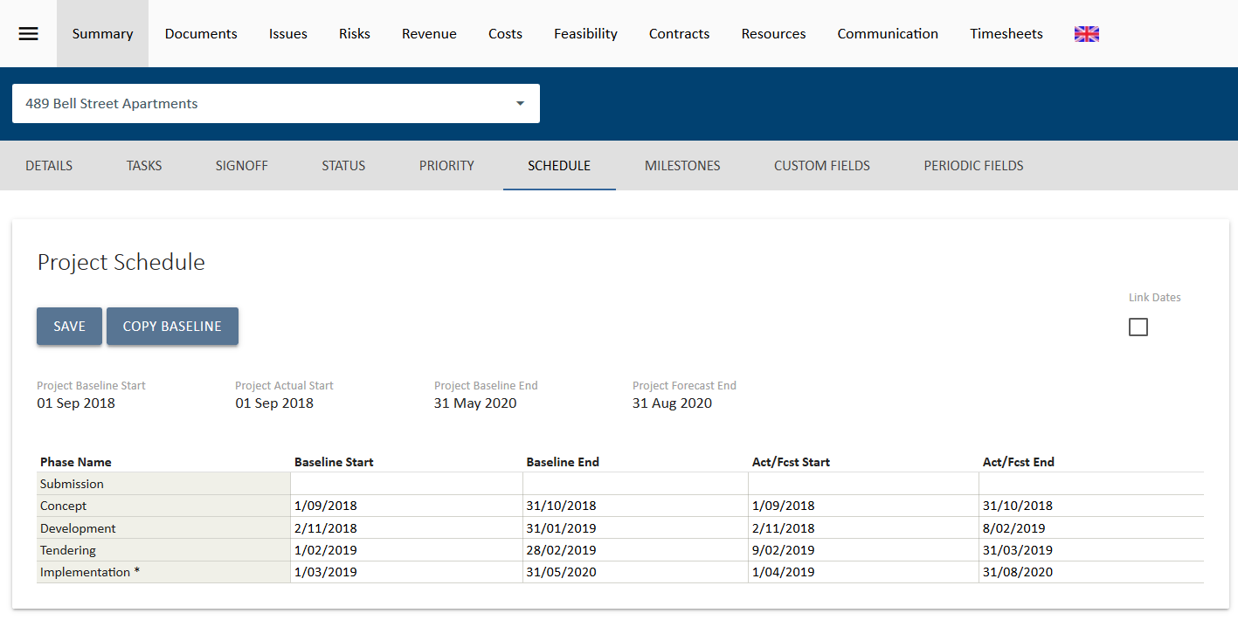
In the example below, some items are linked to the Implementation phase, some to the Development phase and others to Whole of Project.
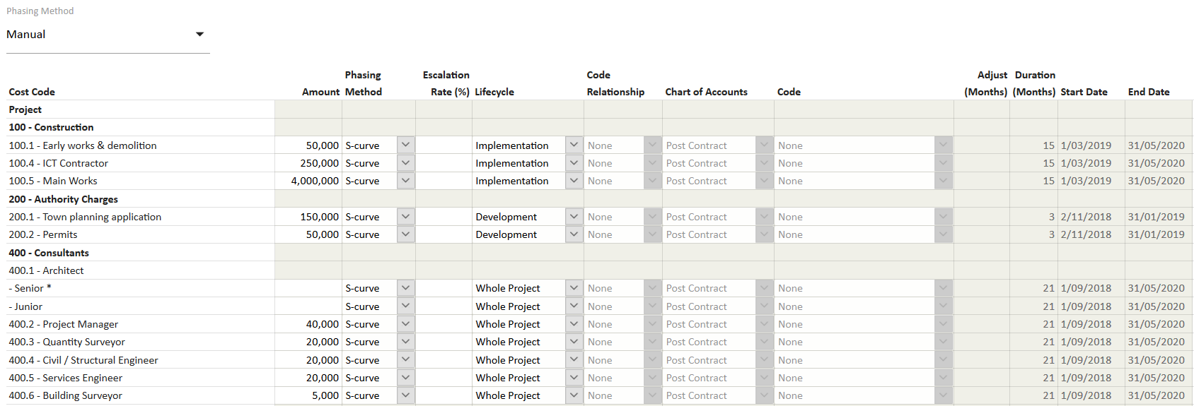
For budget phasing, UniPhi uses the baseline dates from the schedule, for forecast it uses the Actual/Forecast dates. Start and End Dates and durations will blank out with a lifecycle selected.

Linked Account Code Relationships
Code Relationship allows the Start date of the phasing for an item to be determined by its relationship to another cost or revenue item, linked by selecting it from the Code drop down menu.
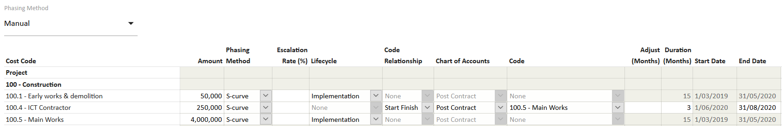
The options available are:
Start Finish – the start date for this item is determined by the end date of the linked code.
Finish Start – the finish date of this item is determined by the start date of the linked code.
Start Start – the start date for this item is determined by the start date of the linked code.

Based on the linked (account) Code Relationship, any change to the phasing dates of the linked code will flow to update the phasing dates in the linked items. The duration needs to be provided to complete the phasing, i.e. if either a start or end date is missing, the duration will be zero and, no phasing will occur.
Additionally, phasing Start dates can be offset from the linked Code related date for a specific line item by entering a value in Months, positive or negative, in the Adjust (Months) field.
In the example below, ICT Conractor code to start two months before the Main Works are completed and go for a duration of 4 months.
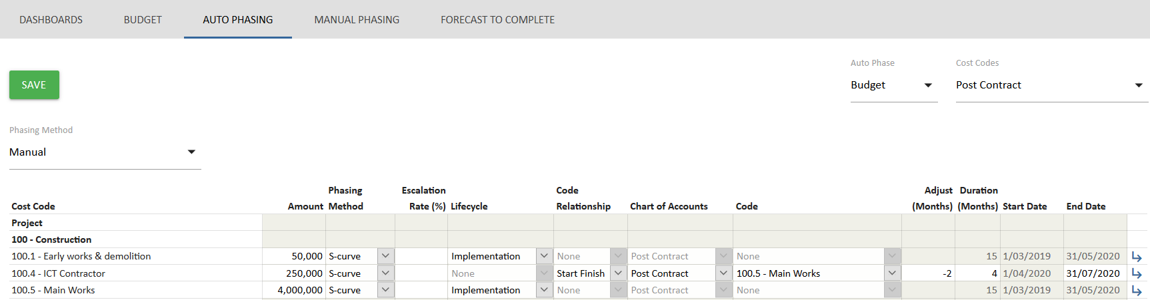

Once the selections have been made, click Save . This will take the user back to the Manual Phasing view to view the phased data.
Once the budget is phased, the user can create budget snapshots in order to capture the phasing information for a particular budget.

Budget Snapshots

Your UniPhi deployment may be configured to allow budget snapshots, budget approvals, and current budget versions to be created by Project Managers, Program Managers, and Administrators, or it may be restricted so that budget versions can only be captured via signed off change request document. Your administrator will be able to advise you of your configuration, and you can also determine these settings by pressing the Snapshot button.
A restricted snapshot configuration will look like this:
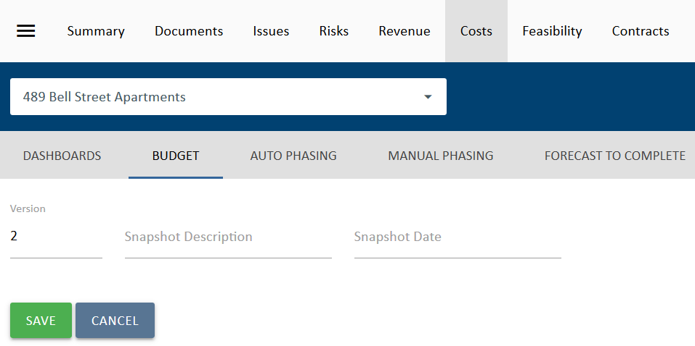

While an unrestricted snapshot will allow you to set an original budget and an approved budget
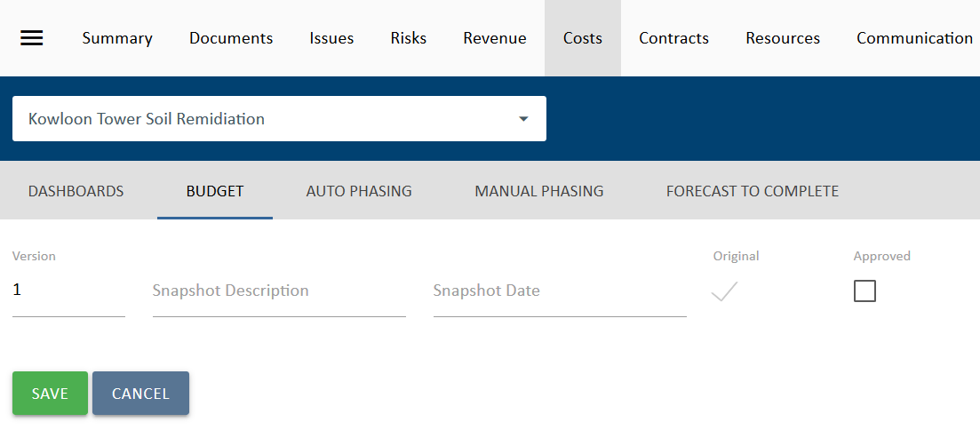

Create an Unrestricted Budget Snapshot
When a budget that has been agreed with the client or your key stakeholders, it should be baselined.

- To do this you need to select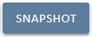.
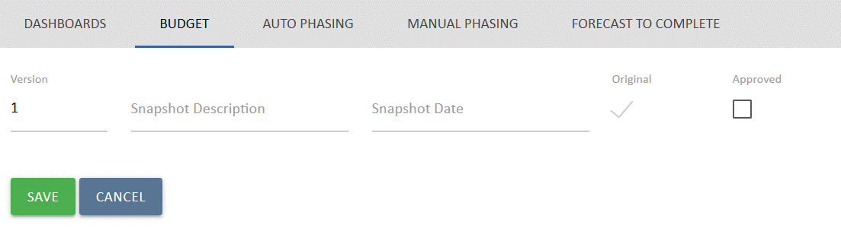
- Enter in the description of the budget, for example “Pre-Tender Estimate” and select the Original Budget tick box. This will be used to decide which budget is “original” in the project costs report. The first budget to be snapshot is the original budget by default. If and when this budget is Approved, you simply place a tick in the Approved

Overwriting a budget snapshot
If you enter in the snapshot description the same Version number as a previous snapshot, the system will overwrite the old snapshot with the new one. You will be prompted to confirm you want to overwrite the old budget.
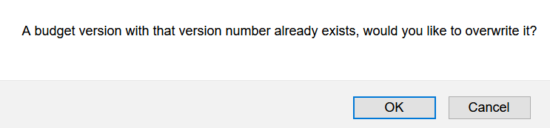
Once a budget is baselined, this baseline can be compared to the current or other budget versions using the compared to filter. Only the current budget is editable, if you select a different version then the budget is displayed in read only mode. Click on 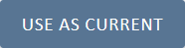 Use as Current to make the version you are looking at the current version, and thereby making it available for edit. The version can also be renamed once selected in this view by selecting Rename 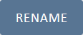.
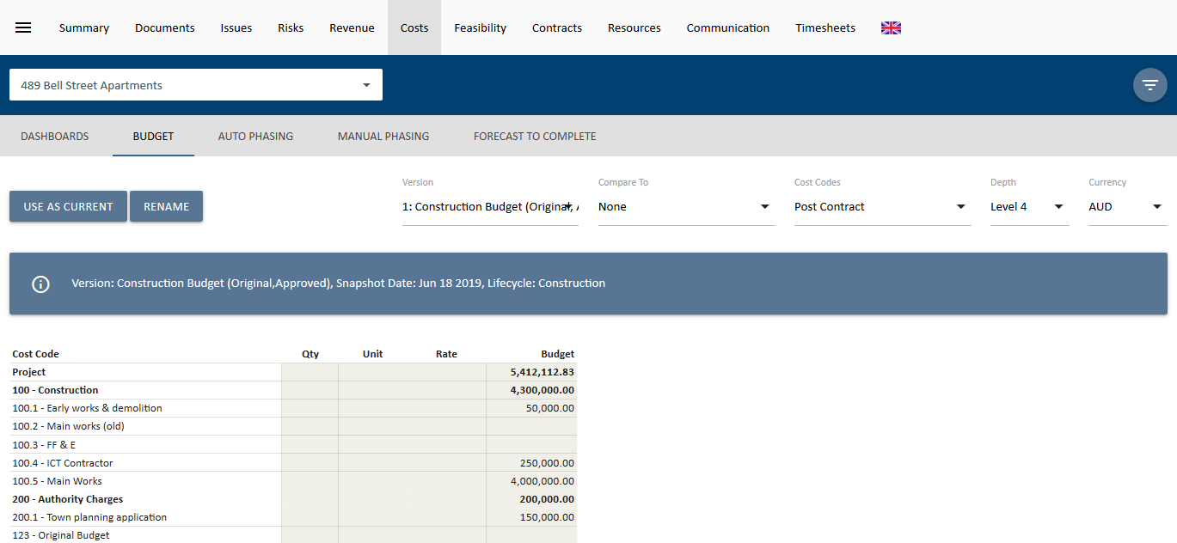

Comparing Budgets
Once you have created a snapshot of your budget, you will be able to compare budget versions. This is useful to analyse the impact to your budget as changes are made. To compare your budget versions, simply select the relevant snapshots available in your Version, and Compare to drop down boxes. This will then display variance at the project level, and at the code structure level.
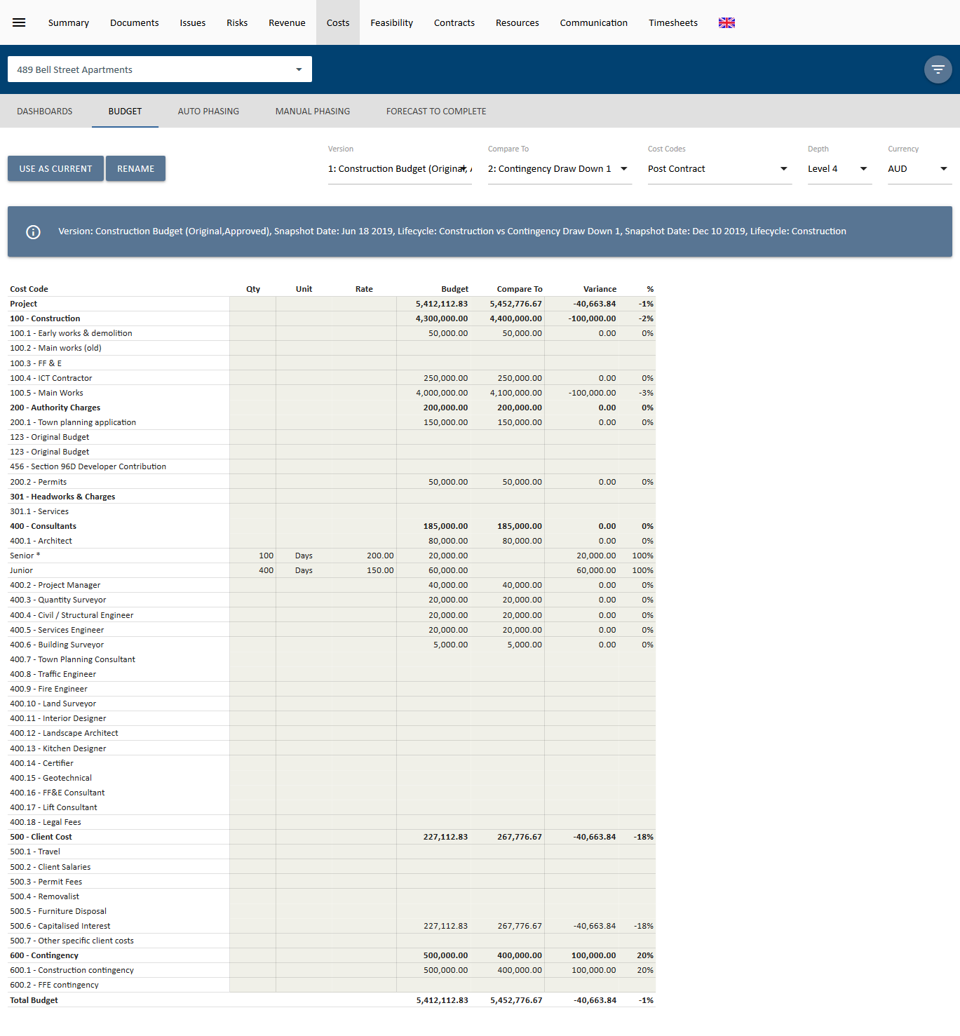

Create a Restricted Budget Snapshot

- Restricted Budget Snapshots can be Original, Approved, or neither. To do this you need to select.
- Enter in the description of the budget, for example “Pre-Tender Estimate” and enter a date for the snapshot.
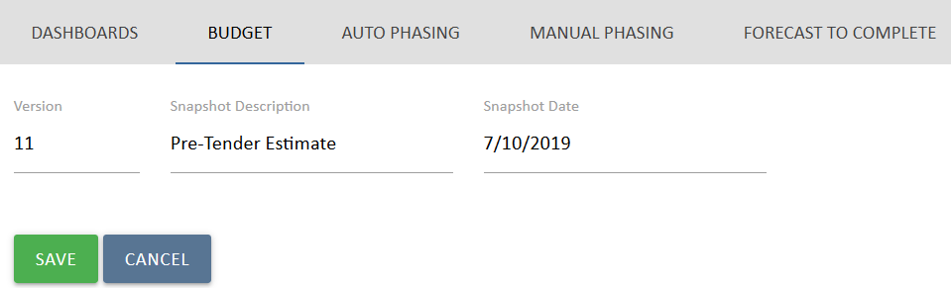
- To mark a snapshot as Original or Approved, simply create a document with a Budget control and select the relevant snapshot from the “Version” dropdown list as shown below.
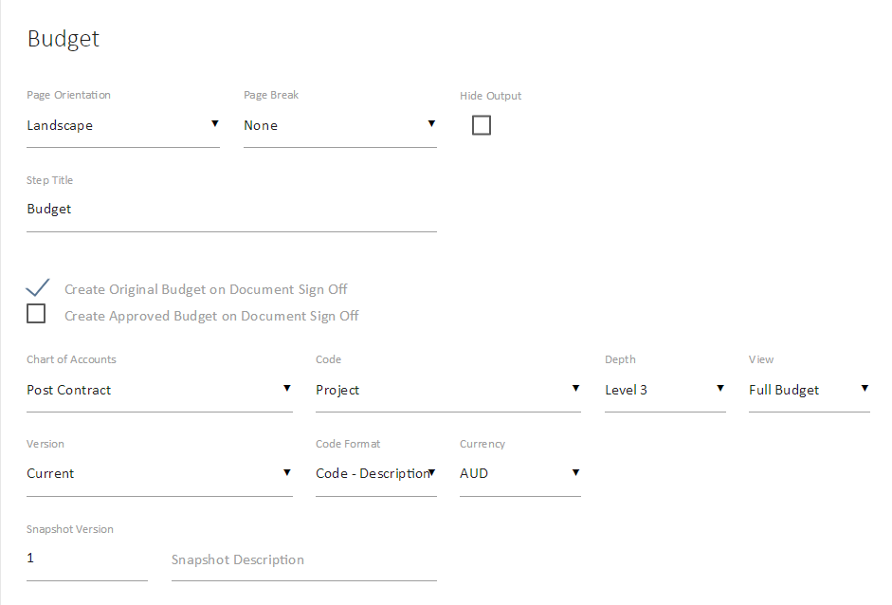
- It is important to note the following at this stage that is possible to create a snapshot as Original and Approved at the same time. Doing so, will overwrite the Original and Approved budget (if they exist). Finally, when the document is signed off, this will complete the process.
- To overwrite a Restricted Budget, the snapshot needs to be created in the document and approved. Creating a snapshot with the same version number in the Cost module will give the following error message.

Cost Budget Summary

UniPhi will display your cost budget summary within the Cost module.
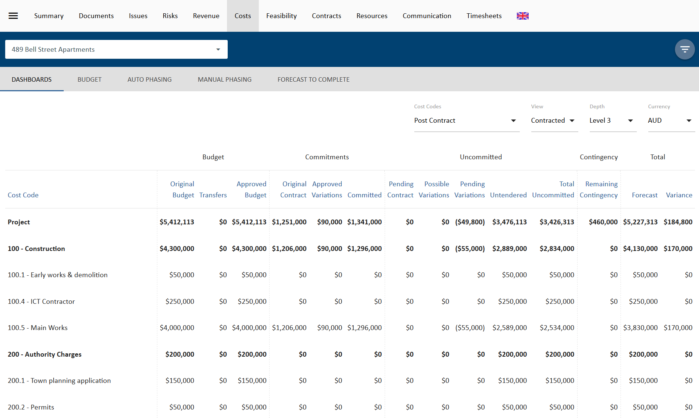
The information is grouped into the following:
- Budget = Original version, the current approved budget and any transfers that have occurred.
- Commitments = Original cost contracts (i.e. signed off or active), and any approved variations to total your commitments.
- Uncommitted = this display any amounts that are anticipated, but not yet committed. The columns displayed include pending contracts, possible and pending variations, and untendered amounts.
- Contingency = the status of any Remaining Contingency
- Total = The total Forecast and any Variance to the Approved Budget.
UniPhi does not know what the amount of any untendered costs are until you enter this information.

Untendered Amounts and Forecast to Complete
UniPhi will report and display the untendered amount in one of two ways – automatic calculation, or manual calculation. The simplest method is to use the Forecast to Complete auto calculate feature.
Go to your cost module, project budget, and navigate to the forecast to complete.
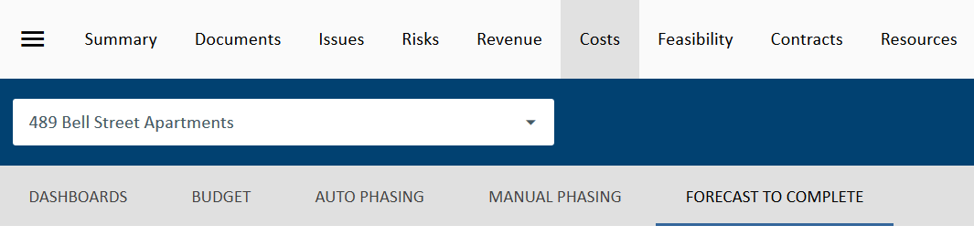
You’ll notice that the Untendered column is now editable. Enter in your estimate of the untendered forecast to complete and select Save.
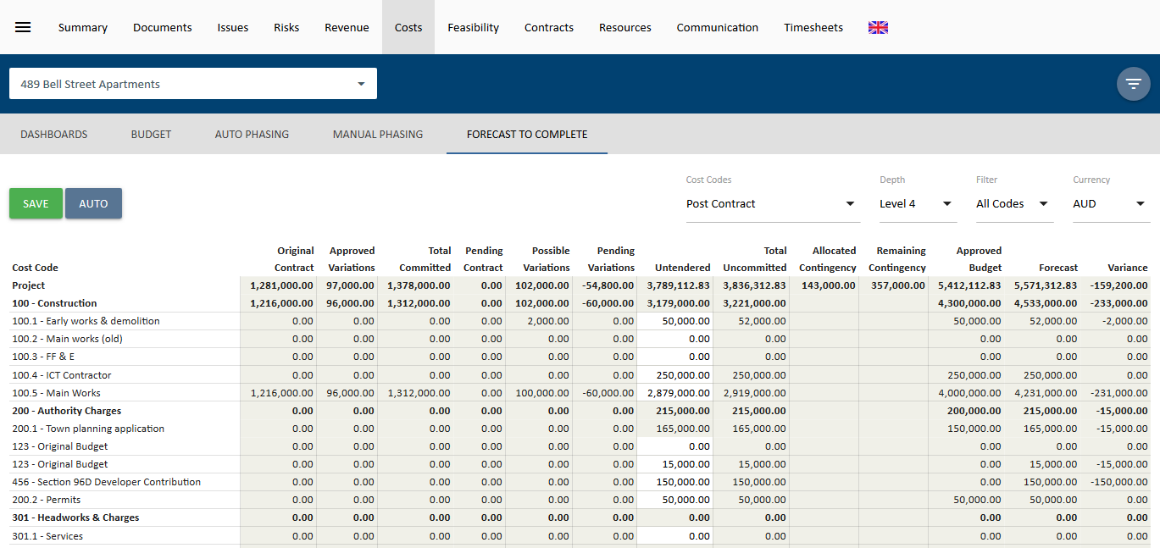
Alternatively, you can select the 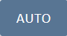 Auto button to have UniPhi calculate the Untendered Values. This feature takes the Approved Budget and subtracts Total Committed, Pending Contacts, Possible Variations and Pending Variations. The columns are now all greyed out as they cannot be edited in Auto mode. To change back, select 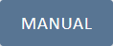 Manual.
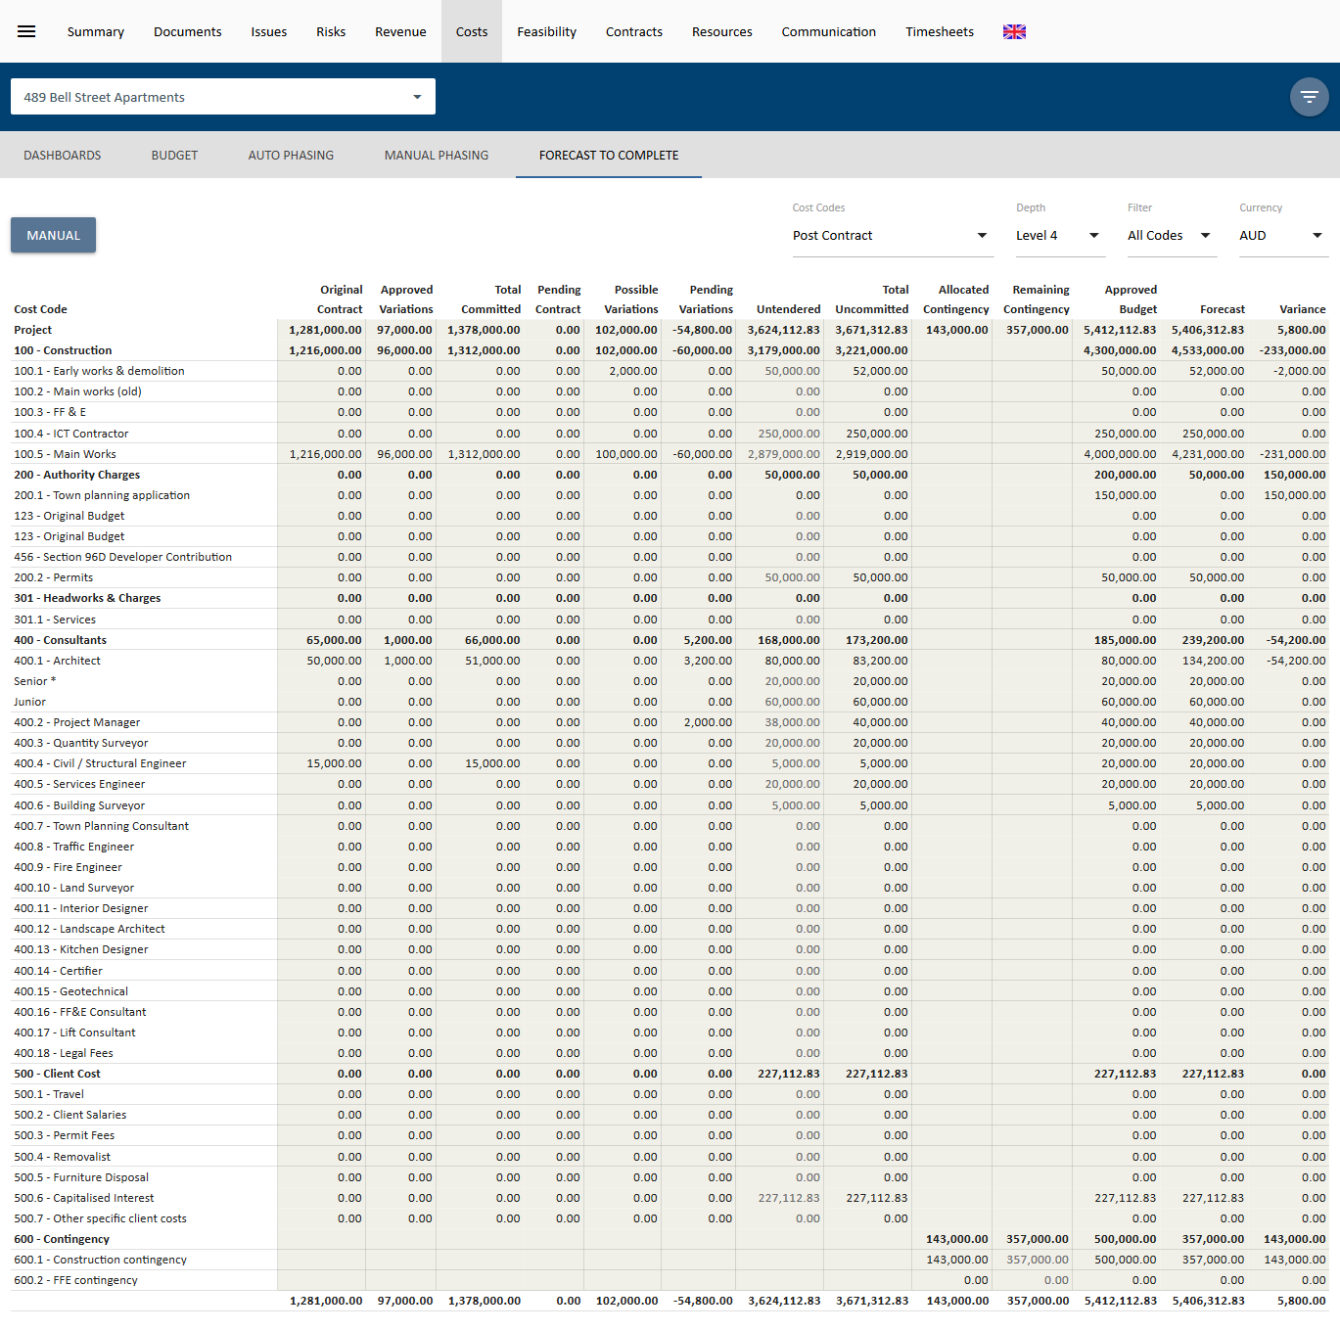
The untendered amounts will now appear in the Costs module, and in cost reports.

Creating a Cost Plan Report
This section demonstrates how to create a Cost Plan Report within UniPhi via a document template. The document template has been designed to draw upon information stored in UniPhi so that content is populated automatically. As this is a sample cost plan report, it may look different to your own reports, and is included here for demonstration purposes only. You may choose to tailor your own Cost Plan Report to meet your own specific needs.
Creating a simple report
Once you have imported and quality assured the cost plan, the cost plan report can be generated from within UniPhi’s document system. UniPhi has been configured by the system administrator to produce a variety of cost plan reports from the one template. To begin the process, select the project you wish to generate the cost plan report for. Click on the Documents module and click “New”
Select Cost Plan Report from the template list. Your project will automatically be selected. Give the document a name. The document name usually appears in the title page of the “Coversheet” stylesheet. Note version numbers will be managed automatically.
Click Create and you will see the following checklist of steps particular to your cost plan template for your business.
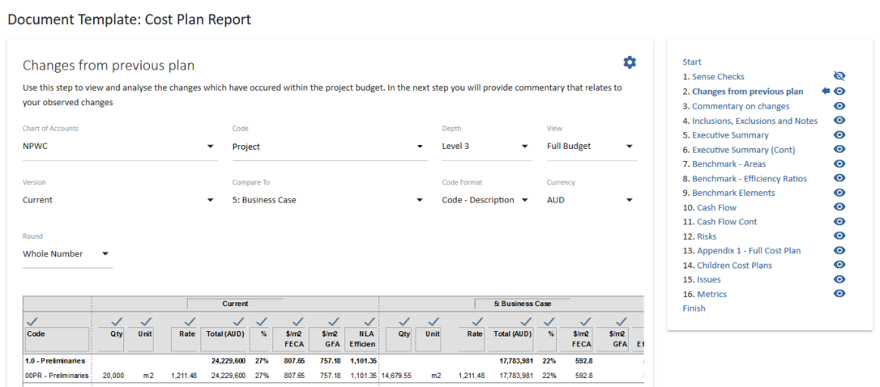
Commentary will be captured in a rich text box.
Rich Text Editor
Using the Rich Text Editor; the rich text toolbar displayed below is available to use with a rich text box and provides functionality to access the HTML environment. The Ctrl key and relevant letter on the keyboard can be used to activate some of the controls exactly the same as you would use in many Windows applications.
For example: Ctrl+C for copy, Ctrl+V for paste and Ctrl+Z for undo.
Some of the text boxes used within UniPhi present a smaller version of this editor. Hover over an icon and a label will appear to tell you what the icon is.
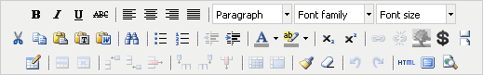
The common commands you will use are as follows:
- highlight text to make formatting changes B – to bold, I to turn to italic or U for underline. Select the letter to either add or remove the formatting type. You can also use the common keyboard commands that you would use in MS Word such as Ctrl+B, Ctrl+I or Ctrl+U. The ABC enables you to strike through the text.
- enables you to position text in the document to the left, right, centre or justified.
- select the heading style you wish to use if required, these have all been predefined for you. The heading styles and paragraph are Calibri. You can manually select font family and font size from the drop down if you wish.
- the cut, copy and paste icons enable you to add or remove text into the rich text box from external documents or sources.
- the paste as plain text icon is used when copying text from MS Word. This is because MS Word has its own mark up language that does not match exactly with HTML. When copying text from
MS Word the rich text editor does its best to convert from word to HTML, however it is not perfect since the two do not match up exactly. The paste as plain text option will remove the word formatting and allow the user to have more control with formatting.
Information can be copied into UniPhi from MS Word by selecting the when pasting into UniPhi and then editing as required. Alternatively, you can copy the HTML version of the document and paste this into MS Word. If this method is used upload the document back into UniPhi.
- provides the options to create or remove a bulleted or numbered list. When you remove these a space will be entered between each line of text. If you wish to remove these spaces place your cursor in front of the first letter of the word you wish to move and select your backspace key. The word will be in line with the word previously above, now select Shift+Enter. The word will be placed back on the line immediately below with no bullets and the space is removed. Alternatively, if you are familiar with HTML you can view the code and make your changes there. (See HTML explanation further on in this section).
- enables you to change the colour of the font by highlighting the text and selecting the drop-down menu to pick your colour.
- enables you to highlight the background of the text, this is particularly useful if you want to note where you have made changes in a document so the author or readers can see what you have amended in the text. UniPhi does not have a track changes option.
- Used to insert a picture and enables you to select the image you want to insert. This can be used for inserting a photo into CV or logos etc. The best method is to create a table and insert the graphic into one cell, that way you can control the positioning.
- The first icon inserts a table into a rich text box and you can enter the number of rows and columns required.
The middle icon displays the table properties and where you modify the number of rows and columns and set width and height properties.
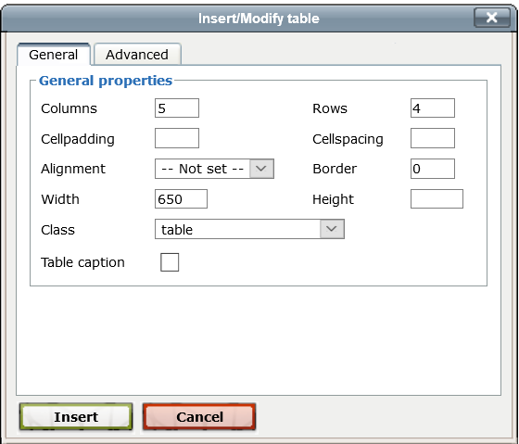
Table width is best fixed to 650 pixels so when document is rendered to PDF it will fit on an A4 page.
The last icon is the cell properties. It is suggested that you modify the cell/column using percentages with a total of all columns across the table equalling 100%. For example, a table with 5 columns may have a width of 20% each, if you change one of the cells in a column you will need to update the remaining columns to maintain 100%.
- Inserts a column in a table to the right or left or the last icon deletes a column. Place the cursor in the column you wish to insert next to or delete and select the relevant icon.
- Inserts a row in a table below or above the row you are in. Place the cursor in the row you wish to insert a new row above or below or delete and select the relevant icon.
- redo or undo the last action(s) that you did. You can also use Ctrl+Z for undo or Ctrl+Y for redo.
- select this icon to access the HTML code for the step. If you are familiar with HTML you may find it easier to use the HTML view and make changes to the code to create your information, amend formatting.
- enables you to view the full screen for the step you are in. Depending on your browser, you may need to place your cursor in the rich text box or table for the step to appear. Clicking a second time will return to the document mode.
. - enables you to indent text to the right or out-dent to the left. You can use this method as well to remove bullets or numbers by selecting all the relevant text and then out-denting until removed.

The variable icon provides for pulling snippets of data from the system and inserting them into the text ‘on the fly’.
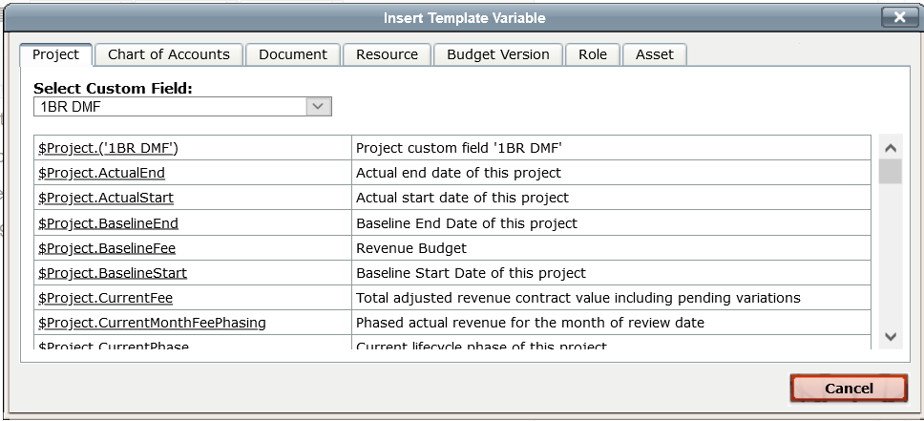
The popup screen allows for selecting various tabs information depending on what has already been selected in the document. For example, if you have selected a chart of accounts at an earlier step then the information from that chart of accounts can be dynamically pulled into the rich text box. The screenshot above shows Project, Document, and Resource based information from the system. The list of data is too extensive to be included here. Browse the tabs and read the descriptions to see what information can be displayed. If there is information you would like included then this can be added via a support request to UniPhi (Aus) Pty Ltd.

Other Template Controls
There are 38 different template controls that pull information into a document dynamically. The main ones used for cost plan reporting are listed below
Cost Plan Table
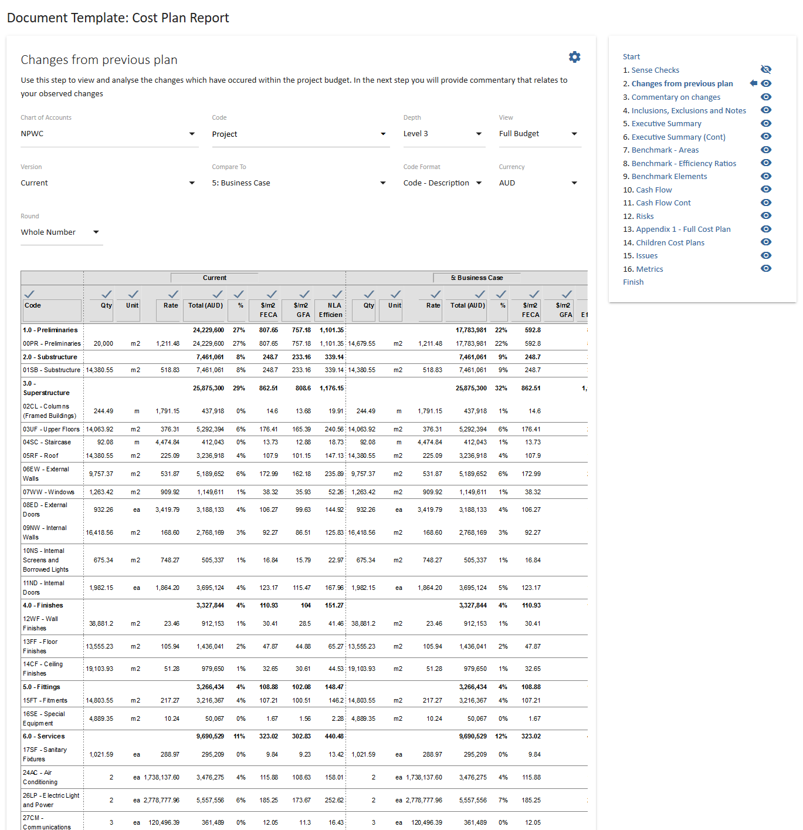
The cost plan table can be used for a variety of outputs. As can be seen from the filters, the depth of the elemental structure can be altered as well as the ability to compare to a previous version with detailed variance analysis dynamically populated. If there are sub project or child project cost plans the summary of each child can be displayed by selected level 1 as the depth. Selecting the lowest level will bring in the entire cost plan which is great for appendices.

Budget Graphs
The graph template control allows you to add as many graphs as you wish to a document step. The list of graphs that can be added are in the screenshot below:
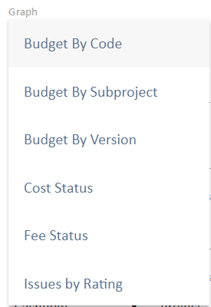
Selecting the “Budget by Version” graph click “Add” will display the following screen:
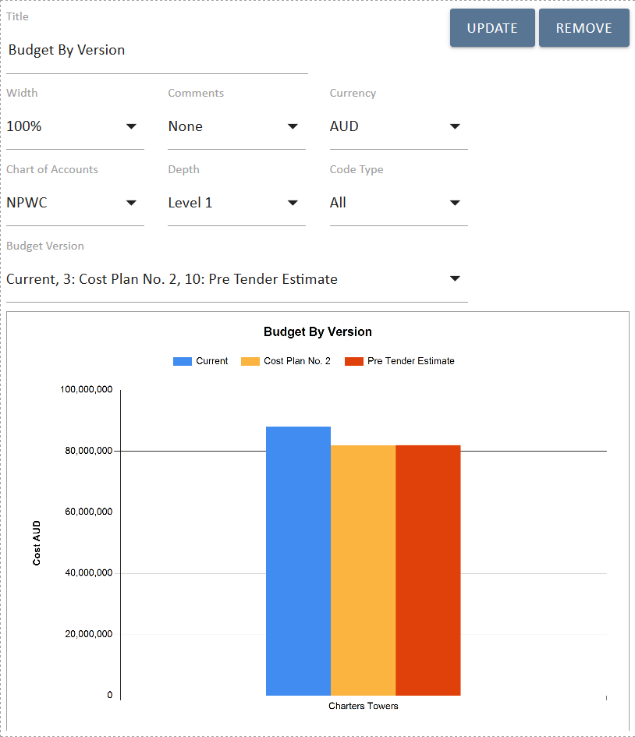
The various options can be selected that allow for different views. For example, multiple versions can be selected from the budget version drop down; the elements that are compared can be selected from the depth and etc. It is generally advisable to either display the graph at 50% or at 100% with a commentary box as the end PDF graph will be very large if left at 100%.
When the filters are changed you need to click on the “Update” icon to update the information in the graph.
Benchmarking table
The benchmark table allows you to compare metrics of your current project to any other in your database.
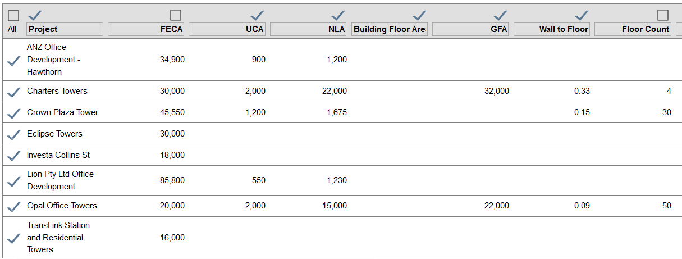
Additional projects can be included by broadening the filters of sector, project type etc. The default selection is the same filters as the current project. Specific projects can be included or excluded by selecting the check box next to each project and the columns can be included or excluded by selecting the relevant check box above the column. Editing the labels changes the titles.
Cash Flow table
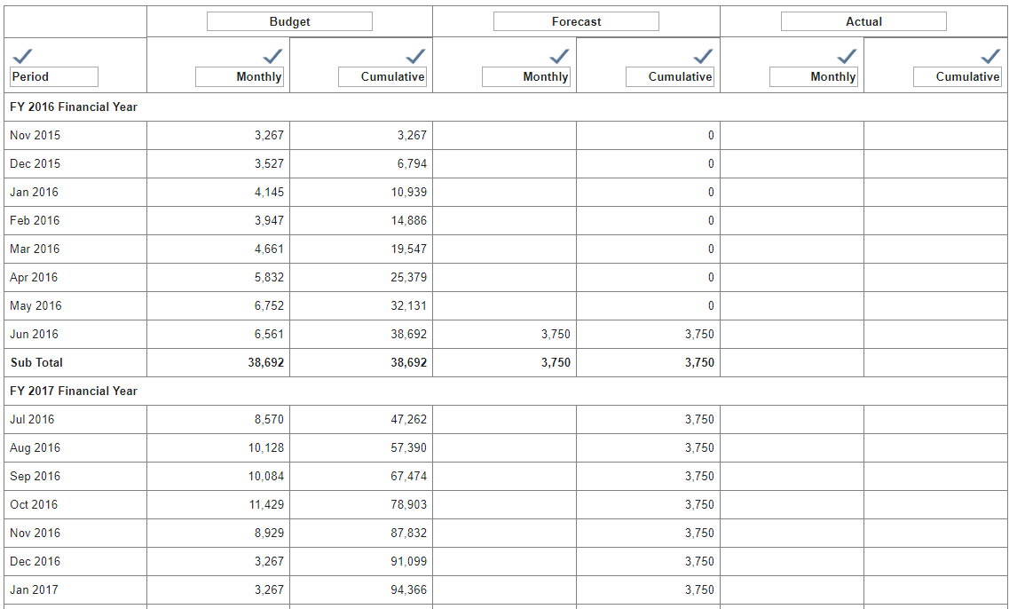
The cash flow table displays any phased data that exists.
Your companies cost plan can evolve over time and be customised by your system admin to get the most out of these controls.

Complex cost plan report – Parent Child
Additional functionality in the template system comes into play when generating cost plans that contain multiple buildings/sub-projects.
Parent child relationships generally enable you to generate consolidated information of all child projects in the parent project. Additionally, the embedded document control allows the parent document to embed individual cost plans generated in each child project.
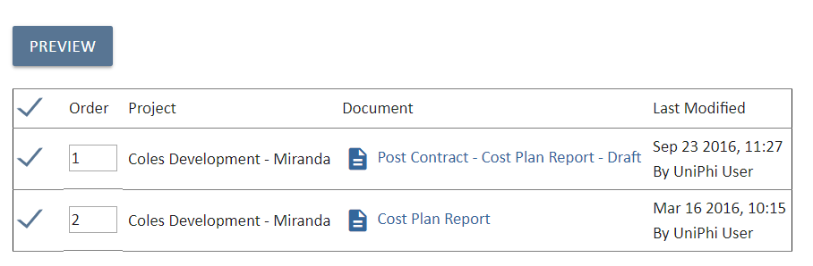
Selecting the check boxes next to each document generates the content of that document within the new parent document.
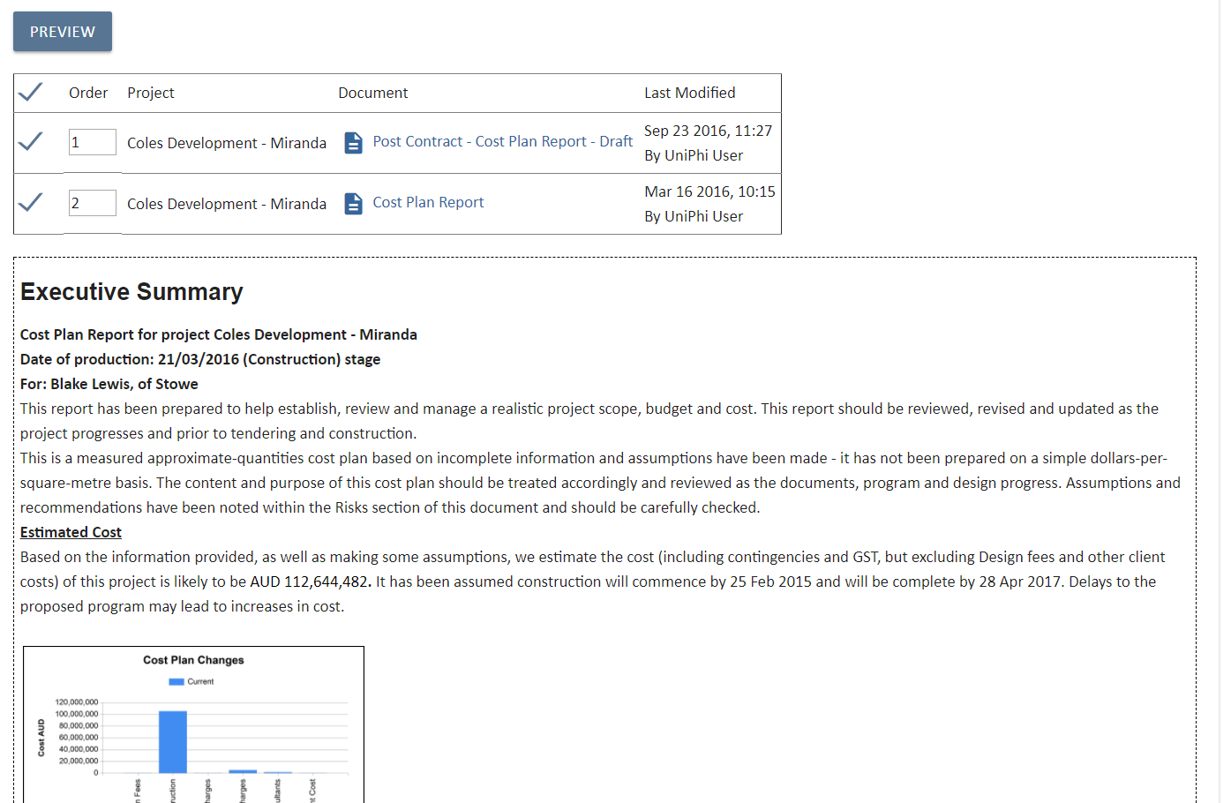
Business rules for document to be embedded
Note that only signed off documents will be available to embed in another document. This should match the workflow of snapshot and creation of building cost plan reports before creating the overall cost plan report.

For more information about documents in UniPhi, refer to the UniPhi 15 Document Management Manual

Contracts

Contracts are used in UniPhi as a way of recognising the deliverable items and work that forms the basis of all project engagements. Contracts can be revenue based where your client will pay you a fee, or cost based where you will make payments to your suppliers.
UniPhi also uses documents as contracts. Using a contract document template allows you to import the details that you have selected when defining the type of contract you are establishing, and the deliverables items that are included. A contract and its associated financials are only classed as “committed” once the contract document has been signed off. Prior to sign off the financials will be classes as pending values

Creating a New Contract
- Filter for the project you wish to work on from the Projects filter
- Go to the Contracts module and click on the 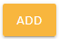 contract button and select the type as a cost contract
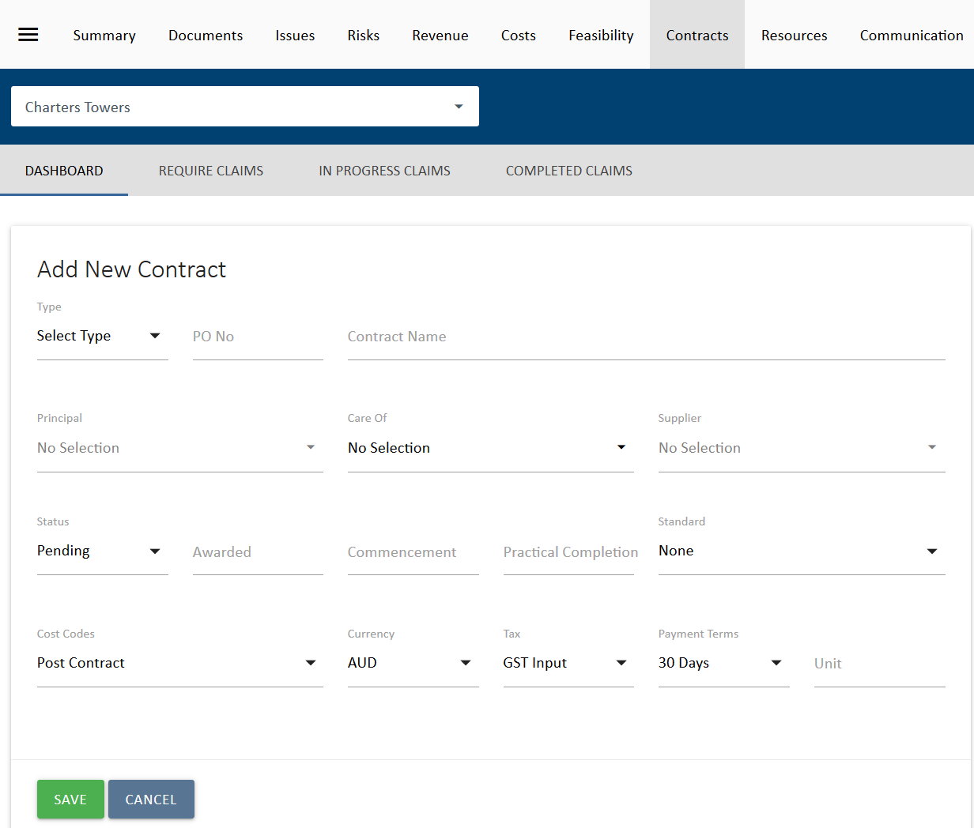
The following items are compulsory on the contract form to enable the contract to be created:
Type used to select if the contract is a Cost or Revenue contract.
Contract Name – the name or description of your contract.
Supplier – this is the contact person at the organisation who is providing the products or services.
- If the contract is a cost contract then the supplier list comes from all available external resources in UniPhi. It is a searchable field.
- Select Save once you have added in the compulsory fields above and this take you into the body of the form for deliverable creation.
The following are optional fields for the contract creation stage:
Status – The status reflects on the stage a contract is at.
- Pre-award or pre-sign-off a contract status can be set to Pending.
- If the client accepts the contract, it is moved to an Active contract status.
- Once the work is complete it becomes Expired.
- If the contract isn’t awarded then it is Cancelled.
Cost codes – Chart of Account codes that each deliverable is applied against for cost reporting purposes.
- This is how the contracts module integrates with the Costs module.
- The Costs module displays consolidated figures for all contracts on a project as well as for all projects in a program or portfolio. These figures are derived from the codes allocated to deliverables and variations in the Contracts module.
Principal – The principal is the organisation that will be liable for payment of the resulting contract services.
Care of – used if someone else is responsible for approving invoices for payment and hence need to be addressed to this person/company.
Awarded – Date the contract is won / approved and moved to Active. This can be a forecast date which will be useful for forecasting purpose.
Commencement Date – the date the contract will start (if known) or started as per the contract document. This can be used to drive the deliverables schedule. Changing the commencement date changes all the deliverables by the same difference in the change. For example, push out the commencement date by one week and all start and end dates in the contract are pushed out by one week.
Practical Completion - Expected date when project will enter defects liability. (As lawyers can’t decide what this term means we leave it to you to decide). If not a construction job then this is the date that all deliverables will be completed.
Standard – The contract standard drop down displays standard Australian contracts. The selected value allows you to nominate the Australian Standard or General Condition contract that will be used to administer the project. This is purely for communication purposes so that others will know what type of contract you are administering. Your administrators can add in additional contracts if they are not displayed in the list.
Unit – This box allows for a default unit for time and material type deliverables. If the contract deliverables list is long but the units are the same (e.g. days or hours) then typing in a default value here will result in each new line will have “days” or “hours”
Currency - this represents the currency the contract will be quoted and awarded in. UniPhi will convert the currency if it is different to the project currency when displaying the values in the fees and costs tabs.
Tax – defaults to GST but can be set to None if appropriate.
Payment Terms – defaults to 30 Days but can be set to a range of payment terms to reflect the contract terms.
Once the contract is saved it will now appear with additional details.
Related Templates – These templates are contract related templates. Each template will derive information from the contracts system
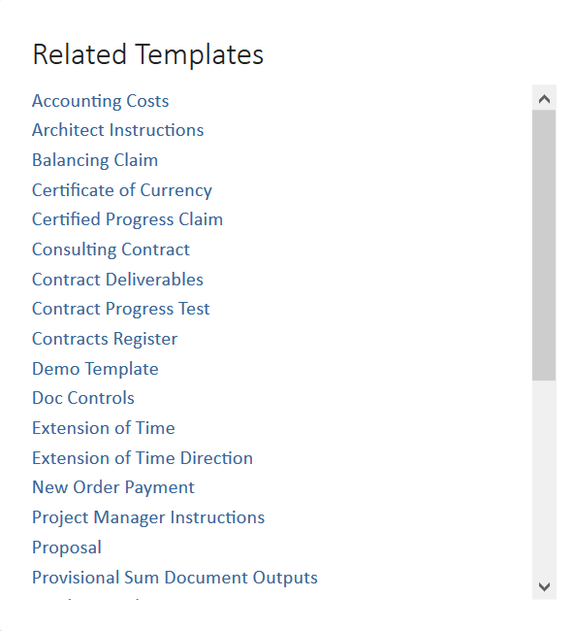

Creating Contract Deliverables
These are the building blocks for creation of the contract you are managing and will provide you the overall total. Deliverables are used to raise progress claims or invoices for your clients.
Contract Deliverables window – this is where you enter in the deliverables (services and materials etc.), assignments, dates and rates for the contract.
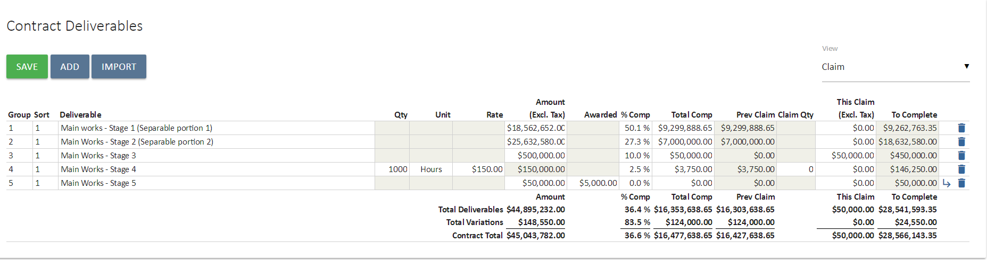
Deliverable Types
There are a number of different deliverables types:
Lump Sum – This is used when the contract is fixed price and will be progressively claimed against over time.
Time and Materials – This is when the deliverable will be done based of effort x a rate. You will need to enter in a Quantity, Unit and Rate for each deliverable noting that the unit can come from the default unit set for the contract (as explained above).
Provisional Sum/Prime Cost – This is a lump sum amount that is included in the awarded value of the contract, usually as a placeholder, and may be adjusted later.
Heading – This inserts a heading rather than details. Please see next page for more details on Heading types and their purpose / use.
Heading Types
Heading types relate to the way information will appear in documents. Contract deliverables can be automatically including in proposals as work activity, contracts as schedule of works and invoices. The type of heading used will affect the way the information is laid out in the final document.
Basic Heading – Does no more than a normal heading in word
Heading with Roll-up* – Sums up the group of deliverables with the same order number and displays the heading line in documentation rather than the detailed deliverables underneath
Heading with Sub-Total* – Adds a total automatically in documents to the group of deliverables that have the same order number
* UniPhi knows what tasks to include under the roll up heading or sub-total heading by the Order ID. Giving deliverables the same order id means that they will be included in the same group as the heading with this order id.

Creating a Lump Sum or Time and Material Deliverable

- Click on the 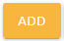 icon in the Contract Deliverables panel
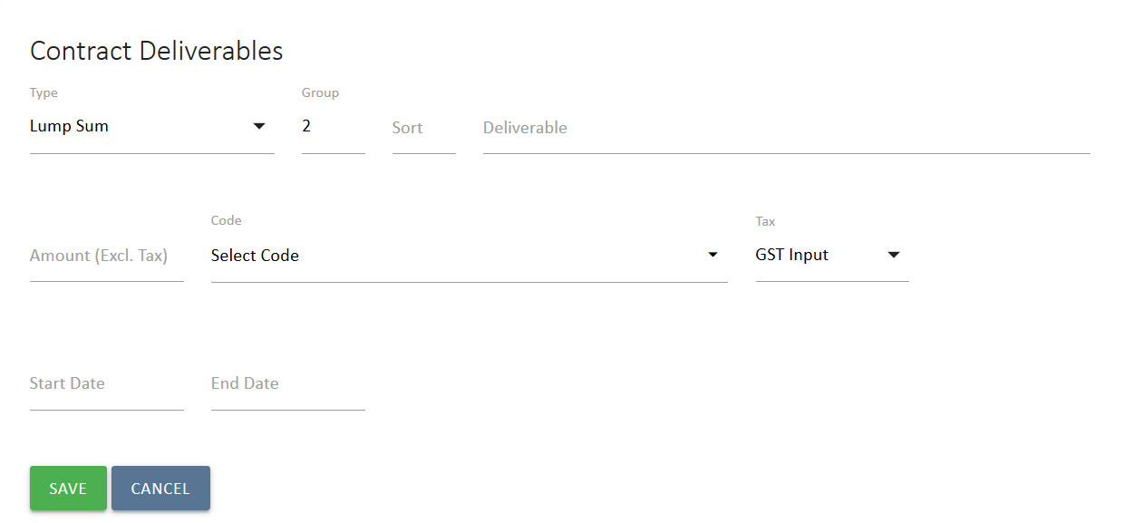
- Select Lump Sum from the Type drop down
- Enter the Deliverable description
- Enter the deliverable Amount
- The Start Date and End Date fields are optional and can be used to generate a post-contract forecast cash flow for the contract.
- Select the cost Code which this deliverable will need to be reported against.
If on the other hand you wish to create a Time and Materials deliverable, Select Time and Materials from the Type drop down
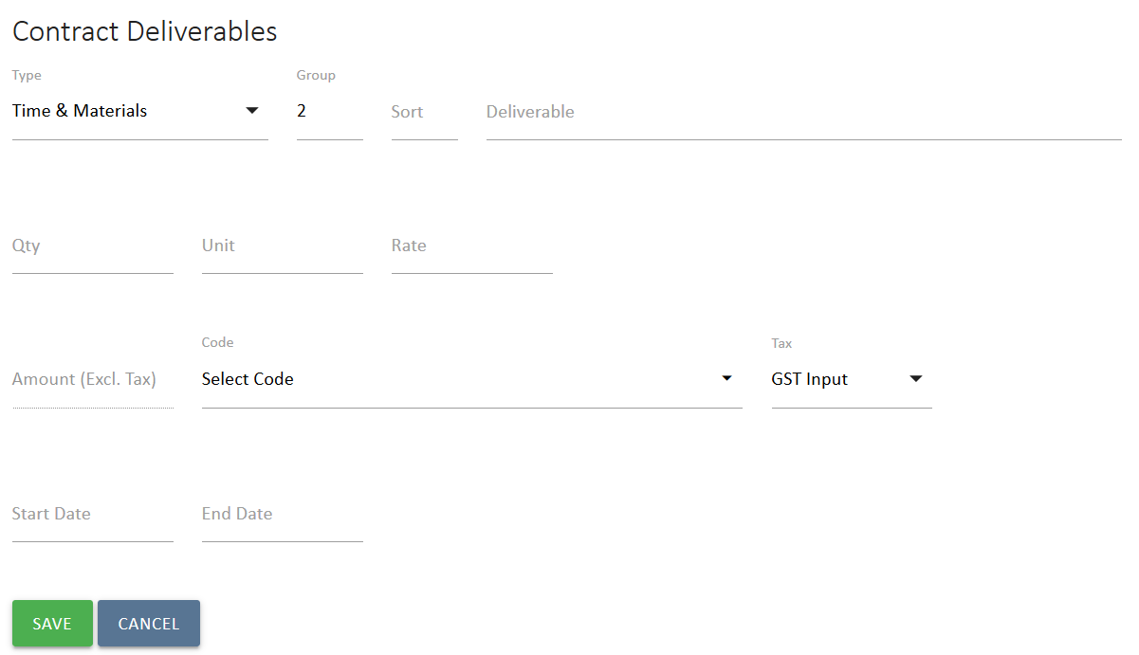
All other fields are the same, however rather than entering the Amount, you must instead specify the Qty, Unit and Rate, the Amount will automatically be calculated by multiplying Qty and Rate
- Save your changes

Importing Contract Deliverables
UniPhi allows for Contract Deliverables to be imported directly into the contract page via an Excel spreadsheet. As per the screenshots below, we are using the sample files to import deliverables.
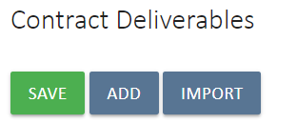
- In the Contract Deliverables module, select 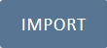Import
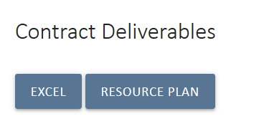
- Select 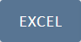 Excel to import from Excel
- Click on Sample File and save the Excel file.
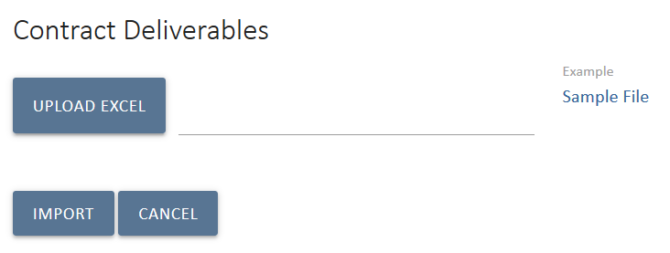
Opening the Excel file will reveal a sample data structure that must be followed for a successful import. It is a useful starting point that the end user refers to the sample file.
The following should be noted before proceeding further with importing deliverables:
- Row 1 in the sample file should not be deleted. This Row is required for successful importation of deliverables.
- Each row in the spreadsheet should be treated as an individual row in the contract deliverables page in the UniPhi contracts page.
Creating contract deliverables are shown below, starting with a basic heading type called Design.
Two deliverables are then added for this heading type. Architectural Services being a time and material deliverable and On Site survey being a lump sum type.
The corresponding Chart of Account code is planning which has a specified code, PL2.
- Once all deliverables have been entered, the range name “Deliverables” must be specified. Range names can be specified via the Name Manger in Microsoft Excel.
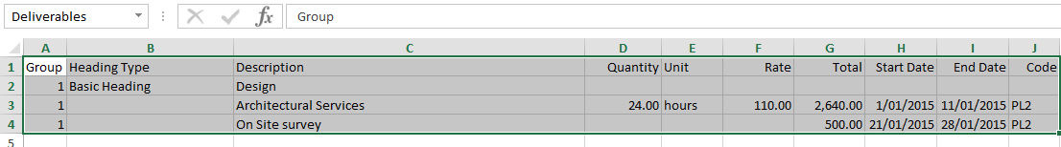
- After the range name has been specified, save the working file, browse to select the file and click the import button.
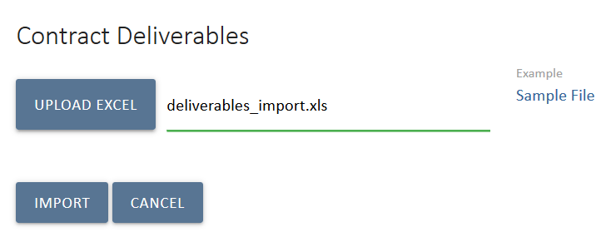
The contract deliverables should now be successfully imported into UniPhi.
Column A: Group – This column corresponds to the Group field in the contract deliverables page. Enter the Group number of deliverables as you would if manually entering deliverables in UniPhi.
Column B: Heading Type – This column allows the user to specify if a particular heading type is to be used for deliverables. Enter the heading type for the corresponding row. Enter the Heading Type for the heading row only – not for all the deliverable rows that are associated.
Column C: Description - Enter the deliverable description in this column. For heading rows, enter the name of the heading.
Column D, E, F, and G: Time & Material – The Quantity, Unit, Rate and Total columns should be filled in if the deliverable is a Time and Material type. If it is a Lump Sum then leave these columns blank and enter the total in Column G. Summation formulas are accepted for calculation purposes.
Column H and I: Schedule Dates – These columns represent the Start and End dates. Enter the dates in dd/mm/yyyy format.
Column J: Code – This column requires the Chart of Account code to be entered. Only the code itself should be entered, not the full name of the account. Refer to the Chart of Account for the applicable codes.

Large contracts and pagination
If your contract has more than thirty lines then it will paginate in the screen. The total displayed at the bottom of the deliverable list is always for the entire contract, not for the page. To view other pages, click the page number at the bottom of the panel. To see all, click all, but note this will take time to load. The best view to see all of the tasks is the “Accounting” view as it has fewer fields to display (see below for more on different contract views).

Contract Views
UniPhi has different views which (except for All) provide a subset of the data entered. This is due to the large amounts of data that can be captured in a contract. These views are All, Accounting, Recommendation, Claim and Schedule.
The View filter within the contract provides options to change the view and you can add in data, specify start and end dates against deliverable, amend GST and cost codes, and raise progress claims.
All View
Displays all fields and is most useful when you need to see each piece of information in one screen. As this view can be comprehensive you may need to scroll to the right in order to view all of the data
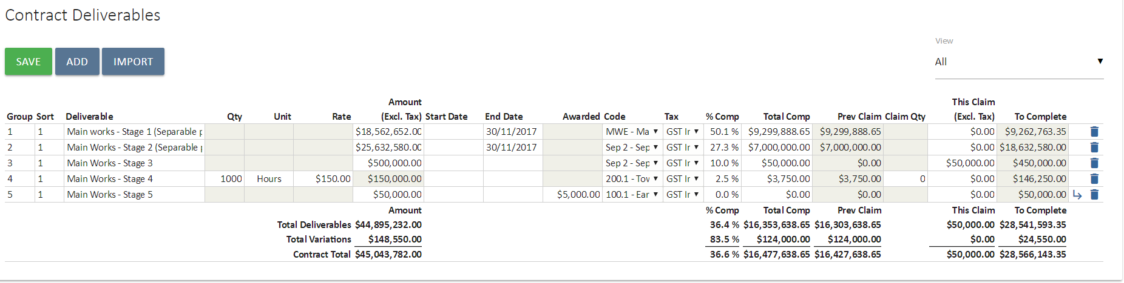
Claim View
Claim view is the default view and displays everything except account codes, GST selections and start and end dates. This view is used for raising invoices. You will notice that the % complete, total complete, and this claim values can each be entered, depending on your preference. Each contract and its deliverables will display the previously claimed amount. These amounts will progressivley increse as the project progresses.
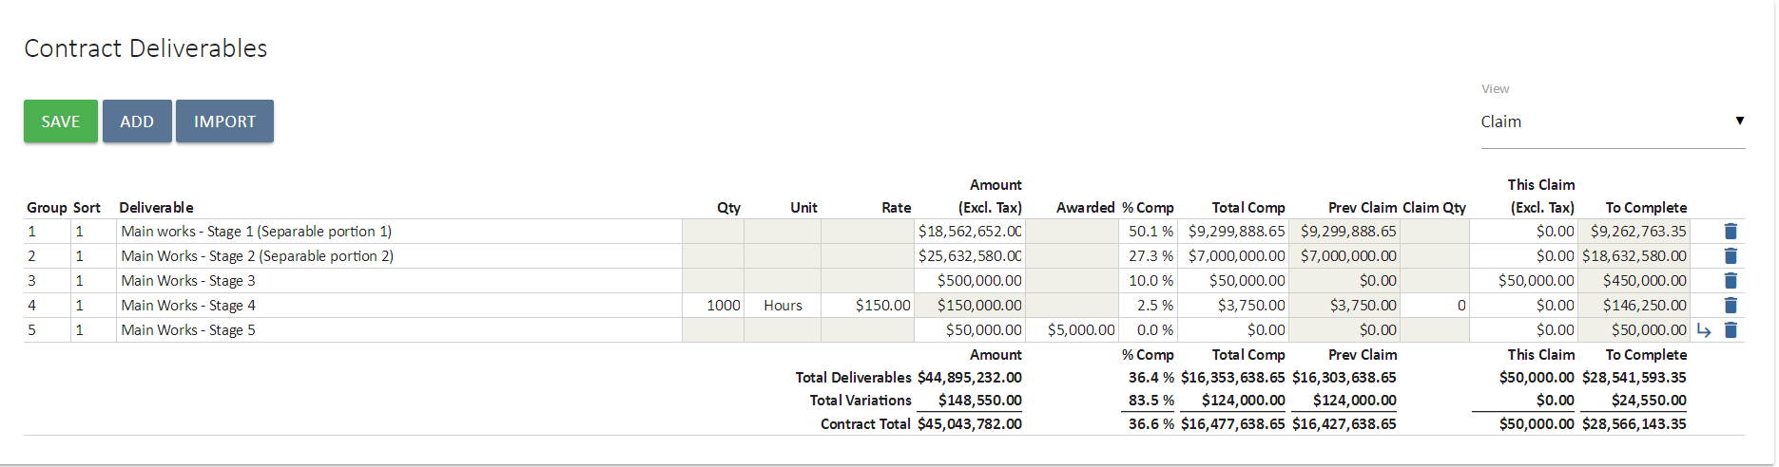
Schedule View
The schedule view enables you to capture expected start and end dates for deliverables. This will flow through to contract cashflow phasing and various documents and reports.
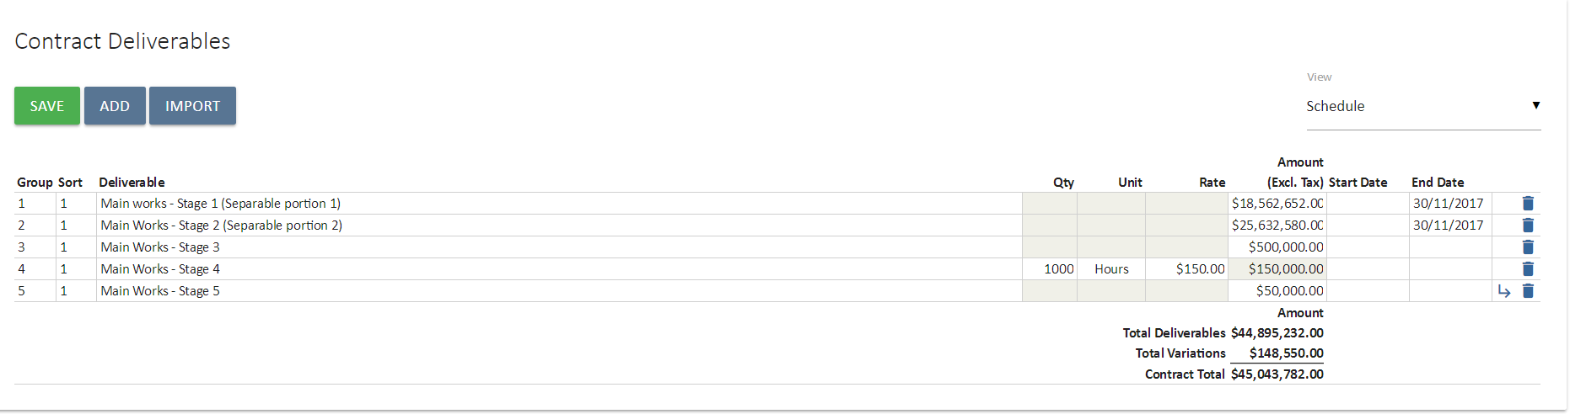
Accounting View
This view allows you to check that the correct cost and tax codes have been selected.
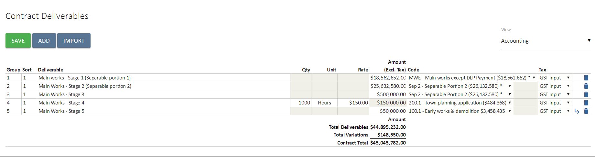
Assessment View
Utilised to recommend the amount that should be claimed by cost managers prior to raising a certified progress claim.
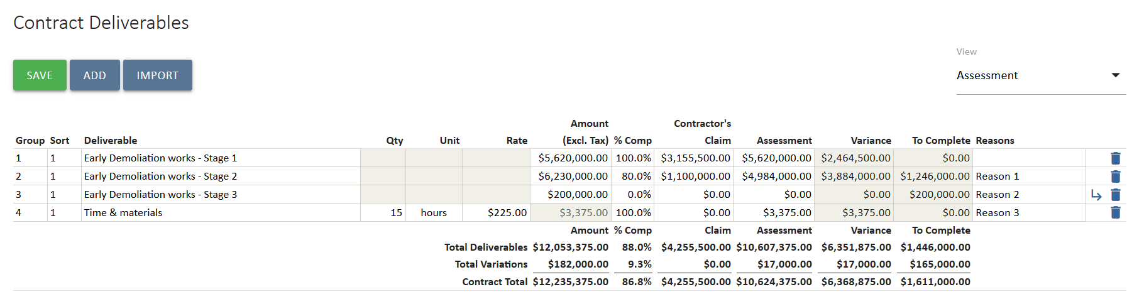

Disbursements
Disbursements are designed to capture project related costs, which are not part of the agreed contract value.
Disbursements are added with your project contract in much the same way that contract deliverables are added. Disbursements values are claimable when the next claim document is produced. The Disbursement costs will appear in the claim document separately from the agreed fee. 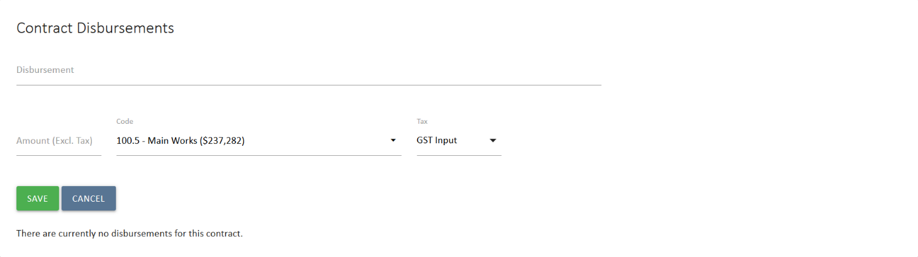

Claim Adjustments and Retention
Retention and adjustments can also be detailed within your contract as and when required. To create an adjustment, simply press the 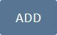 add button. You will notice that a number of default adjustment types currently exist in UniPhi. The options that are displayed here include the most common forms of Adjustments and Retentions; Retention to Date, and Bank Guarantee.
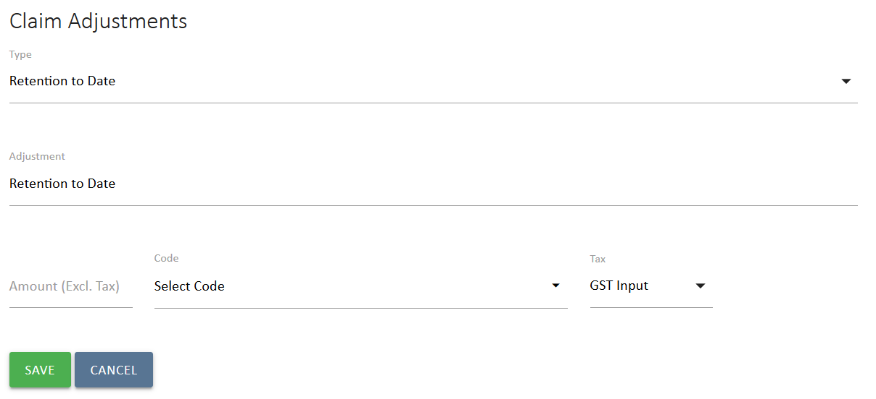
If the wording is not correct for your purposes you can type your own text into the description field. Your adjustment information will appear in your output financial document such a progress certificate.

Add a Derivative Claim Adjustment/Retention
When a set amount of money is to be retained with each claim up to a threshold, UniPhi can calculate this for you with a derivative adjustment.

- In Claim Adjustments select 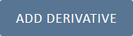 Add Derivative.
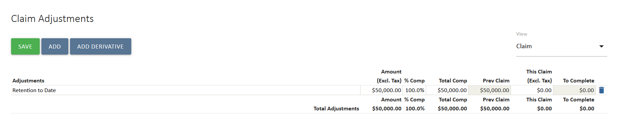
- Select the type of adjustment and give it a description.
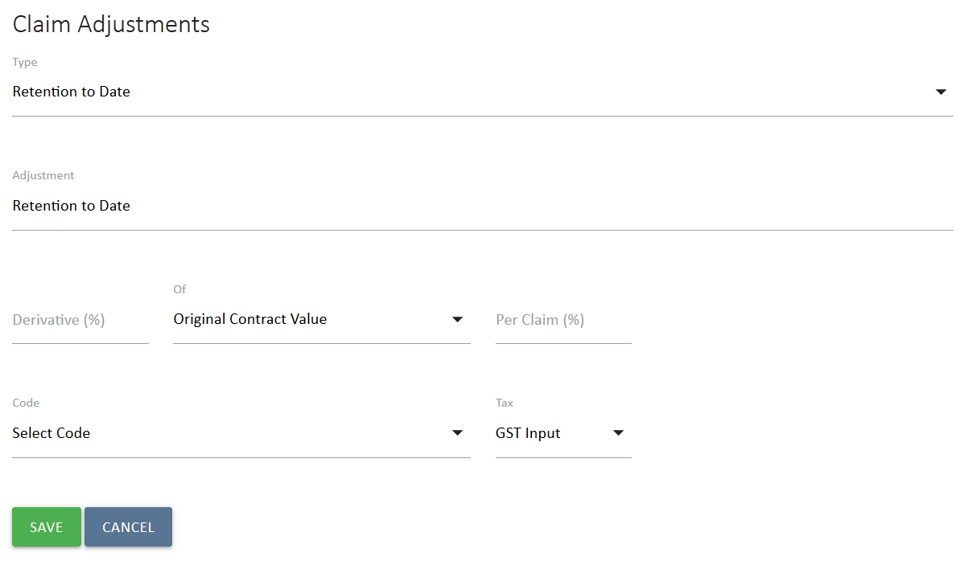
- In the Derivative (%) field, set to total amount of the retention. Not that if you are holding back funds from each claim, this needs to be a negative number, otherwise UniPhi will advance funds with each claim.
- In the Of field, select if the retention applies only to the Original Contract Value (the value of Deliverables) or the Adjusted Contract Value (the value of deliverables plus the value of approved variations)
- In the Per Claim (%) field, enter how much retention you will hold per claim until you reach the threshold. This also needs to be a negative number. In the example below, 5% of the value of the adjusted contract is being retained, but this will be 10% of each claim until that value is reached.
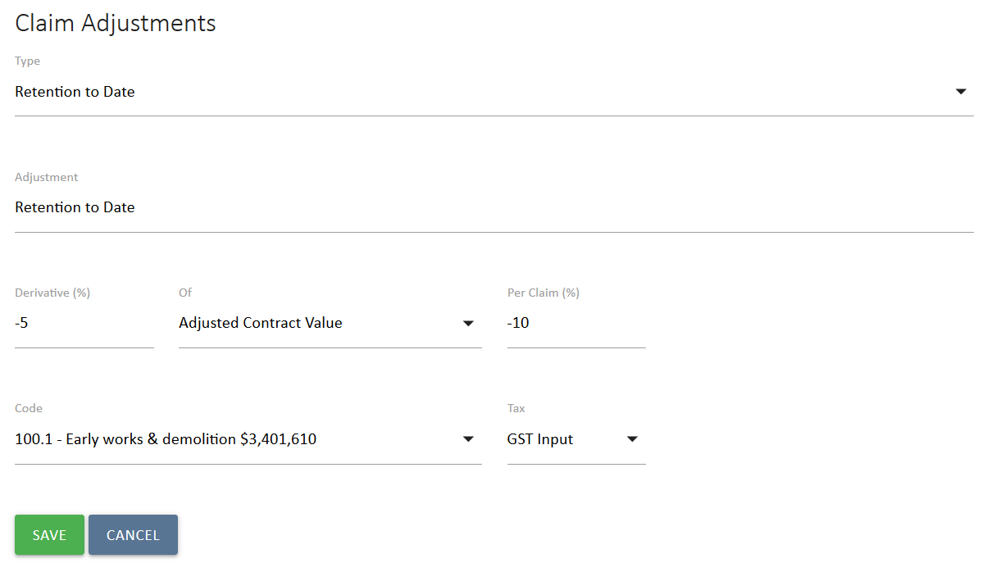
- Select a code and tax. The code is only for the purpose of cash flow, it does not affect forecast. The Tax code should reflect the tax applied to the rest of the contract.
- Select Save to finish and apply the derivative. The value applied to each claim will calculate automatically.
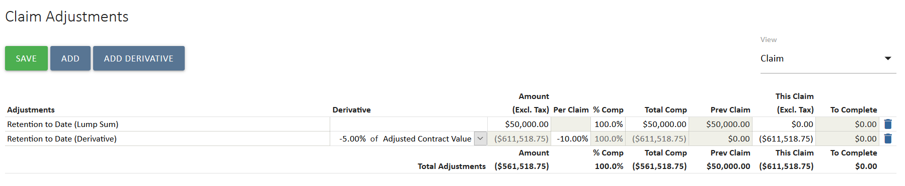

Contracts Details and Registers
The Details view is accessed from the Contract sub navigation options in the Contracts module. When you are editing a Contract, these options appear as below. Select Details.
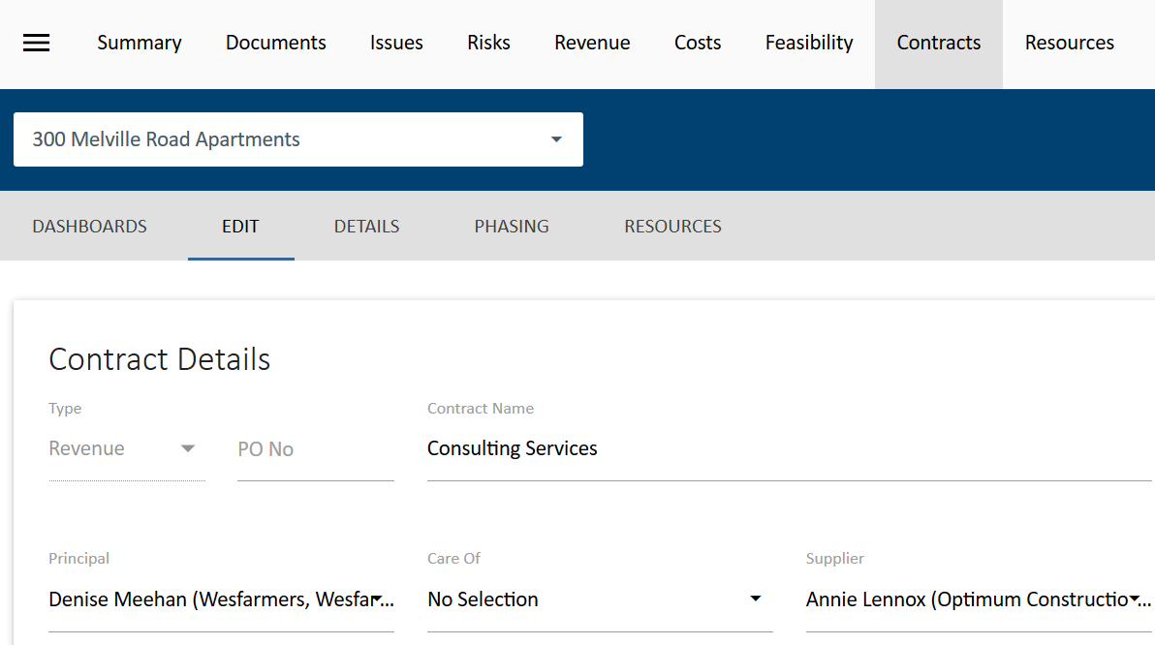

Contract Details
Contract Details provides a snapshot of the contract and details of principles and suppliers, if no addresses or contact information appears you can update this in Portfolio>Resources>All projects by selecting the resource name and updating their details. You will also have a view of the deliverables which make up this contract:
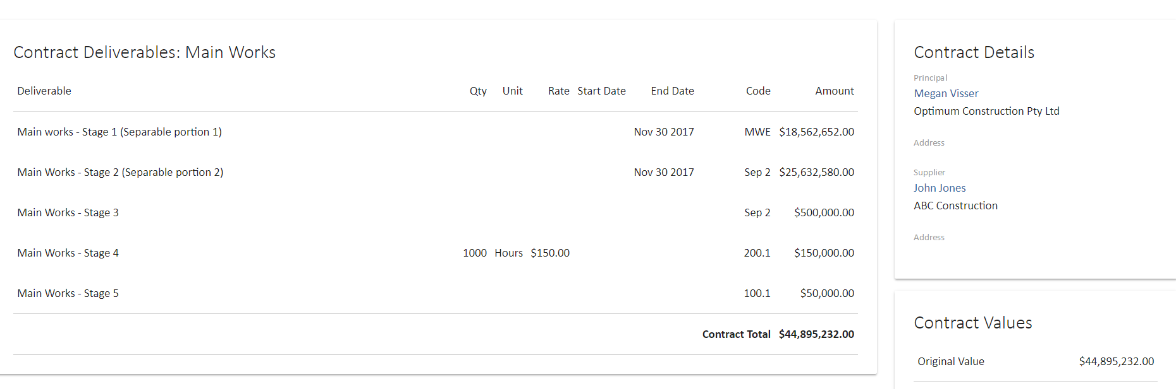
Contract Registers
Registers for contract Variations, Progress Claims, Extension of Time and other related contract documents such as Requests for Information (RFI) or Project Managers Instruction (PMI) are automatically compiled for you.
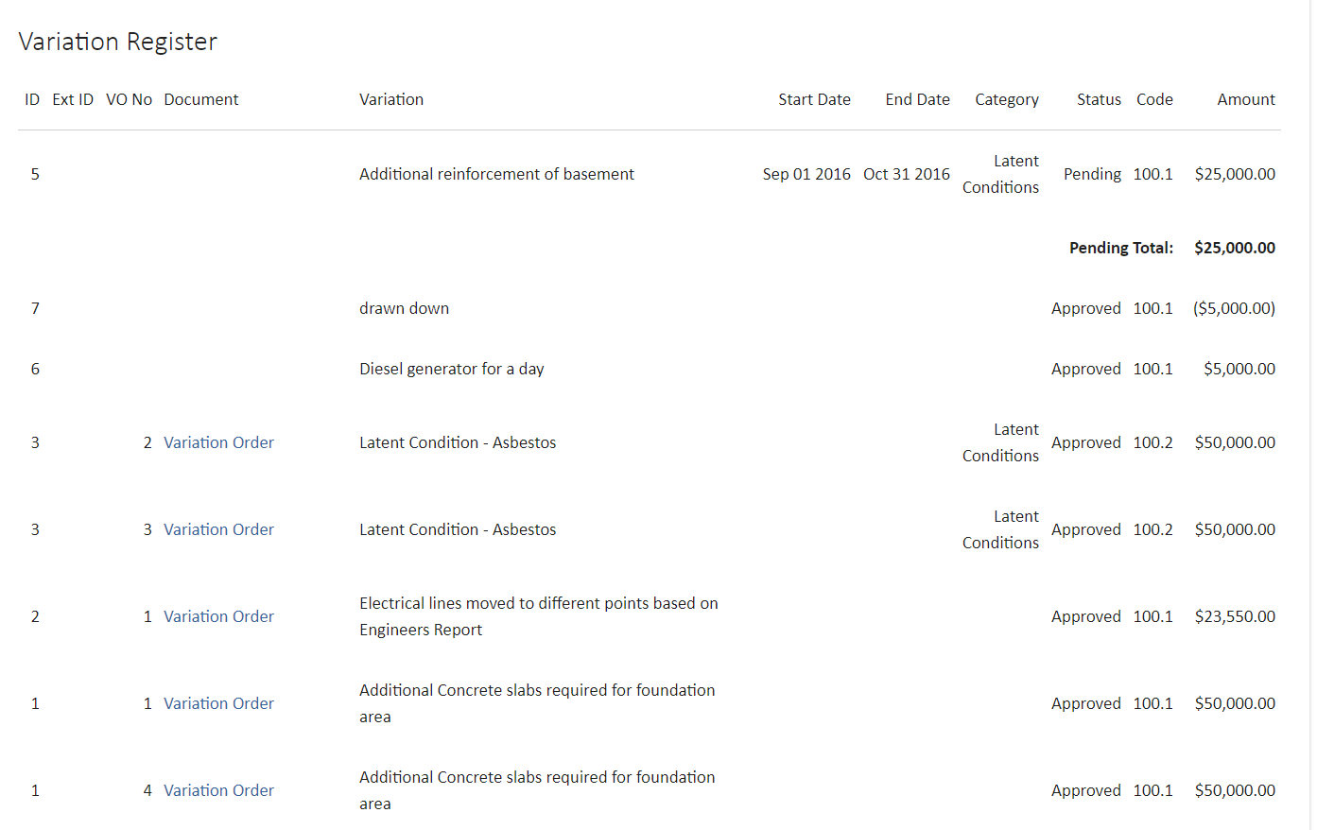
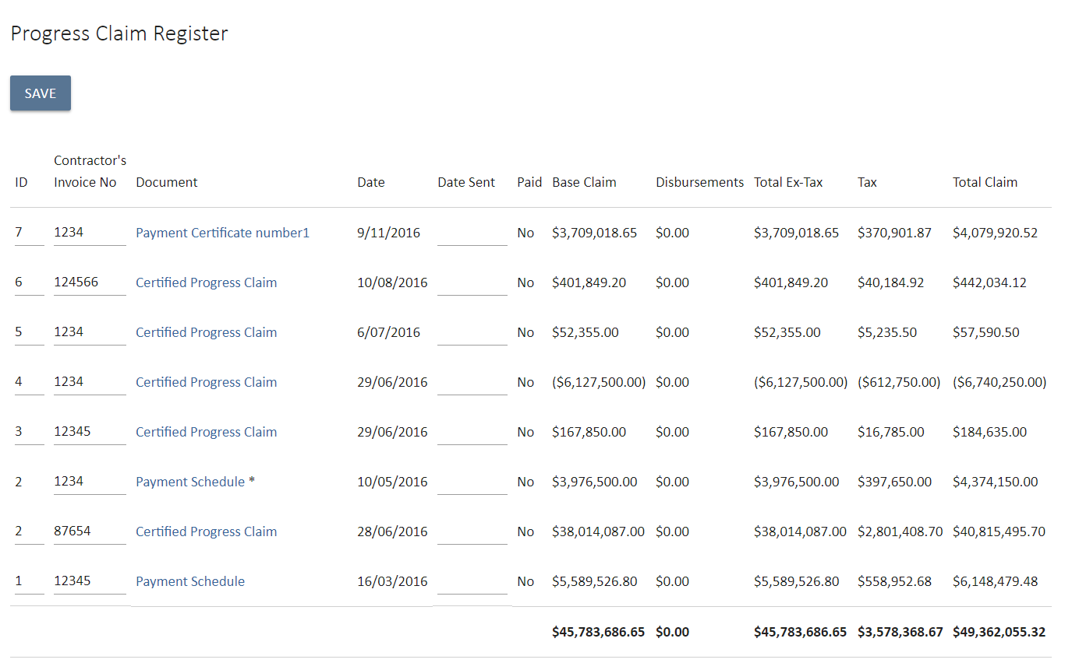
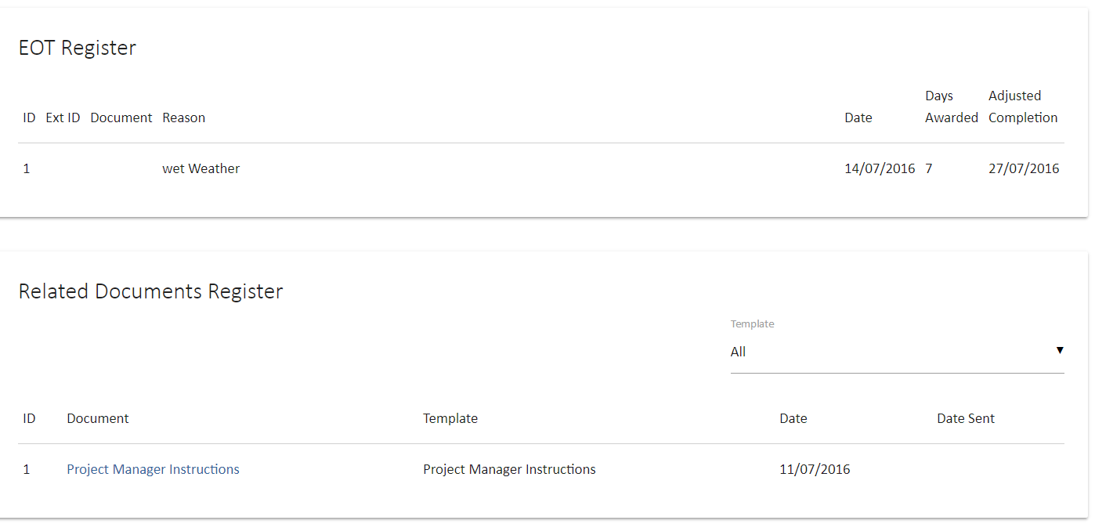

These registers can also be found within the UniPhi Reports module:
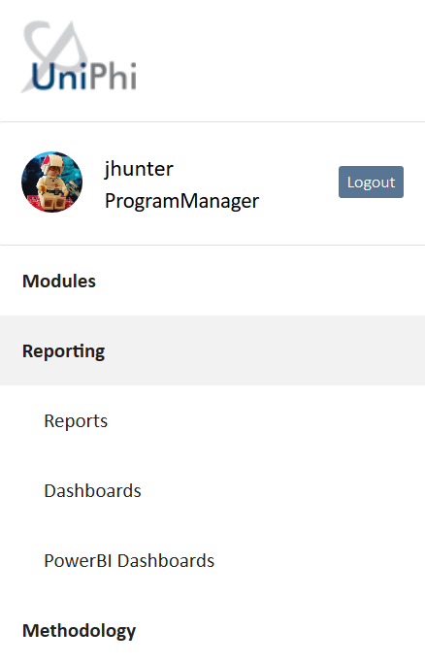

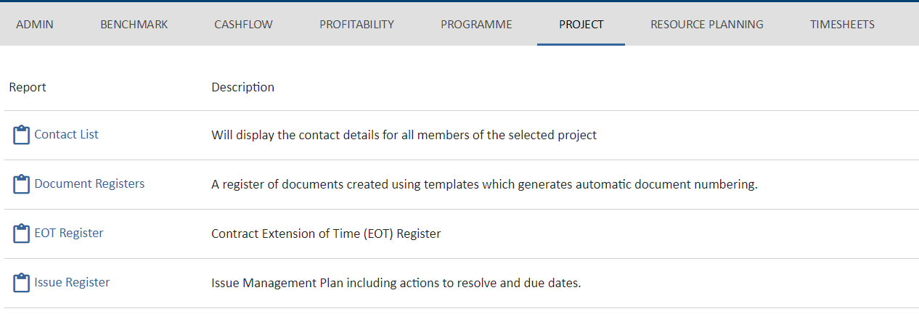
Reports can be saved as excel or pdf.

Variation Management

Best practice variation management within UniPhi involves not only the contract management components of maintaining a variation register and including this in cost reports, but also tracking the communication that surrounds the variation. Leveraging the capacity of the UniPhi Issues module to track a communication thread detailing when a possible variation is initially identified and who was involved in its resolution can be extremely helpful if any disputes arrive down the line.

Issue Creation

- Go to the Issues module and select the relevant project the issue relates to from the Project: filter.
- Click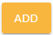. The following issue form will be displayed:
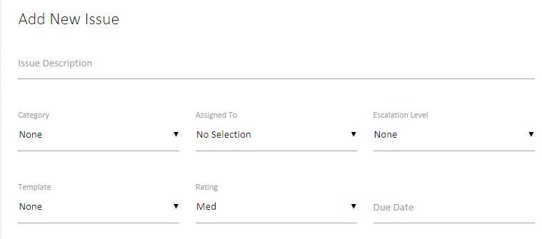
- Enter in as much relevant information as required (description, rating, due date, etc.).
- Select a relevant Category, such as EWN. Change Request or Variation.
- Select 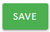 to save your issue, or 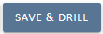 to drill into the issue details.
The term Save & Drill is used when you create an issue and need to be taken into the issue that you have just created. You would choose this option if you plan on adding issue actions, and assigning resources to those issue actions. Otherwise you can simply press save.

Assigning Issue actions
Once an issue has been created you may need to add actions, and assign those actions to people within your project.
- Click into the issue, and click the 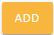 button
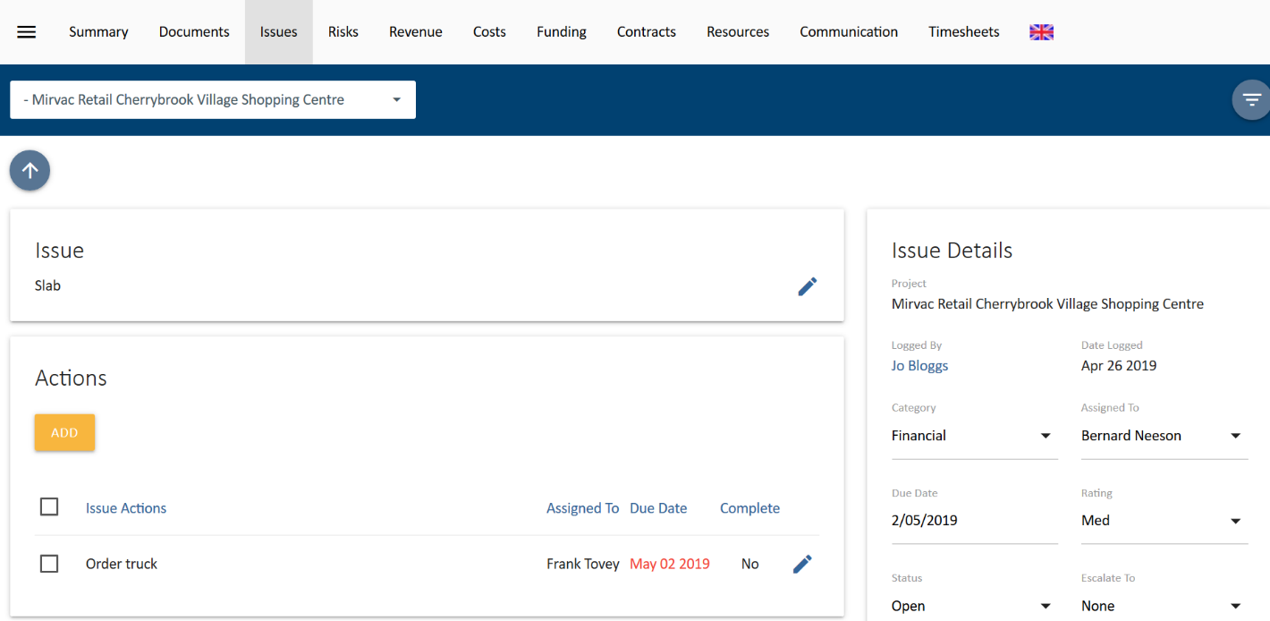

- Enter in a description for your action(s), assign a person who will complete the action, and assign a due date (if relevant)
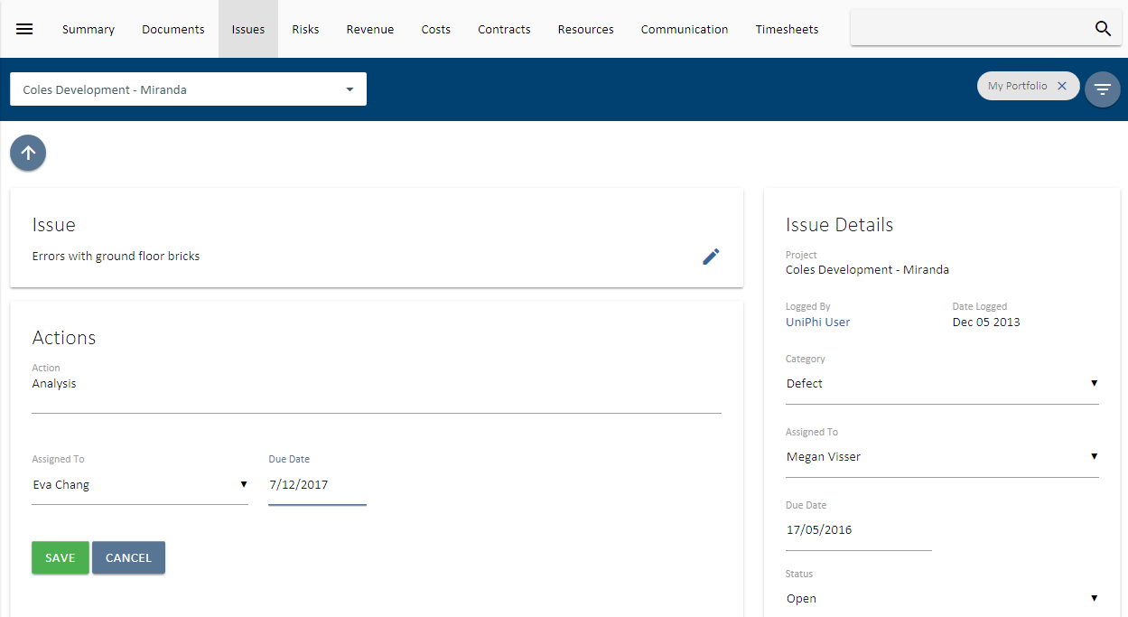
- Continue creating subsequent actions until all required actions have been established.

Attachments and Comments within an Issue

As UniPhi uses Issues as the central location for collaborating on the progress of project activities, it is important to understand how to add comments, and any related files.
- Go into an issue, and press the Add button with the comments panel.
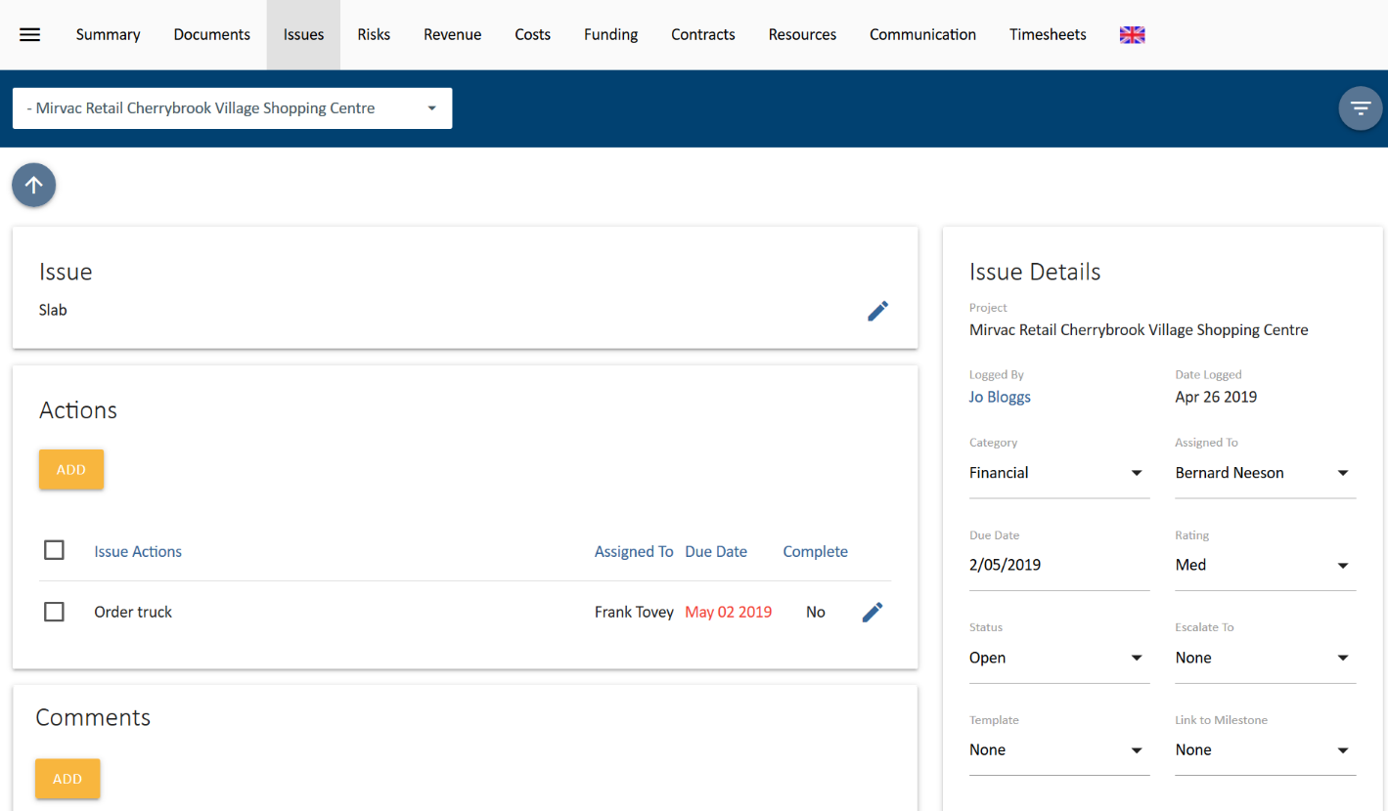
- Enter comments that relate to your issue.
- Press the Attach Files button to add any related files and Save.

Add Variation to Contract
Navigate to the UniPhi Contracts module, filter for the project you are working within and drill into the contract which the variation relates to.
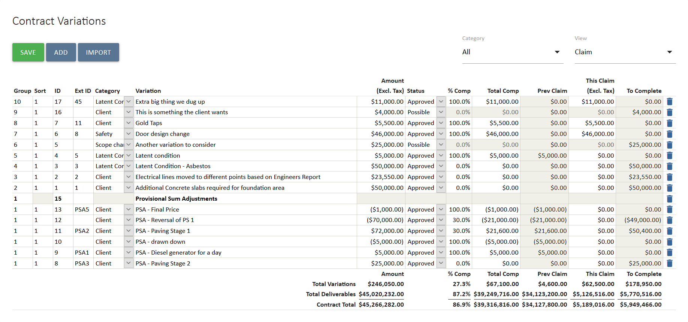
- Scroll down to the Variations card which is below the Deliverables card.
- Select the add button under Contract Variations.
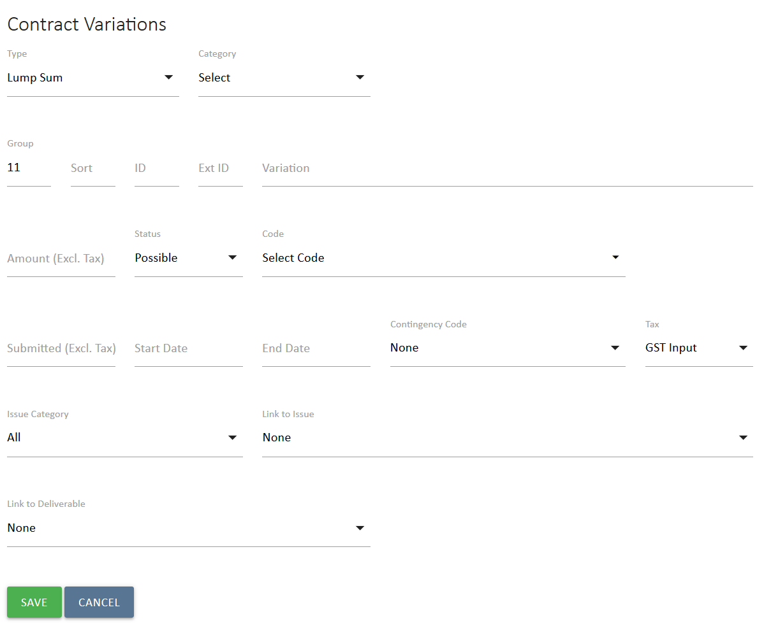
- The following fields are available:
Type of variation. These are the same as for deliverables (i.e. Time & Materials, Lump Sum and Heading)
Category of variation. This field is defined by your System Administrator to enable analysis of the causes of variations across the portfolio.
Group and Sort fields populate automatically, and are only needed when grouping variation line items under a heading.
ID field populates automatically to assign a Variation ID to the line item once saved. This can also be populated manually with a whole number.
Ext ID field is to capture the other contract party’s Variation ID, if known. This is an alphanumeric field. These details will appear in your claim document, and thus allows for clarity and traceability.
Variation is to capture a description of the scope of the variation
Qty, Unit and Rate appear if it is a Time & Material type. Enter these to calculate the value of the variation.
Amount is for the value of a variation if it is a Lump Sum type. For a Time & Materials type this populates automatically.
Status can be Possible, Pending, Approved or Rejected. The status of variations has an impact on where and how that information is displayed back in the Costs module dashboards, and in UniPhi reports. The logic being that approved variations will appear as commitments, while pending and potential variations will appear as uncommitted.
Code is a searchable drop-down list of the Cost Codes used for this contract, to allow you to track the cost of the variation in your forecast. If you have a long list of codes, start typing in the code you want, wither the number or description.
Submitted is used to track the original value of a variation. It allows a comparison of the amount of a variation that was originally submitted versus what was ultimately approved. This is for information purposes only as the Amount field is used in UniPhi as the value of the variation.
Start Date and End Date fields are optional and can be used to generate a post-contract forecast cash flow for the contract.
Contingency Code is selected if the cost of the variation will draw down on a budgeted contingency amount.
Tax is set to the contract default but change be changed if it varies.
Issue Category is a filter to limit the number of issues to select from in the Link to Issue field.
Link to Issue allows the issue related to the variation to be selected, linking the day to day management of the variation and any correspondence and collaboration with the value of the variation in the contract.
Link to Deliverables allows a Provisional Sum or Prime Cost deliverable to be selected, the variation is being used to adjust that Provision Sum or Prime Cost.
- Select Save to capture the variation.
Once the variation is added it can be viewed in the contract deliverables, variations and claim window. Variations are underneath the original contract schedule of deliverables as their own register. The variation status can be amended at any time but can only be deleted if it hasn’t been claimed.
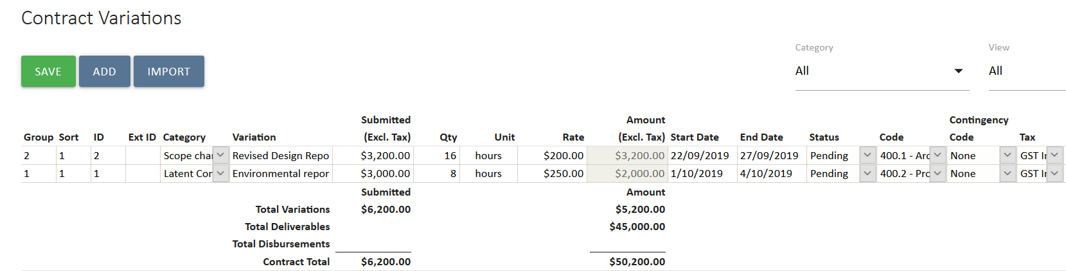
Contingency in UniPhi can be drawn down using variations. If in the Costs module Forecast to Complete it set to Auto, this will happen when a variation is flagged as drawing down contingency using the Contingency field when logging the variation. This allows for reporting of contingency to be updated live as variations are logged in UniPhi. Cost reports are already updated live by updates to variations and contract deliverables.

Variation Request and Variation Order
To advise the project team about the variation or to seek approval of it, a Variation document is generated to advise the relevant stakeholders.

- In the contract select the relevant template from Related Templates. In this case Variation Order, but the process is similar for a Variation Request.
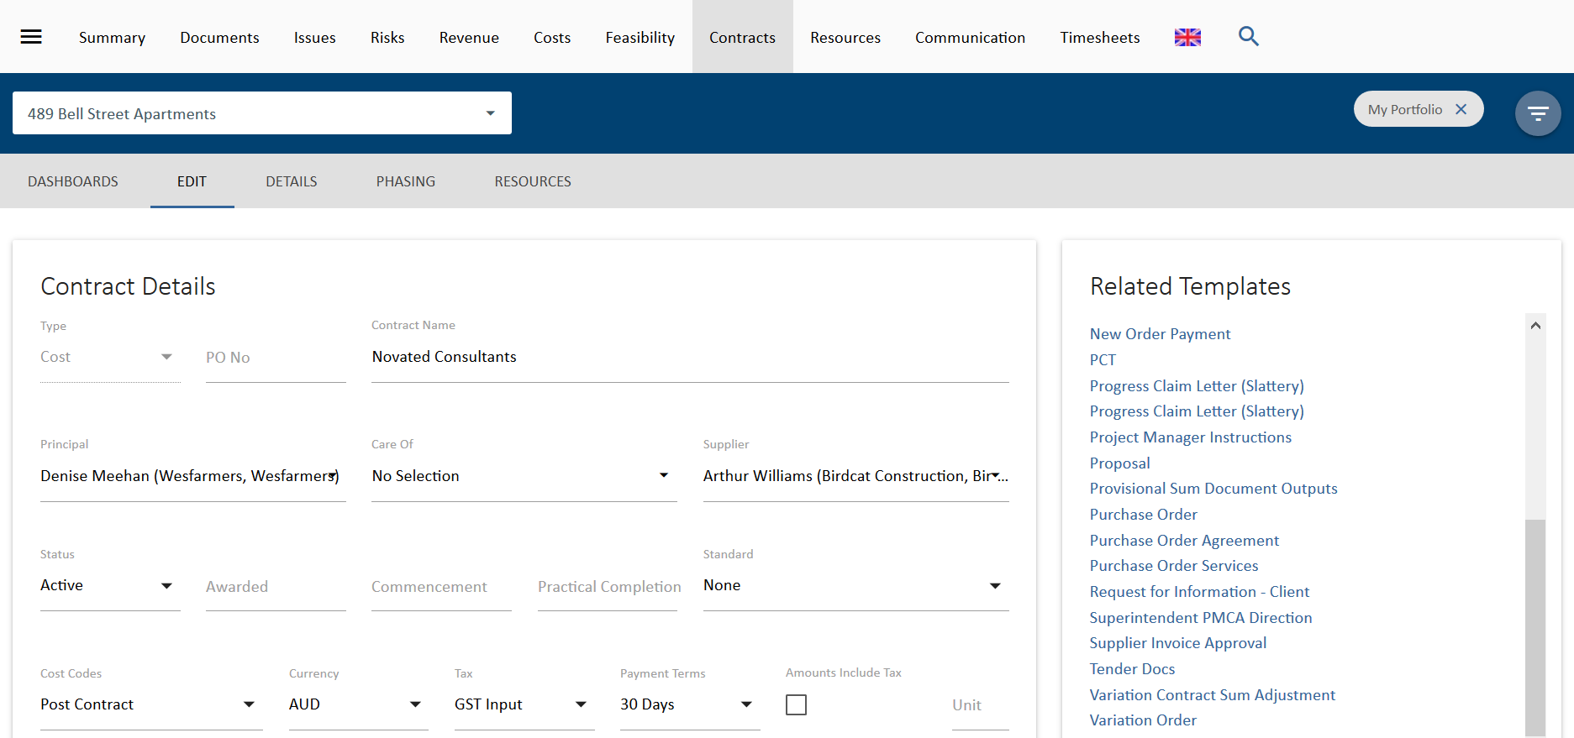
- UniPhi Document creation screen will open in a new browser tab. Note that all the fields have been selected, such as “Use Template” and “Create in Project” because this information is already known. You can also review who the approvers might be and their delegations. Select Create 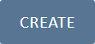 to start the document.
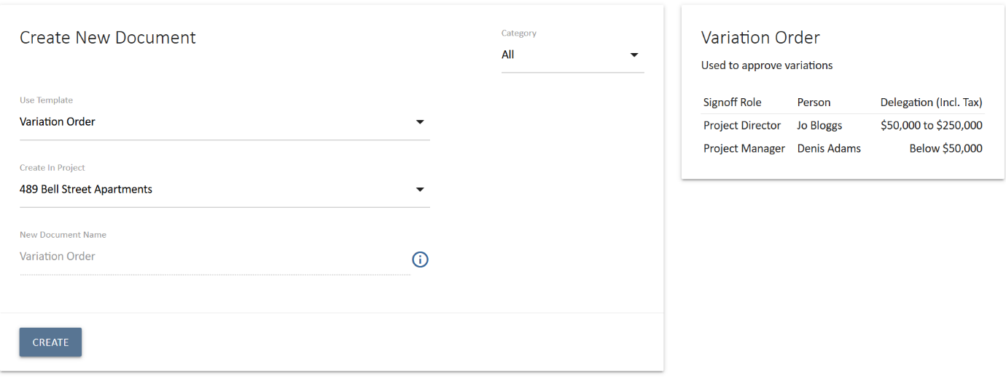
- The first step is to select the variation that is to be approved. Note that the contract and supplier are already selected, as this data is already known. Ensure that only the variation(s) to be approved in this Variation Order are selected. You can also check or uncheck any other available fields to control what appears in the final document. Select a date. Select Save and Continue 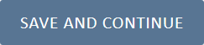 to go to the next step when you are done.
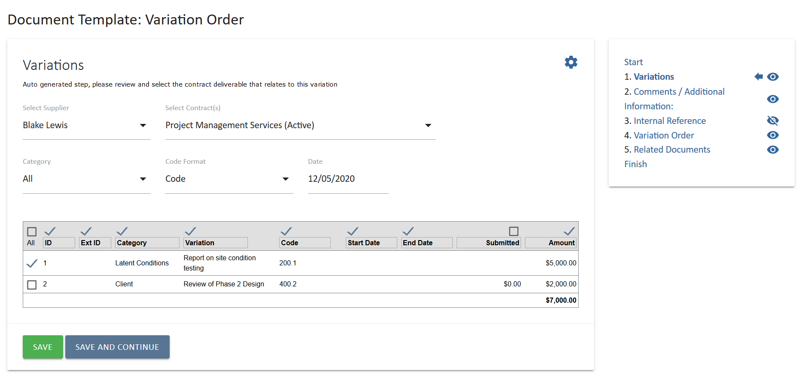
- Follow the rest of the document steps. These will typically include a step to provide commentary, an auto populated header and a step to link to the issue you had logged for this variation (see screenshot below).
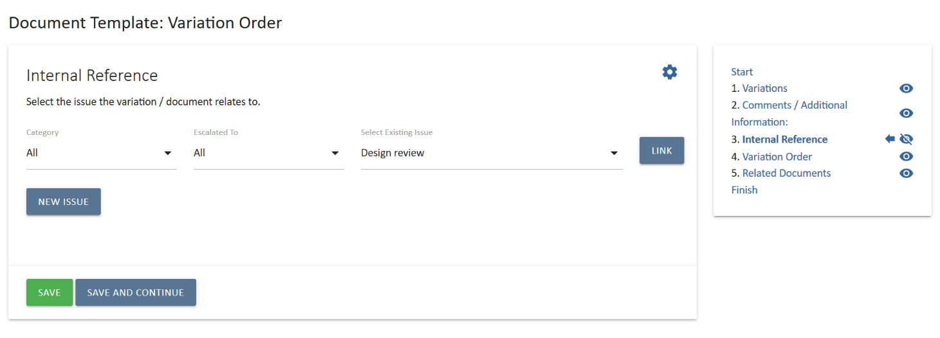
- At the finish step, the document name will auto populate. You can edit the document name if needed, set the status of the document and distribute via email or PDF.
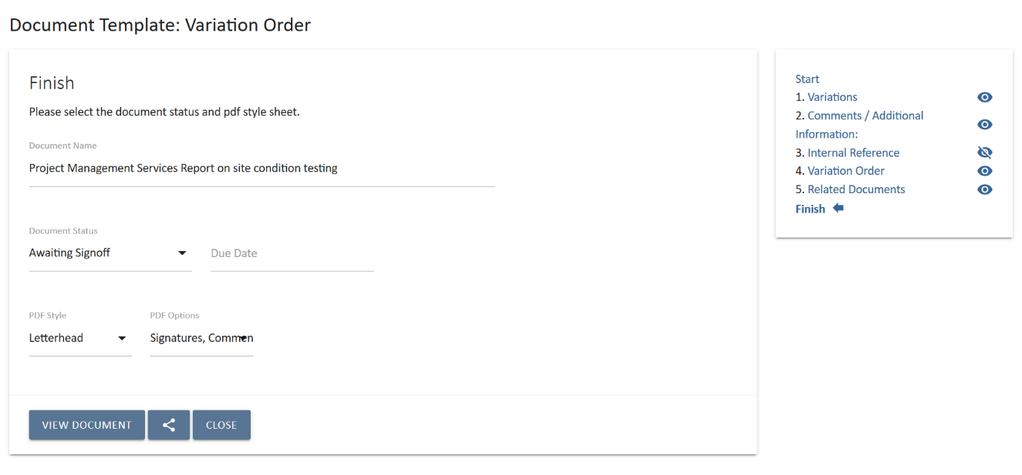
When a Variation Order is set to Awaiting Sign-Off, the UniPhi approval process is triggered. The document will appear in the sign off workflows of the relevant approvers. Once all the approvers have signed off the document, the variation register in the contract will be updated and the status of the variation will change to “Approved”. This will also flow through automatically to the dashboards in the Costs and/or Revenue modules and to all reports.
For more information about documents in UniPhi, refer to the UniPhi 15 Document Management Manual

Progress Recommendations

Progress Recommendations are the first step in assessing the contractor’s claim for payment.

Create a Progress Payment Recommendation
Progress recommendations are prepared in the Assessment view of the contract.

- Go to the contract and change the View to Assessment
- Enter either the % Complete or the Contractor’s Claim value all deliverables and variations which are being claimed against.
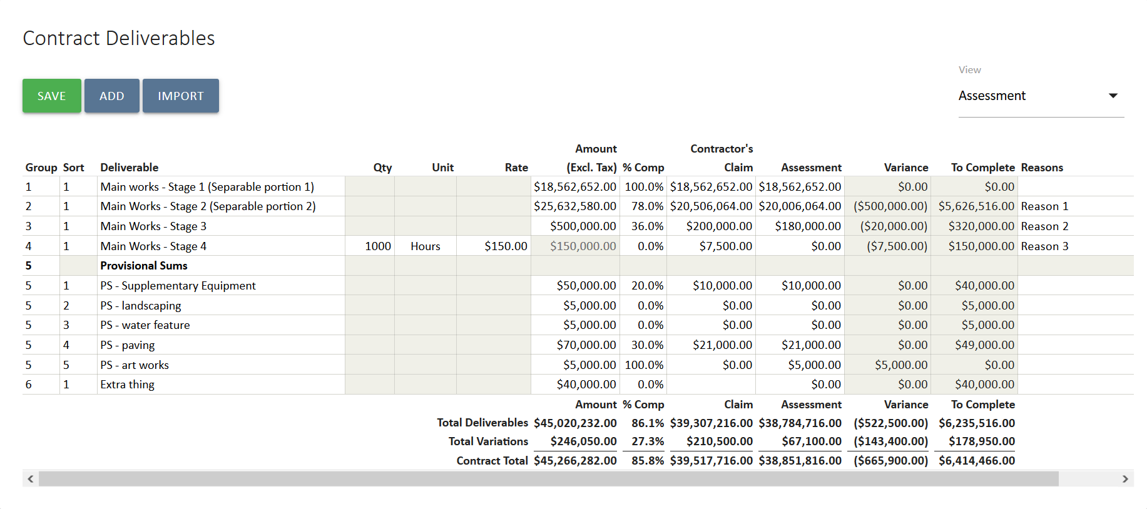
- Select 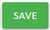 and the claim amount will be displayed with the % complete of the contract.
- If you wish to vary the assessed amount from the Contractor’s Claim then edit the Assessment amount to reflect this and type a reason in the reasons box.
- Select and any variances with the Contractor’s Claim will be.
- Select the relevant recommendation template from the Related Templates panel.
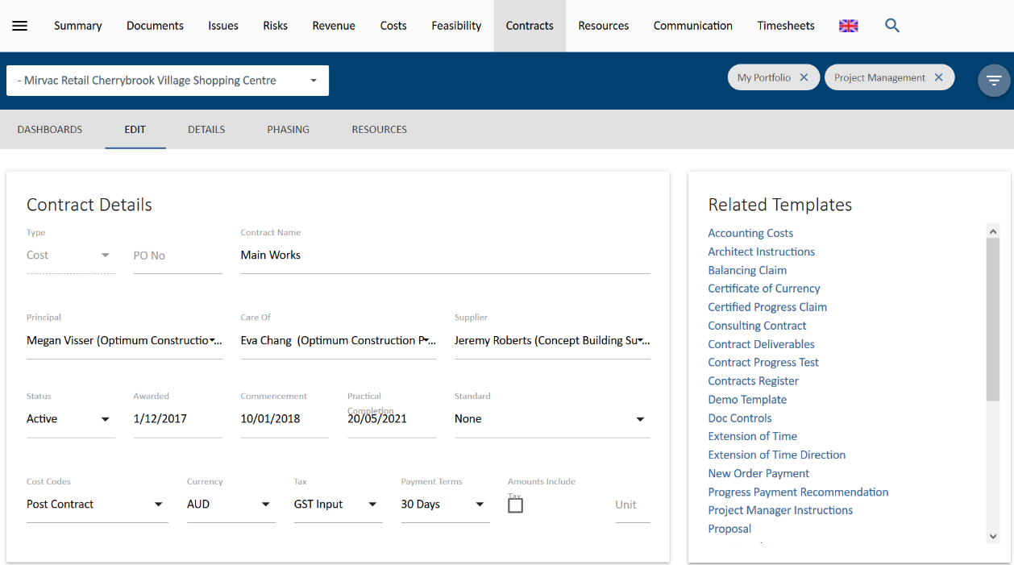
- UniPhi Document creation screen will open in a new browser tab. Note that all the fields have been selected, such as “Use Template” and “Create in Project” because this information is already known. You can also review who the approvers might be and their delegations. Select Create to start the document.
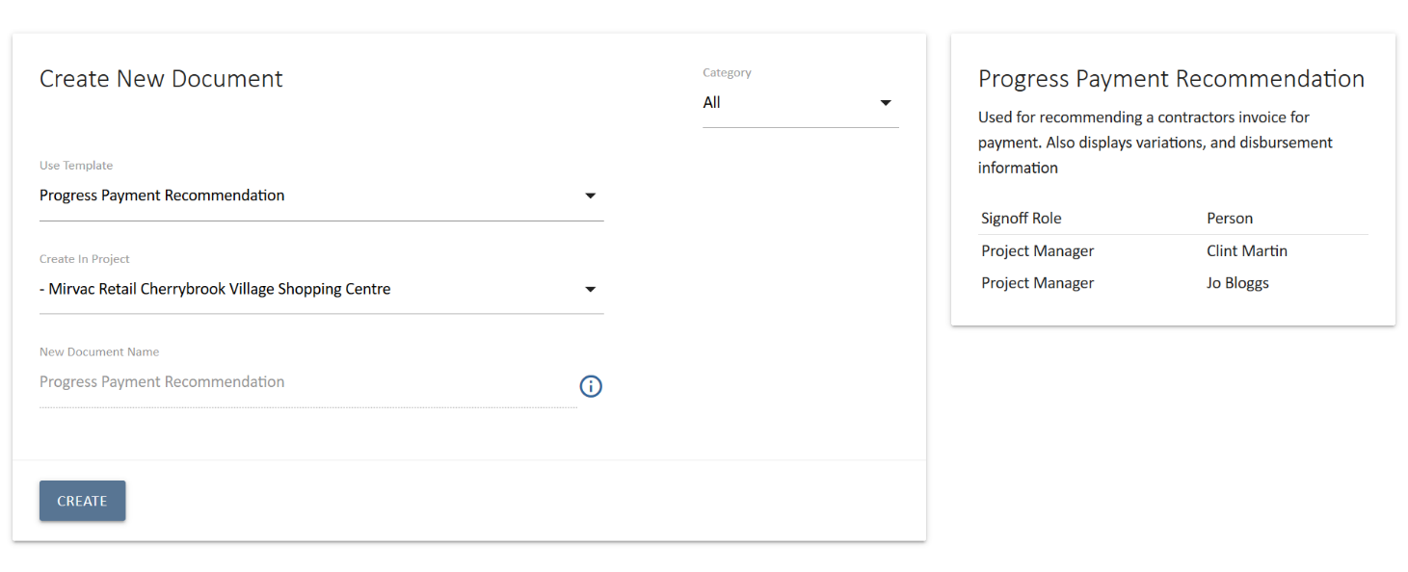
- The first step in the document is to review the recommendation. The Supplier and Contract will be selected automatically.
- Enter the Certification Date.
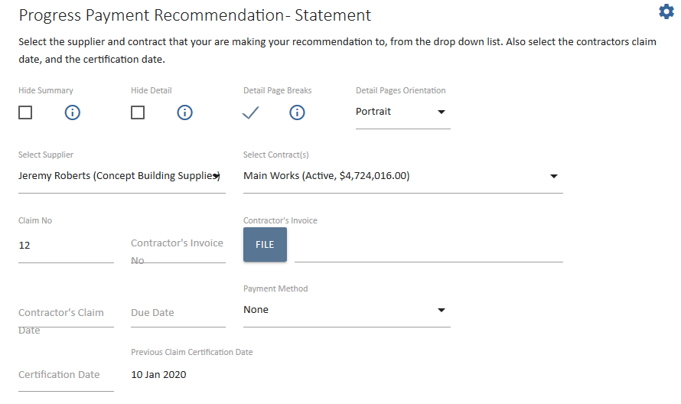
- The claim number is automatically populated; however, it can be overridden

- The values for this claim which were entered into the edit contract screen will be automatically summarised in this step. Review the figures to ensure that they match the recommendation.
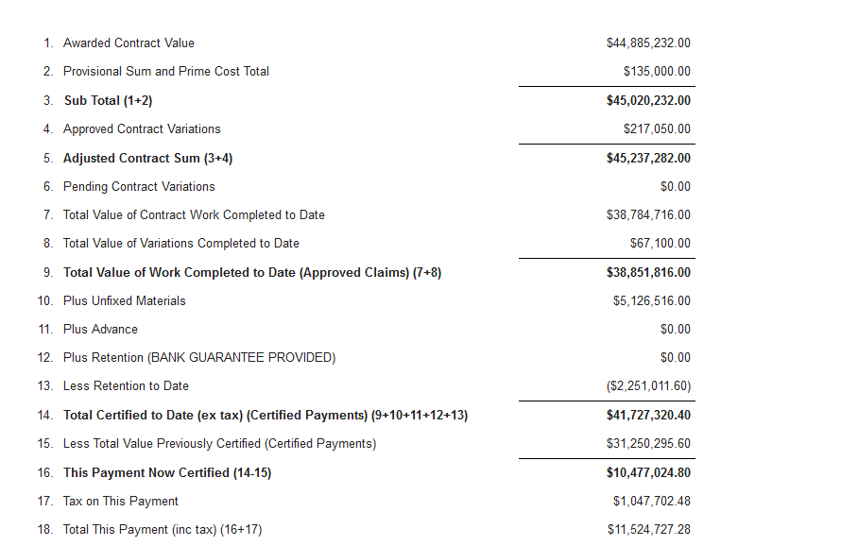
- Further down the page a detailed summary of amounts claimed, assessed and any variance reasons will be displayed for Deliverables, Variations, Claim adjustments etc. These are exactly as entered in to the Contracts Edit view. Review them to ensure they are as intended.
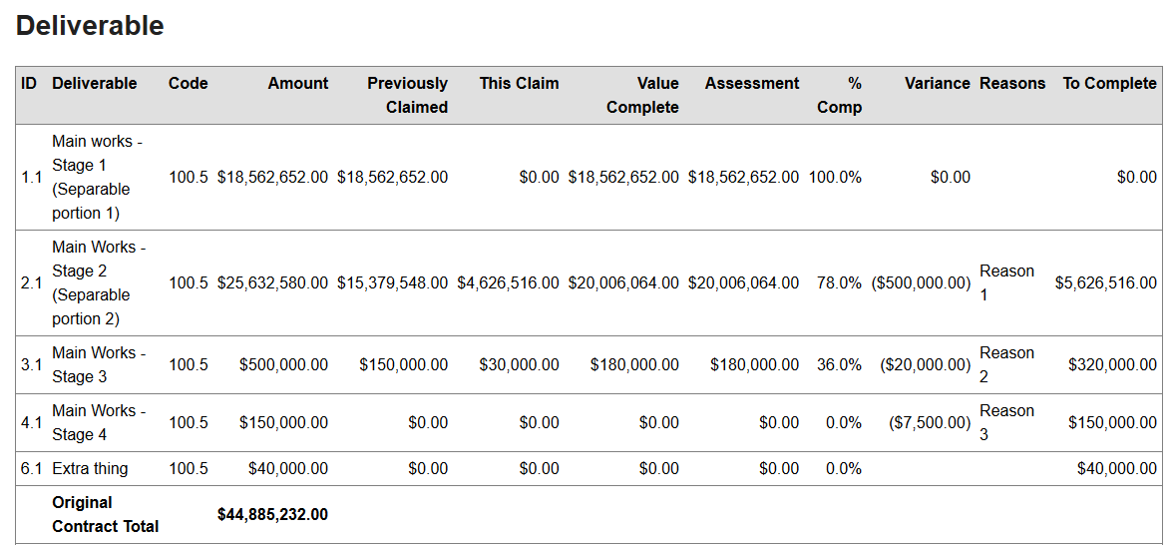
- Select 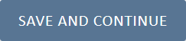 Save and Continue to proceed to the next step.
- The remaining steps will vary with your template but may include a header with details of the claim and the contract and a step to upload photos or other relevant files.
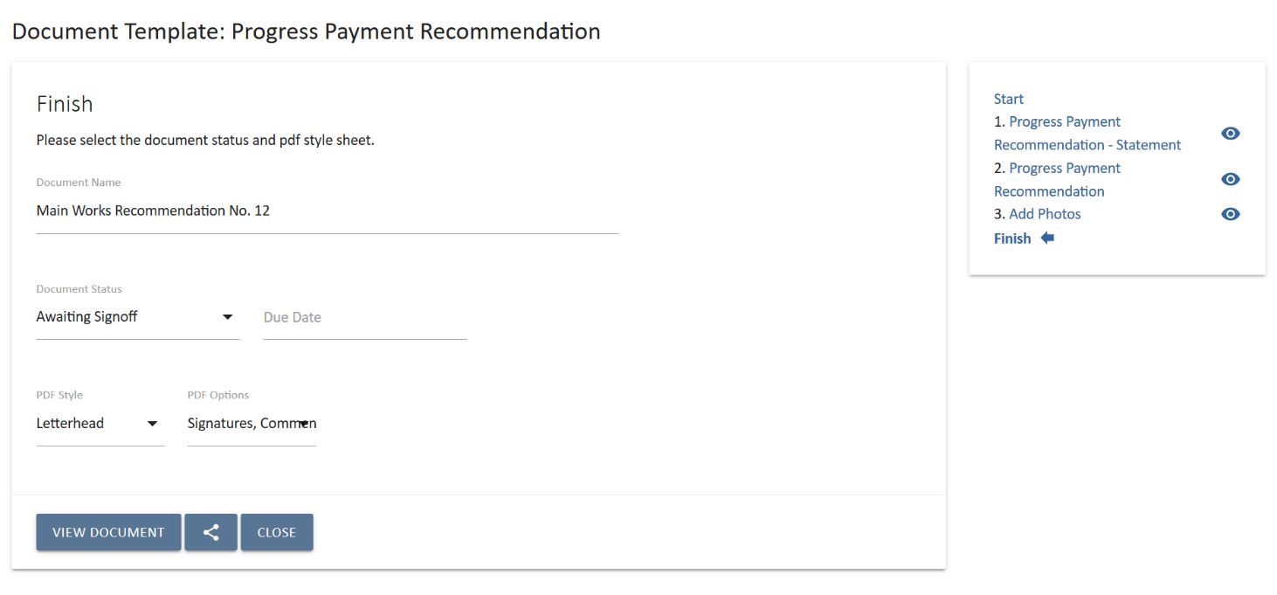
- At the finish step, the document name will auto populate. You can edit the document name if needed, set the status of the document and distribute via email or PDF.
When a Progress Recommendation is set to Awaiting Sign-Off, the UniPhi approval process is triggered. The document will appear in the sign off workflows of the relevant approvers. Once all the approvers have signed off the document, the claim register in the contract will be updated. If the document is set to mark the amounts as claimed then the Previously Claimed values in the contract will update. If not, then a Certified Progress Claim will need to eb created and signed off to update the contract and close out the claim process.

For more information about documents in UniPhi, refer to the UniPhi 15 Document Management Manual

Certifying Progress Claims

To generate a Progress Claim Certificate, the claim details are entered against each contract and its deliverables and variations. Then a document is created based on a Progress Claim Certificates template which is populated by the information in the contract.

Create a Progress Claim Certificate
Progress claims are prepared in the Claim view of the contract.

- Go to the contract and change the View to Claim
- Enter the amount claimed against each item in Deliverables and Variations using any of the following fields:
  - % Comp if using the percentage complete
  - Total Comp for the total value or work to date
  - Claim Qty only available for Time and Material items to claim the total quantity to date
  - This Claim the value for the current claim
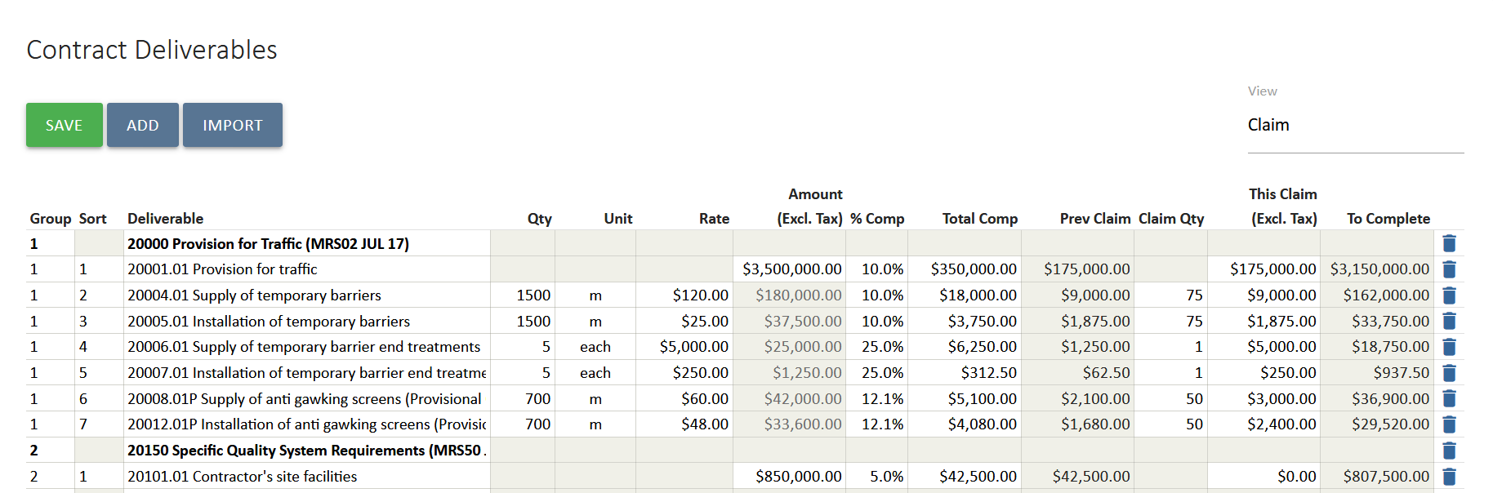
- The fields will update each other for each line item as you enter them.

- Select Save and the claim amount will be displayed, as will the previous claim amount and % complete of the contract.
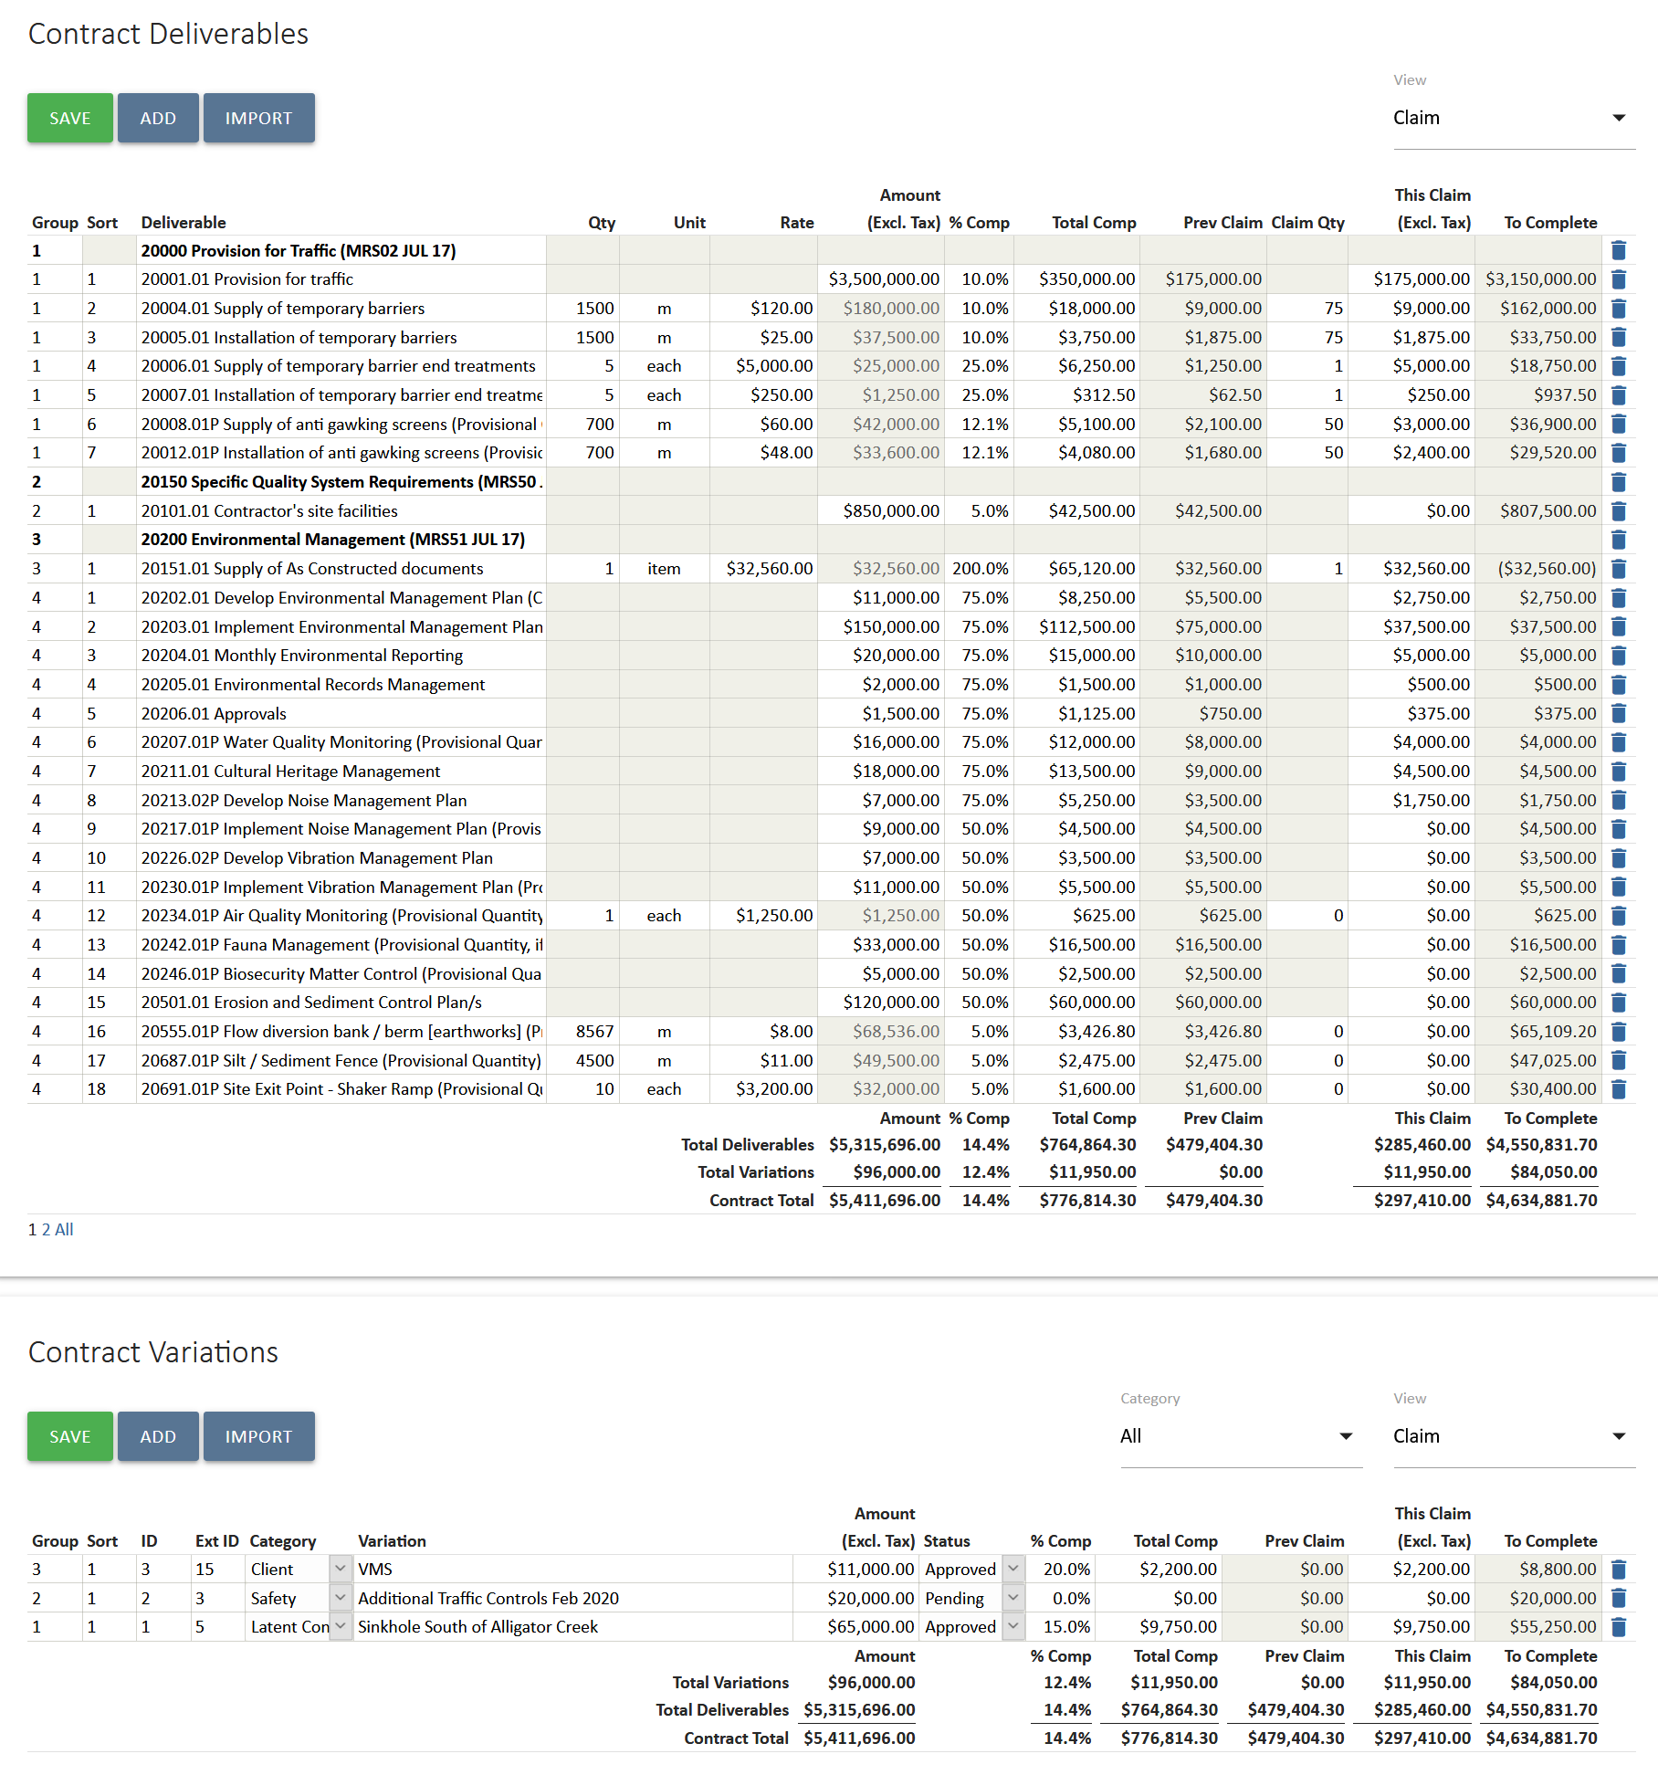

- To raise the certificate, select the relevant template from the Related Templates panel.
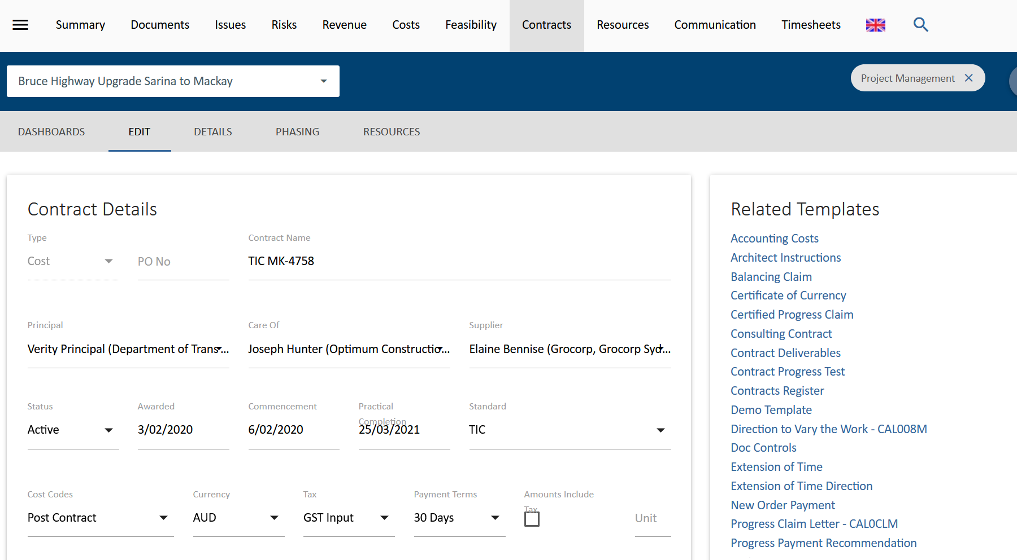
- UniPhi Document creation screen will open in a new browser tab. Note that all the fields have been selected, such as “Use Template” and “Create in Project” because this information is already known. You can also review who the approvers might be and their delegations. Select Create to start the document.
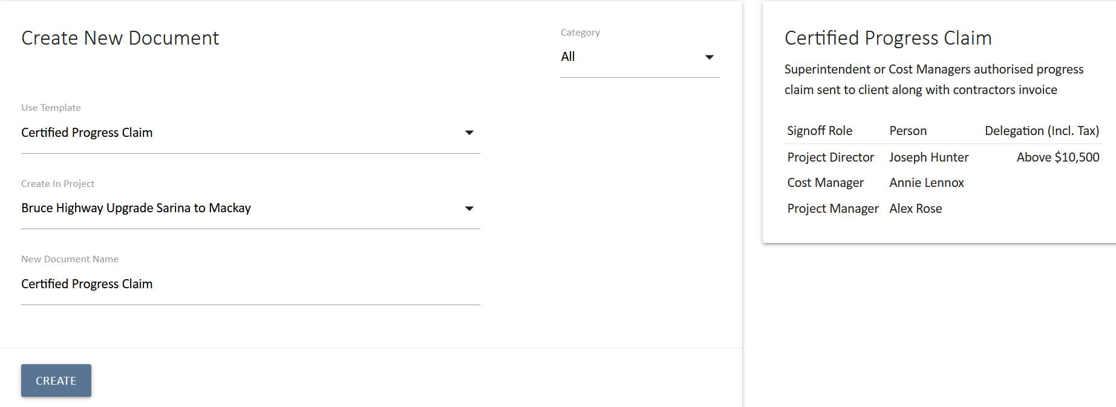

- The first step of the document is to review the details and total of the claim.
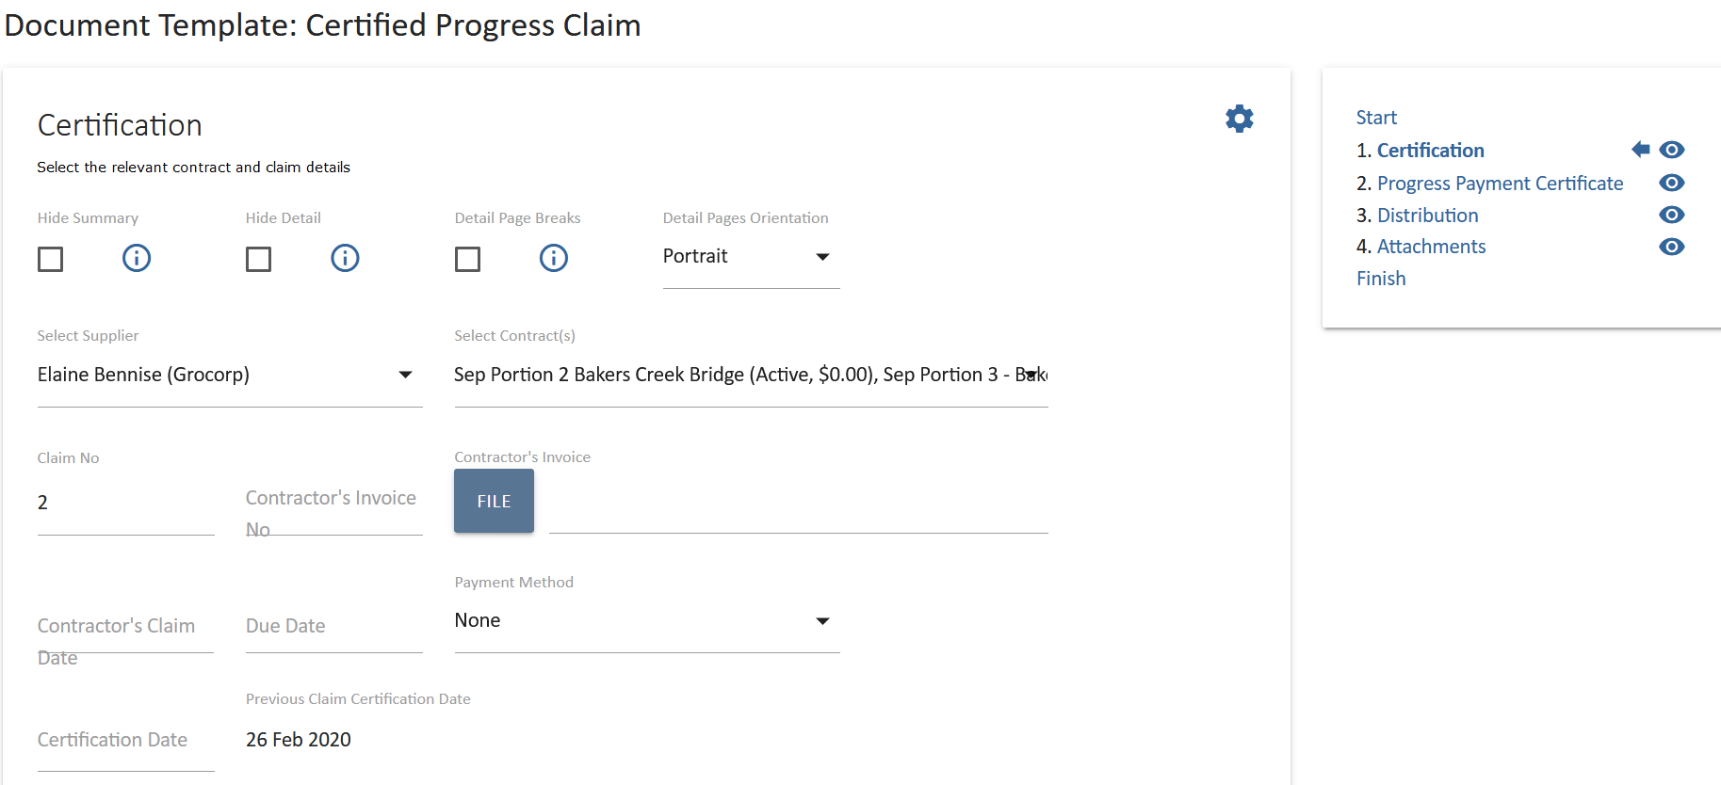

- Enter the Contractor’s Invoice No. and Contractor’s Claim Date
- Enter the Certification Date
- The claim number is automatically populated; however, it can be to overridden it if necessary.

The summary of the claim can be hidden in the final document by checking the Hide Summary check box. Likewise, the line-by-line detail of deliverable and variation progress can be hidden by checking the Hide Detail check boxes. If you are showing the detail, then page breaks can be automatically inserted by checking the Detail Page Breaks check box. These settings are normally selected as needed already in the template.

- The values for this claim are automatically copied into new document from the contract and summarised. Review the values to ensure the total claim is correct.
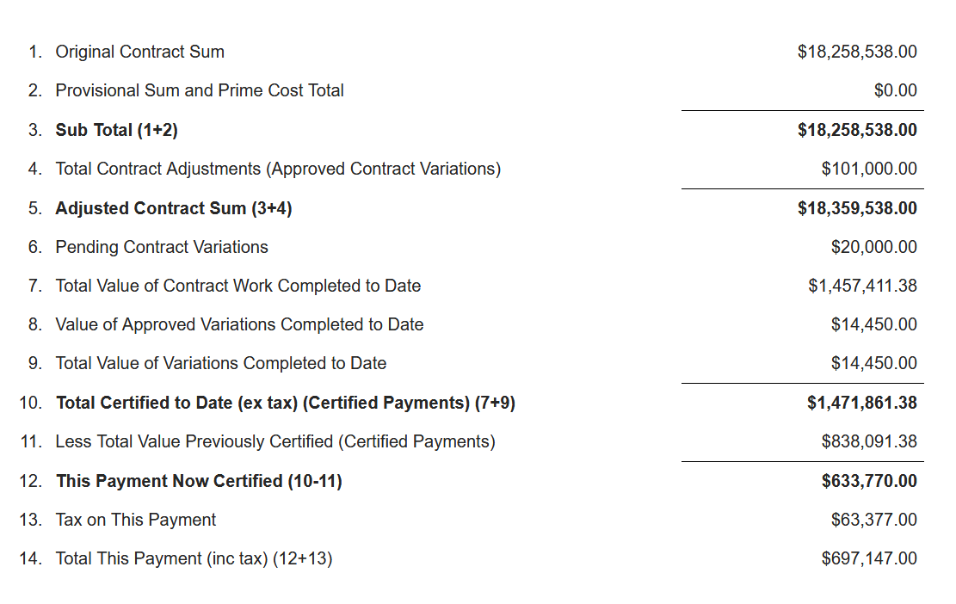
Check the total value of the claim including tax (item 14 above) against the invoice being claimed. This is an easy check to ensure that data entry for the claim is correct. If there are variances, work backwards to either update the claim amounts in UniPhi. Sometimes the contractor’s claim documentation will be incorrect and this is also a way to check for that.

- Select Save and Continue to proceed to the next step.
- The remaining steps will vary with your template but may include a header with details of the claim and the contract, a distribution list and a step to upload documents, photos or other relevant files.
- At the finish step, the document name will auto populate. You can edit the document name if needed, set the status of the document and distribute via email or PDF.
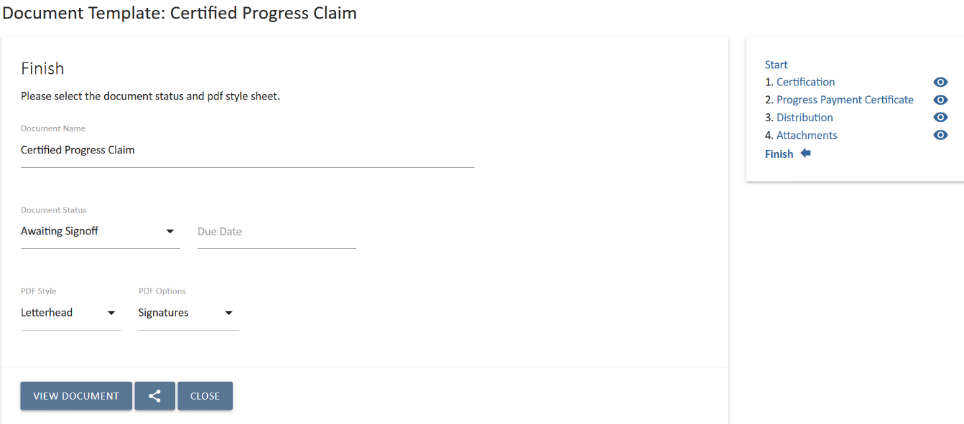
When Certified Progress Claim is set to Awaiting Sign-Off, the UniPhi approval process is triggered. The document will appear in the sign off workflows of the relevant approvers. Once all the approvers have signed off the document, the claim register in the contract will be updated, as will the previously claimed values against the Deliverables and Variations in the Contract.

For more information about documents in UniPhi, refer to the UniPhi 15 Document Management Manual

Project Cost Reports

In UniPhi Reports > Reporting -> Project Sub Nav, there are two cost reports, Project Cost Report and Project Cost Report Detail:
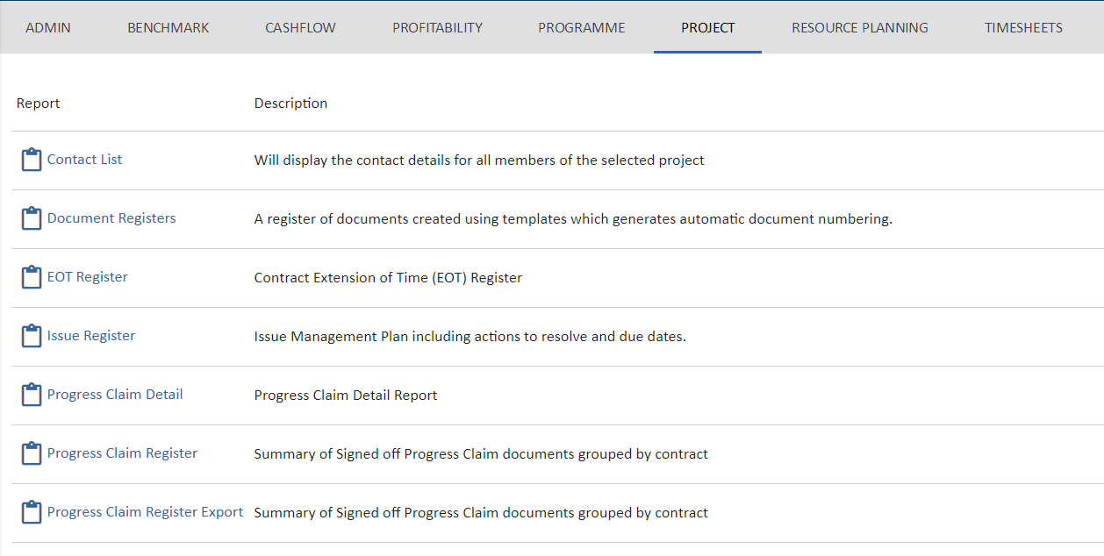
The Project Cost Report details the project budget, contracted costs, variations and expenditure broken down by cost code:
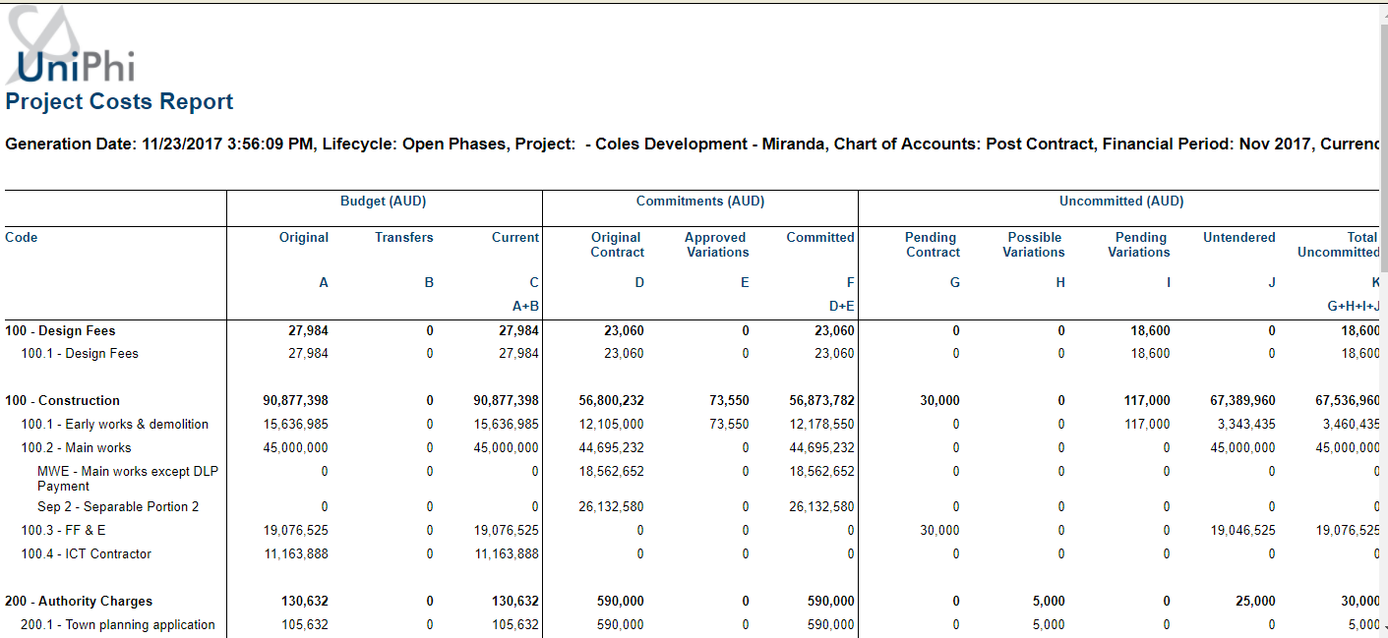
The cost report has its costs grouped into 6 major sections, and 18 sub sections.
The major sections are:
- Budget (the budget view of your project)

- Commitments (any contracts/commitments which have been created)

- Uncommitted (the budget amount which has not yet been formally committed)

- Contingency (contingency amount)

- Total (total cost of the project)

- Expenditure (amount spent relevant to the date of the report)

Breaking down the major sections into their subsections we can see:

Budget
- Budget Original. This is the "original" snapshot taken from the cost module

- Budget Transfers. Once your budget has been baselined via creation of a snapshot, the Transfer column highlights movement from your current budget, and the Original baseline snapshot

- Budget Current. This is your current approved working budget. It is either flagged as Approved in a budget snapshot or has been approved in a Budget or Budget Change Request document.

Commitments
- Original Contract. When you create a contract document and sign it off, it will appear as an original contract value.

- Approved Variation. Similar to original contract values, approved variations are shown in the approval column once they have been included in a signed off document.

- Committed. This is a simple calculation of original contract values, and approved variations

Uncommitted
- Pending contract. All contract deliverable items and their values, which are yet to be associated with a signed off document

- Possible Variations. Deliverables captured in the Variations panel per contract, which have been flagged as Possible Variations

- Pending Variations. Deliverables captured in the Variations panel per contract, which have been flagged as Pending Variations

- Untendered. A calculation of the current budget, minus the committed values, but excluding any variations flagged for contingency. Note: this calculation will only be displayed once you have entered your Forecast to Complete, or you have used UniPhi to automatically calculate the value.

- Total Uncommitted. A calculation of the current budget, minus the committed values.

Contingency
- The amount that appears here is a calculation of your budgeted contingency amounts, minus any drawdowns that have occurred in your contract variations

Total
- Total Forecast. Calculates all Committed costs, all Uncommitted costs, and any Remaining Contingency

- Total Variance. Calculates Current Budget minus Total Forecast
Expenditure
- Last Month. Displays the expenditure from the previous month

- This Month. Displays the expenditure from the current month

- Project Cumulative. Displays the full expenditure

- Unexpended Balance. Calculates the Total Forecast minus the Project Cumulative costs

The detailed version of this report offers the same columns, however also has additional rows detailing the contract deliverables and variations which are apportioned to each cost code:
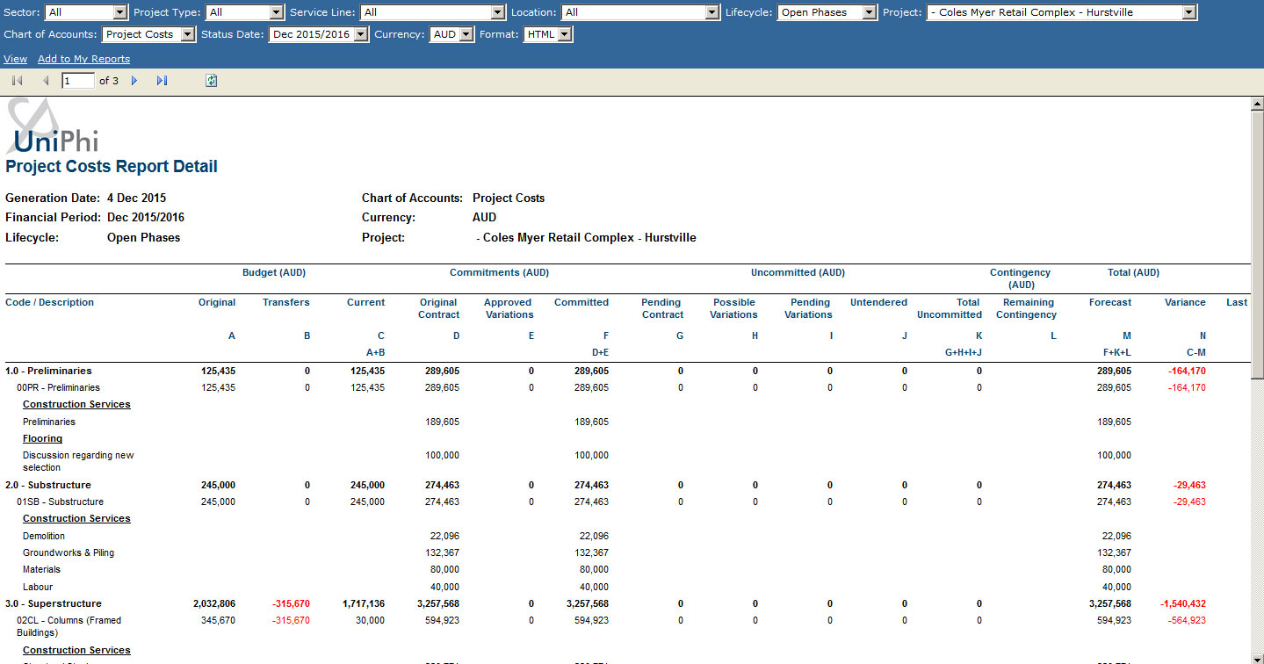

Communication

The Communication module displays all forms of interaction that have occurred across your entire portfolio of project activity. It’s a very broad, comprehensive, and powerful view of information and can be seen as a transaction log of all project communication. This interaction includes all issues, actions, comments, emails (sent from UniPhi or saved into UniPhi using the outlook plugin), and documents. Information is displayed regardless of status, due date, or ownership status. This information can be used for various purposes, such as viewing all communication on a project with the electrical contractor or viewing all variations across all contracts.
By applying the correct filters, such as selecting particular project, it is possible to see exactly what has occurred to date. In effect this means that when you are speaking with someone associated with the particular project/organisation you are viewing, you can see all related issues, and documents, even those issues which have been previously closed.
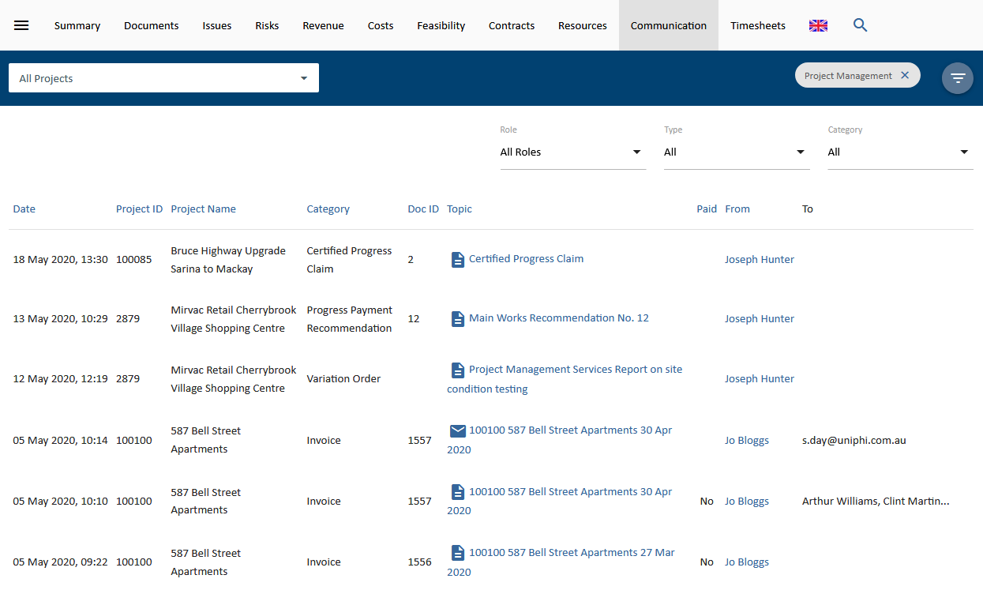
Communications can also be narrowed down using the following filters:
Roles: These are the project roles setup in UniPhi prior to implementation. Once resources are allocated to their roles, any form of communication done by them in UniPhi can be viewed using this filter.
Type: This filter allows you to choose between different forms of communication used. The types of communication in UniPhi are Comments, Email, Issues, Risks and UniPhi Documents.
Category: The Category filter contains a list of all the document templates and issue categories that have been used. Based on the usage, this filter allows you to select and display a specific category of communication.

Correspondence
The Correspondence panel is located within the Resource Details card, and displays all forms of direct interaction that have occurred between your company and the resource that you are viewing. You can view all correspondence that has occurred by clicking into a specific contact, site, or organisation. The correspondence list is contextualised to the resource that you have specified. This makes reviewing the correspondence items more focussed.
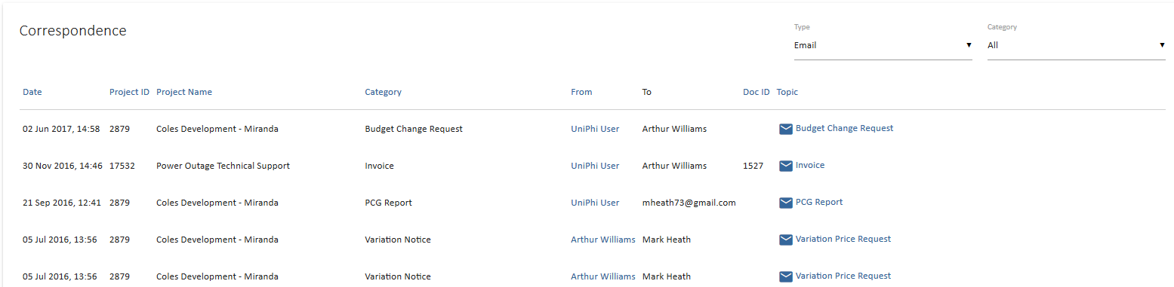

Saving emails into UniPhi
Project specific communications from external parties often come via email. As these emails are directly related to a project, it is useful to save them into the Issues comments section within UniPhi via the UniPhi for Outlook Add-In that can added to your Outlook Add-Ins. Saving emails into UniPhi issues aids with collaboration and provides additional transparency to each issue. The entire project team can see all saved emails, and their file attachments. The UniPhi for Outlook Add-In can be used to create a new issue, append an existing issue, or create new or append an existing document. (The plug-in download is available here: http://uniphi.com.au/community)

Project specific communications from external parties often come via email. As these emails are directly related to a project, it is useful to save them into the Issues comments section within UniPhi via the UniPhi for Outlook Add-in that can linked to your Outlook account. Saving emails into UniPhi issues aids with collaboration and provides additional transparency to each issue. The entire project team can see all saved emails, and their file attachments. The UniPhi for Outlook Add-in can be used to either create a new issue, append an existing issue, or create new or append an existing document.
(The plug-in download is available here: http://uniphi.com.au/community)

Save an email into UniPhi Issues

- Once relevant email communication has been received via MS Outlook, select the email and click on the “Save to UniPhi” button, which is located in the Outlook menu ribbon.
- This will launch the Add-in form and ask you to login:
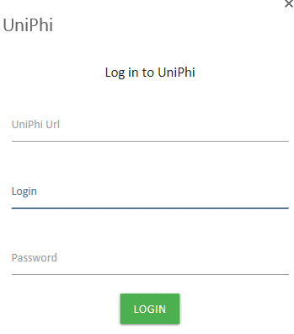
- Then select to save the email as either a new issue or append it to an existing issue
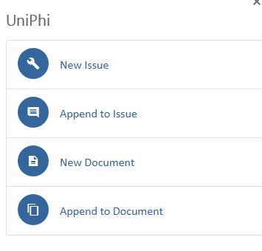
- If you select New Issue, the Create New Issue form will appear. The email title will auto-populate as the Issue Description. Select the project from the drop-down menu. Select any of the other relevant fields.
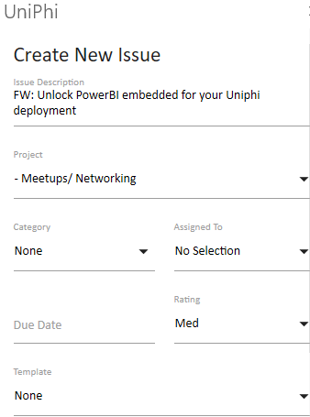
- If the email has attachments, these will be listed at the bottom of the form as an option to save into the issue. Check the box next to the attachments you want to save.
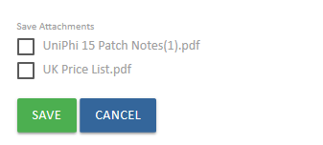
- If you select Append to Issue the Append to Issue form will appear. Select the project and the issue you want to save the email to. The Save Attachments option will also appear f relevant.
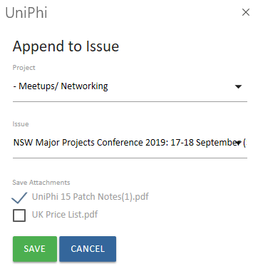
- Select Save to complete the process. The email will now be linked to UniPhi and the UniPhi for Outlook Add-in will show the link. If you select the issue, UniPhi will open the issue in your browser.
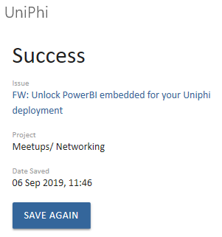

Once the email has been saved, you (and your project team) can also locate it via the Issues tab. Here you will be able to view the original email and any attachments, add comments / instructions to aid communication and workflows surrounding the issue, and add actions required to close out the issue.
