UniPhi 15

Issues & Actions Management
Training Manual

Contents
Issues Management 4
Logging a new issue into UniPhi 5
Assigning Issue actions 6
Attachments and Comments within an Issue 8
Viewing Issues 12
Email Summary Notifications 12
Saving emails into UniPhi 13
Link an issue to a document 19
Issue Escalation 27

Course Aim
The aim of this manual is to provide instructions on managing issues and actions. Within this manual you will learn how to create a new issue, set an issue due date, assign an issue owner, escalate an issue, and work with issue categories. You will also learn how to create actions within an issue, set due dates, and assign people to your issue actions. And finally, you will learn how to utilise comments and attachments within an issue to ensure that they are the central transparent location for all attachments, and collaborative communications (comments and emails) related to issue resolution.

How to use this User Training Manual
As you read this manual you will notice the following icons recurring which will help to highlight and enable you to quickly locate activities and summary areas, they will also assist you to understand UniPhi, and avoid any problems.
Puzzle Piece:
The puzzle piece appears at the beginning of each session and any major section to mark the overview of that item’s content or concept.
Cogs:
The cogs denotes a step by step activity to be completed using UniPhi by the participant relative to the section it is located in.
Light bulb:
The light bulb denotes a helpful hint or tip you should be aware of.

Screen shots have been used throughout the manual to demonstrate what you should be viewing as you move through the activities. They are for illustrative purposes only. Details such as dates, budget figures and other entered text/data may vary.

Issues Management

Within UniPhi, the Issues module is the centralised point of reference for all activity that is occurring, or scheduled to occur within a project. Each issue is logged within the project that it relates to, and is available and viewable by all members of the project team. Project Managers, Program Manages, and Administrators can set due dates, and close issues, while Team Members can create issue, create issue actions, and provide updated comments and attach emails and files. Issues can be created at any time throughout the project, and are in fact the project manager’s best friend.
Team Member licence users cannot close an issue, instead they move it to an Awaiting Review status. This ensures that the Project or Program Manager is satisfied that an issues has been resolved and can be closed.

When creating an issue it is advisable to add as much information as is relevant to the issue, as this will assist the rest of the project team to understand what the issue relates to, and how it needs to be resolved.
UniPhi allows only one “owner” to be assigned to an issue, as this ensures accountability. The issue owner may assign tasks within the issue to numerous people, which facilitates collaboration.
Logging a new issue into UniPhi

- Go to the Issues module and search for or select the relevant project the issue relates to from Project Selection.
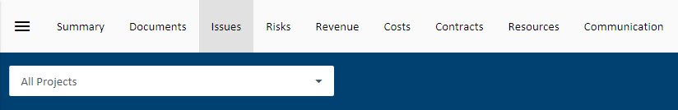
Figure 1 Project search
- Click. The following issue card will be displayed:
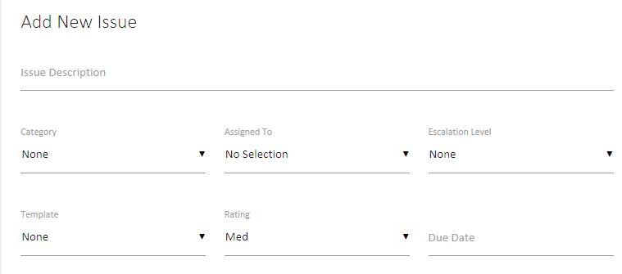
Figure 2 Add Issue card

- Enter in as much relevant information as required (description, rating, due date, etc.) and click to save your issue, or to drill into the issue details.
The term Save & Drill is used when you create an issue and need to be taken into the issue that you have just created. You would choose this option if you plan on adding issue actions, and assigning resources to those issue actions. Otherwise you can simply press save.

Assigning Issue actions
Once an issue has been created you may need to add actions, and assign those actions to people within your project.
- Click into the issue, and click the button in the Actions card
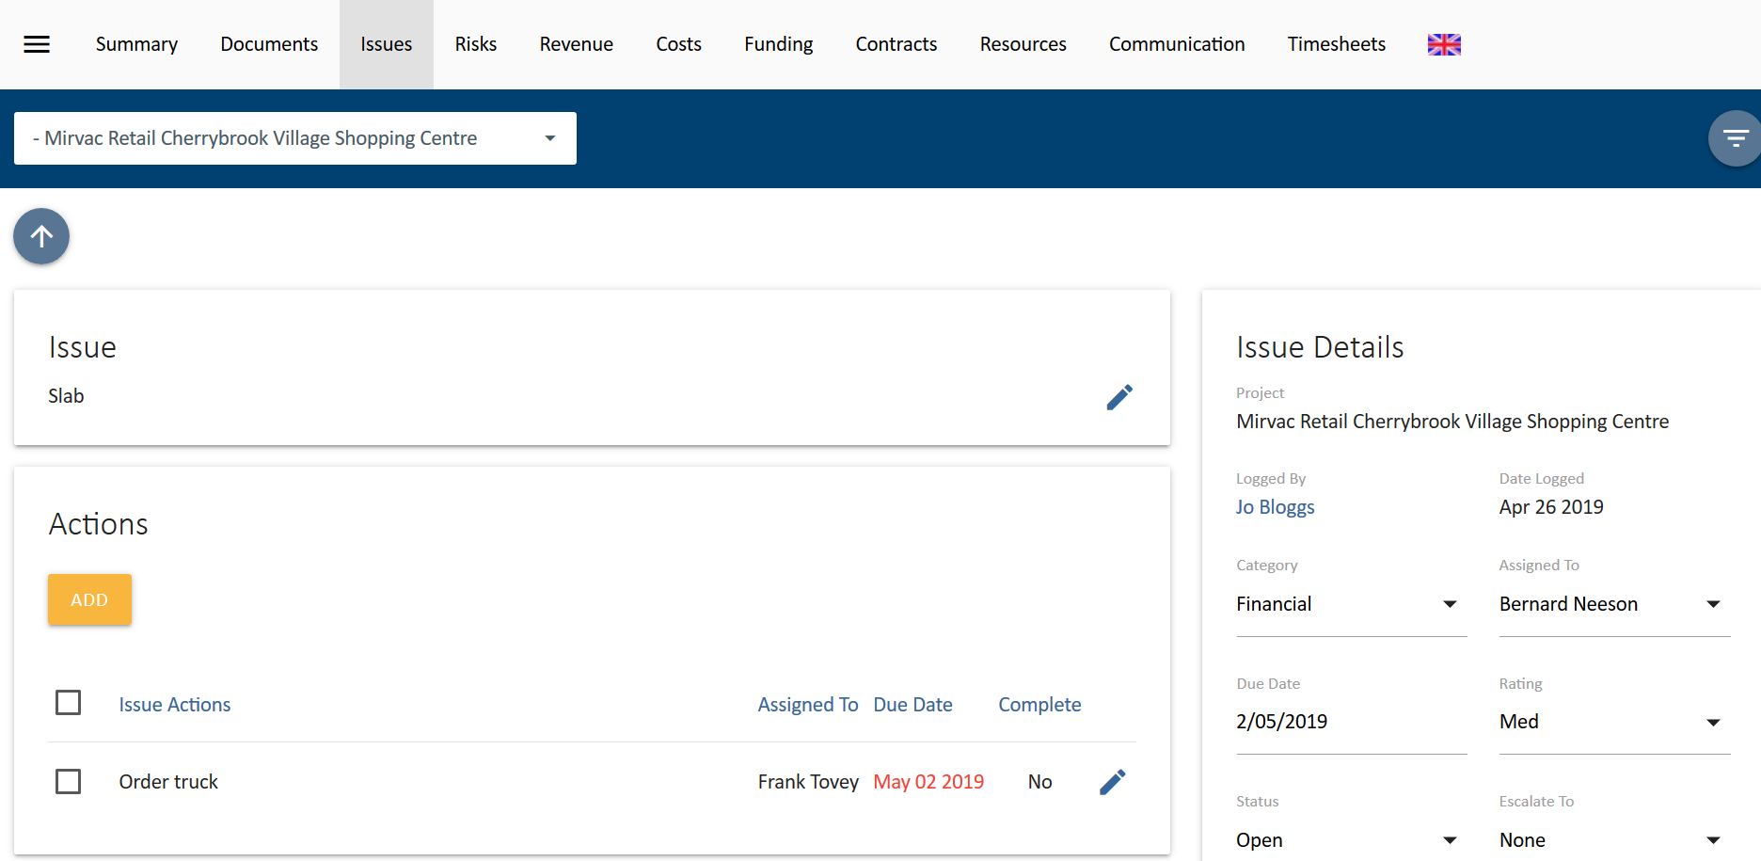
Figure 3 Select Add in the Actions card
- Enter in a description for your action(s), assign a person who will complete the action, and assign a due date (if relevant). These select .
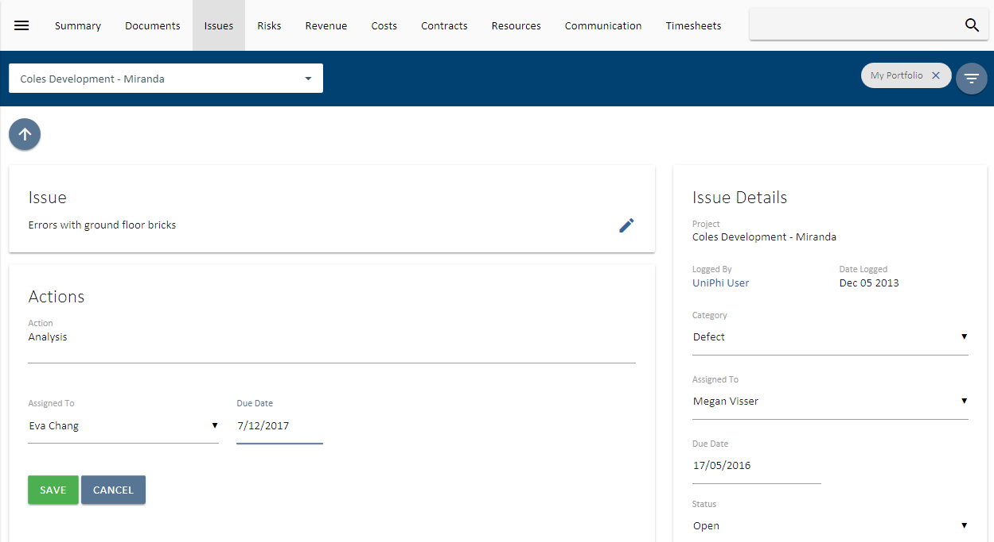
Figure 4 Adding an Action to an Issue
- Continue creating subsequent actions until all required actions have been established.

When adding a due date to an issue action where the actions due date is later than the overall due date of an issue, the overall due date will be extended so that it matches the latest action due date. This can be useful for team members who cannot change an overall due date, but can create an issue action which effectively changes the overall due date.

Attachments and Comments within an Issue

As UniPhi uses Issues as the central location for collaborating on the progress of project activities, it is important to understand how to add comments, and any attach related files.

- Go into an issue, and press the button with the comments panel.
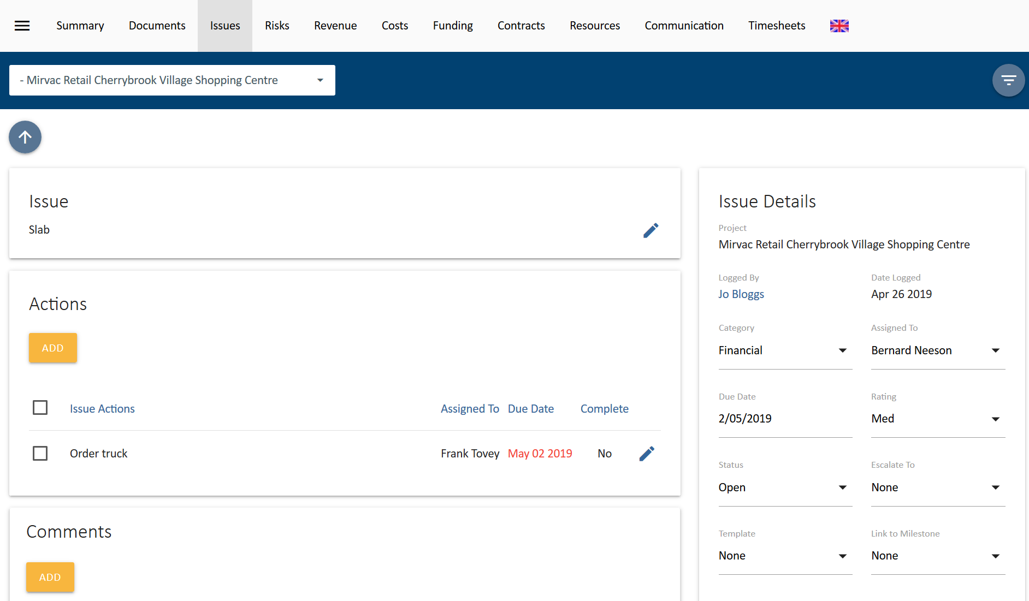
Figure 5 Adding a Comment to an Issue
- Enter comments that relate to your issue.

It can be useful to include a hyperlink to a website within your comments. This is done by highlighting your comments, pressing the right click button, and selecting the link option. Then simply paste your URL and press save.
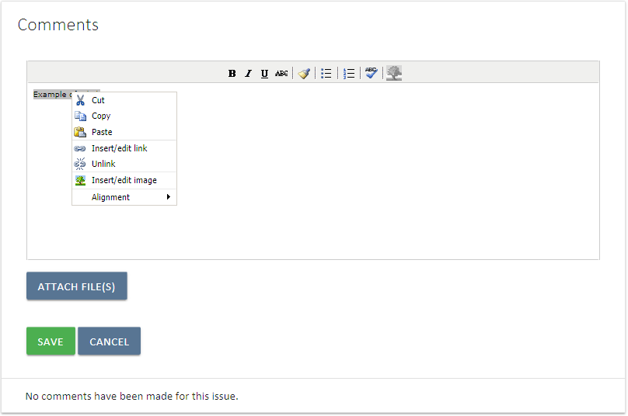
Figure 6 create a link within the Comments card of an Issue
Figure 7 Links appear with blue text

- When attaching one (or more) files, press the button in the Comments card, then the 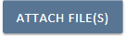 button and select your files.
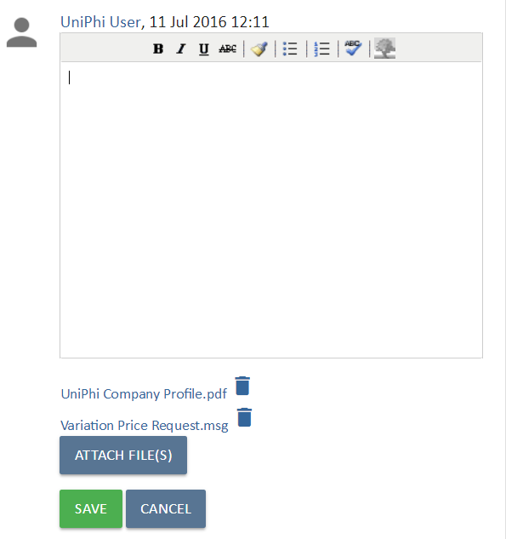
Figure 8 Attach relevant files
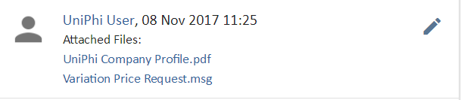
Figure 9 Saved attachments as they appear within comments

Once a comment has been saved into an issue it cannot be deleted. You may edit your own issue comment to remove a comment that you made, though it will be evident that you have deleted a comment. It is not possible to alter or amend the comments made by any other user.

Issues can have linked UniPhi documents associated with them, files can also be attached within issue comments. UniPhi stores these items in convenient panels within each issue. In the screen shot below you will see linked document in the Related Documents panel, and related files in the File Attachments panel. The file attachments panel is very useful for identifying file attachments chronologically, particularly when there is a long commentary.

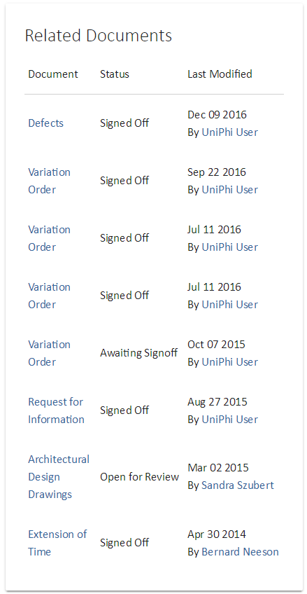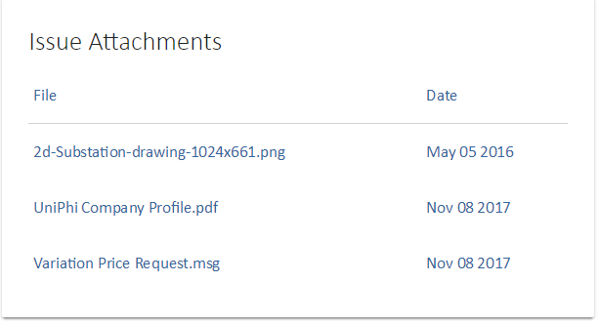
Figure 10 Instantly find related files and documents

Viewing Issues
Project correspondence will come from a variety of sources; meetings, phone conversations, emails, normal hardcopy mail, and issue comments made by the project team. All of these conversations, when requiring more than a token effort to deal with, should be logged in UniPhi so they can be tracked, delegated, prioritised and resolved effectively.
The My Portfolio view is displayed below and you will see that the “assigned to” list has a variety of people who have been allocated responsibility for resolving an issue.
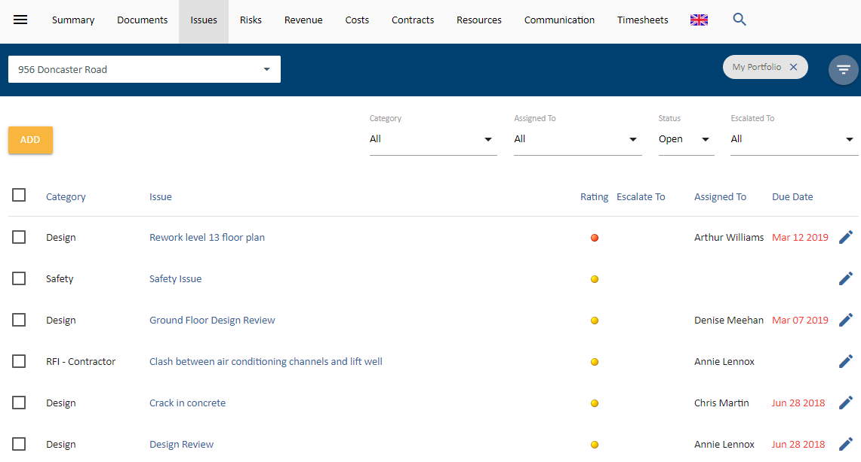
Figure 11 My Portfolio/Issues Displays all issues across each of the projects that you are involved in
UniPhi sorts all issues according to their priority (High, Medium, and Low). Within each priority level, the most recently added issue is placed at the bottom of the priority list. E.G, a new Medium rated issue will appear at the bottom of the list of medium issues, and directly above the first Low rated issue

Email Summary Notifications
Each stakeholder associated with an issue will remain updated on the status of the issue. Stakeholders are classified as anyone who is interested or involved in the issue. Typically this occurs by people being assigned ownership of an issue, or being assigned an issue action, or having made a comment on an issue. UniPhi can be configured to provide regularly scheduled email updates to all stakeholders when changes are made to an issue. Issue changes that trigger an email update can include; addition of comments, actions, re-assignments and/or changes to due dates.

Issues can be updated in bulk from the Issue module. The checkbox next to each issue needs to be selected before the changes can be applied. When the checkbox is selected, additional options appear. The changes that can be made in bulk are, changing an issue due date, rating, or assignment. It’s also possible to move an issue (or multiple issues) into a different project.
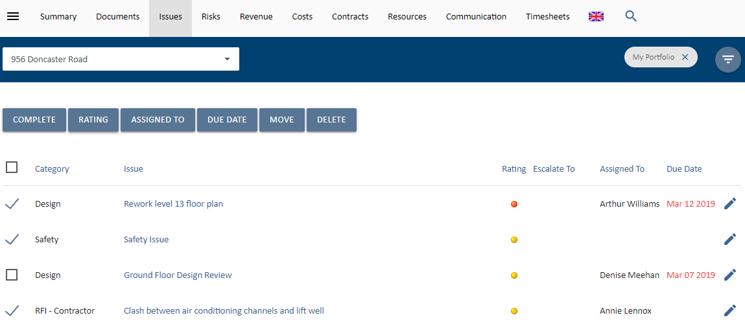
Figure 12 Select Issues to update them in bulk

Saving emails into UniPhi
Project specific communications from external parties often come via email. As these emails are directly related to a project, it is useful to save them into the Issues comments section within UniPhi via the UniPhi for Outlook Add-in that can linked to your Outlook account. Saving emails into UniPhi issues aids with collaboration and provides additional transparency to each issue. The entire project team can see all saved emails, and their file attachments. The UniPhi for Outlook Add-in can be used to either create a new issue, append an existing issue, or create new or append an existing document.
(The plug-in download is available here: http://uniphi.com.au/community)

Save an email into UniPhi Issues

- Once relevant email communication has been received via MS Outlook, select the email and click on the “Save to UniPhi” button, which is located in the Outlook menu ribbon.
Figure 13 UniPhi for Outlook Add-in button
- This will launch the Add-in form and ask you to login:
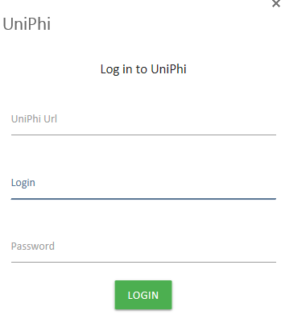
Figure 14 UniPhi for Outlook Add-in Login
- Then select to save the email as either a new issue or append it to an existing issue
Figure 15 UniPhi for Outlook Add-in options
- If you select New Issue, the Create New Issue form will appear. The email title will auto-populate as the Issue Description. Select the project from the drop-down menu. Select any of the other relevant fields.
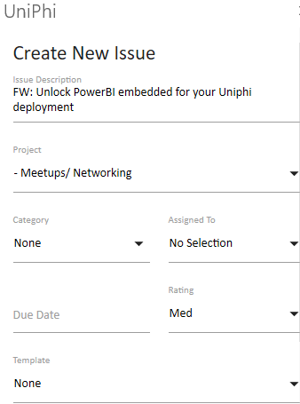
Figure 16 UniPhi for Outlook Add-in Create New Issue form
- If the email has attachments, these will be listed at the bottom of the form as an option to save into the issue. Check the box next to the attachments you want to save.
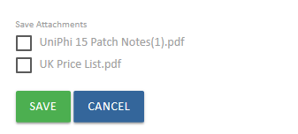
Figure 17 UniPhi for Outlook Add-in Create New Issue form - attachments
- If you select Append to Issue the Append to Issue form will appear. Select the project and the issue you want to save the email to. The Save Attachments option will also appear f relevant.
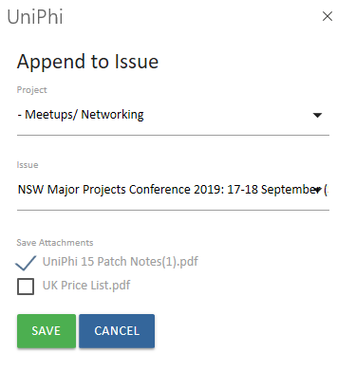
Figure 18 UniPhi for Outlook Add-in Append to Issue form

- Select Save to complete the process. The email will now be linked to UniPhi and the UniPhi for Outlook Add-in will show the link. If you select the issue, UniPhi will open the issue in your browser.
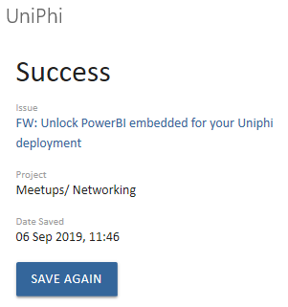
Figure 19 UniPhi for Outlook Add-in shows the link to the saved email

Once the email has been saved, you (and your project team) can also locate it via the Issues tab. Here you will be able to view the original email and any attachments, add comments / instructions to aid communication and workflows surrounding the issue, and add actions required to close out the issue.
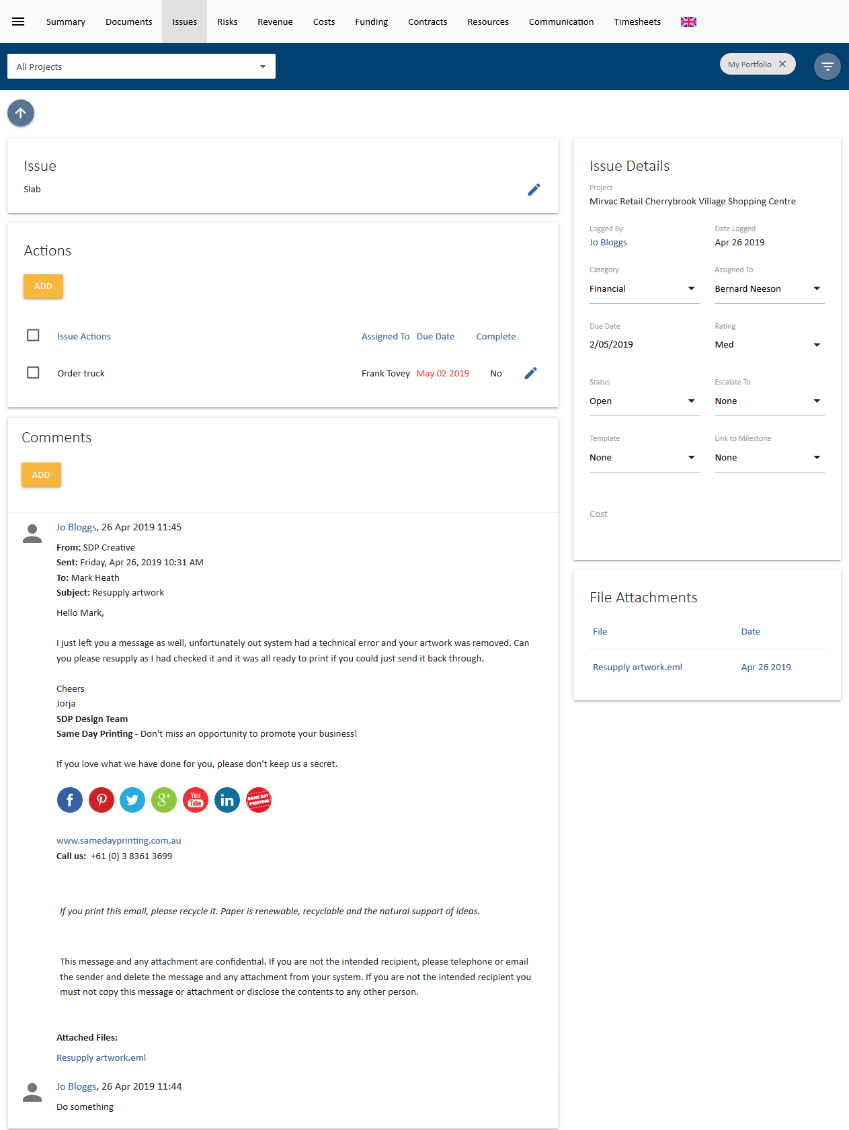
Figure 20 UniPhi Issues module showing an email saved using the UniPhi for Outlook Add-in

Link an issue to a document

The UniPhi Documents module can create a document that is linked to an issue so that all communications can be seen in the one screen. Note the attached file in the comments thread and the response document (in this example a Site Inspection Report) in the Related Documents box.
To link a document to an issue:
- After having received and / or created an issue in UniPhi that requires a linked document (e.g. a response document), go to the Documents module (ensuring you are drilled in to the relevant project).
- Click to start the Create Document wizard (this will open in a new tab or window):
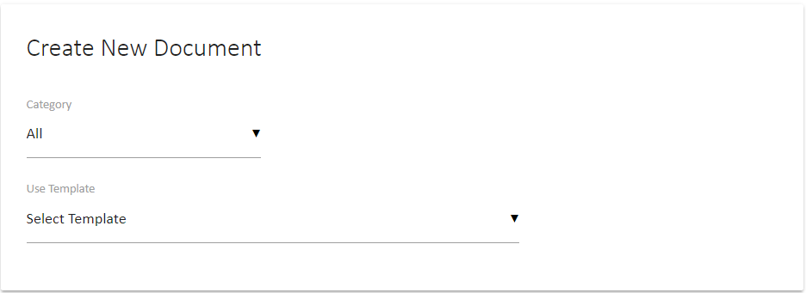
Figure 21 UniPhi Create New Document wizard
- Select a Template that has been designed to capture a specific issue (e.g. Project Managers Instructions) and Name the document. Click Create to create the document.

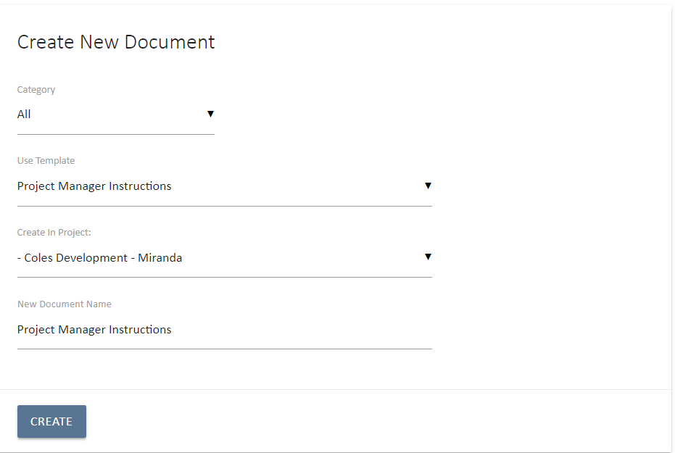
Figure 22 UniPhi Create New Document wizard – Project Manager Instruction template selected
Select the Issue that your document relates to at the related issues step
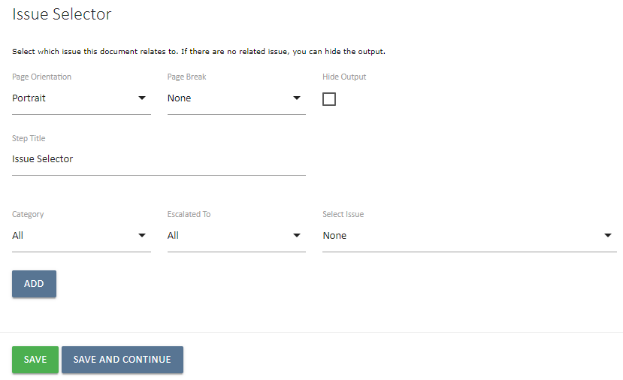
Figure 23 Issue Selector Document step
- When you have finished creating your document, you will find that you have a circular reference between the document and the issue that it is linked to.
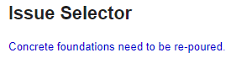
Figure 24 Excerpt from a document with a linked issue
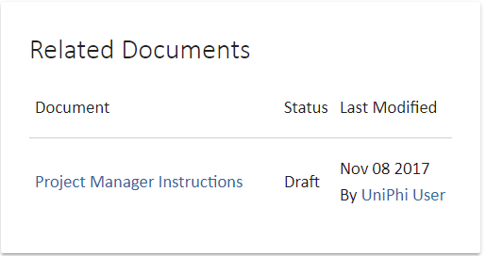
Figure 25 Link back to document
Save an email into UniPhi Documents

- An email can also be saved into a document using the UniPhi for Outlook Add-in. Select the email and click on the “Save to UniPhi” button, which is located in the Outlook menu ribbon.
Figure 26 UniPhi for Outlook Add-in button
- If you have not already logged in to UniPhi in Outlook, this will launch the Add-in form and ask you to login:
Figure 27 UniPhi for Outlook Add-in Login
- Then select to save the email as either a new document or append it to an existing document
Figure 28 UniPhi for Outlook Add-in options
- If you select New Document the Create New Document form will appear. The email title will be auto-populated as the Document Name. Select the Project and then use the Category and Template selector to select the UniPhi Document Template you wish to save the email into. Attachments can also be selected. Set the status you want for the document and select Save .
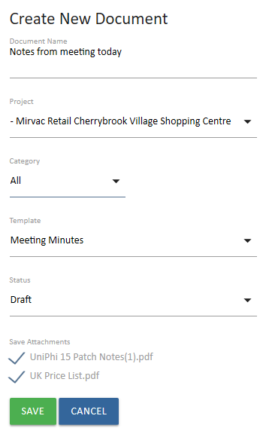
Figure 29 UniPhi for Outlook Add-in Create New Document form
- If you select Append to Document, the Append to Document form will appear. Select the project, category (optional) and template to be given a list of documents to choose to save the email to . Attachments can also be selected. Set the status you want for the document and select Save .

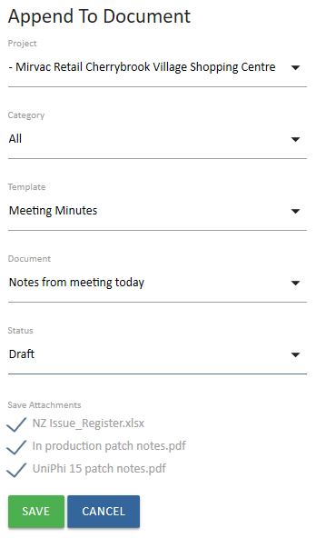
Figure 30 UniPhi for Outlook Add-in Append to Document form

- When you save, UniPhi for Outlook will show you the details of the document sand provide a link to it.
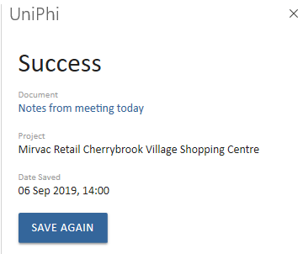
Figure 31 UniPhi for Outlook Add-in shows the link to the saved document
- Select the link and the document will open in UniPhi. You will see that the contents of your email now appears within the document you have either created or amended.

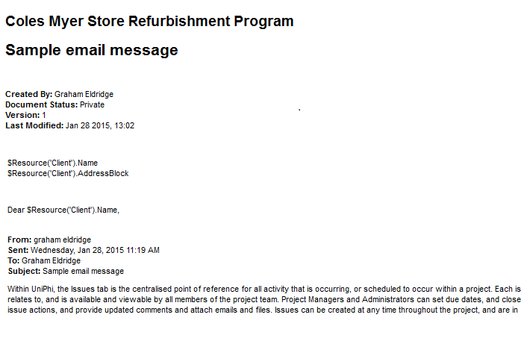
Figure 32 Document created with the UniPhi for Outlook Add-in
- You may wish to continue working on the document that you have saved your email into. In this case you will need to press the edit button to take you into the document edit mode.
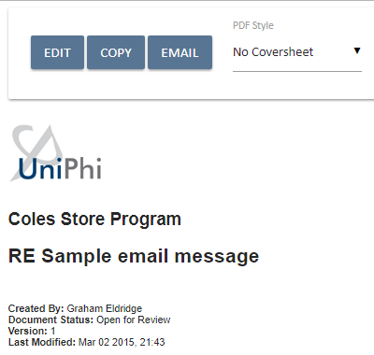
Figure 33 Selecting the Edit button in a document
- Once you are in edit mode, each of the template steps will appear, thus allowing you to create and update the necessary contents.
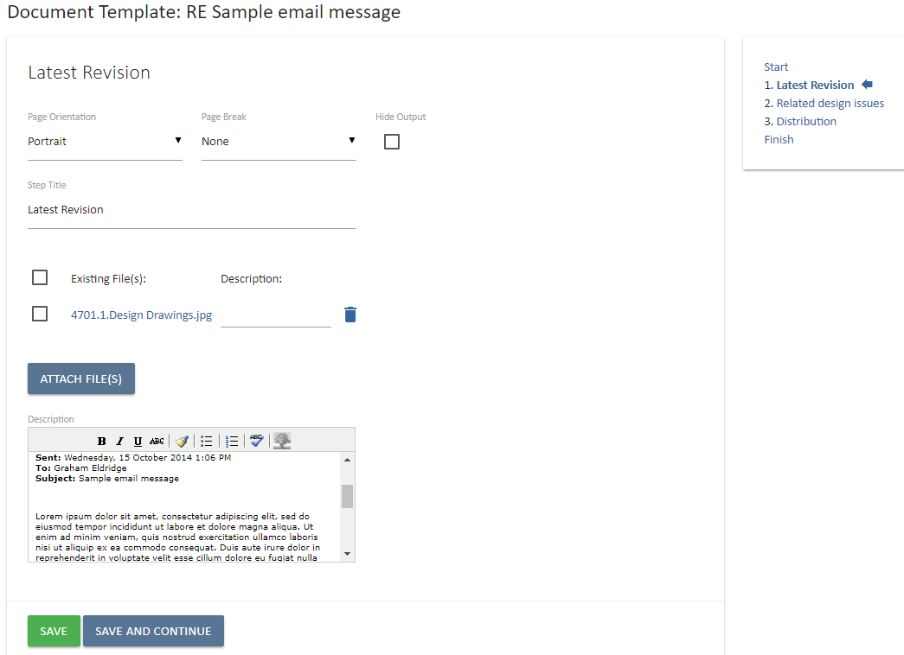
Figure 34 Editing a Document created with the UniPhi for Outlook Add-in

Issue Escalation
Issues can be rated according to a High, Medium, or Low priority. Issues can also be assigned to specific category. By setting priority levels and by applying issue categories, it is quite easy to focus on a particular set of issues.
In addition, UniPhi also allows you to escalate issues. Issue escalation is useful where a large number of issues have been logged, and you want/need those issues to be viewed by a particular person, or group of people.
Issue categories and escalation levels are configured by your UniPhi System Administrator.

