UniPhi 15

Resource Planning
Training Manual

Contents
Resource Planning in UniPhi 4
Resource Planning in One Page 5
Navigation 5
Resources, Rates and Standard Hours 8
Modifying Project Schedule Dates 11
Lifecycle Phases and Project Schedule 14
Resource Planning Reports 19

Course Aim
The aim of this manual is to provide instructions on creating new projects and managing projects from a Resource Planning perspective. The focus of this manual is on Resource management aspects of UniPhi.

How to use this User Training Manual
As you read this manual you will notice the following icons recurring which will help to highlight and enable you to quickly locate activities and summary areas, they will also assist with tips for keeping out of trouble.
Puzzle Piece:
The puzzle piece appears at the beginning of each session and any major section to mark the overview of that item’s content or concept.
Cogs:
The cogs denotes a step by step activity to be completed using UniPhi by the participant relative to the section it is located in.
Light bulb:
The light bulb denotes a helpful hint or tip you should be aware of.

Screen shots have been used throughout the manual to demonstrate what you should be viewing as you move through the activities. They are for illustrative purposes only. Details such as dates, budget figures and other entered text/data may vary.

Resource Planning in UniPhi
Resource planning in UniPhi is a macro level tool that facilitates broad utilisation data and forward workload forecasting based on current and future scheduled activities.

The ability to present the forecast data relies on relevant data being populated in UniPhi for an individual project and the aggregation of all the populated projects to provide support for Resource Planning for the organisation.

Timesheet activity records the actual hours and is regarded as a micro-management aspect of Resource Planning. There are numerous impacts of recording hours on projects with the timesheet system including tracking project costs in terms of value and effort, supporting project profitability calculations, facilitating accurate client charges where invoicing is based on actual effort expended, and supporting forecasting of remaining effort to complete a project. All of which can be aggregated to support portfolio calculations of actual and forecast values.

This document references all the specific aspects of Projects, Schedules, Resources, Contracts, and Reports that impact or relate to the Resource Planning aspects of UniPhi.

It is assumed that the UniPhi system has been established with default configurations and that the other UniPhi manuals can be referenced for topics outside the scope of this manual.

Resource Planning in One Page
In order to ensure you get the most valuable and reliable information out of UniPhi, it is important to ensure that the following key pieces of information are adhered to.

- Ensure that all Internal Resources (staff or team members) have their Profile information of Charge Rate, Cost Rate, and Standard Hours entered.
- Ensure that the Project Schedule dates for all active lifecycle phases are entered. Confirm this by checking the Summary > Schedule.
- Populate the Resources > Resource Planning > Budget view with the project budget in hours.
- Populate the Resources > Resource Planning > Act/Fsct (Actuals and Forecast) view with the remaining hours for completion. (When first setting up a project the remaining hours should = 100% of the project budget in hours unless the project is in a pre-award phase in which case the percentage hours will be risk adjusted according to the forecast Win % and Fee %.)

If preparing Revenue contracts for a Practice Management process, ensure that Contract Deliverables for Time & Materials are assigned where appropriate with the team member selected, contract charges and hours, and schedule dates for delivery. Use the Import from Contract option in the Resource Planning Budget view to automatically populate the budget values from the contract. This process is explained in the UniPhi 15 Practice Management Manual.

Navigation
The key elements of Resource Planning in UniPhi are summarised in this section. Further sections in this manual provide the details of each area that has an impact on Resource Planning.
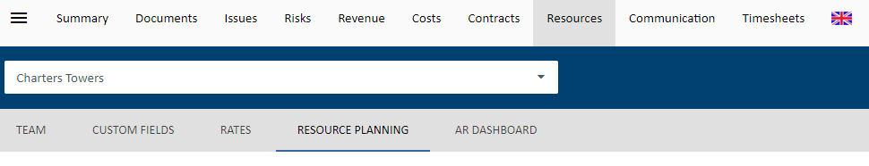
Selecting a specific Project in UniPhi from the My Portfolio or Portfolio > Resource module > Resource Plan will take the user to where the resource planning is done.

Resources
The Resources tab provides top level access to the Resource Pool if the default filter of “All Projects” is selected. 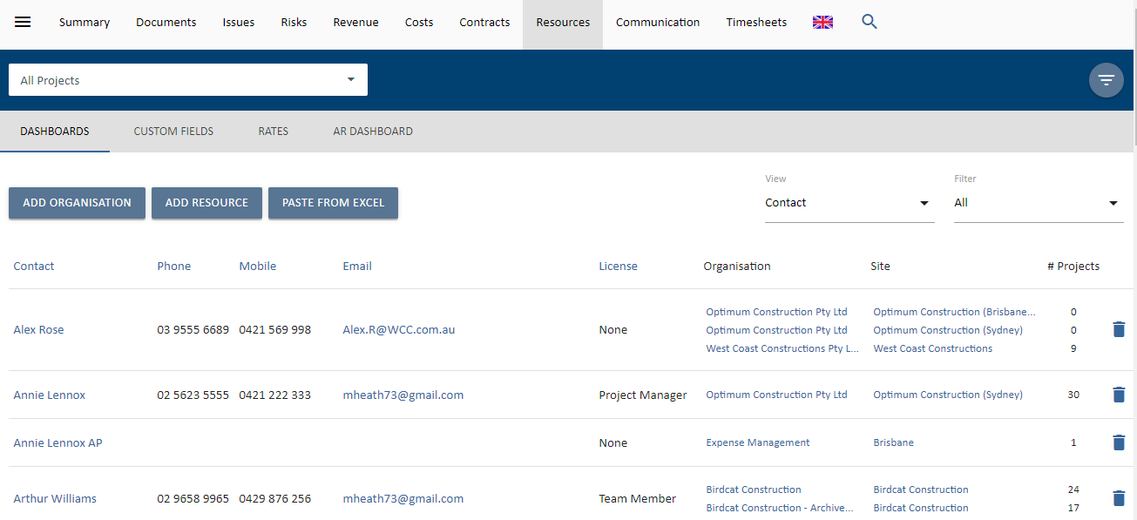
The Resource Pool provides a full listing of all Internal and External potential team members.
Internal refers to the team members considered as staff in the business entity while External is anyone else that could be associated with a project, i.e. Clients, Suppliers, Advisors, etc.
Consider a RACI model and anyone that can be named in the RACI documentation should be detailed in the Resource Pool.
Filtering for a specific project will present the nominated Project Team for the selected project.
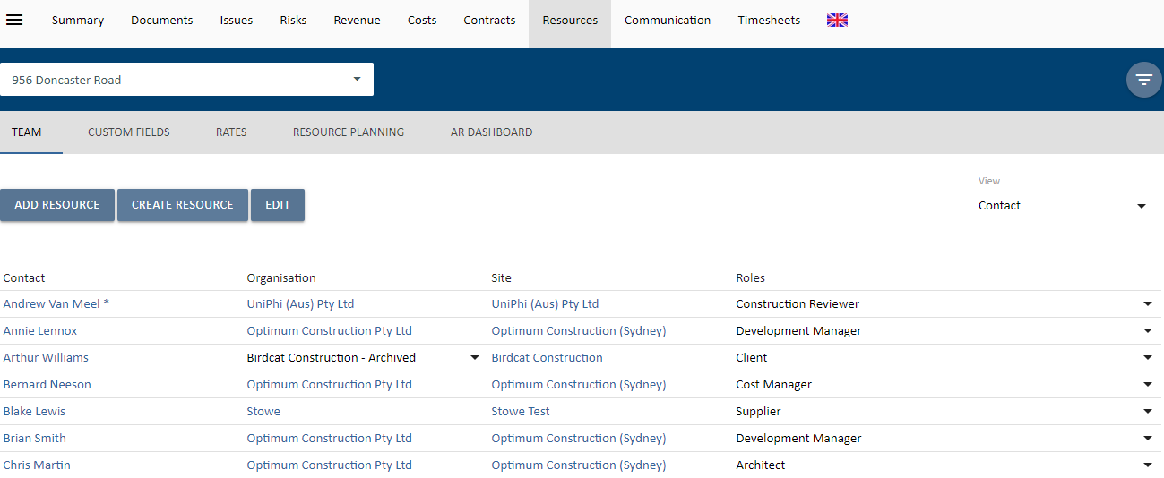
Resources can be edited (i.e. you can add or remove resources) at any time throughout the lifecycle of the project.

Resources, Rates and Standard Hours
One area that should already be configured as a part of establishing a UniPhi installation is to ensure that Charge and Cost Rates and Standard Working Hours are recorded for internal team members.

It is important that all of the following information is entered so that UniPhi able to make the necessary calculations for Resource Planning. From the Resource Pool or Resource Project Team screens select the relevant resource.

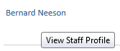

The Employment details card includes fields for the Default Charge Rate, Default Cost Rate, and Standard Hours worked (per day).

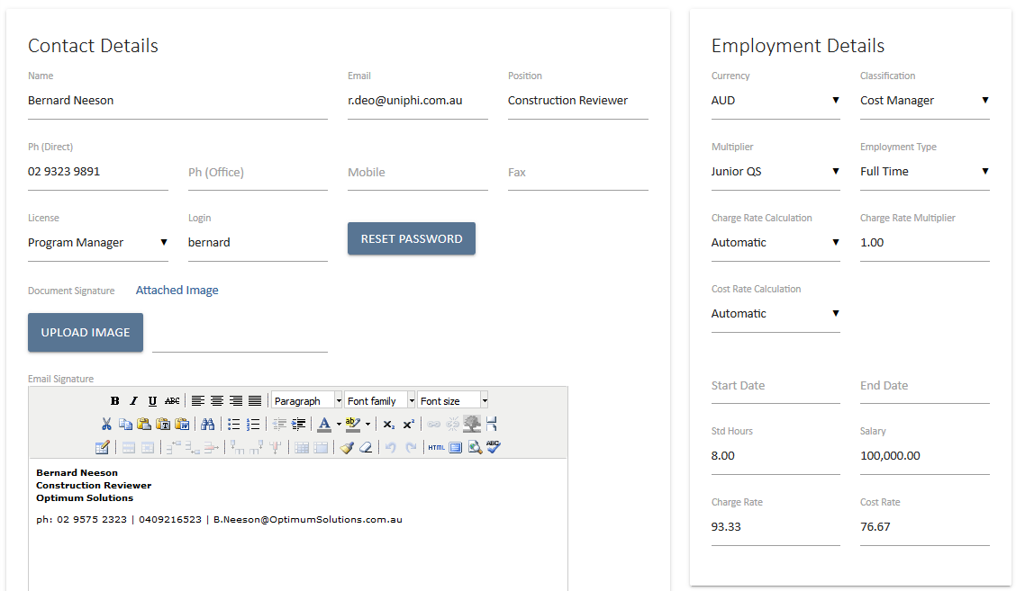
For Resource Planning and Project Costing / Profit Reporting it is important that the Standard Hours, Charge Rate and Cost Rate fields are completed.

Unless there are specific circumstances, i.e. a permanent part time role, generally an 8 hour day is assumed. The standard hours are used to calculate Equivalent Full Time (EFT) staff loading for the business in Resource Planning and standard cost calculations.

The Charge out rate is the specified rate at which each individual team members hours will be charged out, e.g. to a client. The Cost rate is an internal rate that should include all on-costs to employee that person. Both of these specified rates are used for calculation of Standard Charge and Cost values and are utilised in Reporting and Resource Planning to assist in calculating various profit or variance reports.

The Cost Rate should include all costs to employ and support the staff member. It is a calculation that the business can use to form a baseline costing for ‘keeping the doors open’

Rate History is maintained for both Charge and Cost rates and historical reporting will reference the appropriate periodic changes.

Typically, standard hours should be based around a 40 hour week. Variations to this make reported values complex and when assessed over a 6 month period in a macro view of hours have minimal impact on overall business / project resource planning.
Project Schedule
The Project Lifecycle Schedule provides for the start and end dates for both baseline and actual / forecast project schedule. Select the Schedule panel from the Project Summary page.

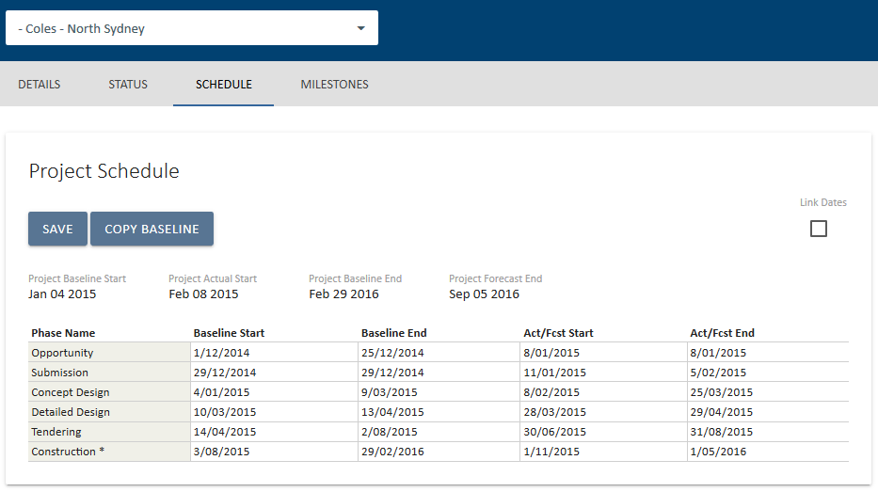
The Project Schedule screen displays the overall Project Baseline dates and the Lifecycle Phase schedules.
For a new project with no schedule dates the Baseline fields are editable.
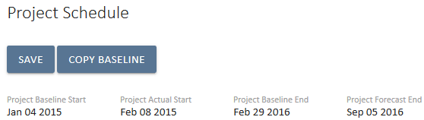
While the project has no detailed schedule dates, the overall project start and end dates are available for data entry / editing. When the detailed lifecycle phases are mapped the overall project schedule is drawn from the lifecycle phase details. Project start is the start date of the earliest Post-Award Lifecycle phase. Project end date is the end date of the last Post-Award lifecycle phase. The Post-Award phases are determined in the Methodology Project Lifecycle administration section.

Scheduling Dates
The dates in the create project screen are Baseline dates. As each phase represents a stage and requires a trigger to move one, dates cannot overlap. This is to support stage gate decision making.

The Pre-Award and Post-Award lifecycle phases are presented for data entry. The current Lifecycle Phase of the project is highlighted with the * character to the right of the phase name.

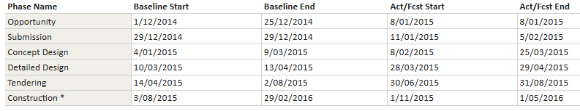
In this example the lifecycle dates have been populated. The current lifecycle phase of the project is noted by the asterisk as the Inspection phase. The lifecycle phases will vary depending on the UniPhi configuration.
Clicking the date cell displays a calendar to allow for date selection. You can also type in the date in dd/mm/yyyy format.

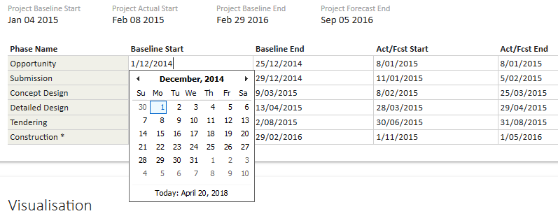
Once the calendar is open a date must be selected. To cancel, select any date which closes the calendar, and then delete or modify the date in the field.

Modifying Project Schedule Dates
The Project Schedule provides for managing the schedule throughout the life of the project. The schedule entered during project creation process will more than likely require some adjustment during the course of project delivery.
When modifying schedule dates the system requires that dates cascade with the end of each phase preceding the start of the subsequent phase.
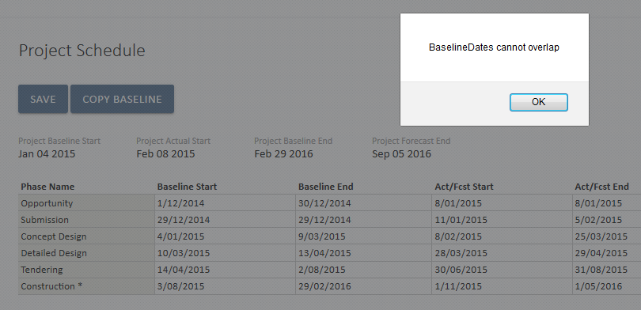
In the above screen the Submission phase baseline date has been changed to be later than the Concept phase start date, this is not accepted and will generate the error message.
Similarly changes to the Actual / Forecast dates will trigger an error message
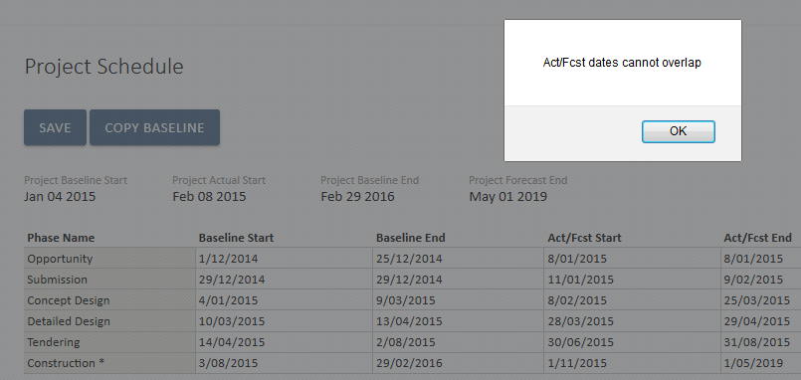
Schedule dates are also controlled from the perspective of Actual vs Forecast date lines.
An Actual date is any start or end date that is associated with a closed lifecycle phase. In the following example the current phase is ‘Develop’ and so the start and end of the Submission and Concept phases are considered to be actual, while the dates for the phases Develop and later are considered as Forecast dates.

Actual dates cannot be future dates and conversely Forecast Dates cannot be in the past.
However, if dates must be modified for past phases, then adjusting the project lifecycle phase from the project summary screen to an earlier or later phase will allow for modifying the dates to be consistent.
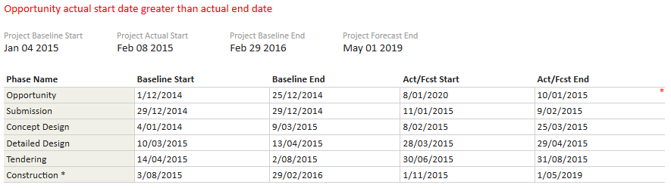
Where specific dates are inconsistent with the schedule rules the error message appears in red above the schedule and the offending date row is marked with a red asterisk.
Entering the Baseline dates first and using the Copy Baseline option will copy all the baseline dates to the Act/Fcst fields. This highlights that the first Baseline schedule should be reflected in the forecast at the earliest stage of the project. As the project commences and revisions to forecast are made comparisons between the Baseline dates and the Forecast can be made.
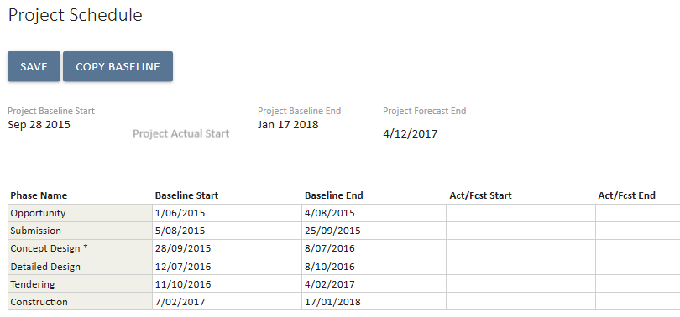
This screenshot demonstrates the Project dates at the top of the screen being populated from the lifecycle phase dates. In this case only the baseline dates have been detailed, so the overall Project Actual and Forecast dates are editable at the top level. Selecting the Copy Baseline option will duplicate the baseline dates into the Act / Fcst fields
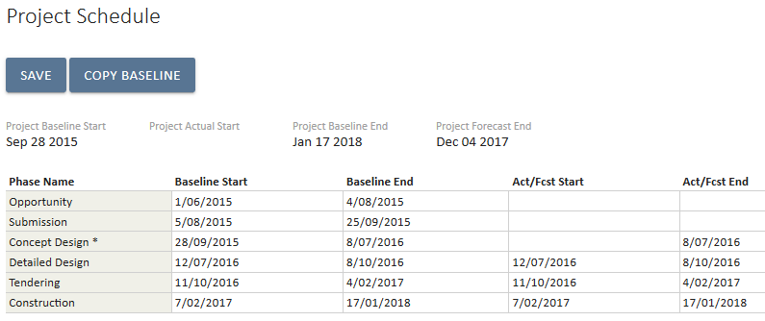
Note that not all lifecycle phases need to be dated if the project does not have that phase.

Lifecycle Phases and Project Schedule
The Actual date of the end of a Lifecycle Phase and the Actual Start date of the next Lifecycle phase will be updated by the system when the Status of the project Lifecycle is changed.
i.e. Moving a project from Concept to Develop on the 15/07/2017 will update the Actual End Date of the Concept phase as the 15/07/2017 and the Actual Start Date of the Develop phase as 16/07/2017.
- Phase dates cannot be out of sequence and cannot overlap. They may have gaps between them. The start date of any phase must be at least one day later than the end of the previous phase.
- The Project Baseline Start is for the first Post-Award Lifecycle phase and will not include Pre-Award phases. The Project Baseline End Date is for the last scheduled Post-Award Phase end date.

Resource Planning
UniPhi leverages the dates entered in the lifecycle schedule to phase out resource effort and provide for managing the resource budget of a project. The Resource Planning page is accessed from the Resources module for a selected project. Select the Resource Planning tab.

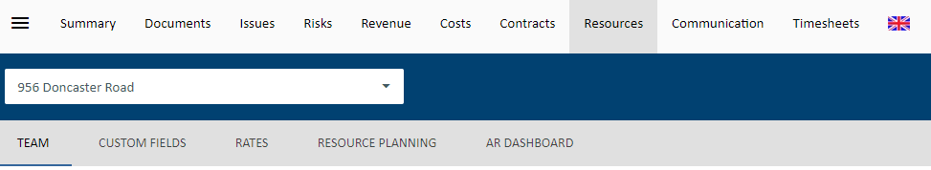

The Resource Planning page for a new project will presented in the following structure.
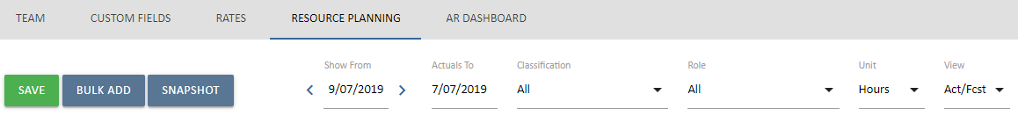
On the left, there is present a Save, Bulk Add and Snapshot button. On the right, there are filters that can be applied to the resource plan. These filters are based on the tags associated with the users added to the resource plan.
Once a project has a project team (resources allocated to the project), the Bulk Add button can be used to populate this screen.
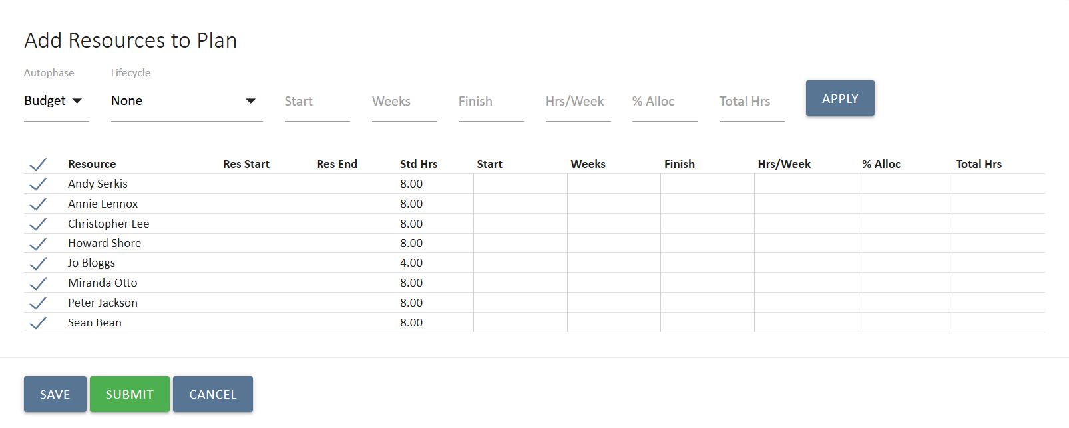
When adding the users, the resource plan parameters must be applied. This can be done in two ways, globally or individually.
To use the global settings, the parameters are to be entered in this section of the screen:
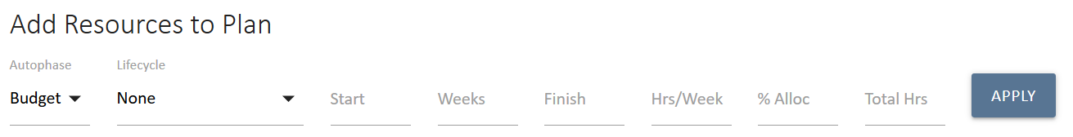
In this example, only by entering the Weeks, Hrs/Weeks & the Start Date will calculate the End Date and Total Hrs & copy this to all selected resources once you select Apply :
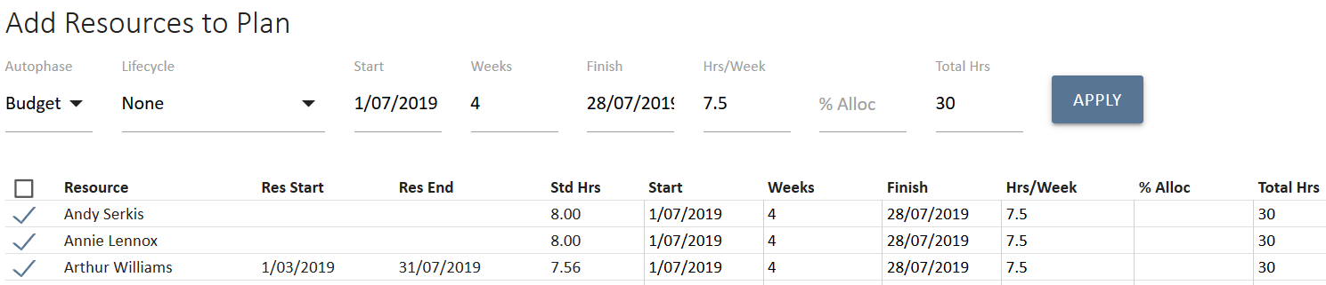
The % Allocation field is an alternative to Hrs/Week and will multiply the % with the Standard Hours of each resource multiplied by the weeks entered.
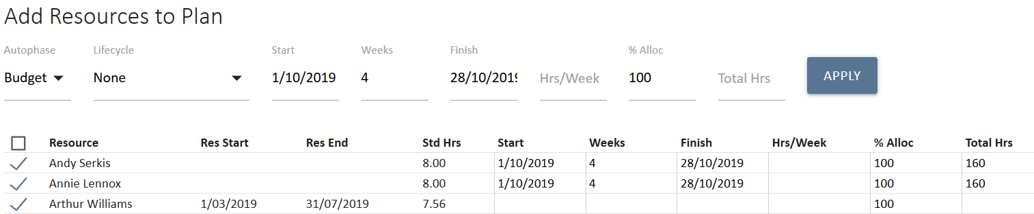
NB: For Arthur Williams, using the % Allocation method has not entered parameters as the Resource Start and Resource End dates as a resource (29/01/2018 – 31/07/2019) occurs after the dates entered for phasing (01/10/2019 – 28/10/2019). The Resource Start and Resource End dates will always overwrite any date should it be overlapped.

The lifecycle dropdown can be used if budgeting hours against a particular phase. By selecting a lifecycle phase, it will copy the start and end dates into each resource row. The lifecycle dropdown also has a Whole of Project selection which pulls the start and end dates of the project.
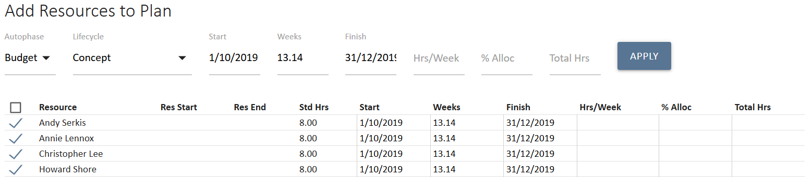
If desired, the individual resource data can then be altered to suit. This is the alternative method to populate the resource plan parameters.
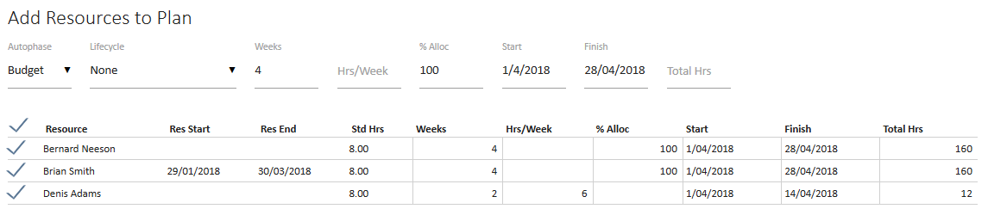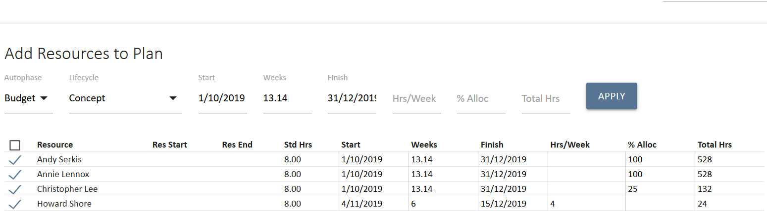
Once parameters are in, click Submit . You will now be presented with the results
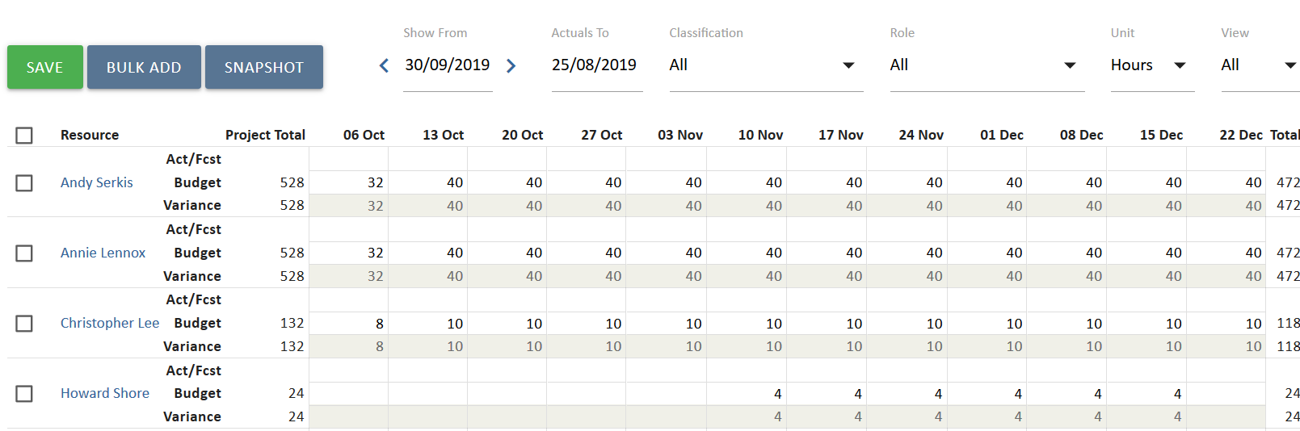
The data is saved against the Budget row.
In order to copy to forecast, select the user(s) and click Copy Budget. Alternatively, to copy forecast to budget, click Re-Baseline.
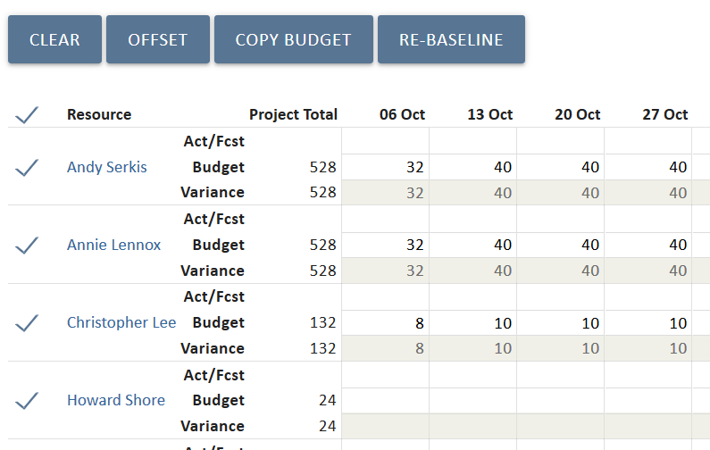

The snapshot functionality allows multiple plans to be captured. Clicking the Snapshot button will allow the user to provide a snapshot name and version number.
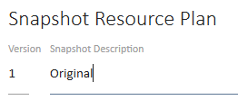

Once saved, the plan is able to be selected & viewed using the Version dropdown filter.
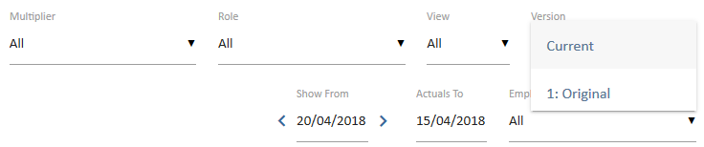

As user’s timesheet, the actuals row will populate with this data. As actuals start to populate, the variance row will be calculating automatically & provide a difference between it and budget.
NB: When a financial period is closed, this locks off the Act/Fcst row and displays the actuals. This data cannot be modified.

Resource Planning Reports

The following three reports are available in UniPhi via the Reports tab:

Full Time Equivalents by Role
Displays the full time equivalent per role allocated one projects. This information is displayed via a rolling 12 month period of resource hours converted to full time equivalents with 6 months of the past displayed and 6 months into the future. This is useful for trending purposes to validate current forecast skills required for the business.

Project Allocation by Resource
Displays resources and the projects they’re working on over a rolling 12 month period of resource hours with 6 months of the past displayed and 6 months into the future. Actual and Forecast hours are compared to phased budget month by month. Use the timesheet trend (i.e. actual hours) to validate your current forecast remaining. Use the over allocation/under allocation feature to spot constraints and spare capacity.

Resource Allocation by Project
Displays projects and the resources allocated to them over a rolling 12 month period of resource hours with 6 months of the past displayed and 6 months into the future. Actual and Forecast hours are compared to phased budget month by month. Use the timesheet trend (i.e. actual hours) to validate your current forecast remaining.

Responsible, Accountable, Consulted, and Informed. RACI Model reference: http://en.wikipedia.org/wiki/Responsibility_assignment_matrix

