UniPhi 15
Document Management
Manual

Table of Contents
Locating Documents 5
Navigating the Documents Module 9
Advanced Search 12
Working with Existing Documents 16
Creating Documents 18
Create a New Document 20
Viewing a Document 29
Stylesheets 32
Copy a Document 33
Copy an Entire Document 34
Partial Copy 34
Document Editing, and Version Control 36
Reverting Changes 41
Document Transmittal 42
Emailing a Document 43
Send as an Attachment 46
Send as Embedded Text 46
Document Sent Records 48
Share Documents with Drobox 50
Save Documents to Dropbox 52
Document Controls / Input Objects 54
Rich Text Editor 56
Create a Certified Progress Claim 60
Documents and Issues Management 67
Recording communications as project issues 68
Linking Response Documents 78
Linked Contract Documentation 83

Manual Overview
The aim of this manual is to provide instructions for using the Documents module in UniPhi. This manual covers the majority of document functions such as finding documents, creating and modifying documents, and distributing documents both internally (e.g. colleagues), and externally (clients/suppliers). You will also learn how to save content from your email directly into a UniPhi document, and how to link a UniPhi document with a UniPhi issue.
All of the documents that you work with in UniPhi are created from templates as defined by your System Administrator, or are the standard templates that come “out of the box”. Concepts such as template design, your organisation style guides, and custom drop down lists are configurable by your System Administrator. The focus of this manual is therefore on guidance through the document management aspects of UniPhi from an end user perspective.

How to use this Manual
As you read this manual you will notice the following icons recurring which will help to highlight and enable you to quickly locate activities and summary areas, they will also assist with tips for keeping out of trouble.

Puzzle Piece:
The puzzle piece appears at the beginning of each session and any major section to mark the overview of that item’s content or concept.
Cogs:
The cogs denotes a step by step activity to be completed using UniPhi by the participant relative to the section it is located in.
Light bulb:
The light bulb denotes a helpful hint or tip you should be aware of.

Screenshots have been used throughout the manual to demonstrate what you should be viewing as you move through the activities. They are for illustrative purposes only. Details such as dates, budget figures and other entered text/data may vary.

Locating Documents

UniPhi is comprised of modules, such as Documents, Issues and Risks that are viewed using filters. The modules are shown across the top of the browser window and can also be access from the “hamburger” menu . The filters are accessed by selecting the filter modal on the right of the browser window. This opens the Portfolio Filters card. Filters are used to select a wide range of options such as Sector, Project Type and Location. The View filter is the most important in relation to documents in UniPhi as it changes the context of what is viewable in the Documents module.
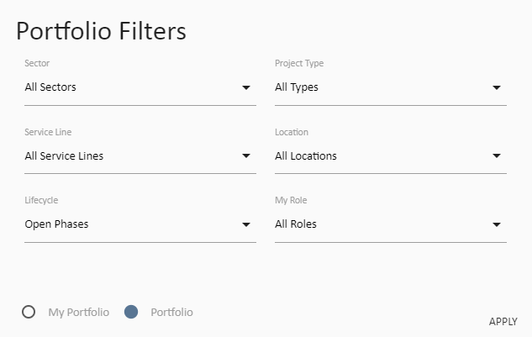
Figure 1 Portfolio Filters
- With the My Portfolio option selected, the Documents module will display documents associated with each of the projects that you are working on.
- With the Portfolio option selected, the Documents module will display the full list of all documents across your entire organisation. Portfolio view is only available to Program Manager and Administrator licenced users.

Once you have selected the appropriate view you can quickly and easily locate a specific document, or a group of documents according to your requirements. This ability to quickly search your entire project or portfolio for specific documents is one of the key features of UniPhi, and one of the major benefits when compared to using traditional network folder storage technologies.
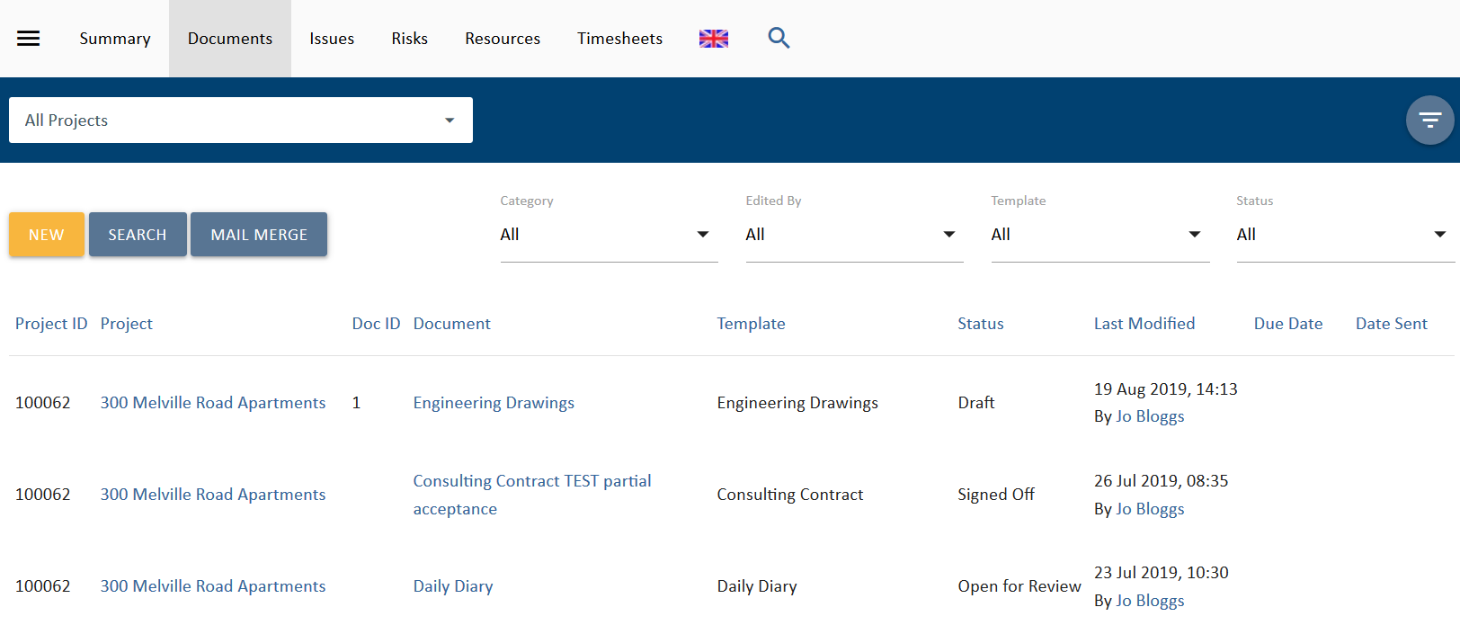
Figure 2 Team Member licenced user view of UniPhi showing Documents
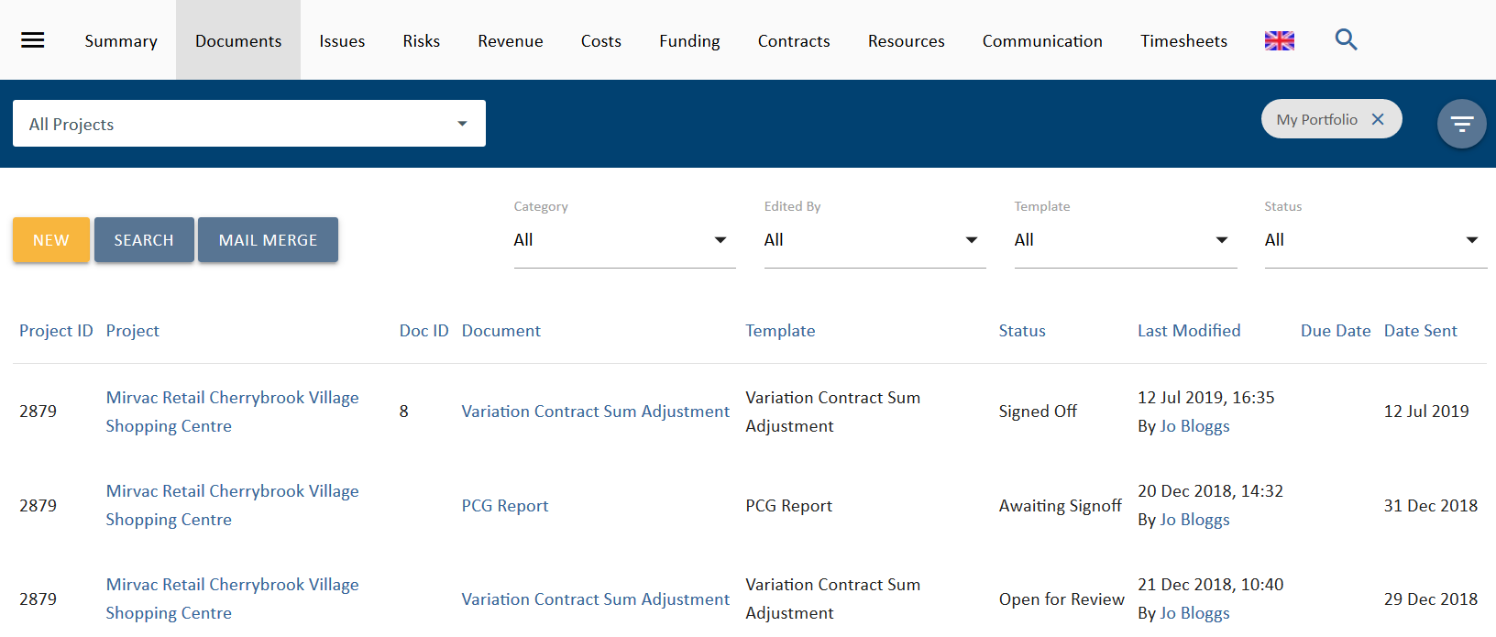
Figure 3 Program and Project Manager licenced user view of UniPhi showing My Portfolio Documents

With the correct context in mind, you can view the documents according to the filters that are relevant for your search. For example, you may choose to view all documents within a specific project; in which case you would select the project from the project search filter:
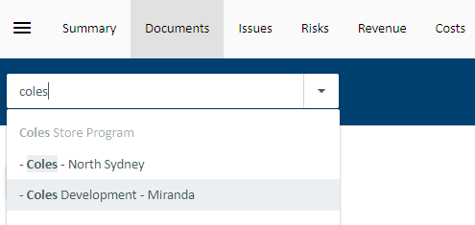
Figure 4 Using the Project Search filter

Once you have selected your project, you can then filter for a document by category or template:
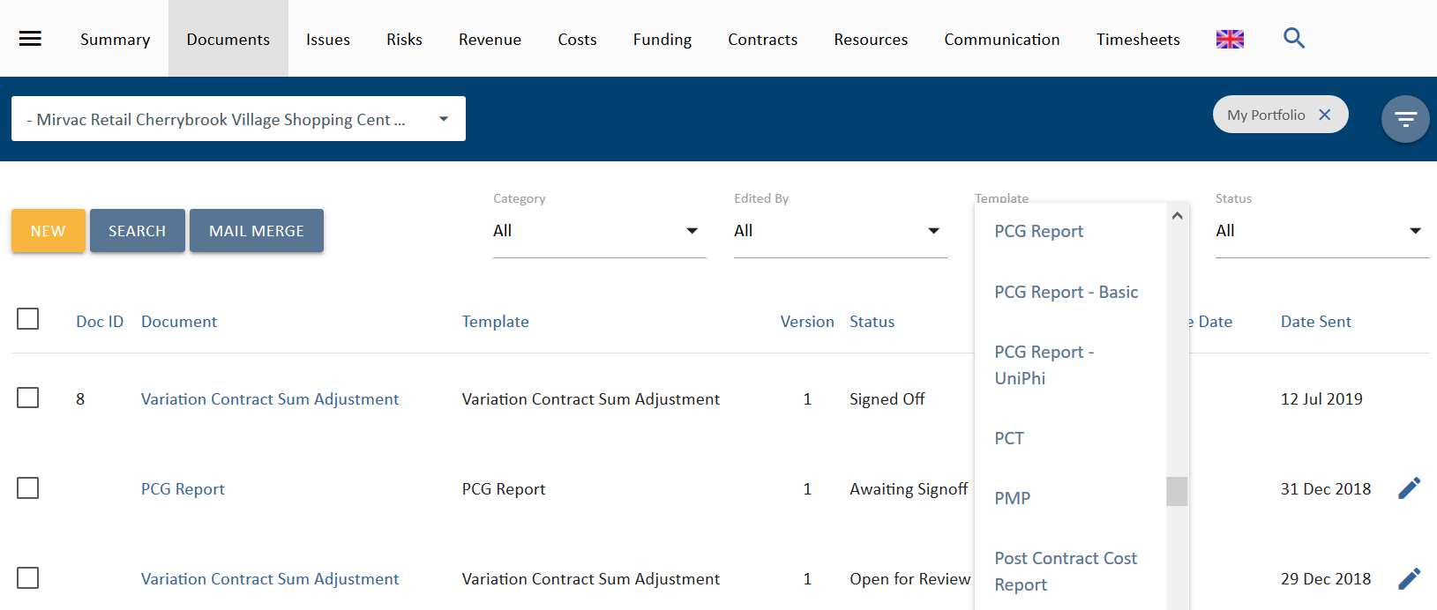
Figure 5 Select the type of document you require by specifying the template that was used to create it

You can also filter by the last person to edit the document:
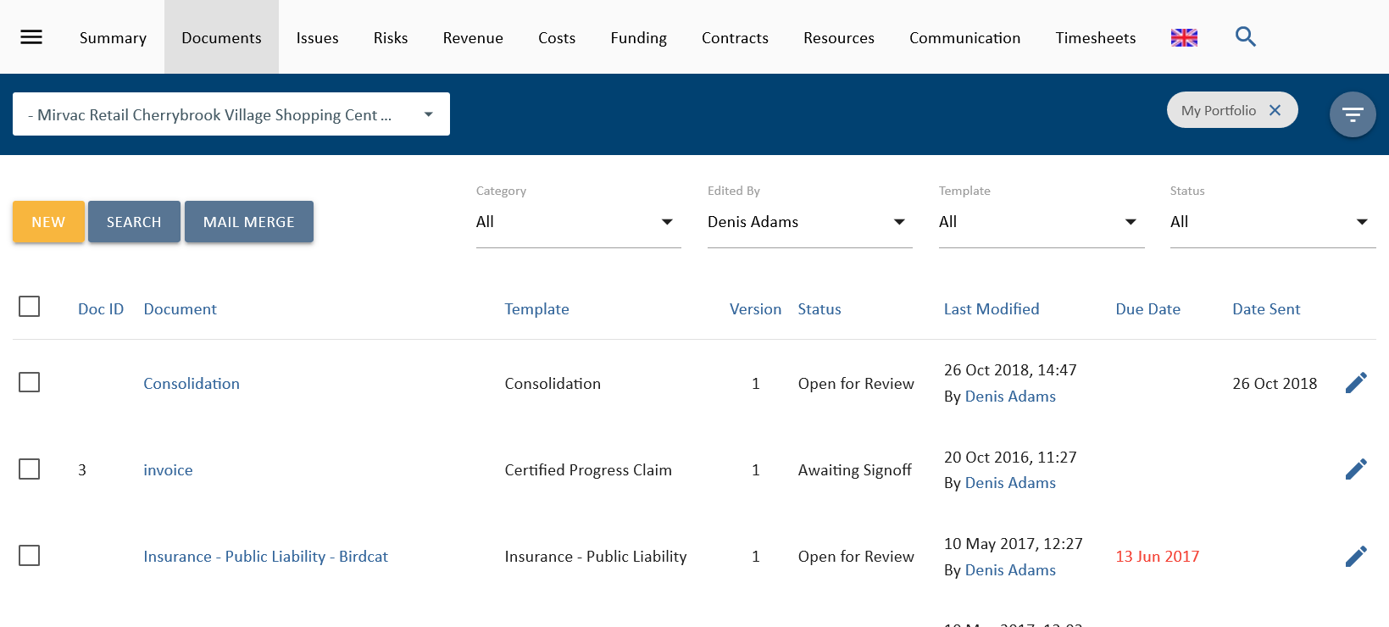
Figure 6 Filter for a document based on who edited it

And finally, you may wish to filter the list of documents by status.
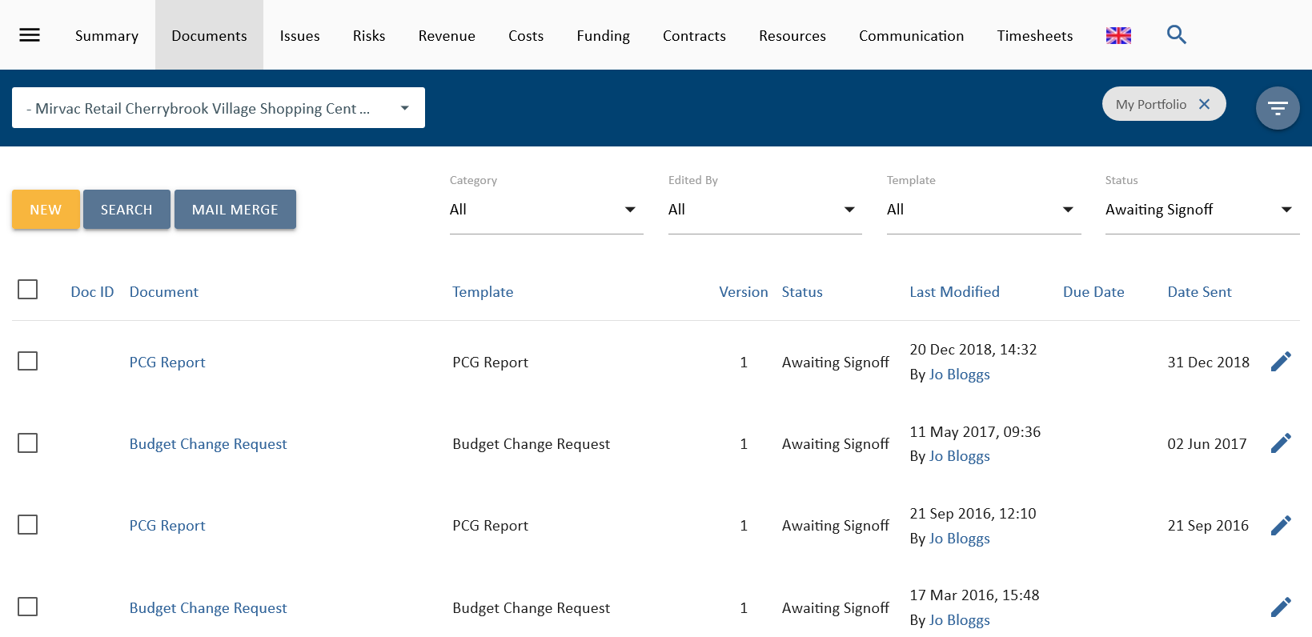
Figure 7 The above search locates a particular document within a project and according to its status

UniPhi uses security permissions that are set at the document template level based on user licence levels. These security settings are established and maintained by your system administrator, and in effect mean that certain documents will not be visible to certain licenced users. As an example, contract documents may be restricted to Program Manager licence, meaning that Team Members will not be able to see any contract document.

Navigating the Documents Module
When viewing the Documents module, you will see your documents listed in a table format according to any filters that have been applied. Filters can be applied across portfolios, project types, business sectors or service lines, locations, etc., or for a specific project.
Document detail filters provide for filtering by Category, Edited By, Template or Status of the documents.
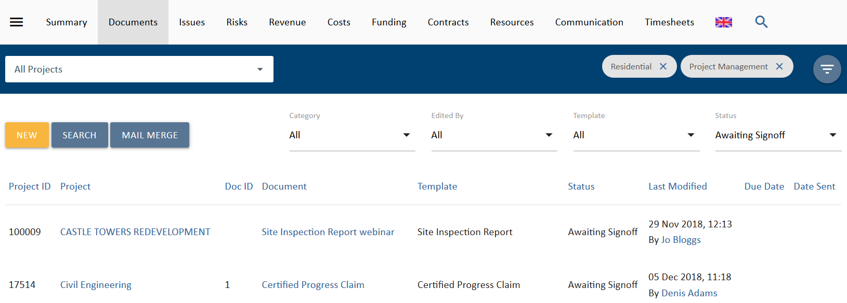
Figure 8 Simply search by applying filters
The Search function is usually towards the upper right corner of the screen at the end of the list of modules. It is available for text searching within the title of the document.
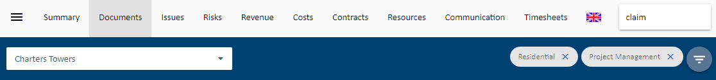
Figure 9 Documents search
As with any Windows based application the use of Ctrl-F key combination will also provide a Search for text within the current screen.

Each of the table headings can be sorted in ascending or descending order.
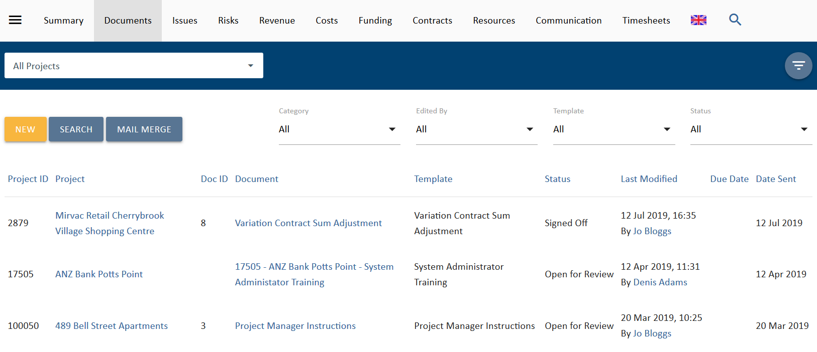
Figure 10 Change the sort order by clicking the column heading
UniPhi presents all of the relevant information per document. In the example above you can identify the Project name, the document name, the template that it was created from, the document version, the document status, the date of last modification, and any due dates, and distribution sent date.
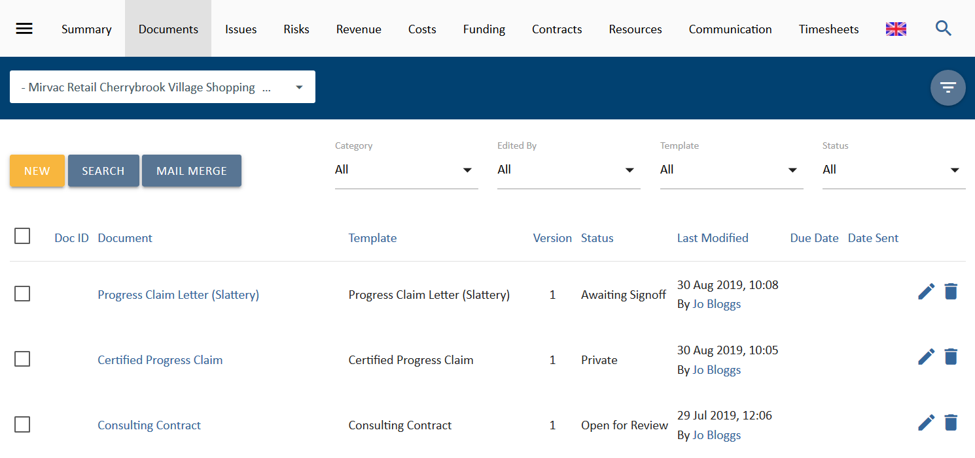
Figure 11 In a project you can edit or delete documents that have not been signed off if you have the necessary permissions
On the far right had column you will see two icons that are used for editing document properties and for deleting a document. Pressing the edit icon allows you to change the document ID, the status, and the due date of the document. Pressing the delete icon will delete your icon. If you accidently delete a document, you will need to ask your system administrator to recover it for you. If these icons do not appear for some documents, then you do not have the permission to edit those documents.

Advanced Search
In addition to being able to filter for documents according to the template that it was created from, and its status, UniPhi also allows you to perform an advanced search. The advanced search button includes additional search fields based on any of the document custom lists that have been created for your organisation’s deployment of UniPhi.
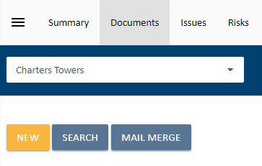
Figure 11 Advanced Search

Your UniPhi administrator is able to create custom checklists and bells12
drop-down lists that can then be applied to any relevant document of issue. Once a custom list has been applied to a document it will appear as a searchable option within the Advanced Search function.
Advanced search allows you to search the actual contents of your UniPhi generated documents. By typing a word or a phrase into the Keyword Search field, UniPhi will locate any document that matches your phrase

As a simple example of how this feature works, let’s assume that your organisation stores design drawings. Each of the design drawings will relate to a specific trade or discipline. Rather than having multiple design drawings per project, and not knowing which trade or discipline they relate to, and instead of creating a template per each trade discipline, you can select the specific trade discipline as the document is created. By adding in a single step that prompts the document author to nominate the trade, it is then possible to locate a design drawing according to the trade discipline that it relates to.
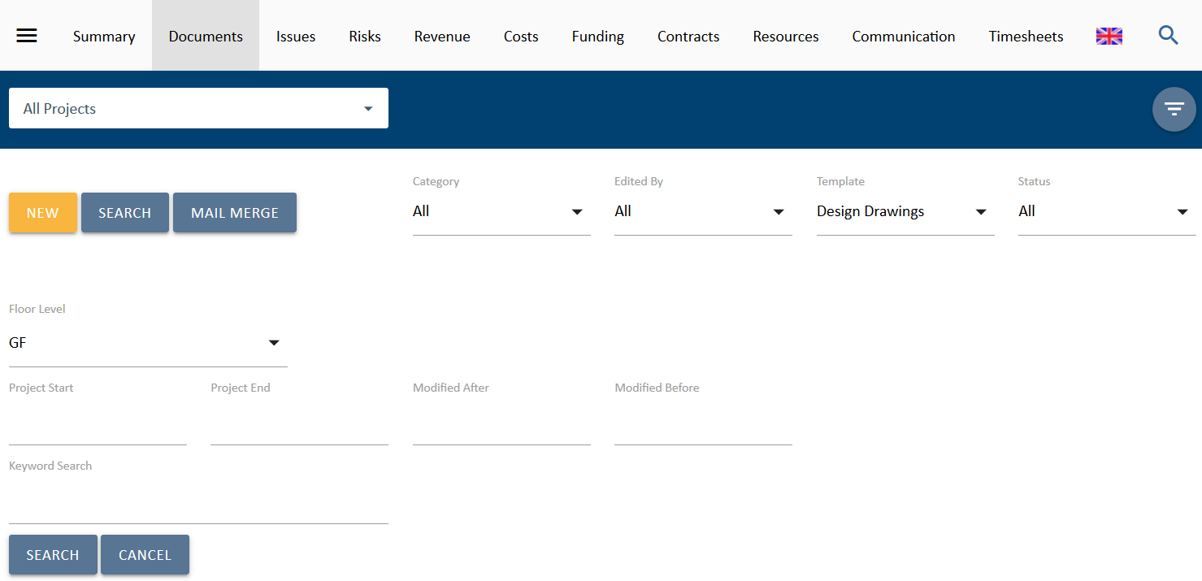
Figure 13 The advanced search screen will show all custom lists according to the selected template
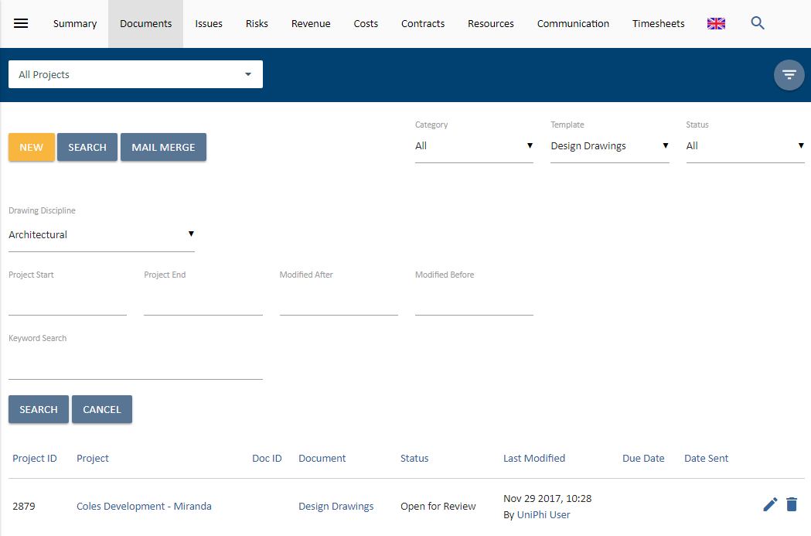
Figure 13 Selecting the required discipline returns all documents matching your search
Depending on your organisation and the data that is being captured via your document templates, the number of custom lists used can vary. Regardless of the number of lists, UniPhi will present each of these lists within the advanced search function. A more complex example is included in the screen shot below. Notice that UniPhi now allows you to search according to a multitude of criteria.
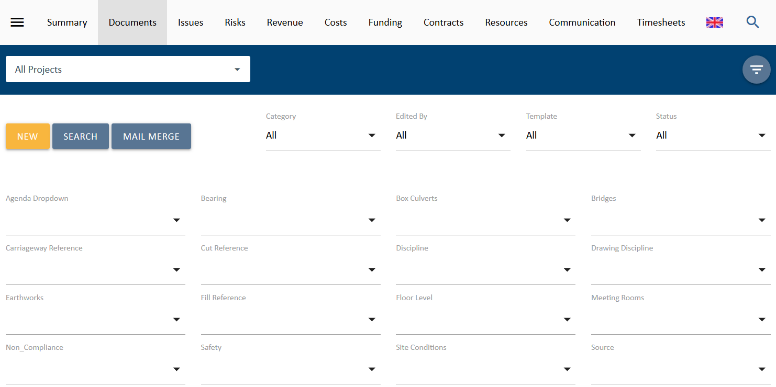
Figure 15 Where no template has been selected, all custom lists will be available for advanced search
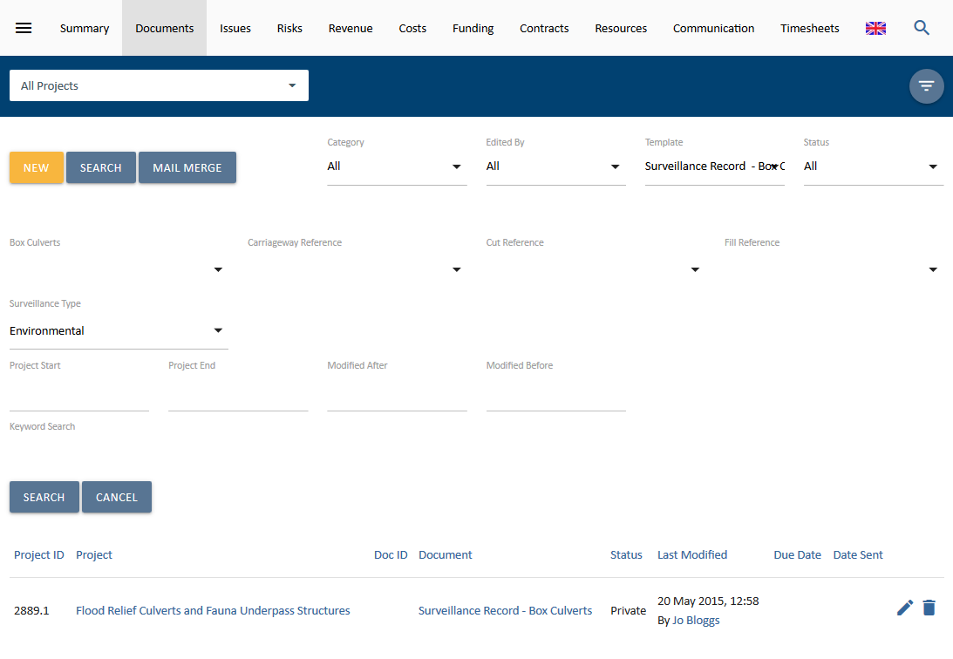
Figure 16 Advanced Search on a template with multiple custom lists
In the screen shot above you will notice that the search results in the location of a document that is a includes an Environmental surveillance.
The Advanced Search feature allows for a wide range of search criteria to be applied, including project start/end dates, document modified date range, and keyword search.

Working with Existing Documents

Viewing a Document
To view a document from the document module, simply click on the document name.
UniPhi will open the selected document in a new browser tab and display the contents in a simple reviewable HTML format. In order to view the document in the format that will be seen externally by your supplier/clients, from the UniPhi Document Toolbar, select the Share button to access the Document Sharing Toolbar. You can press the Save as PDF button to generate a PDF file.
Figure 17 The UniPhi Document toolbar
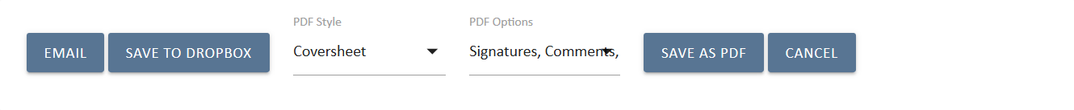
Figure 18 The UniPhi Document Sharing toolbar

Document Status
There are seven document status types that are used in UniPhi. You can observe the status of all documents via the Documents module, and you can also use the filters to selectively locate documents based on their status.

The document statuses in UniPhi are:

Private - This document status is for documents that are in a pre-draft early stage form, or those currently being actively edited by their creator. While a document is in private status it can only be viewed by those who have edit rights to that document.
Private documents can only be seen by the document author.

Draft - This document status opens a document up to be read by any other project team member. A draft status means that the document is still under development, it can be modified, and can have comments added to it.

Open For Review - Like the draft status, this document status allows all other team members to view and comment on the document. The difference is that in the eyes of the creator, the document is completed and “open for review”.

Awaiting Sign Off – This document status allows people who need to sign off a document to sign it off. The system administrator configures document sign off requirements per template. Once a document is moved to Awaiting Signoff it will appear in the Summary module Signoff view of the people/person who are required to sign it off. If there is no specific sign off role for that template, then the document creator can sign it off.

Signed Off - This document status completes a document’s life cycle. A signed off document cannot be edited, though it can be copied or deleted.

Closed – This status can be selected for any document that does not require a sign-off process and is considered as finalised.
Deleted – This option displays all documents that have been deleted.
Deleting Documents in UniPhi can be done, though technically a document is never actually deleted from UniPhi. Rather, deleted documents are removed from view, and can only be recovered by an Administrator licenced user.

Creating Documents

Documents can be created from various locations throughout UniPhi depending on the work that you are performing at the time. Though the most common way to create a new document is to press the New button from within the Documents module (as shown below), documents can also be created from within the Contracts module related documents, or directly from Methodology Templates.
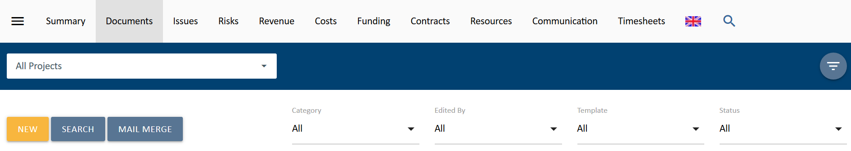
Figure 19 Create a new document by pressing the New button

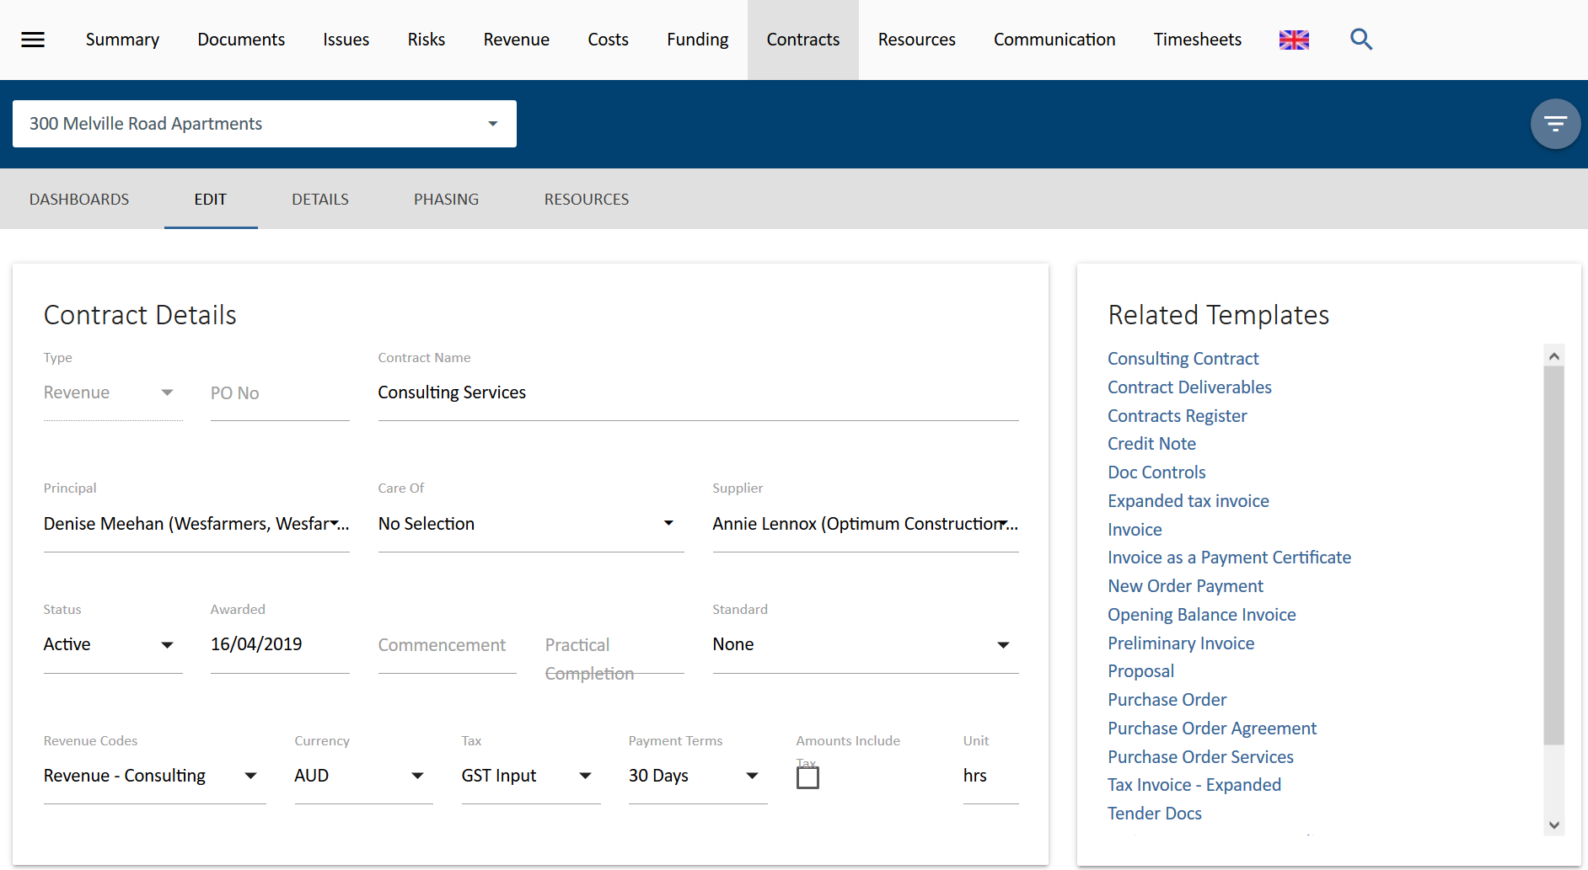
Figure 20 Related documents are conveniently available within other modules
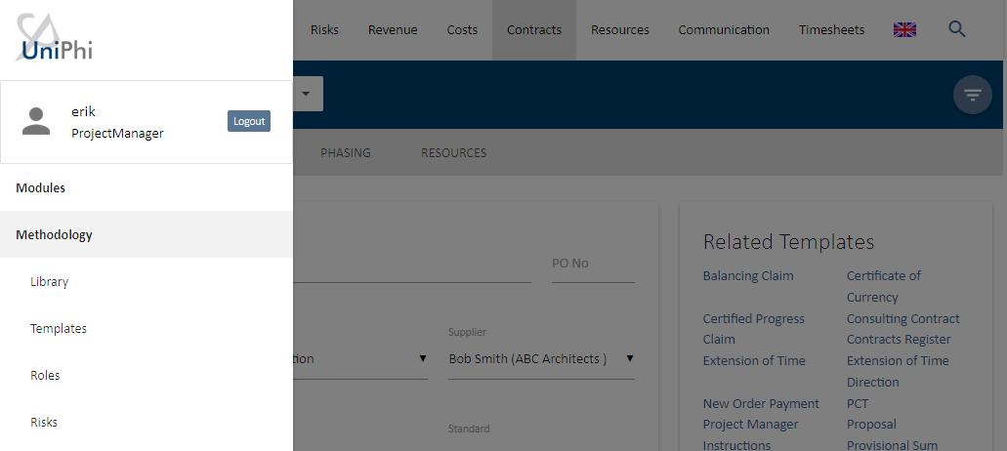
Figure 21 Methodology is located by selecting the Menu on the top right of the browser window
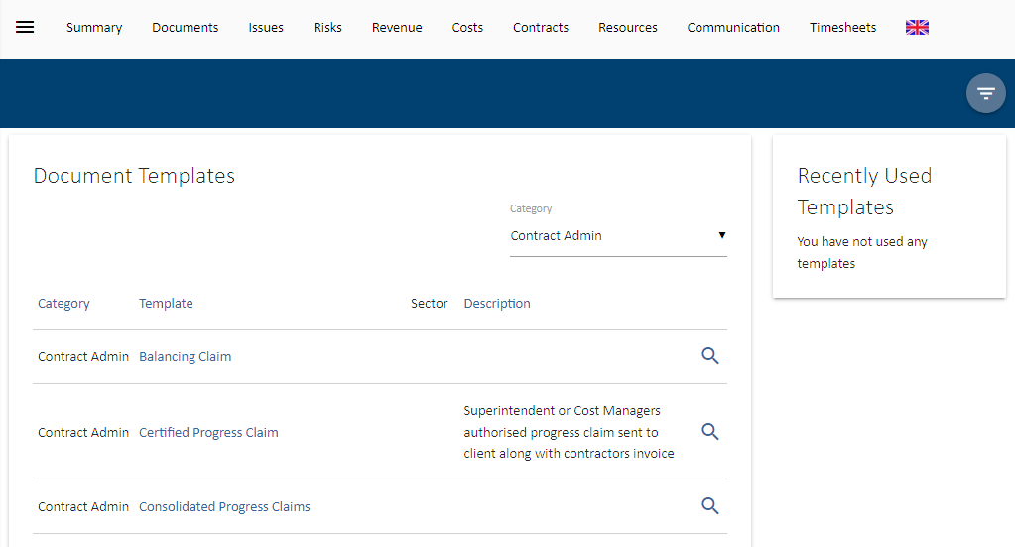
Figure 22 All available templates can be viewed and launched from Methodology Templates

Create a New Document
Regardless of how you create your new document, UniPhi will launch a new document pop up window, which will guide you through the document creation process, according to the workflow and template that you have selected.

Create a document

- You will need to select the document template that you would like to use when creating your document. If your UniPhi deployment has numerous templates, that may be grouped into logical categories. This makes the template selection process simpler as the list of available templates is reduced.
- The Use Template selector will provide a list of templates available for selection based on the template configurations and the users access level. Any template that is set to have an access level higher than the logged in user’s level will not be displayed

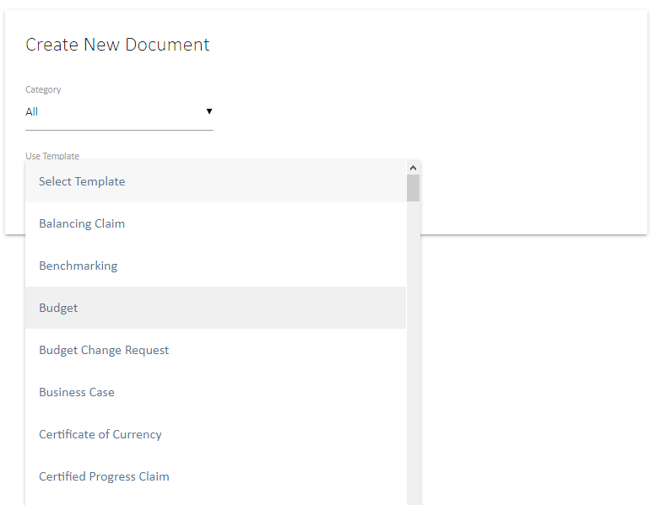
Figure 23 Template selector in the Create New Document window

If you attempt to create a new document and UniPhi appear to not respond, make sure you have allowed pop-ups from UniPhi within your web browser

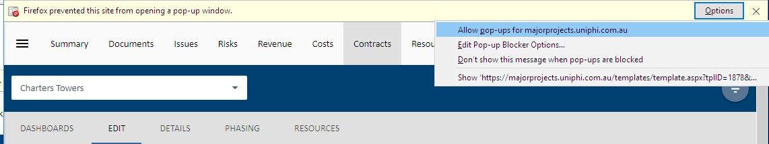
Figure 24 Pop up blockers need to allow UniPhi to launch new browsers/tabs

- As projects are the central reference point for all information within UniPhi, you will next need to specify the project that your new document relates to.

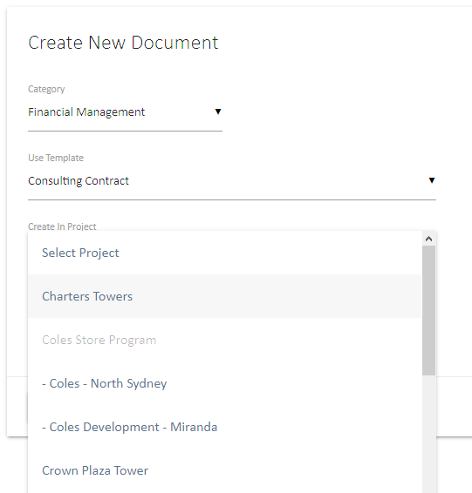
Figure 22 Nominate the project that your document belongs to

- Next the New Document Name field will default to the name of the template that you have selected. This field may be set up to auto populate once you have completed the document. If so, it will be greyed out and not editable. Either way this field can be edited when you reach the finish step of the document, so does not need to be updated now.
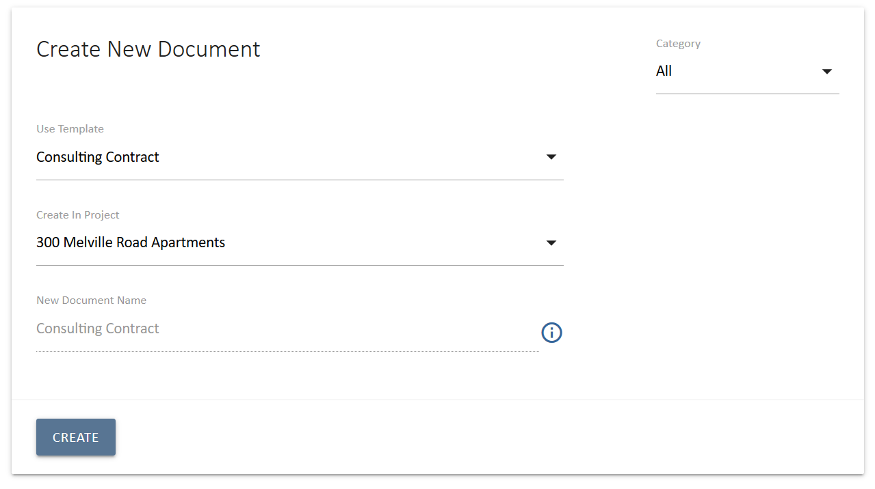
Figure 26 This template has an auto-populated document name, indicated by the greyed out document name

- Once all of the details relating to your new document are correct, press Create .

The new document data entry screen consists of two sections: the primary section is on the left which presents the current step or element of the document being prepared and the Checklist section on the right which provides a summary list of each of the steps in the document.

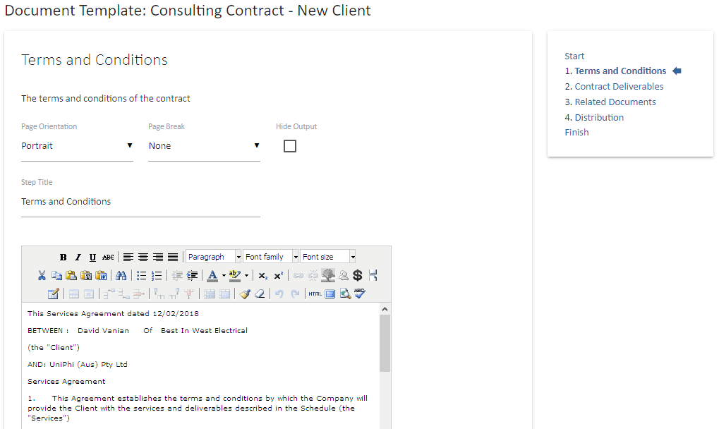
Figure 27 The body of your document is on the left, while the navigation checklist is on the right
The current step in the screen show above is a Rich Text box which provides editing functions similar to a word processing application.

Using the Checklist: The checklist is used as a way of navigating from one step to another, and is useful if you need to move in a non sequential manner. If you are progressing sequentially, you can also use the Save and Continue button at the bottom of each step.

- Select 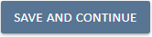 Save and Continue from the lower left of each page to proceed through each step, in sequence, and arrive at the Finish step.

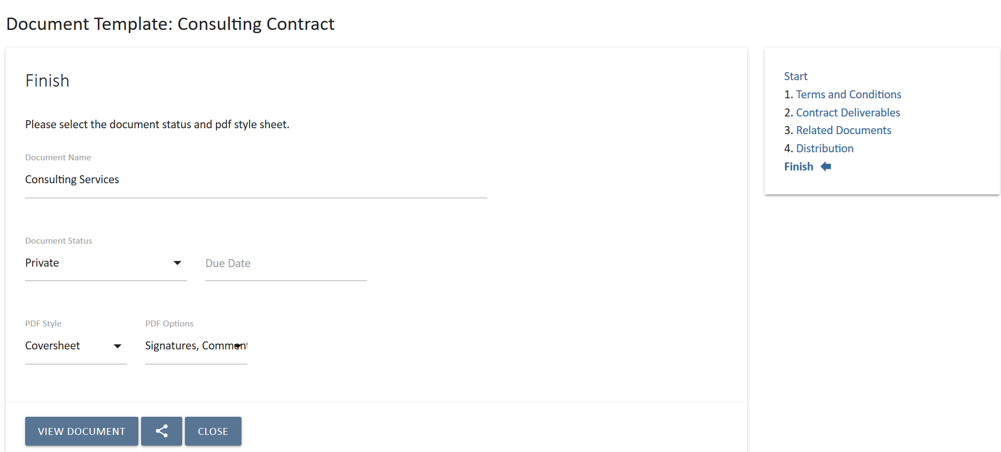
Figure 28 The Finish step allows you to review your document, and set its status

The Finish step shown above provides a number of options for how your newly created document will be treated in UniPhi.

The options available at the Finish step are as follows:
- Document Name: If the template is set up with an auto-name this will populate at the Finish step, see Figure 28 above. This document name can still be edited at this step if required.
- Document Status: As mentioned above, UniPhi has 7 document statuses to choose from, and it is at this step that you can set the document status.
- Due Date: Setting a due date will ensure that should a document require sign off, it will appear in the Summary Signoff view of the person requiring sign off. A due date set here will also appear in the Documents module view, and is a useful way to see upcoming document due dates, and those that are overdue.
- PDF Style: Your UniPhi deployment has been configured to have 2 or more organisation specific style sheets to choose from. These style sheets will typically include your logo, address details, and other font and formatting setting. Using the drop-down menu here allows you to change the default style sheet set by your system administrator.
- PDF Options - Signatures: UniPhi can be configured to show signatures on documents that have been signed off. Checking of unchecking this box will determine if signatures are shown or hidden.
- PDF Options - Comments: UniPhi allows people reviewing and contributing to the document to make comments within the document. Checking or unchecking this box will ensure that comments are shown or hidden
- PDF Options - Transmittal: Includes any UniPhi generated email transmission of the document in the output PDF.

- Review your document: At this stage it is beneficial to take a closer look at the contents of your document. Your template may have been configured to draw on various pieces of information stored in UniPhi and while still in Private status, you can review and make any required changes. The simplest way to do this is to use the View Document , or select the Share button and then Save as PDF .
The View Document option will show you an html format of your document, while the Save as PDF will present you with an exact version of the document as it will be produced and set to your stakeholders. If you realise that a change is required you can simply click back into the necessary step from the Checklist on the right-hand side and make your changes.

- Once any necessary changes have been made and all configurations have been set, press Close 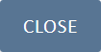 to take you back to UniPhi’s documents module, where your new document will be stored.
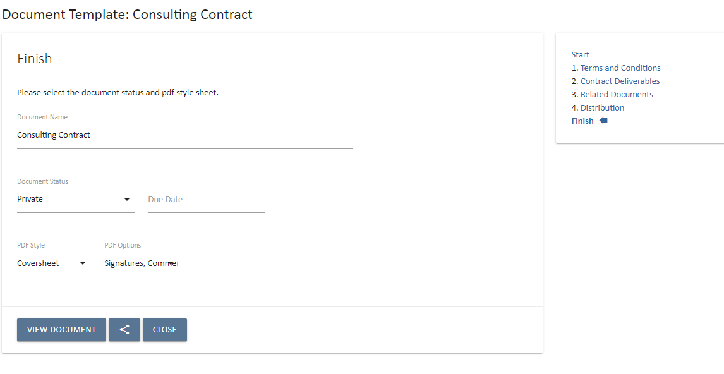
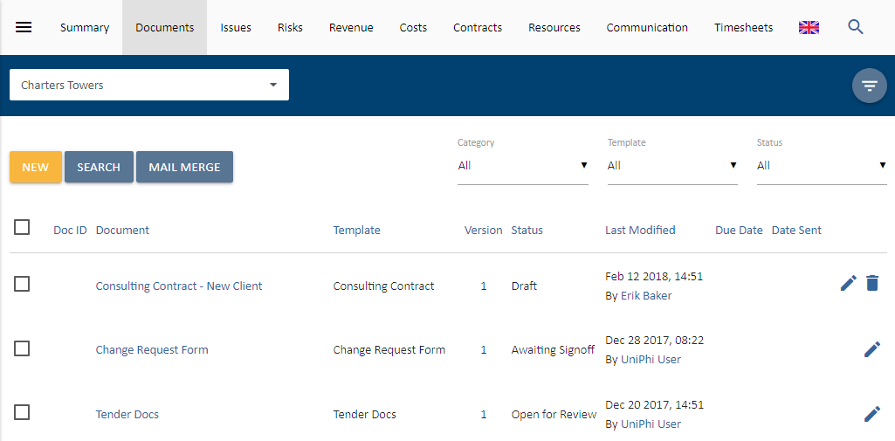
Figure 29 The close button will take you back to UniPhi

Document Status can be changed via inline by using the Edit icon to the right of the document record:

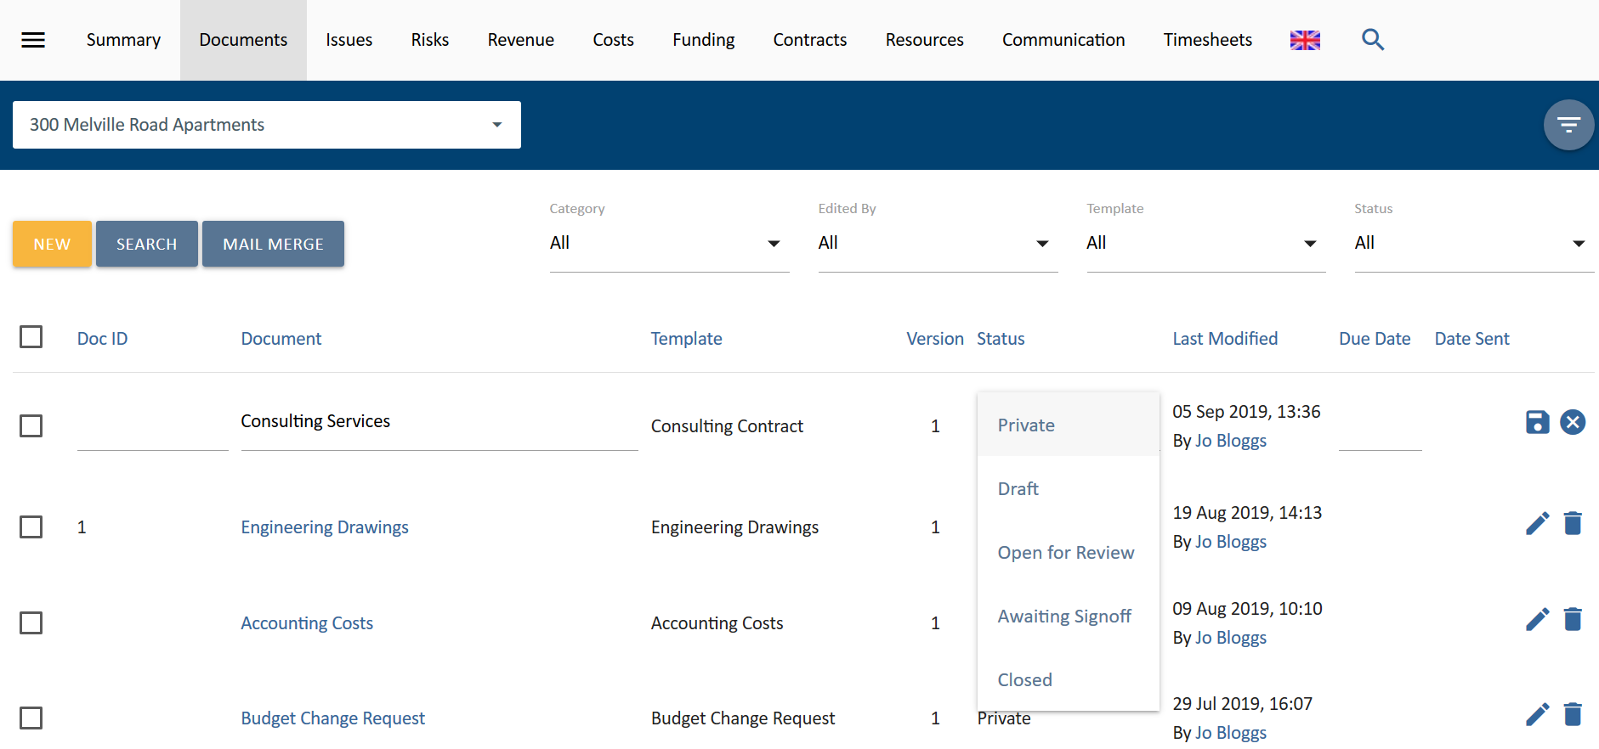
Figure 30 Perform quick edits by modifying your document in-line

Filtering by Document Status when searching for documents provides some additional status options:
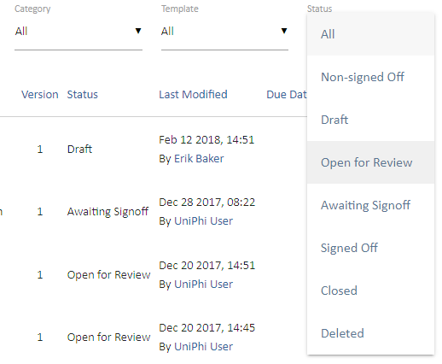
Figure 31 Filter by grouped status

The Status Filter provides for:
All – This selection is the default and displays All open documents excluding Deleted documents.
Non-signed Off – This filter groups all documents that are current in Draft, Open for Review or Awaiting Sign-off statuses.

Viewing a Document
When launching a document, UniPhi will open a new window or new tab on your browser.
Once your document has launched you will see a document toolbar which sits at the top of your document. Depending on the status of your document, the toolbar will present you with various congtrols and options.
As a standard, each document status will include the following:
Figure 32 Document Toolbar
By clicking on the share button you open the document sharing toolbar:
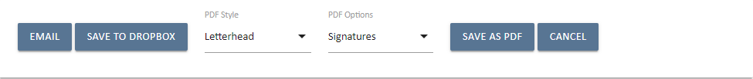
Figure 33 Document Sharing Toolbar

- Edit: Unless a document has been signed off, it may be edited. Editing a document will create a new version of the document.
- Copy: Enables an existing document to be copied either as a duplicate within the same project, or as a new document within a different project. The entire document can be copied or a partial copy can be made. The Partial Copy feature looks up where the same template controls exist and allows you to map the date from your current document into another document template.
- Show Hidden: Displays any steps that have a status of Hide Output. These will not show in a PDF, but can be viewed in UniPhi.
- View Version: Where multiple versions of a document have been created, this drop down allows you to view previous versions of a document.
- Email: Allows a document to be transmitted via email.
- Save to Dropbox: Allows a document to be saved to Dropbox and shared with people outside your UniPh user base.
- PDF Style: the style sheet that will be used when the document is emailed or saved as a PDF
- Signatures, Comments, Transmittals: These may be hidden from view, or made visible
- Save as PDF: creates a PDF file of the document based on the selected PDF Style
Private Status documents will only display the Edit and show Hidden icons, and cannot be emailed:
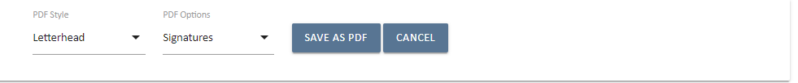
Figure 34 Document Toolbars in Private status
Draft status document will also include Watermark in PDF Options:
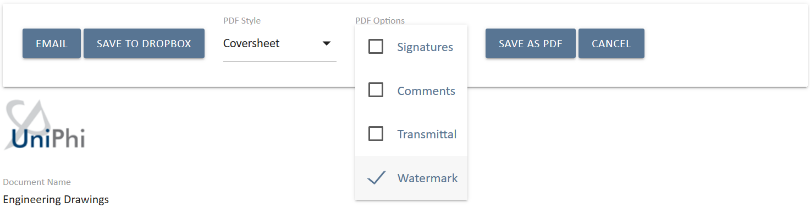
Figure 35 Document Toolbars in Draft status
- Watermark: When you need to make sure that your stakeholders are aware that a document is in draft mode (e.g. if it is printed out), then ticking the Watermark box will insert a DRAFT watermark across your document.

Open for Review, Awaiting Sign off, and Closed documents cannot show a Watermark
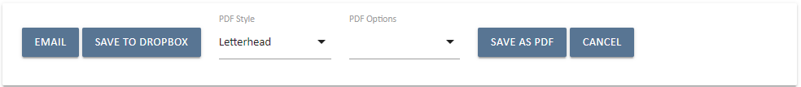
Figure 36 Document Toolbars in Open for Review, Awaiting Sign-Off and Closed statuses
Signed Off documents cannot be edited.
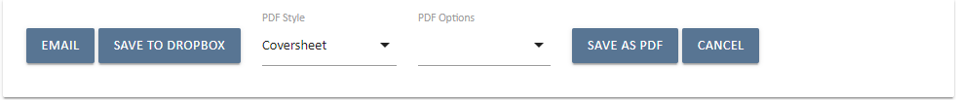
Figure 37 Document Toolbars in Signed Off status
A document cannot be edited if another person is modifying it. This is designed to eliminate version conflict and data loss.

Document Toolbar Defaults: the Signature, Comments, Transmittal boxes are checked by default, and the default style sheet is nominated per template by your System Administrator. You may change these setting for your document if necessary.

Stylesheets
Your organisations corporate style guide will be configured into your UniPhi deployment, allowing a standard look and feel to all document produced via UniPhi. Style is separated from the templates allowing for changes to the corporate standards to be applied quickly and with minimal disruption.

Stylesheets are created by the UniPhi support team and are based on an organisations style guide.

Stylesheets are selected when creating a document.
The styles govern the font selection and standard text sizes in the PDF and any printed hard copies. The stylesheet will manage things like font size, heading size and colours, which means you won’t need to perform manual formatting within your document text – UniPhi will do it for you in the defined style.
If the corporate style is updated, or new versions are added, the list of available stylesheets can be configured by UniPhi developers and made available to all users of your deployment.
Changes to your stylesheet will not impact the documents that have already been created. All of the content will remain intact, but you will have the ability to generate your documents (even the signed off ones) using whichever stylesheet you require.

Because documents are created in UniPhi within a new tab, or browser window you may notice you’re your newly created document is not immediatley visible in your document module. Refreshing your browser will display your new document.

Copy a Document
When opening an existing document, the document Edit toolbar provides the option to Copy a document.

Selecting Copy will present a detail screen with the following options:
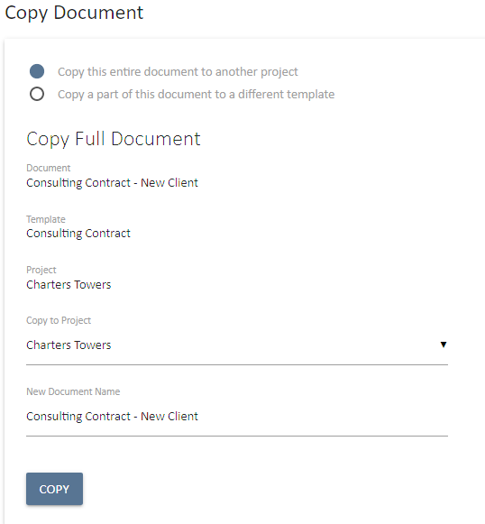
Figure 38 Copy a document to a new project

Copy an Entire Document
The first option is “Copy a part of this document to another template”. The Copy to Project list provides for the selection of the target project that you want to copy the project to. The target could be the same project.

When the target project is selected the document name box will be presented to allow for modifying the document name.
When the document name has been changed and the Copy option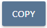selected the new document will be opened ready to start editing the steps. If the document has been copied to a different project all the relevant information will be updated as each step is accessed with the current project information.

Partial Copy
The second option is “Copy this entire document to another project”. The Partial Copy feature looks up where the same template controls exist and allows you to map them your current document into another document template. You need to select extra field To Template for the destination template as well as the destination project. A list of fields than can be mapped will appear. Select the ones you want to map and then select Copy.

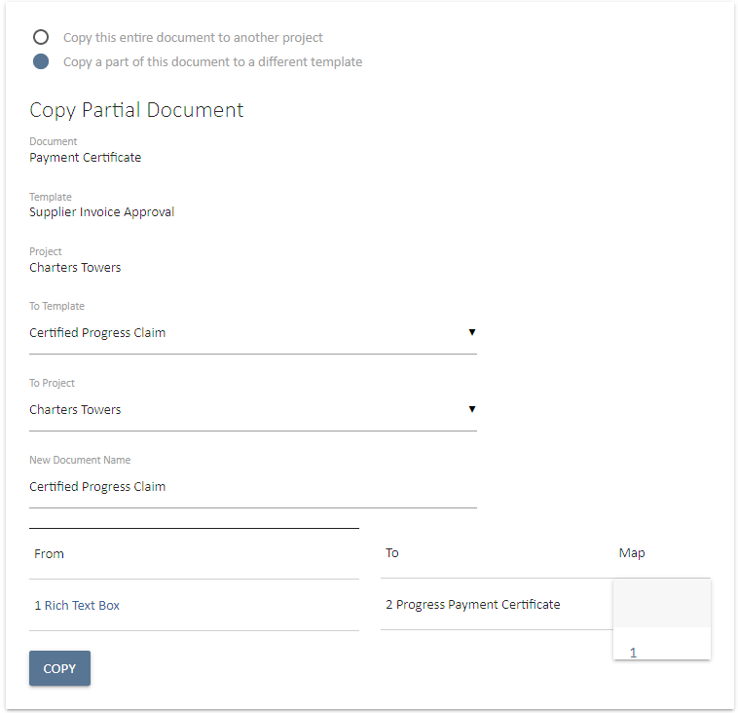
Figure 39 Copy a document to a new project

Document Editing, and Version Control

Members of the project team can edit all documents unless their role or license level does not have editing or view rights to the underlying template. Each time the document is edited a new version is created (for any status other than Private). Previous or Superseded versions can be accessed and reviewed when viewing a document. Document reviewers and collaborators can observe changes that have been made between versions, add comments within the document, and can revert back to previous versions of a document. 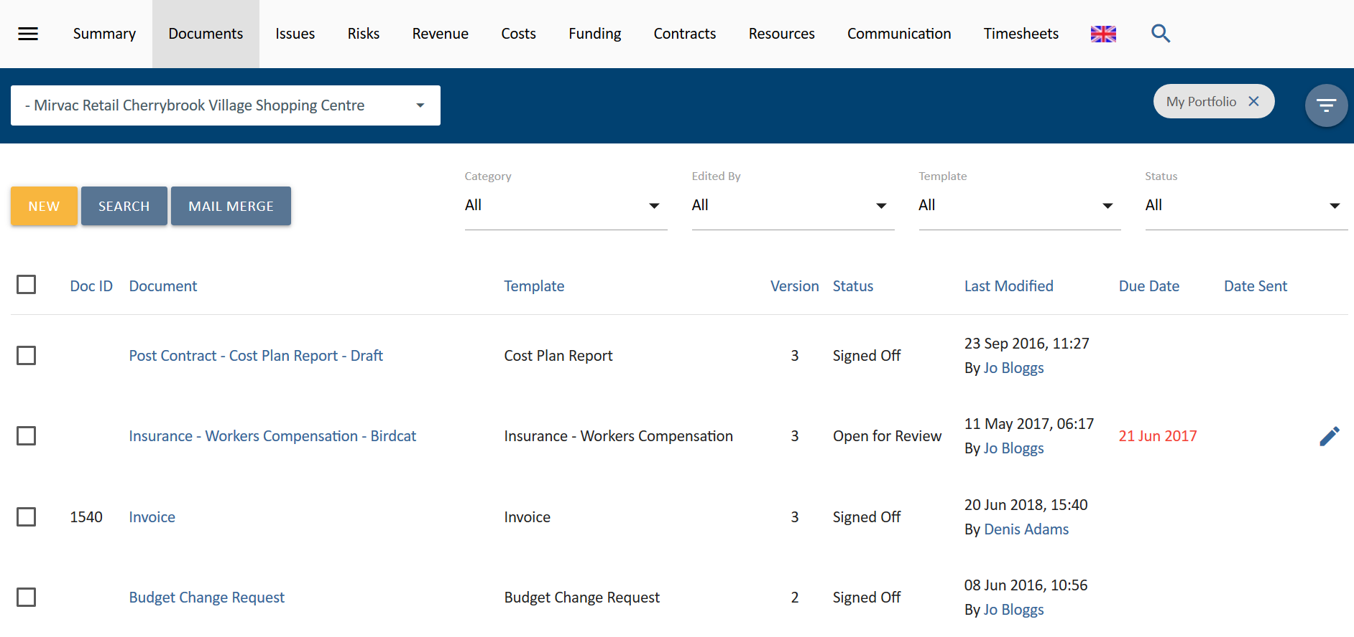
Figure 40 Document version numbers

Document version control can also be utilised where a document is produced on a recurring basis. As an example, a monthly Minutes document can simply be produced each month as the same document. The benefit in doing so is that UniPhi will not contain numerous copies of the Minutes, but rather will have one document that contains multiple historic versions.
Figure 41 Select the version that you require
Document Version Control in Action
Version Control is a powerful method for both collaborating in the production of a document, and in viewing historical changes to a document that have occurred. The following steps will guide you through modifying a document, replacing attachments within the document, adding comments, and then reverting back to a prior document version.
- From the Documents module, select a document that you would like to edit.
- The document will launch in a new browser tab. Press the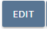 edit button
- Re-name your document, and press Continue
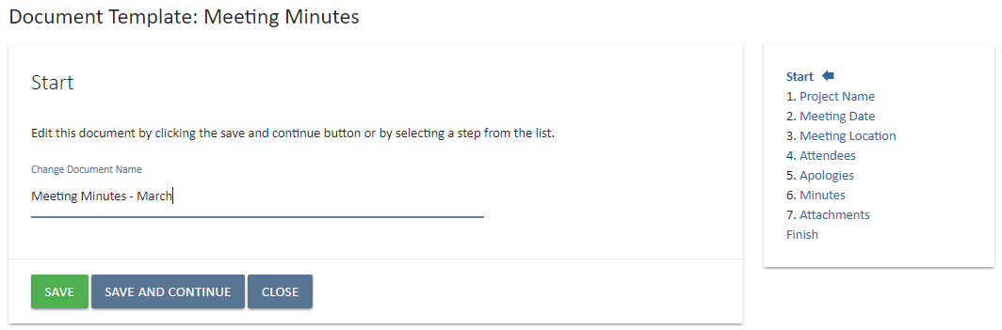
Figure 42 Rename your document

UniPhi will alert you that you are about to create a new version of your document. Click OK to continue
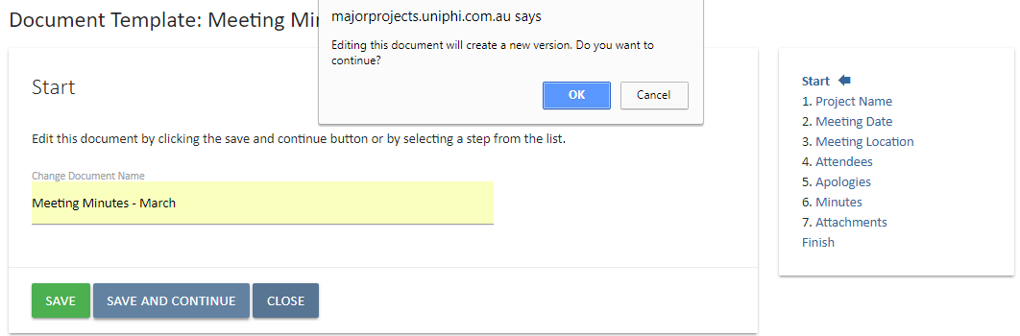
Figure 43 UniPhi version control
- Make some changes to your document.
The document being edited in the screen shot below has a new file attachment added at step 7
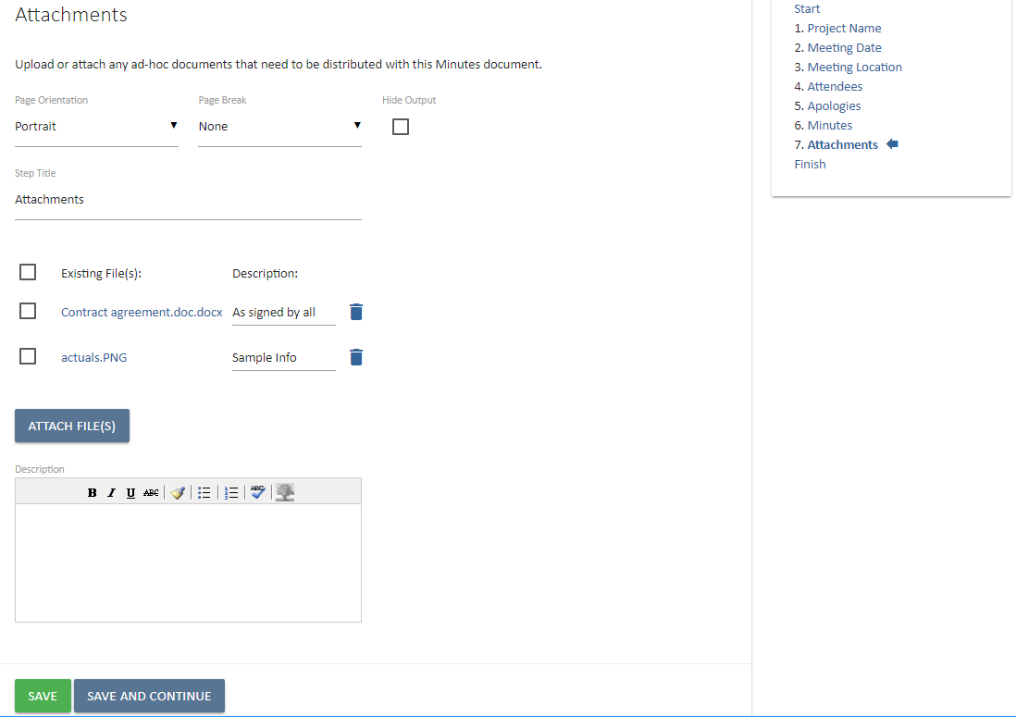
Figure 44 Add attachment descriptions if necessary
The document control type shown in the screen shot above allows the document author/editor to add a description per file attachment, and to make general commentary relating to the step
- Save any further changes and modifications and continue until you reach the Finish step.
- Review your changes in either html format, or by saving at PDF
In the screen shot below, the document presents a change log view of all changes that have been made with the file attachments. Notice files have been added and superseded. UniPhi lets you know when a file was added, or changed.
Figure 45 Example output PDF document

Document attachments. UniPhi is able to save file attachments into documents. When viewing this information in your UniPhi document you will see thumbnails of any image files, and titles for any other files such as word document, spreadsheets, etc. You will find the actual files saved within the PDF file attachment. In Adobe PDF reader this is located via a paperclip icon in the top left corner of the PDF. Clicking on the files will launch them on your computer.
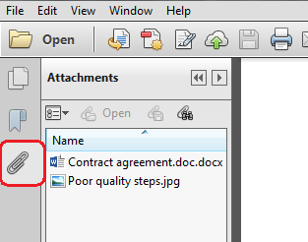
Figure 46 The paperclip icon includes each of the attached files

Reverting Changes
In the event that you are reviewing changes to a document and you do not agree with the changes that have been made, you can revert the changes to a prior version.
To revert changes, simply launch your document and select the appropriate prior version from the list of available versions and press the Revert button.
Figure 47 Select a previous version of a document to view it.
UniPhi will alert you that the process of reverting documents to a previous version is not reversible, as you cannot undo the change or go back to the removed version of your document.

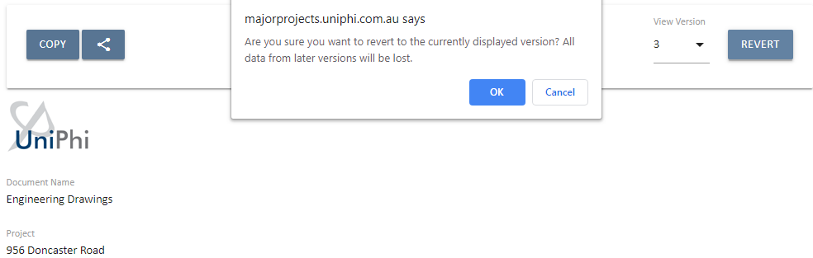
Figure 48 Reverting to a previous version of a document cannot be undone.

Document Transmittal

Once your documents have been created, and reviewed, you may also be required to send them via email. UniPhi has a document email functionality, which is designed to allow for doucment to be shared, regardeless of your recipeint having a UniPhi licence or not. The functionality also stores a record of your transmittals, which is a useful feature when anyone needs to know what was sent, to whom, and when.
Documents are emailed from UniPhi via the document toolbar. By simply opening your UniPhi document and clicking on the share button, you will find the email button .

Figure 49 Email from the Documents Sharing Toolbar

If you have just edited a document, you can email from the Finish step after clicking on the share button.
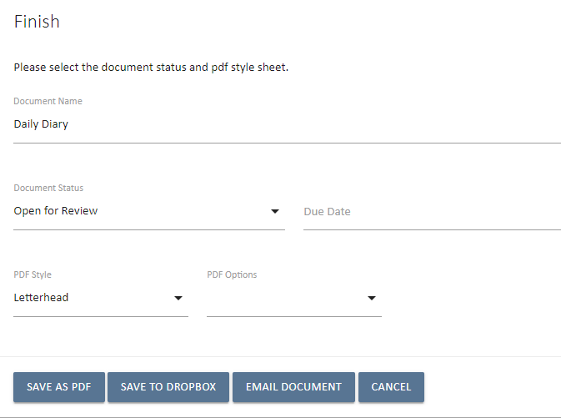
Figure 50 Email from the Finish document step

Emailing a Document
Selecting the Email option presents the UniPhi Email screen. A list of email addresses and resource will appear. The resources displayed in this list are typically the Team List, which as its name suggests, are those resources associated with the project that your document has been generated from.
The View option in the upper right corner allows for selecting 3 different views of the contact email details.
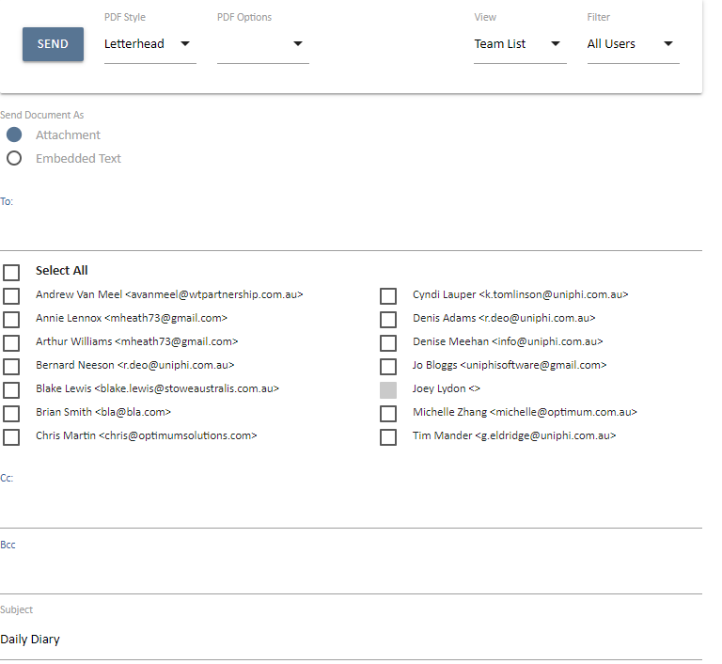
Figure 51 Select the recipients according to the role

The View list options are:
- Team List: All resources associated with the project.
- Project Roles: All resources associated with the project grouped by Role.
- Global Roles: All Resources from all projects in UniPhi grouped by Role.
The default list will be set within the document template but all three options are always available.
If an email address has not been entered via the Resources module, the contact the <> braces will be displayed without an email address and will be greyed out so they cannot be selected.
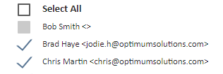
Figure 52 Contacts without an email address appear with the < > characters

In the above example Bob does not have an email address. Bernard, Gerard, and Jane have been selected as recipients of the email in the To: field. You may also add recipients to the CC: and BCC: fields by clicking on the blue CC: or BCC: headers.
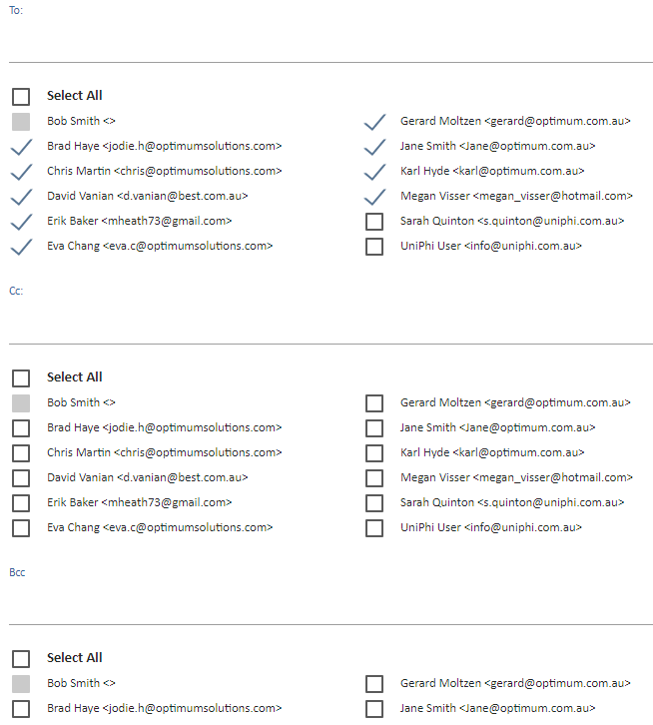
Figure 53 Click on the Cc: and Bcc: headings to send emails within those fields

Any intended recipient that does not appear can be manually added in the TO: CC: or BCC: fields.
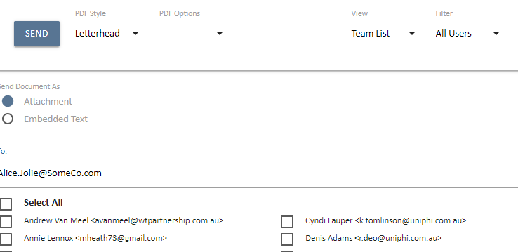
Figure 54 You can also manually enter an email address if necessary

There are two options for transmitting your document from UniPhi:

Send as an Attachment
UniPhi automatically determines how to handle the email attachment format. If a recipient has a UniPhi licence then the email will contain the body of the email and a link to the UniPhi system View Document screen.
External Email Addresses will automatically trigger UniPhi to not include a link to the UniPhi document replacing it with a PDF formatted attachment. The basis of this being that the external user cannot access UniPhi to view the document. If any of the recipient email addresses are external then ALL recipients will get a PDF attachment.

Send as Embedded Text
UniPhi turns the contents of the document into the body text of the email. This text is still editable in the mail editing view.
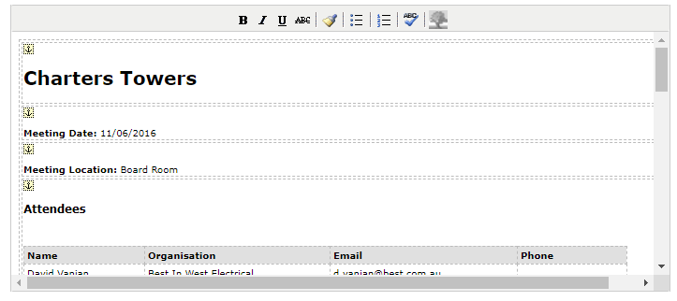
Figure 55 The email editing view when the Embedded Text option is selected.

Document Sent Records

Document Module: For traceability and record keeping, UniPhi maintains a record of the date that a document was sent. 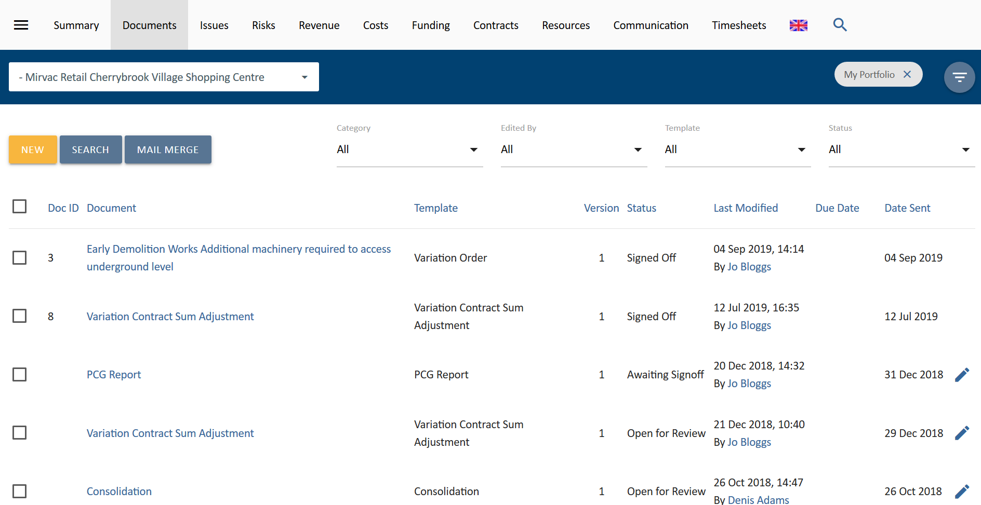
Figure 56 UniPhi automatically stores the date that a document was sent

Contracts Module: For other areas in UniPhi the Date Sent option is presented as an editable field like on the Contract Details view in the Progress Claim Register card.

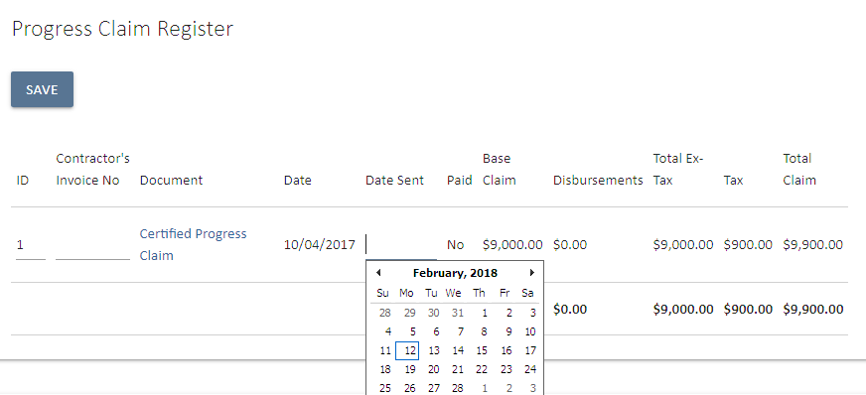
Figure 57 Select a sent date in Contracts Details Progress Claim card.

In this case selecting the Date Sent from the Calendar button or manually typing the sent date and Selecting the Save button in the upper left corner will record the manual entry.

The Sent Date is included in any document reports that detail the transmittal records.

Recording Sent Date when Emailing a Document is not required as UniPhi automatically records the date and time of the outbound email in the transmittal records. If a document is sent multiple times the most recent sent date is displayed.

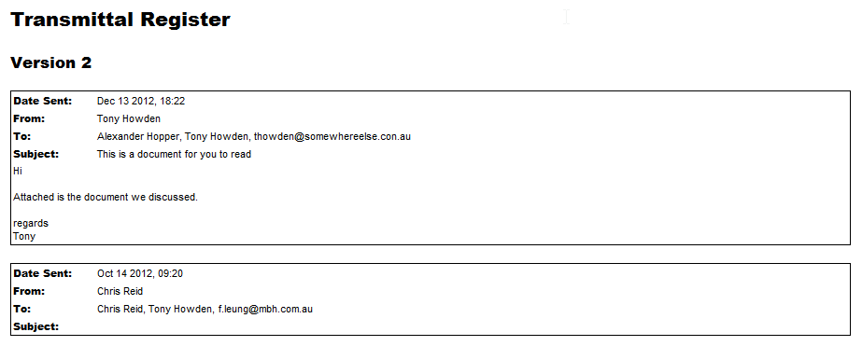
Figure 58 Document Transmittal Register.
In this case Version 2 of the document has been sent twice, once without an email subject or body and once as per the example above.

Share Documents with Drobox

UniPhi supports sharing documents with Dropbox. This is a new feature in UniPhi 15 and needs to be enabled by your system administrator. For information on how to do this, refer to the UniPhi 15 System Administrator Manual.

Link UniPhi to Dropbox
The first time you attempt to share to Dropbox, you will be asked to sign in to link you Dropbox profile with your UniPhi account.

Figure 59 Sign in to link UniPhi to Dropbox.
- Enter your email and password for Dropbox and select Sign In.

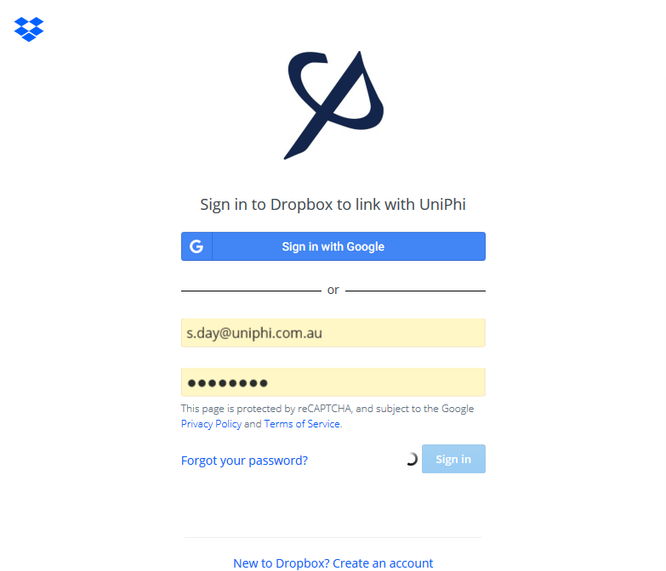

- When you sign in, you may also be presented with this additional warning screen below. Select Continue.
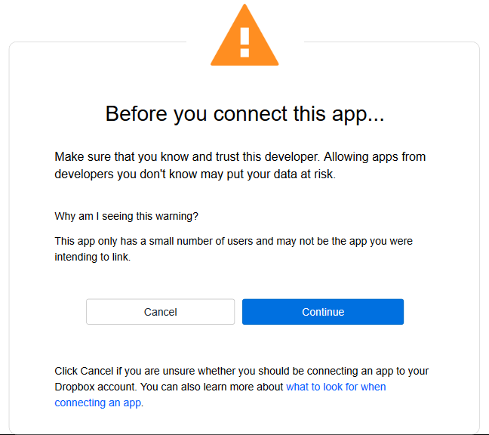
Figure 60 Dropbox warning screen.
- Finally, you will be presented with a confirmation screen, select allow to enable your Dropbox account to be linked to your UniPhi profile.
Figure 61 UniPhi confirmation to link with Dropbox.

Save Documents to Dropbox
To save a document to Dropbox from the Documents module, select the project then check the box next to the document you want to share. Select the Save to Dropbox button.
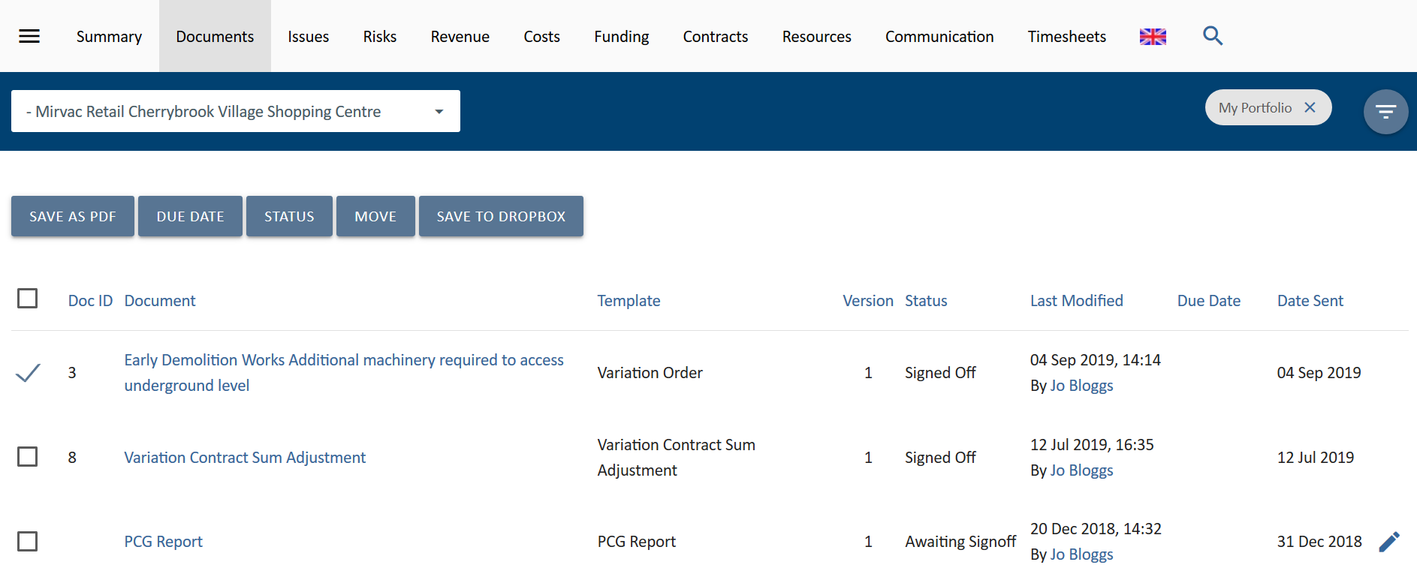
Figure 62 Save to Dropbox from the Document module.
UniPhi’s Dropbox upload window will open showing available folders in Dropbox. Select the folder you want to save to and select Upload .
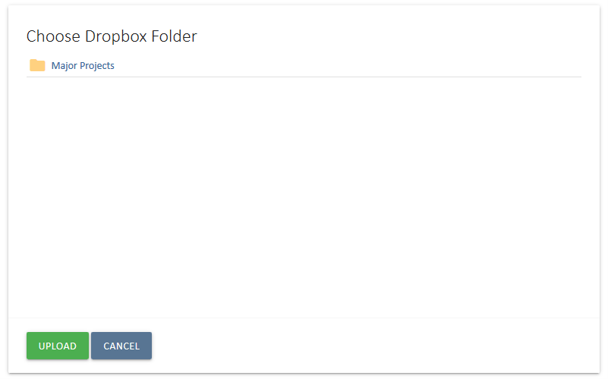
Figure 63 UniPhi Dropbox upload window.
UniPhi will save a PDF of the document in the destination folder and the window will close and return you to UniPhi.

The same functionality is available when you are in a document. Select the share button form the Document Toolbar to show the Document Sharing toolbar.
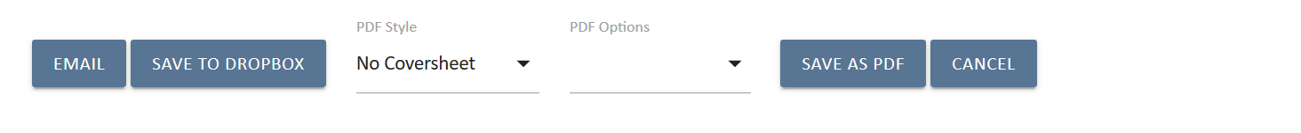
Figure 64 Document Sharing Toolbar.
Select Save to Dropbox and follow the same steps above to upload the document.

Document Controls / Input Objects

Document controls are an integral part of the document management system. They enable quick creation of documents based on information that has already been entered into UniPhi for the relevant project or portfolio.
They are used to display project data in pre-defined views some of which have controls that can modify the content during document preparation.
The building of a template that can be used for document generation in UniPhi is the topic of a separate manual. Please refer to the UniPhi System Administrator Manual.
The following pages present information relating to the preparation of a document based on a number of different templates and how the author of the document can control the output of their document.
The following examples are not an exhaustive list but address the most commonly used input objects and the source of the data.
For most of the input objects, if the document being prepared does not display the expected data, there is either something incorrect in the selection (date, period, project, filter, etc.) or in the underlying data itself. Commonly un-submitted timesheets, unsigned progress claims, documents started and left in Private status, will impact on the validity of the document data. The remedy is to save the current document and edit the underlying data. Returning to the document later and recommencing the edit process will trigger an update of the existing document and present the current (and now correct) data.
Example Document Controls:
The Textbox (Rich) document control appears in most templates. Using this control the user can enter in unlimited text, tables and graphics into their document. Default text can also be entered by the template creator / administrator and will be displayed, and can be edited or deleted by the user.
A Contract Details control can be built into a template to let the user specify which contract the document refers to as projects can have multiple contracts. This method is used to make information from the selected contract available for use in the document you are creating.

Rich Text Editor

Using the Rich Text Editor; the rich text toolbar displayed below is available to use with a rich text box and provides functionality to access the HTML environment. The Ctrl key and relevant letter on the keyboard can be used to activate some of the controls exactly the same as you would use in many Windows applications.
For example: Ctrl+C for copy, Ctrl+V for paste and Ctrl+Z for undo.
Some of the text boxes used within UniPhi present a smaller version of this editor. Hover over an icon and a label will appear to tell you what the icon is.
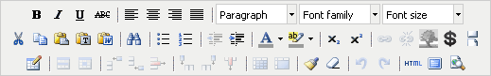
Figure 65 Rich Text Toolbar.
The common commands you will use are as follows:
- highlight text to make formatting changes B – to bold, I to turn to italic or U for underline. Select the letter to either add or remove the formatting type. You can also use the common keyboard commands that you would use in MS Word such as Ctrl+B, Ctrl+I or Ctrl+U. The ABC enables you to strike through the text.
- enables you to position text in the document to the left, right, centre or justified.
- select the heading style you wish to use if required, these have all been predefined for you. The heading styles and paragraph are Calibri. You can manually select font family and font size from the drop down if you wish.
- the cut, copy and paste icons enable you to add or remove text into the rich text box from external documents or sources.
- the paste as plain text icon is used when copying text from MS Word. This is because MS Word has its own mark-up language which does not match exactly with HTML. When copying text from MS Word the rich text editor does its best to convert from word to HTML, however it is not perfect since the two do not match up exactly. The paste as plain text option will remove the word formatting and allow the user to have more control with formatting.
Information can be copied into UniPhi from MS Word by selecting the when pasting into UniPhi and then editing as required. Alternatively, you can copy the HTML version of the document and paste this into MS Word. If this method is used upload the document back into UniPhi.

- provides the options to create or remove a bulleted or numbered list. When you remove these a space will be entered between each line of text. If you wish to remove these spaces place your cursor in front of the first letter of the word you wish to move and select your backspace key. The word will be in line with the word previously above, now select Shift+Enter. The word will be placed back on the line immediately below with no bullets and the space is removed. Alternatively, if you are familiar with HTML you can view the code and make your changes there. (See HTML explanation further on in this section).
- enables you to change the colour of the font by highlighting the text and selecting the drop-down menu to pick your colour.
- enables you to highlight the background of the text, this is particularly useful if you want to note where you have made changes in a document so the author or readers can see what you have amended in the text. UniPhi does not have a track changes option.
- Used to insert a picture and enables you to select the image you want to insert. This can be used for inserting a photo into CV or logos etc. The best method is to create a table and insert the graphic into one cell, that way you can control the positioning.
- The first icon inserts a table into a rich text box and you can enter the number of rows and columns required.
The middle icon displays the table properties and where you modify the number of rows and columns and set width and height properties.
Table width is suggested to be fixed to 650 pixels so when document is rendered to PDF it will fit on an A4 page.
The last icon is the cell properties. It is suggested that you modify the cell/column using percentages with a total of all columns across the table equalling 100%. For example a table with 5 columns may have a width of 20% each, if you change one of the cells in a column you will need to update the remaining columns to maintain 100%.
- Inserts a column in a table to the right or left or the last icon deletes a column. Place the cursor in the column you wish to insert next to or delete and select the relevant icon.
- Inserts a row in a table below or above the row you are in. Place the cursor in the row you wish to insert a new row above or below or delete and select the relevant icon.
- redo or undo the last action(s) that you did . You can also use Ctrl+Z for undo or Ctrl+Y for redo.
- select this icon to access the HTML code for the step. If you are familiar with HTML you may find it easier to use the HTML view and make changes to the code to create your information, amend formatting.
- enables you to view the full screen for the step you are in. Depending on your browser, you may need to place your cursor in the rich text box or table for the step to appear. Clicking a second time will return to the document mode.
. - enables you to indent text to the right or out-dent to the left. You can use this method as well to remove bullets or numbers by selecting all the relevant text and then out-denting until removed.
The variable icon provides for pulling snippets of data from the system and inserting them into the text ‘on the fly’.
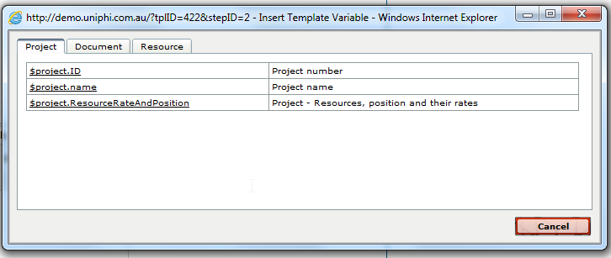
Figure 65 Insert Variables.
The popup screen allows for selecting Project, Document, and Resource based information from the system. The list of data is too extensive to be included here.

Create a Certified Progress Claim
Progress claims can be created as recommendations from a Quantity Surveyor, or a Certification from a superintendent, or as an invoice from a contractor. This example presents the basics of creating a progress payment certificate. Revenue and Cost Contracts will present differently; the following is a Cost Contract example.

- Select a contract from the project Contract system.
- When viewing in the Contract summary view, note values in the Progress Claims and % Comp columns:
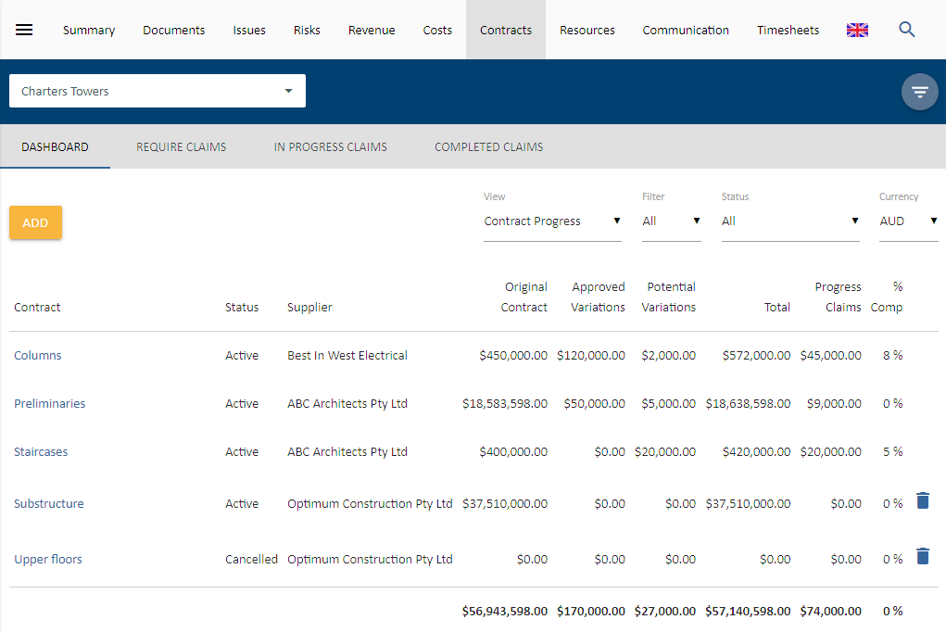
Figure 67 Contracts summary view
- Select the contract you need to create the progress claim (ensure you’re in the Claim view)
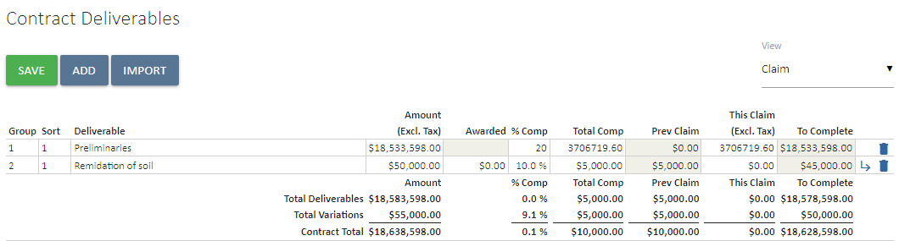
Figure 68 Update the % complete, or the This Claim value
- Enter in either the % of work completed or the actual $ value being claimed.
Click save.
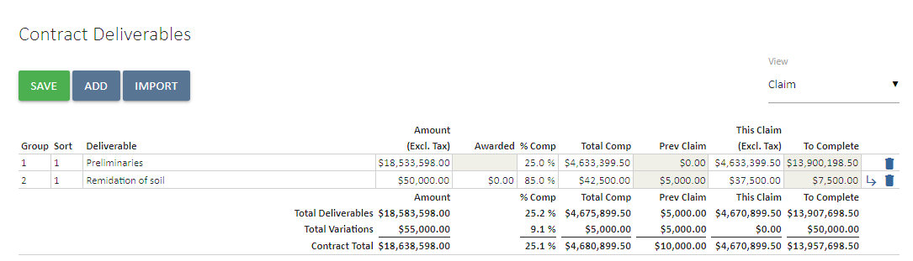
Figure 69 Contract deliverables claim view updated for a claim

- The total value of the current claim is saved and now ready for the document Progress Claim to be prepared.
Document Sign-off is required. These values have not been committed so if you roll up to the Contract Summary view, the values will not have changed.

To prepare the appropriate document to certify / commit the claimed values, click on the link to the Certified Progress Claim template in the upper right corner “Related Templates” panel on the contract screen.
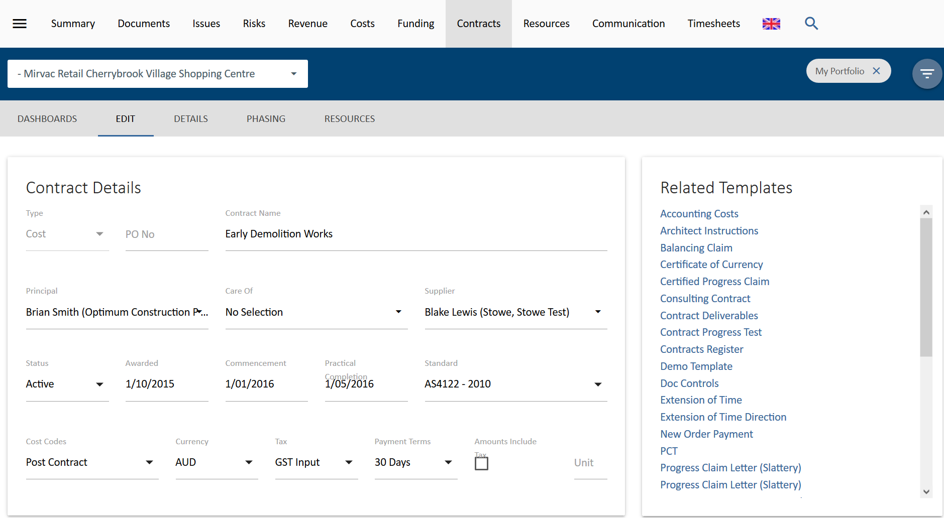
Figure 70 Related Documents in a Contract
This will launch the Create Document wizard
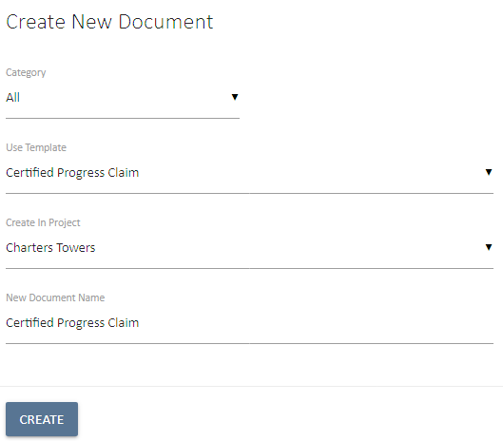
Figure 71 Create New Document wizard

Modify the New Document Name to something appropriate and click 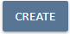 create to begin making/certifying your progress claim
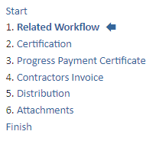
Figure 72 UniPhi Document steps
Move through the template steps (in the example demonstrated the template consists of the following steps:
Related Workflow – here you can select the issue that the claim is related to so that the completed document appears associated with that issue.
Certification – the document control that certifies the progress claim
Progress Payment Certificate – Contact and other details in the format of the certificate
Contractor’s Invoice – Attach the Contractor’s Invoice
Distribution – here you can select who is to receive the completed document
Attachments– users can upload invoice and other relevant documents
At the Certification step, enter in the certification date, ensuring the correct contract etc is selected:
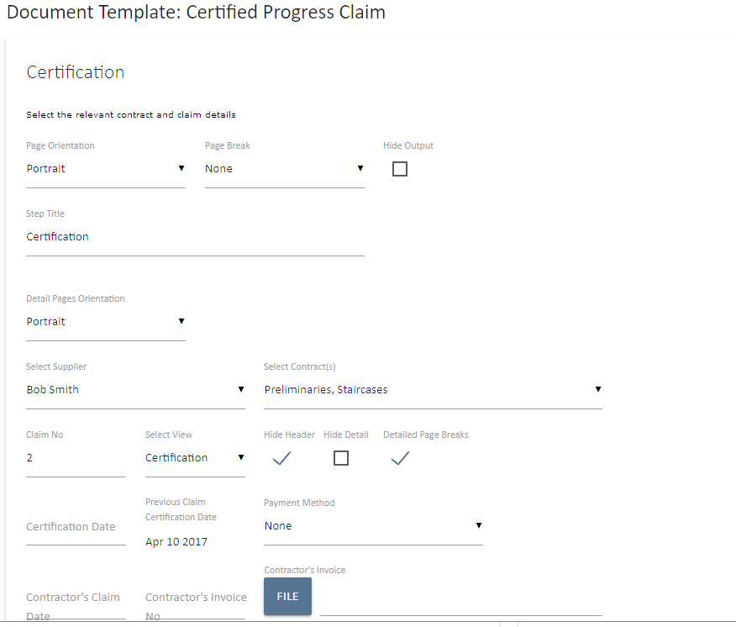
Figure 73 Progress Claim / Certification document step - upper
This is the upper half of the screen displaying the Contract selection (which is by default the contract that the template was triggered from). The view can be a Certification or a Recommendation depending on the relevant role / timing of the document. The Contractors Claim date and Certification Date fields are provided and must be filled in before continuing.
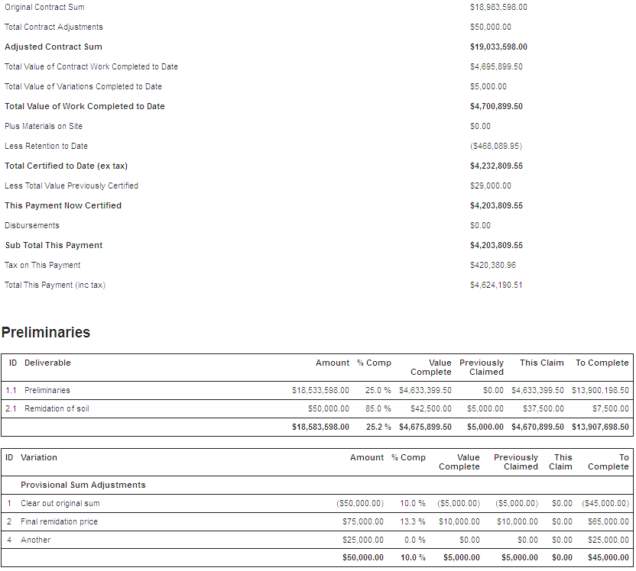
Figure 74 Progress Claim / Certification document step - lower
The lower section of the claim screen displays the actual Deliverable line items and any Variations that have been entered to the contract. This is provided to expand on the summary data that is presented in the upper portion of the claim.
If there is a disbursement claim value a cost code will need to be selected to allocate the cost. GST will normally be calculated but if it is different to the invoice and this difference is valid (e.g. GST free component of a building surveyors registration), the GST calculated can be manually changed. Click 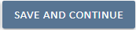 save and continue to continue creating your progress claim.
Once the claim is completed, and signed the document off, go to the Contract Summary view to review the contract values. Note the values have been committed and a total % complete for the project has been calculated:
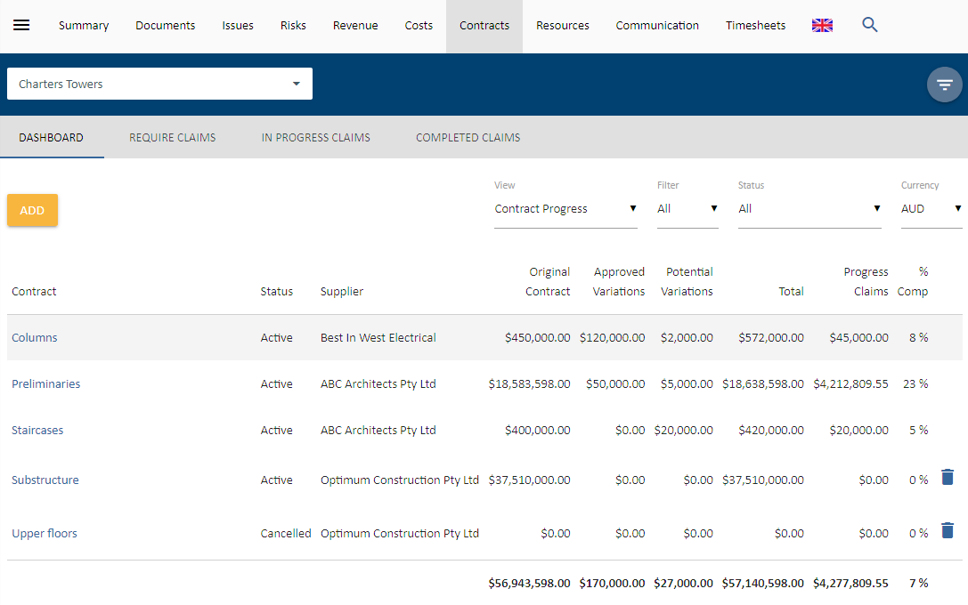
Figure 75 Contract dashboard contract progress updated for a signed off claim
This is one example of a document input object and how they can be used. Every UniPhi installation will have different template configurations and requirements. The System Administrator manual provides a more detailed view of all the document input objects.

Documents and Issues Management

UniPhi uses the Issues module for effective project collaboration. The Issues module achieves that through comments, and issue actions, which are accessible to the whole team. UniPhi also allows issues to be integrated with UniPhi documents.

The relationship to the Documents module is in ensuring that as Issues are resolved there is documentation to support the approved resolution.

In this section you will see how this is managed in UniPhi through the integration between:
- Issues (RFI tracking)
- Contracts
- Documents (Surveillance Reports)
All information that is worth recording on a project relates to the resolution of an issue. If this statement is true, then all communication is usually in resolution of an issue. This may be as simple as getting site fencing erected to major change in scope or budget.

The following examples will demonstrate how UniPhi assists with recording initial communications / issues and appending information responses to communications.

Recording communications as project issues

Project related communications often come via email, and it is important to ensure that this information along with any file attachments are stored in UniPhi so as to allow for effective collaboration in addressing the issues. UniPhi integrates with MS Outlook via the UniPhi for Outlook Add-in that allows users to quickly and easily save emails and attachments directly into UniPhi as either a document or an issue. For more information about logging issues in UniPhi see the UniPhi 15 Issues Management Manual.
Save an email into UniPhi Issues

- Once relevant email communication has been received via MS Outlook, select the email and click on the “Save to UniPhi” button, which is located in the Outlook menu ribbon.
Figure 76 UniPhi for Outlook Add-in button
- This will launch the Add-in form and ask you to login:
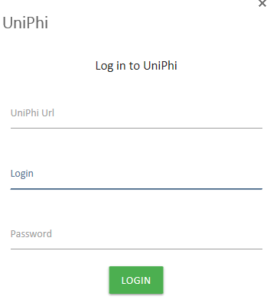
Figure 77 UniPhi for Outlook Add-in Login
- Then select to save the email as either a new issue or append it to an existing issue
Figure 78 UniPhi for Outlook Add-in options
- If you select New Issue, the Create New Issue form will appear. The email title will auto-populate as the Issue Description. Select the project from the drop-down menu. Select any of the other relevant fields.
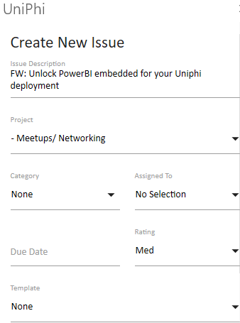
Figure 79 UniPhi for Outlook Add-in Create New Issue form
- If the email has attachments, these will be listed at the bottom of the form as an option to save into the issue. Check the box next to the attachments you want to save.
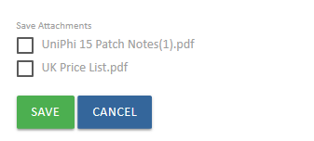
Figure 80 UniPhi for Outlook Add-in Create New Issue form - attachments
- If you select Append to Issue the Append to Issue form will appear. Select the project and the issue you want to save the email to. The Save Attachments option will also appear f relevant.
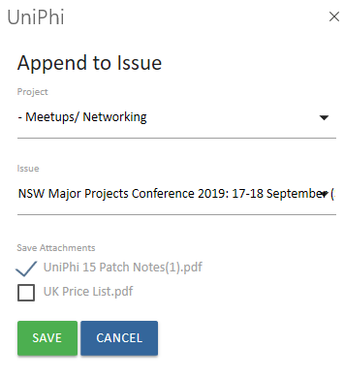
Figure 81 UniPhi for Outlook Add-in Append to Issue form

- Select Save to complete the process. The email will now be linked to UniPhi and the UniPhi for Outlook Add-in will show the link. If you select the issue, UniPhi will open the issue in your browser.
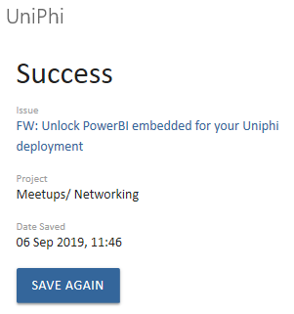
Figure 82 UniPhi for Outlook Add-in shows the link to the saved email

Once the email has been saved, you (and your project team) can also locate it via the Issues tab. Here you will be able to view the original email and any attachments, add comments / instructions to aid communication and workflows surrounding the issue, and add actions required to close out the issue.
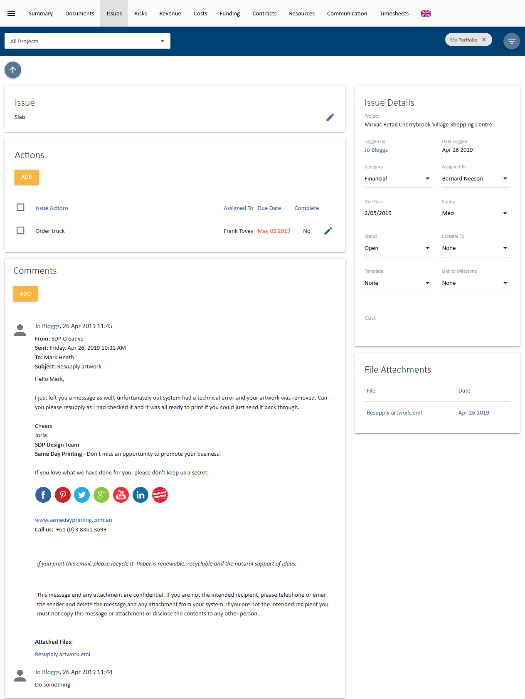
Figure 83 UniPhi Issues module showing an email saved using the UniPhi for Outlook Add-in

The resulting Issue record can now accept additional
- actions
- further comments
- email responses
- additional file attachments
- changes to due dates

Incoming communications is only one of the ways that issues arise on a project. Team members can record ideas and phone calls. If only to annotate the file to evidence that a call was made or received. Note taking of ‘random thoughts’ like something that might be needed in a few months can help with the quality management process of a project.

Save an email into UniPhi Documents

- An email can also be saved into a document using the UniPhi for Outlook Add-in. Select the email and click on the “Save to UniPhi” button, which is located in the Outlook menu ribbon.
Figure 84 UniPhi for Outlook Add-in button
- If you have not already logged in to UniPhi in Outlook, this will launch the Add-in form and ask you to login:
Figure 85 UniPhi for Outlook Add-in Login
- Then select to save the email as either a new document or append it to an existing document
Figure 86 UniPhi for Outlook Add-in options
- If you select New Document the Create New Document form will appear. The email title will be auto-populated as the Document Name. Select the Project and then use the Category and Template selector to select the UniPhi Document Template you wish to save the email into. Attachments can also be selected. Set the status you want for the document and select Save .
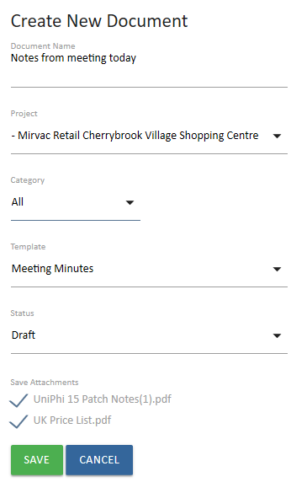
Figure 87 UniPhi for Outlook Add-in Create New Document form
- If you select Append to Document, the Append to Document form will appear. Select the project, category (optional) and template to be given a list of documents to choose to save the email to . Attachments can also be selected. Set the status you want for the document and select Save .

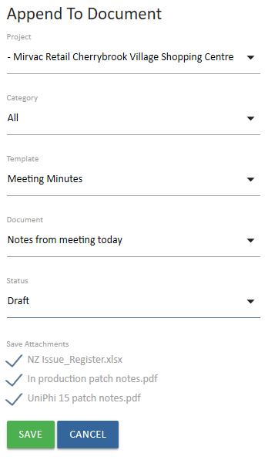
Figure 88 UniPhi for Outlook Add-in Append to Document form

- When you save, UniPhi for Outlook will show you the details of the document sand provide a link to it.
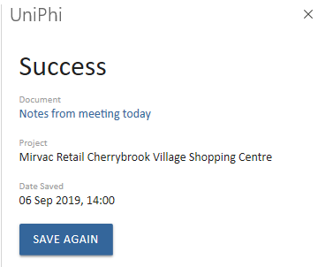
Figure 89 UniPhi for Outlook Add-in shows the link to the saved document
- Select the link and the document will open in UniPhi. You will see that the contents of your email now appears within the document you have either created or amended.

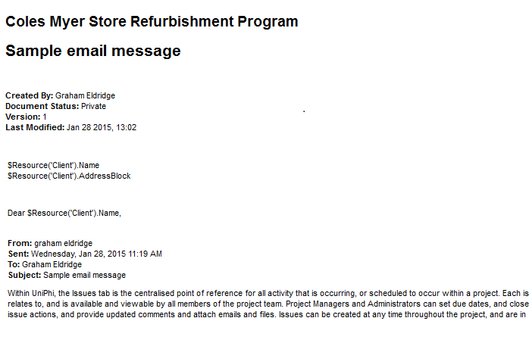
Figure 90 Document created with the UniPhi for Outlook Add-in
- You may wish to continue working on the document that you have saved your email into. In this case you will need to press the edit button to take you into the document edit mode.
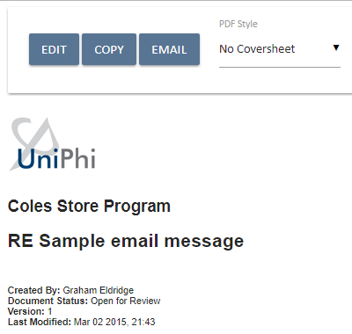
Figure 91 Selecting the Edit button in a document
- Once you are in edit mode, each of the template steps will appear, thus allowing you to create and update the necessary contents.
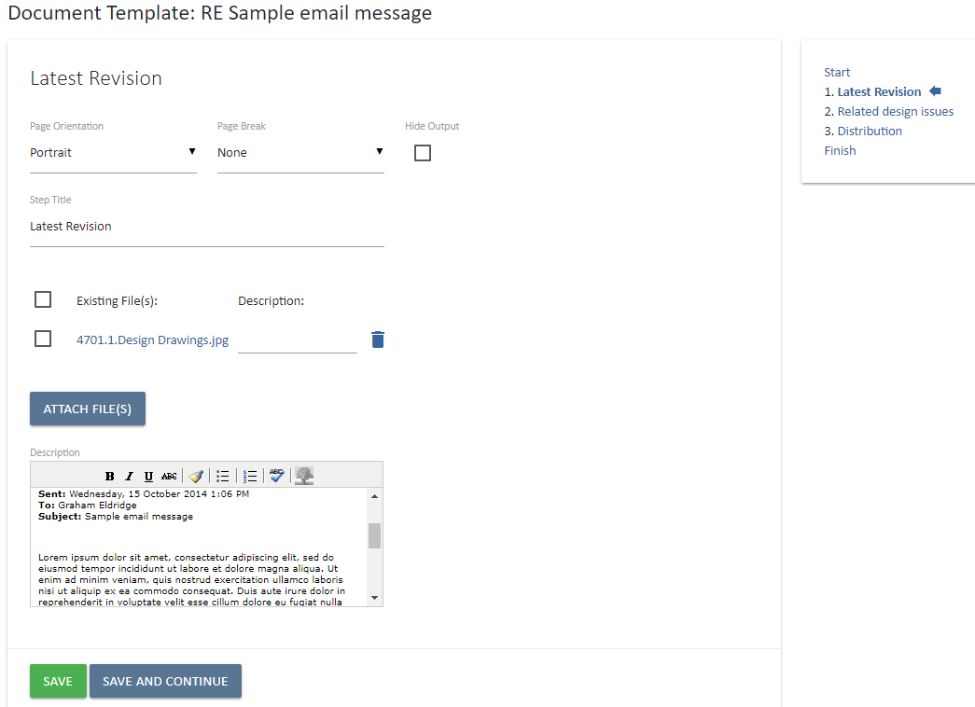
Figure 92 Editing a Document created with the UniPhi for Outlook Add-in
Linking Response Documents
Responses are made using the documents system and they can be linked within UniPhi so that related documents can be viewed in context. In the issue a Related Documents card appears below the Issue Details Card
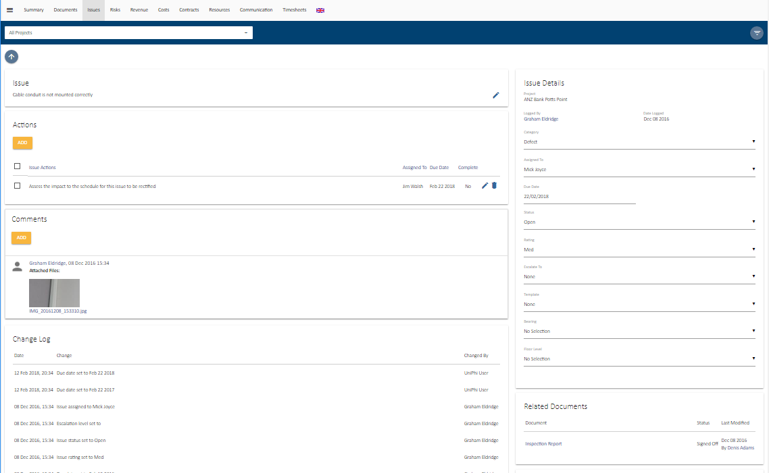 Figure 93 An issue with a related document
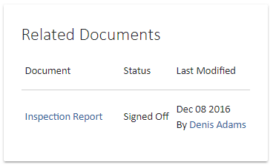
Figure 94 The Related Documents card in an issue

To link a document to an issue the relevant document template must have an Issue Selector input object included in it. It is assumed that the creation of the templates that are relevant to Issue responses will have this option available.
When creating the relevant document simply select the related issue with the Issue selector and as in the example above the document will display as a Related Document in the Issue detail level. Note that the Document status of Private will not display, any other status will display.
Document controls: Documents can be linked to issues, contracts and other documents by using Documents Controls built in to UniPhi templates.

Below are a few examples demonstrating the different document controls and how they link to different areas of UniPhi:
- The Contract Details document control is used to link the document (e.g. a Project Manager Instruction) to the selected contract (Preliminaries)
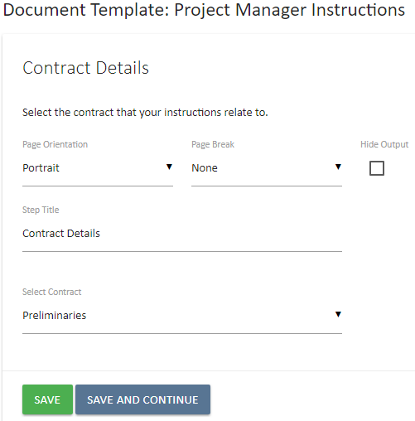

Figure 95 Contract Details links the document to the relevant contract.

- The Issue Selector document control is used to link the document / communication to the initial issue:
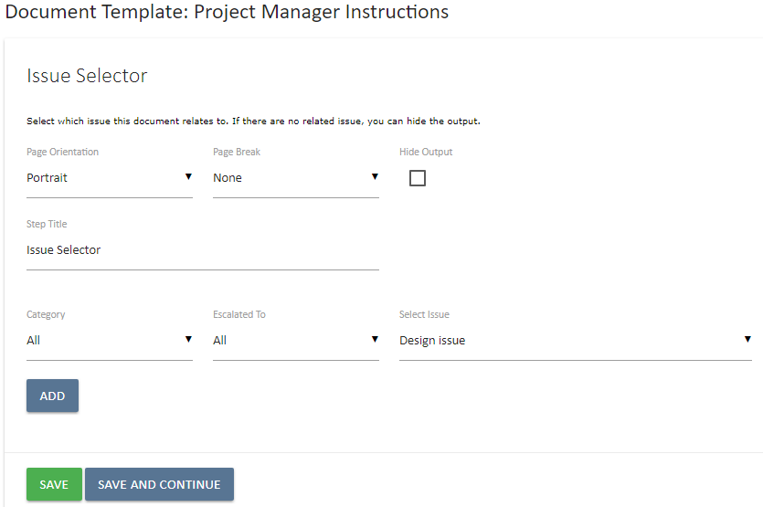
Figure 96 Issue selector links the document to the relevant issue.
This document will now appear in the Related Documents box when you have drilled into the selected issue.

- The Document Selector document control links all other communication related to the initial issue into the response document. The documents must be signed off to be available.

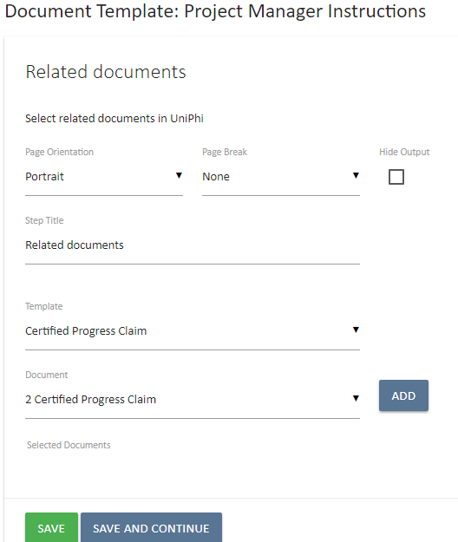
Figure 97 Document Selector links the document to any relevant signed off UniPhi documents.

- The File Upload (Multi) document control allows you to attach other external documents that can then also be linked:
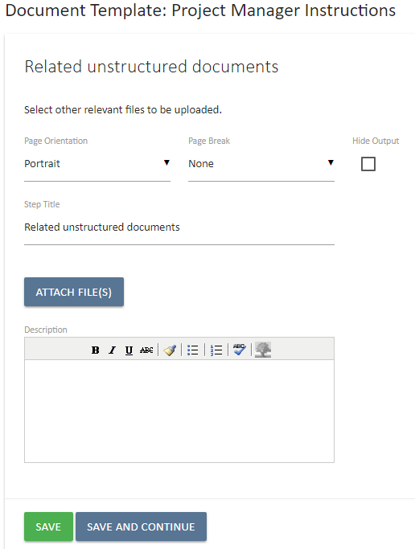
Document upload link enables you to upload multiple files.
Figure 98 You can attach any file at this step.

UniPhi then acts as a document transmittal register for the documents

The client-side project manager should be constantly monitoring and using the UniPhi issues system making sure that all issues are recorded and actioned. Overdue issues should be reviewed and followed up. The Issues Register report (located in the Reports module) can be used if this list needs to be issued to a contractor as part of the follow up.

The Issue sign-off or resolution process provides for Team Members to not “Close” an Issue but to set a status of Awaiting Review. The process being to alert the Project Manager that they consider that their actions have been completed. The Project Manager should review the actions and results and Close or Re-open the Issue based on their findings.

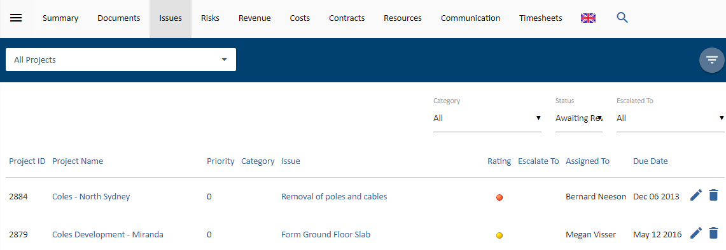
Figure 99 Issues Awaiting Review.

Linked Contract Documentation
Each contract has a number of views including an edit view (used for creation of a contract, and generating claims) and a details view (for contract summary information). You can toggle between these views via the sub-navigation menu within the contract. The details view displays all the documentation related to that contract (as per below). These include Variations, Progress Claims, EOTs and other Related Documents.
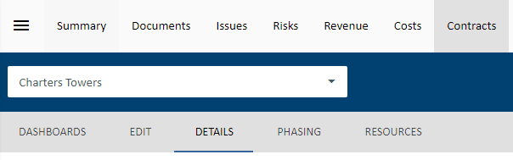
Figure 100 Contract module sub-navigation menu.

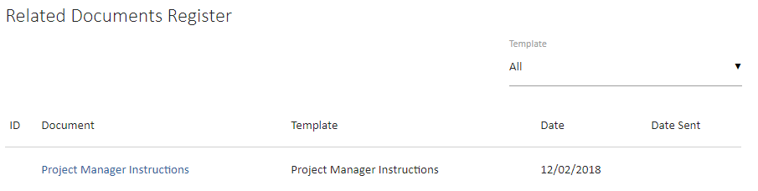
Figure 101 Contract module Details Related Documents Card.

