UniPhi 15

Timesheets for

Team Members

Training Manual

Contents
Timesheets for Team Members 4
Adding Projects to your Timesheet 5
Timesheet Week vs Day View 8
Entering Hours 10
Submitting Your Timesheet 13
Rolling Back Timesheets 13

Course Aim
The aim of this manual is to provide instructions for any Team Member that is required to enter Timesheet data to the UniPhi system. A separate manual addresses Administration tasks for Project Managers and System Administrators.

How to use this User Training Manual
As you read this manual you will notice the following icons recurring which will help to highlight and enable you to quickly locate activities and summary areas, they will also assist with tips for keeping out of trouble.
Puzzle Piece:
The puzzle piece appears at the beginning of each session and any major section to mark the overview of that item’s content or concept.
Cogs:
The cogs denotes a step by step activity to be completed using UniPhi by the participant relative to the section it is located in.
Light bulb:
The light bulb denotes a helpful hint or tip you should be aware of.

Screen dumps have been used throughout the manual to demonstrate what you should be viewing as you move through the activities. They are for illustrative purposes only. Details such as dates, budget figures and other entered text/data may vary.

Timesheets for Team Members
The use of Timesheet system supports a number of aspects of UniPhi:
- Where timesheet entries align to a contract on a project the submitted hours support calculating progress claims against the contract
- Project Costs and implicitly Profit calculations can be reported
- Resource Planning for the organisation uses Actual Hours submitted on projects to calculate the remaining budget hours and make adjustments for estimates at completion
- Provides data for the team Utilisation calculations
- Ultimately this data supports the organisation analysis of effort expended

The Timesheet view is as follows:

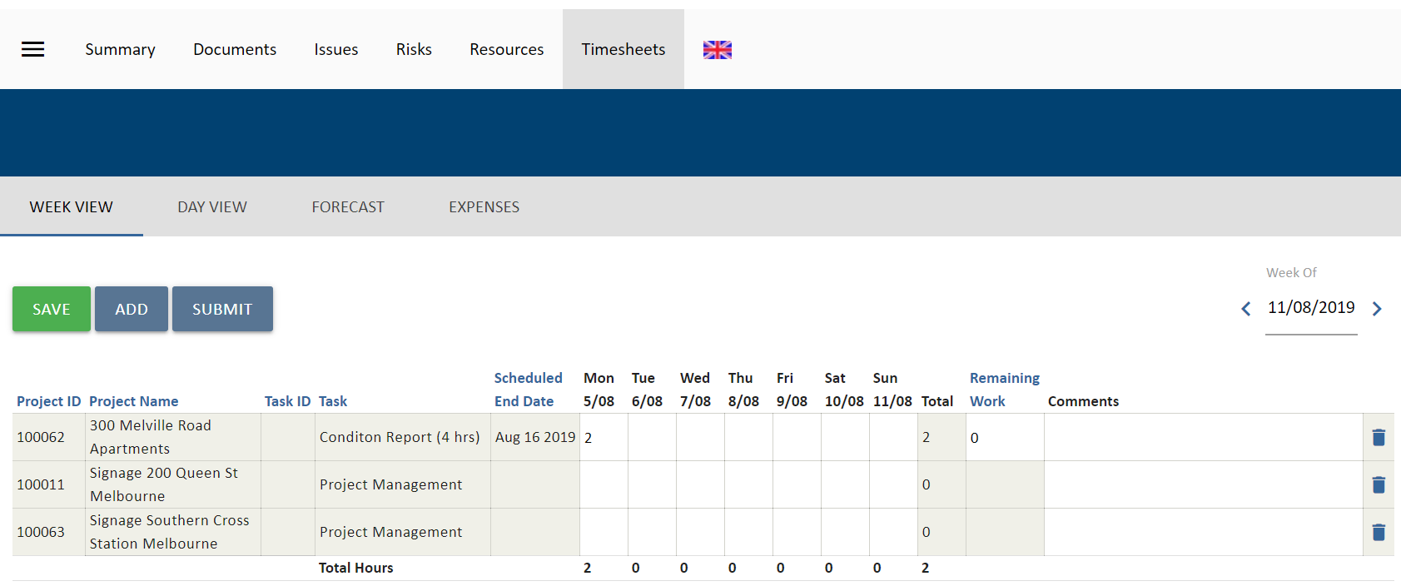

When selected the filter option disappears as it is not relevant to the Timesheet module.
There are a number of fields and controls presented:
- “Week of”: will default to the first day of the week that is yet to be submitted for the team member
- : the “<” and “”>” move backward or forward a Week or Day to depending on the selected view
- 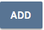 Provides for the selection of a project to add to the Timesheet
- Allows the team member to save the entries and date entered to the system. Saved data can be edited, changed, or removed at any time prior to submitting.
- Commits the Timesheet to the system, updating the Work in Progress for the relevant projects and closing the Timesheet from editing.
- “Scheduled End Date”: is only for Timesheet Contract Deliverables and Variations that are assigned to the Team Member. It shows the end date of the deliverable
- “Remaining Work”: is only for Timesheet Contract Deliverables that are assigned to the Team Member. It shows the hours left for the deliverable; this can be updated by the Team Member.
The sub-navigation options in the grey menu allow access to the following:
- “Week View”: is the standard timesheet view and shows the timesheet for the week of the selected date.
- “Day View”: changes the view to a single day
- “Forecast”: access the timesheet forecast function
- “Expenses”: access UniPhi’s expense management function (this is explained in another manual).

The following pages describe a step by step process for managing timesheets.

Adding Projects to your Timesheet

Select Timesheets
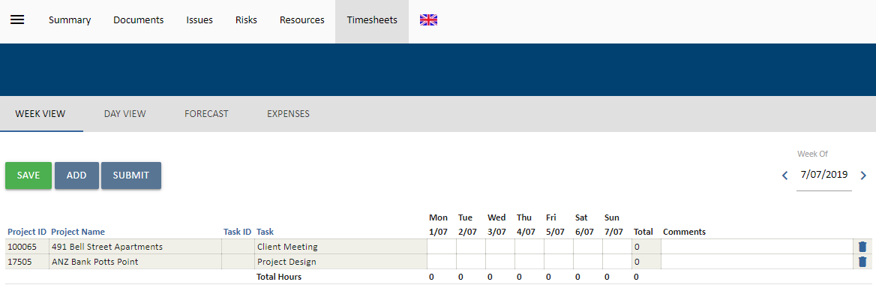
Click on the icon.

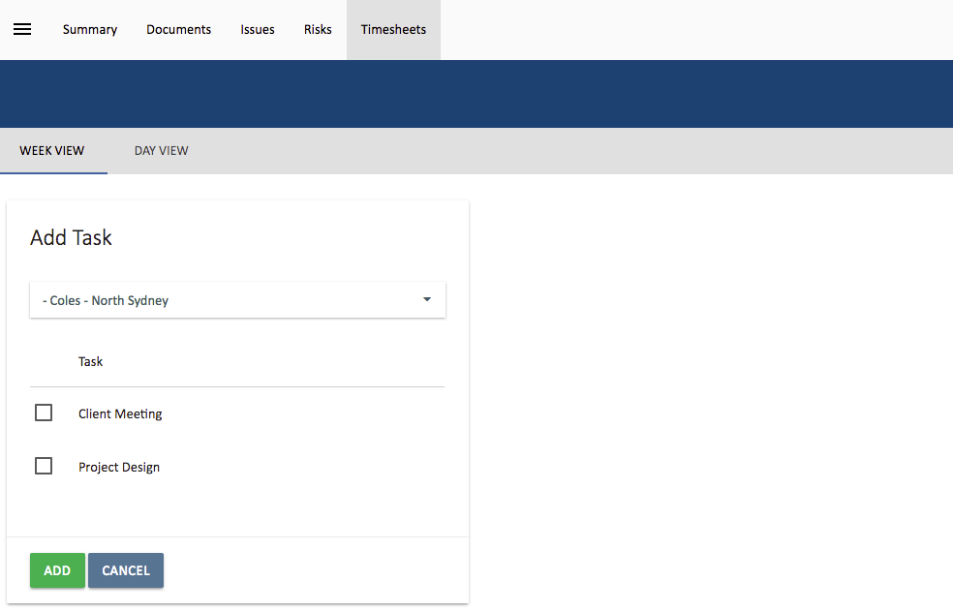

Select the Project you want to add to your timesheet from the Add Task: field. This will search for the project as you type or work as a drop-down list to select.

Project Resources: Only projects that you are assigned to will appear in the drop-down filter of the timesheet. If you have worked on a project that you are not yet assigned to, go to the Portfolio > Resources tabs and add yourself to the project. If you are not authorised to add yourself as a resource, please raise this with the designated Project Manager.

If a Standard Task List has been specified for the project, a Tasks checklist will appear. You can use this to add selected tasks from the Tasks list. If a Task List is assigned you must select at least one task. Select as many tasks or assignments as required using the checklist.

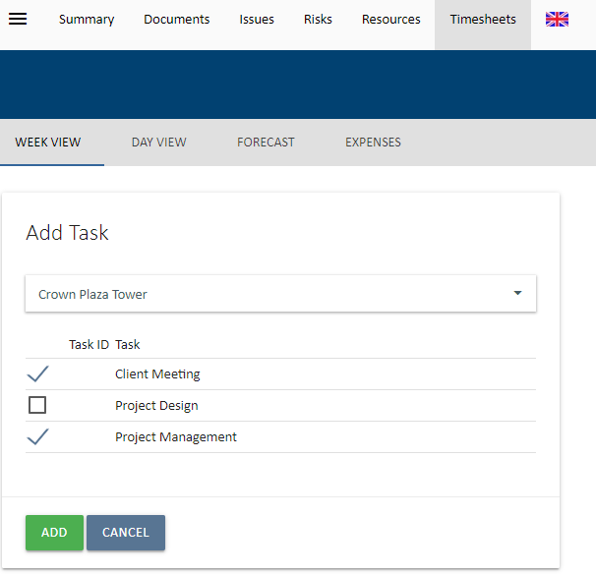

Click the icon. The Project and selected task and assignments will now be listed in the timesheet view.

The screenshot shows the result of adding two projects to a Timesheet with the selected standard task list and an assignment from a contract deliverable with a schedule. Standard tasks have no Scheduled End Date.

Scheduled End Dates only appear where a Contract Deliverable is assigned and has had a schedule added to it on the Contract.

The at the far right of the line indicates that this item could be removed from the Timesheet if it is incorrectly selected.

If there is no Standard Task List assigned to the project the Tasks selector will not appear. This indicates that the project is not available for timesheets.

Timesheet Week vs Day View
The default setting for UniPhi Timesheets is to display the week that requires submitting. Assuming that the team member is pro-active this should be the current working week.
The Week view presents a full 7 days while the Day view focuses on a specific day.
The Day View provides for entry of time data and for Comments or notes about the activities undertaken. The Comments field will hold 256 characters although only about 40 are displayed depending on your screen resolution.
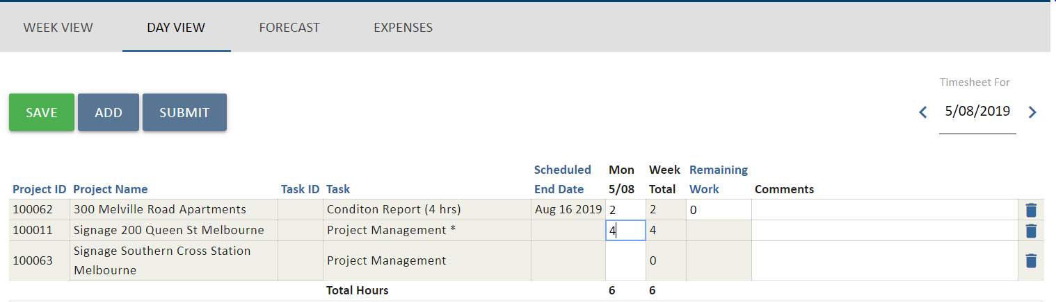

The same Timesheet is shown below except that the Project Manager has selected “Require Comments” for all project timesheet entries. This is signified by the asterisk * against each task.
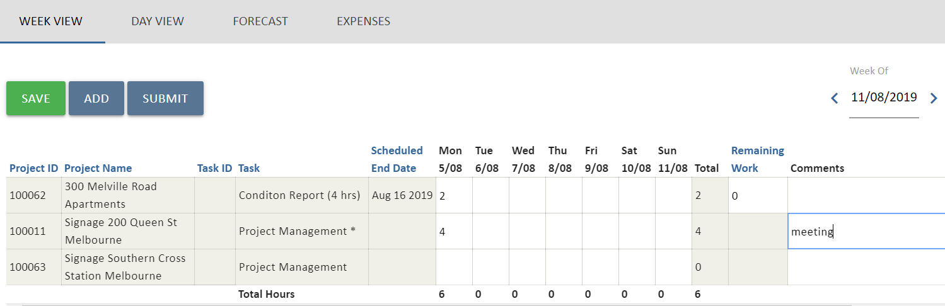
In order to submit the timesheet, a comment must be entered for each line item with the asterisk. Comments can be entered in Week or Day views.
The Save and Submit options work similarly in both views saving or submitting the selected data as one day or one week.

Attempting to Submit a Day or Week that has an empty comment where a comment is required will be rejected.
You can select the timesheet Date using the icon. You can scroll back to a previous week/day by selecting “<” or scroll ahead by selecting “>”.

Entering Hours
Projects can be added to the Timesheet at any time prior to submitting the Timesheet. Additional Standard Tasks can be added by adding the project again and selecting the required option from the Tasks selector. Ensure that the Date for the week or day you wish to timesheet against has been selected correctly.
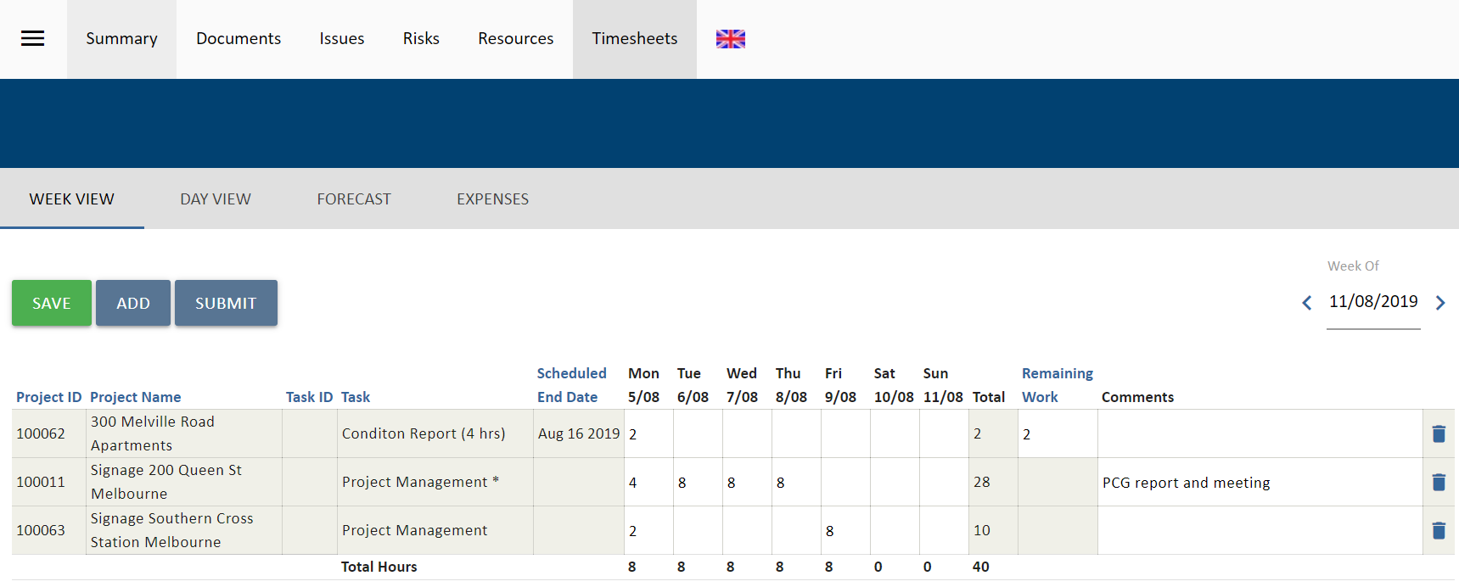Note that the project timesheet has been specified as “Comments Required”. Enter in the hours you worked on projects for each day. Note that the hours are automatically tallied up to give the total hours worked for that day and week.

Hours can be entered as decimal hours. UniPhi recommends minimising the complexity by sticking with increments of 30 minutes or .5 hours as an adequate level of detail. However, your organisation may vary and utilise for example .1 to .9 reflecting 6 minute increments.

Enter in comments against the task by selecting the Day view and typing in the comment field. Here you could enter more specific information regarding the task you have worked on.

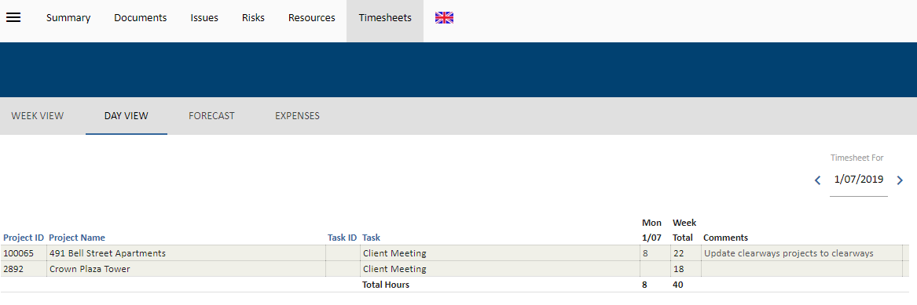
To save your hours, select the icon.

Note that once you have entered hours and saved them these hours will be available to report on project progress (although these will be identified as ‘Entered’ hours as opposed to ‘Submitted’ hours).

Submitting Your Timesheet
When the Timesheet is completed for the day or week it can be submitted. Timesheets must be submitted sequentially. The Submit option will only appear for the Week or Day that is next in sequence. Submitting a Timesheet locks the entries and disables editing or changes to a Timesheet.
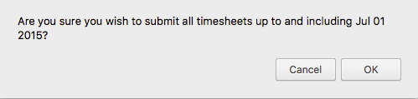
It is easier to Submit from the Day view directly so that each day is checked for comments. Submitting a Timesheet at the Week or Day View with no hours or all zeroes is accepted in UniPhi.

If there is a Comment required selection that has not been completed a message will appear:
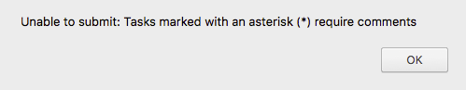

You are able to view submitted timesheets by using the navigation buttons. Submitted timesheets will be greyed out and only weeks will be viewable. Selecting Day View will return from the submitted Timesheet to the next Day that is to be submitted. The history of Daily information can be viewed via Timesheet Reports.

Rolling Back Timesheets

Occasionally a Timesheet may need to Rollback (the Team member may have missed a day, entered incorrect hours etc.). Only UniPhi users with Administrator Access are authorised to rollback submitted timesheets.

While an Administrator may be able to roll back a Timesheet this can only be done within the current financial period. Once a financial period is closed the Timesheet roll back facility is also controlled.

A suggested process is to log an Issue in UniPhi against an Administrative project and assign it to the relevant UniPhi Administrator. This maintains a record of roll backs and will assist with debugging any errors made during the process.

Rolling back timesheets may impact on Work in Progress for a project if it is done without consideration for the flow on effects.

A Rollback of a time sheet will also re-open all subsequent timesheets.
This is because timesheets must be submitted sequentially. When this occurs not data is lost. Amend the incorrect sheet, submit it, and then re-submit the following correct sheets to return to the current period

