Xero Integration
Manual

Contents
Setting up Chart of Accounts 4
Set up Tax Codes 6
Logging into Xero 7
Contacts 9
Accounts Payable (AP Export) 10
Accounts Receivable (AR Export) 11
View Exported Invoices, and Contacts 14

Xero User Guide
UniPhi includes a simple to use user interface with the Xero accounting software package. This document details the configuration steps required for an administrator to configure accounting integration between UniPhi and Xero, and instructions on how to export information to Xero. This document also covers some of the typical error messages, and how to resolve them.
The accounting integration interface allows administrators to export financial information such as contact details, invoice and or expense payment details from UniPhi into Xero. Effectively this means that as your project team raise invoices, or approve payment requests, the transactions will appear in the Accounting Integration tab, awaiting export.

Setting up Chart of Accounts
Your organisation will have defined at least one chart of accounts. If you have been using Xero for some time, and have recently implemented UniPhi, you will need to set up both your CoA, and tax rates in UniPhi. This information need to be replicated from Xero into UniPhi. You will also need to import your contacts from Xero to UniPhi.
If on the other hand you have been using UniPhi and Xero separately and without any integration between both systems, you will need to review and validate the structure that you will use in both systems. In this case you will need to standardise your CoA across both UniPhi and Xero, set up your tax codes, and merge and/or import contacts from Xero and UniPhi.
To view and or change Chart of Accounts information from Xero, go to the company section within My Xero
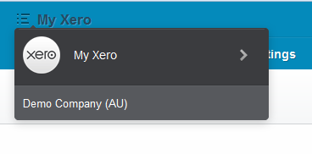
Figure 1 Xero company file selection
Then go to your Setting / Chart of Accounts tab
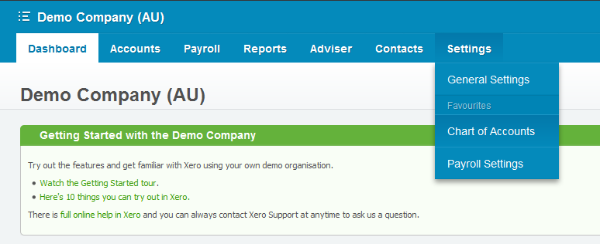
Figure 2 Xero Chart of Accounts menu
If you are working with a small chart of accounts, you may choose to simply copy and paste each account code from Xero into UniPhi. For larger and more complex charts, it will be more efficient to export the data from Xero and then import that data into your UniPhi chart of accounts.
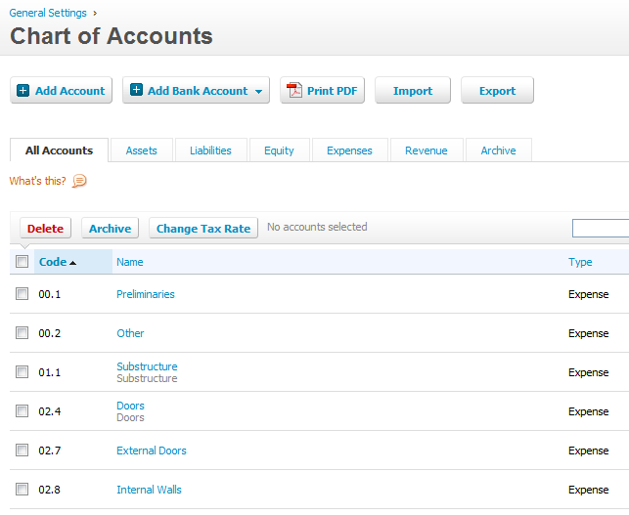
Figure 3 Xero Chart of Accounts
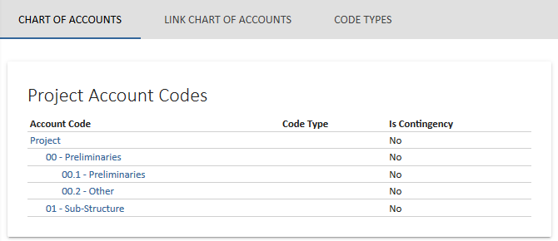
Figure 4 UniPhi Chart of Accounts
The Chart of Account mapping between both systems is done on the ‘Code’. As seen in the example above, 00.1, 00.2, 00.3, etc are the codes replicated in both systems.
Any account which has a code not replicated in the other system, will not export/import any data recorded against it.

Setting up Tax Codes
Both Xero, and UniPhi recognise tax codes (such as GST, VAT, etc.) per cost and revenue item. It is therefore necessary to map your tax codes between Xero and UniPhi.
From UniPhi, go to your Configuration > Tax Rates tab. In the example below you will notice that GST codes have been set up for Cost and Revenue contracts. These have been set as the default codes. Logically the revenue contracts are associated with Xero’s GST on Income codes, and cost contracts are associated with Xero’s GST on Expenses.
The Account Code dropdown should be a list of Tax Rates from your Xero application. You must select the code that you have mirrored in UniPhi.
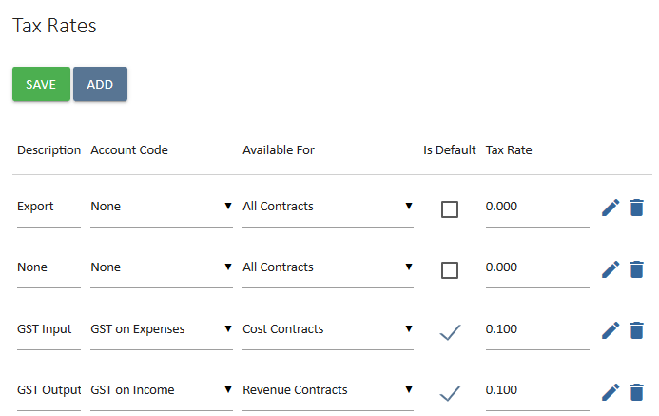
Figure 5 UniPhi Tax Rates configuration
Tax codes are located in Xero via Settings, General Settings, Tax Rates
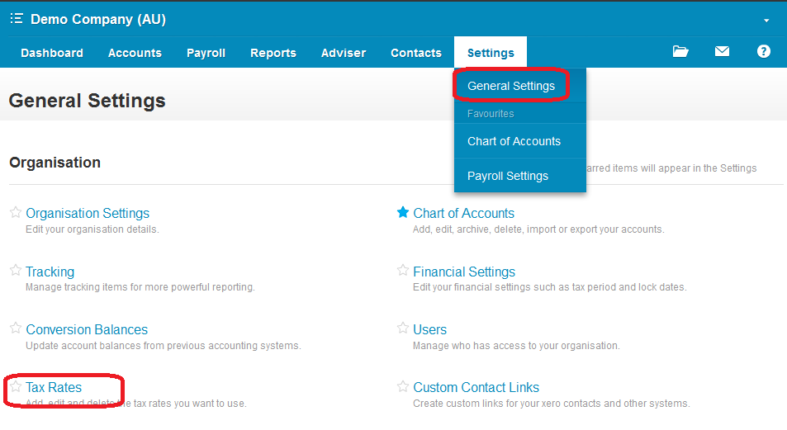
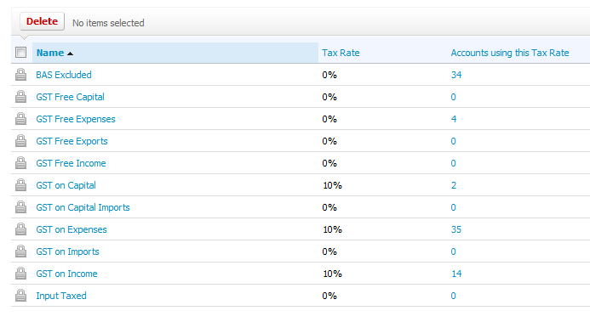
Figure 6 Xero Tax Rates
In the last 2 screenshots above, we have mapped 2 tax codes. GST on Imports & GST on Exports.

Logging into Xero
In order to view the integration interface in UniPhi, you will need to log into Xero. The Xero login screen will appear as soon as you go to UniPhi’s Accounting Integration tab.
Go to Configuration > Accounting Integration tab in your UniPhi.
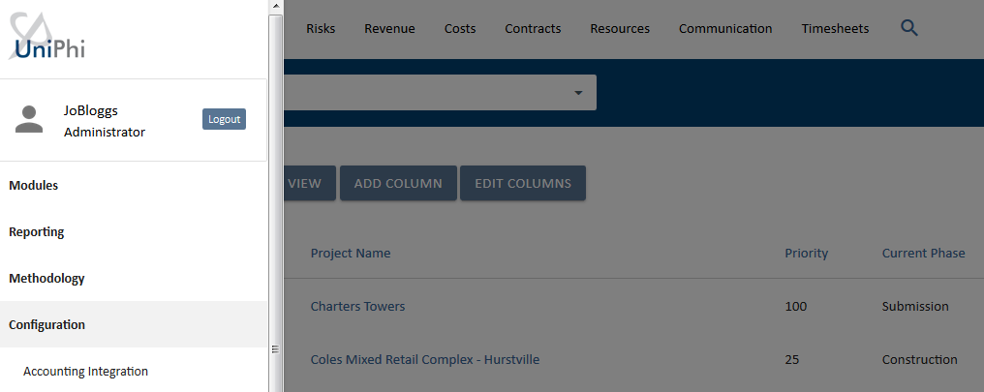
Figure 7 UniPhi's Accounting Integration screen
- If logging in for the first time, you will be required to enter credentials for Xero. This screen will open in a new browser tab. Do not close the UniPhi tab.
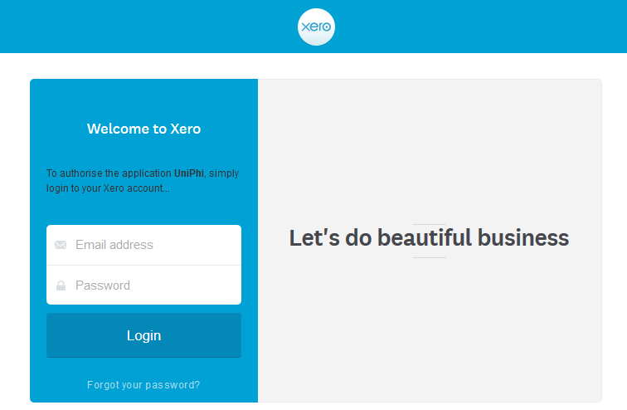
Figure 8 Xero's login screen

If the login does not appear, check that your browser is not set to ‘Block Pop-ups’. Depending on the web browser configuration there may be a warning message appear (commonly upper right corner of the browser) that states ‘Pop-Up Blocked’ or a red X to indicate blocking. Select or set the browser to ‘Always allow Pop-ups’ from your UniPhi site.

2. Xero provides for applications like UniPhi to connect for a maximum of 30 minutes per session. This means that you will need to login each time you need to manage the Xero Accounting Integration in UniPhi. Click Allow access for 30 mins.
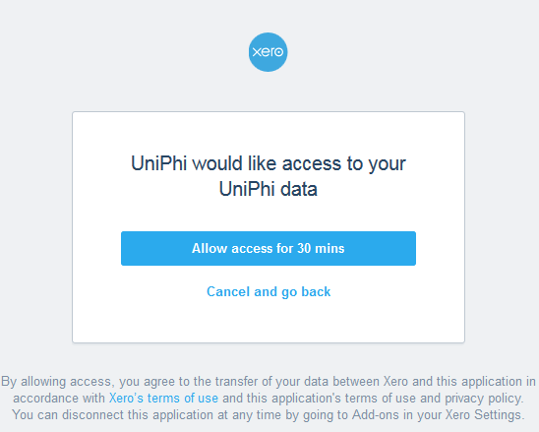
Figure 9 Allow Xero access to UniPhi
Generally, UniPhi users do not require more than 10 minutes to process transfers to Xero and the 30-minute limit provides for strong security access to the Xero data.

3. The page will generate a code. You are required to copy this code.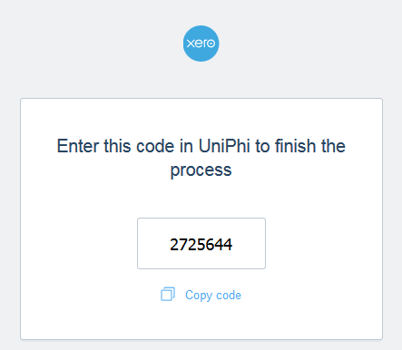
Figure 10 Copy code from Xero
And past it in to the Accounting Integration tab opened next to it.
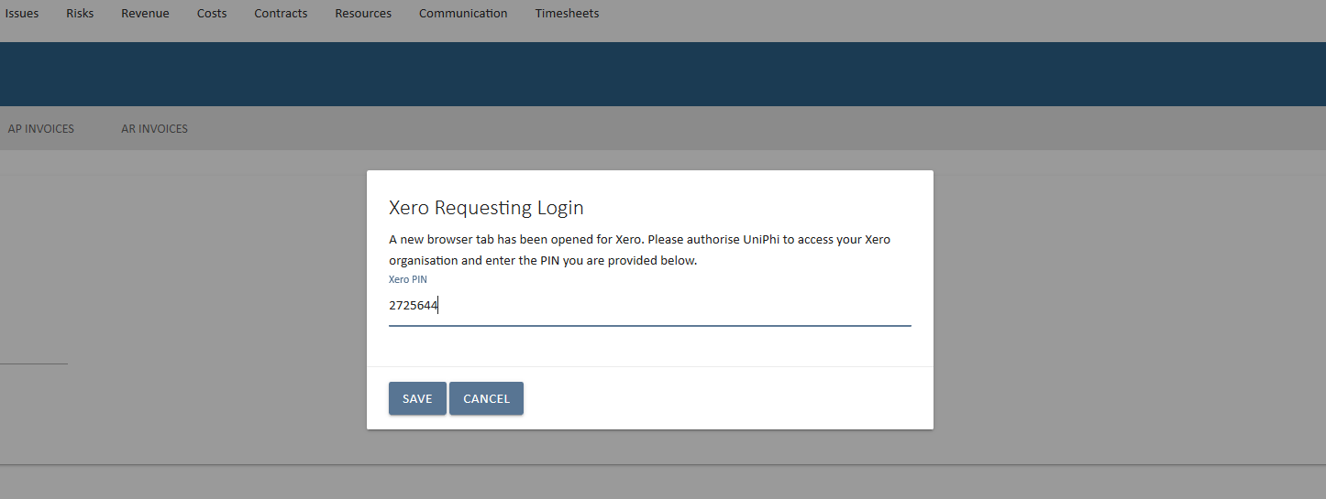
Figure 11 Enter Xero code
Click Save.
You have now successfully logged into Accounting Integration to Xero via UniPhi. You are now in the Dashboard screen and should be greeted with the following view:
Figure 12 Accounting Integration Dashboard

Contacts
UniPhi’s accounting integration allows you to quickly and conveniently import or export your contacts. By clicking into the Contacts panel, and selecting the appropriate task from the drop down list, and pressing the export button your contacts can be exported to UniPhi or to Xero.
As the task descriptions suggest;
- “Export to Xero” will push all contact information from UniPhi into Xero 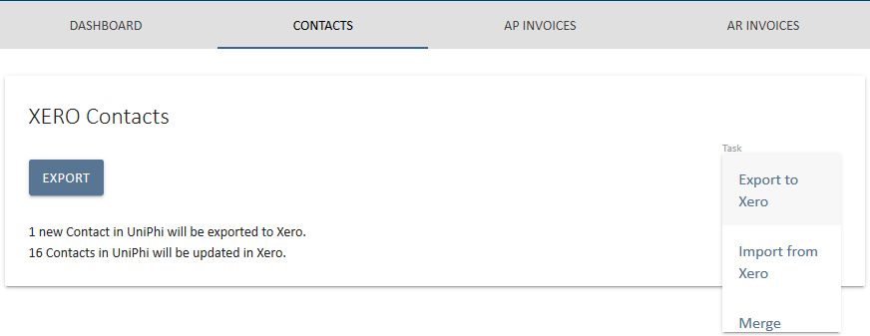
Figure 13 Contacts - Export to Xero
- “Import from Xero” will pull all Xero contact information into UniPhi
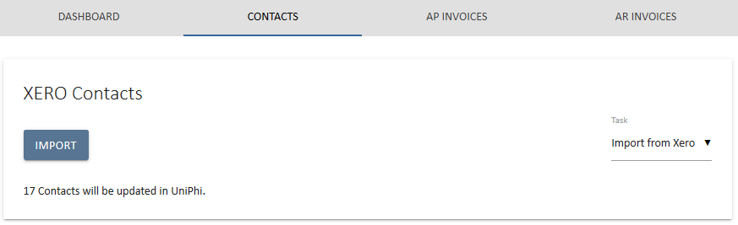
Figure 14 Contacts - Import from Xero
- “Merge” function works so that if you already have the same contact in both Xero and UniPhi, Merge will allow you to connect them together so the details stay in sync, and any changes made in either Xero or UniPhi will be replicated.
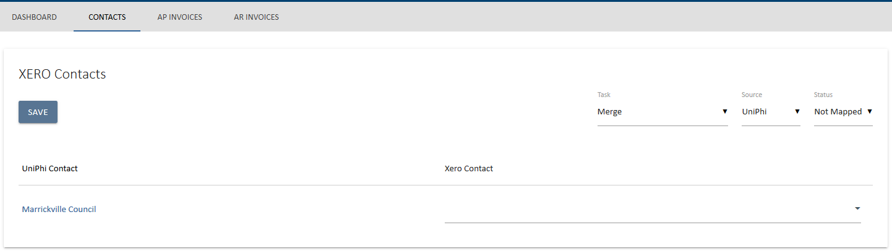
Figure 15 Contacts – Merge
Business rules around merging contacts – UniPhi to Xero
When the Principal/Customer contact for a contract is changed in UniPhi, UniPhi will update the details of the contact in Xero and overwrite the contact that was last there.

If there is an organisation with multiple contacts and contracts, UniPhi will overwrite in Xero which ever was the last contract to be synced from UniPhi to Xero.

In short, the Principal/Customer contact in UniPhi = the primary contact for the customer in Xero. Change this in UniPhi and it will be changed in Xero.

Accounts Payable (AP Invoices)
The AP Invoices section is the location where your Accounts Payable (AP) data is transferred from UniPhi into Xero.
The Xero Accounting Payable Invoices panel allows you to view payments which are awaiting export, successfully exported, and payments which have failed to export.
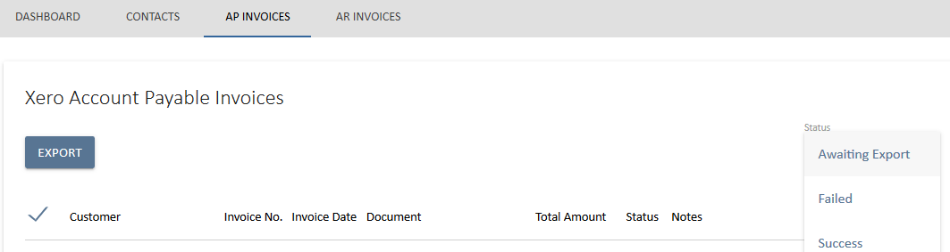
Figure 16 AP Status selection
AP invoices will appear as awaiting export once a corresponding document has been produced in UniPhi and signed off (e.g. a Payment Approval document). From the Awaiting Export view, you may select all invoices, or use the tick-box selection to include or exclude invoices as necessary.
Providing your chart of accounts has been configured correctly, you invoice will export successfully to Xero. You may view all of the successfully exported invoices via the Success status filter.

Accounts Receivable (AR Invoices)
The AR Invoices section is the location where your Accounts Receivable (AR) data is transferred from UniPhi into Xero.
The Xero Accounting Receivable Invoices panel provides for viewing invoices which are awaiting export, successfully exported, and invoice exports which have failed.
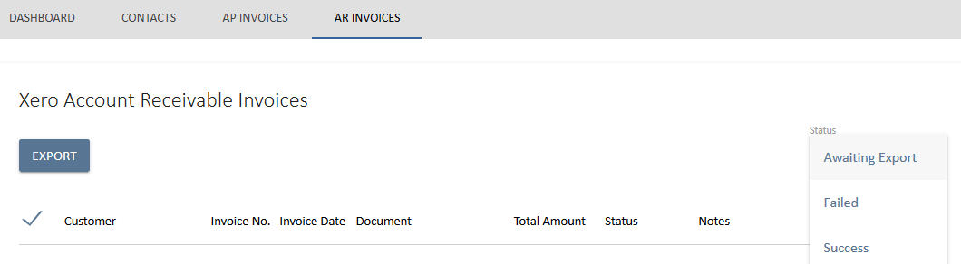
Figure 17 Accounts Receivable tasks
AR Invoices will appear as awaiting export once a corresponding document has been produced in UniPhi and signed off. From the Awaiting Export view, you may select all invoices, or use the tick-box selection to include or exclude invoices as necessary.
Providing your chart of accounts has been configured correctly, you invoice will export successfully to Xero. You may view all of the successfully exported invoices via the Success status filter.

Export Failure Messages
In the event that an invoice fails to export, it will appear in the Failed status filter view. A list of failure messages is listed below with an explanation of how to resolve each one.
- Some line items do not have account codes.
Occurs when an invoice document has been produced prior to changes to the UniPhi chart of accounts. To resolve this issue you will need to ensure your contact deliverables are mapped to the correct and current chart of accounts, then delete the problematic document and recreate it.

- UniPhi account codes 'Xx.Nn', 'Xy.Nn' cannot be found in Xero accounts.
Occurs when a chart of accounts code exists in UniPhi, but is not present in Xero. To resolve, go into Xero and manually create the missing code entry. Make sure that your new account entry in Xero matches the code in UniPhi’s chart of accounts
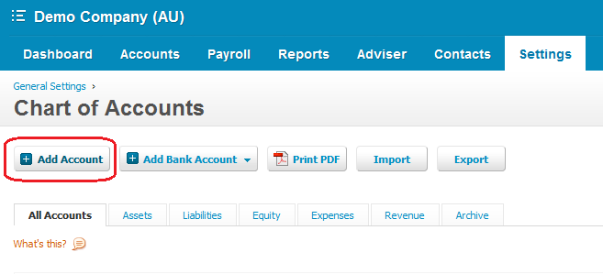
Figure 18 Add a code to Xero Chart of Accounts
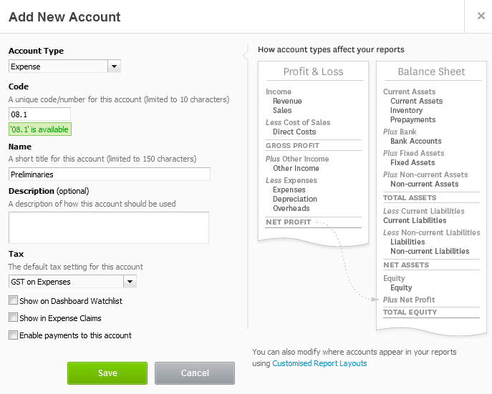
Figure 19 Xero Chart of Accounts entry

- The TaxType code GST does not exist or cannot be used for this type of transaction.
This error occurs when your GST codes have not been mapped. Refer to “Set Up GST Codes” section within this document (above) for the standard and most common GST configuration settings

- The TaxType code 'OUTPUT' cannot be used with account code 'Xx.Nn'.
This error indicates that a contract deliverable item has been allocated the incorrect GST code.
Refer to your contract;
  - if it is a Cost contract, check that the nominated GST code matches the settings specified as per the ‘Set Up GST Codes’ section of this document (above).
  - if it is a revenue contract, ensure that the correct GST code is set.

Note, GST fields are specified in the Contract Deliverables, Variations and Claim Adjustment panels in UniPhi.
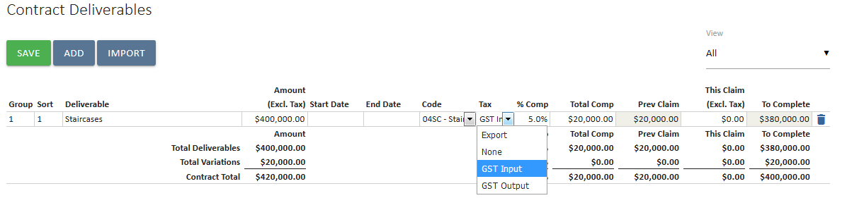
Figure 20 UniPhi Tax code selection

View Exported Invoices, and Contacts
Once an invoice has been exported successfully from UniPhi, it will appear in Xero within the Accounts tab, under either Sales, or Purchases (depending on your invoice coming from a cost or revenue contract)
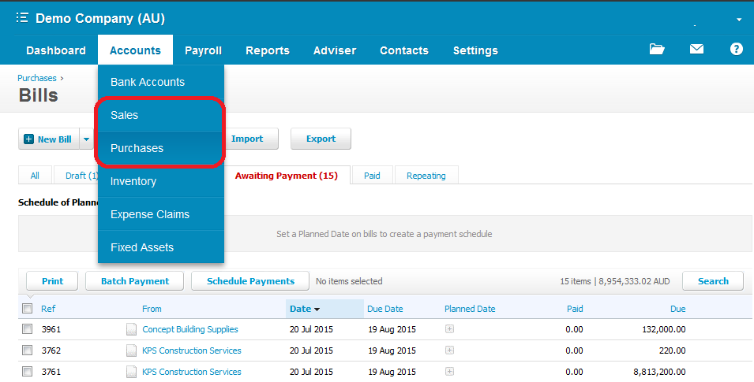
Figure 21 Xero view of invoice transactions
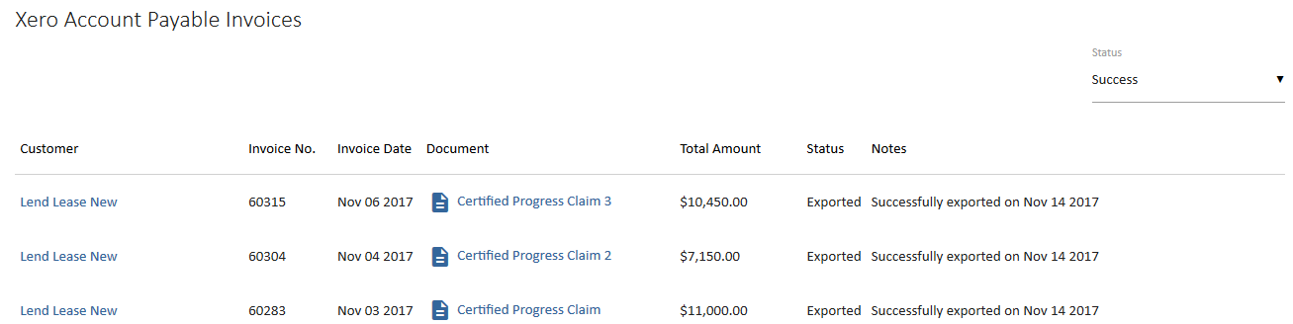
Figure 22 UniPhi view of invoice transactions
Synchronised contacts appear in Xero with a log file informing you of when the contact record was updated.
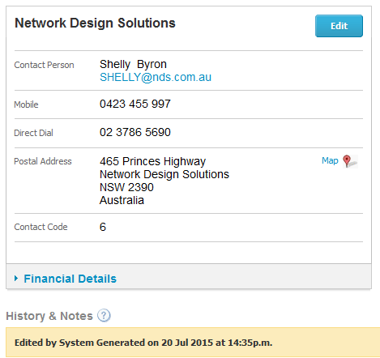
Figure 23 Xero Contact view
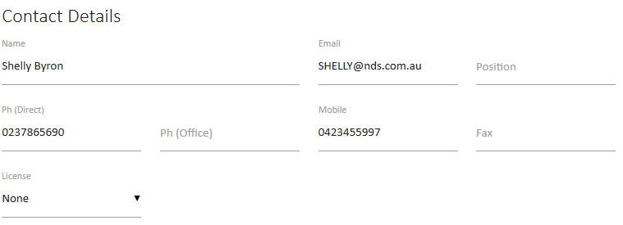
Figure 24 UniPhi Contact view

